2023-03-07

1. In the view folder there should be separete file for each page of the website that user interacts with - HomeView, LoginView, BookDetailView, MyProfileView, MyOrdersView, MyCartView, BookListView. Each of them containg main UI interface and components the user has a direct interactions with.

In the components folder we should have BookDetail, BoolList, LoginForm, SearchBar, SideBar, UserAvatar, HeaderInfo, BookCarousel, Book components. They are basically “Lego parts” of our project. We define them in separate files to make the project reusable, maintainable and scalable. Then we just call the already defined components from our View files.

Service folder is needed to keep the scripts that will interact to out back-end logic (typically written in other languages). For this website we should have bookService and userService scripts to fetch book/user info from database.

2.

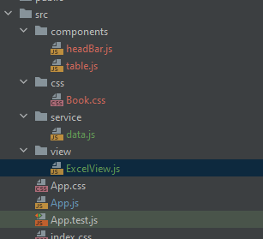

I have added data.js in serivce which just simple declares and holds hard-coded values. We have to components table and headerBar. Their functionality is separate that’s why we implement them in different files. I have also moves Book.ccc into css folder and add ExcelView to render basic html for table and headerBar components for UI.