2023-03-11  
A.

This is my projects structure. I have created view, css and component folders to implement **layered architecture**. In view folder there are the pages that the user has access to and can navigate back and force. In css folder I have put all necessary css files. In the component folder I have Layout.js file where I create my basic <nav> manu. App.js renders BasicRoute compnent which is defines in Router.js. In Router.js file I used <BrowserRouter> to create a basic router. Now user can easily navigate between pages by simply clicking on menu items.

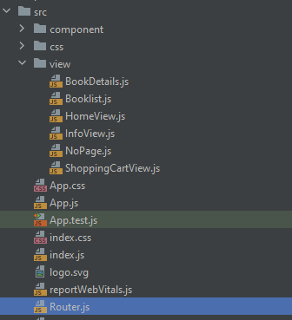.

Home:

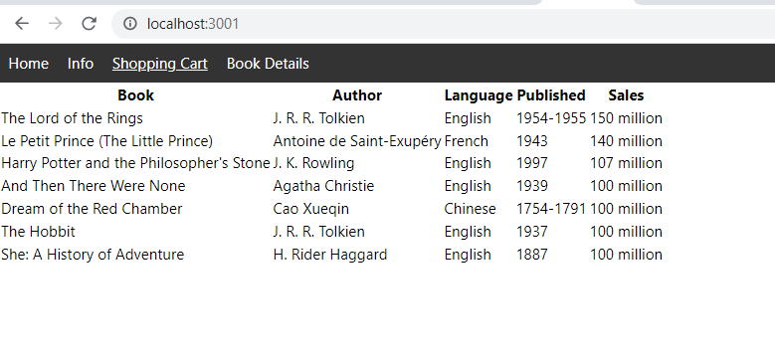

Info:

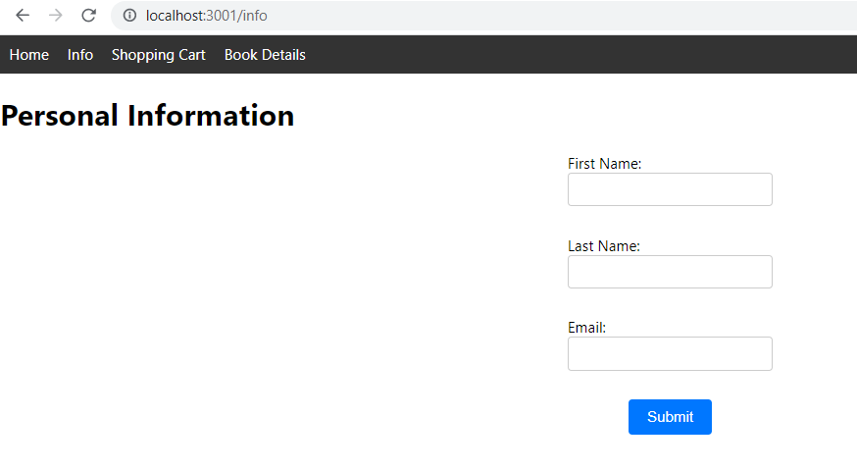

Shopping card: (TODO)

