Big Data & Cloud Computing · Final Capstone Project
From Spreadsheet to Streaming
An end-to-end big-data pipeline on the Online Retail II dataset

PROJECT TEAM
Member | Roll No | Responsibility
Ayesha Ameen | GEM/25/AIDS/1013 | GDPR, sustainability & architecture
Mahnoor Hashim | [ Roll No ] | Task 1 — SQL & NoSQL
Muhammad Vahaj Ur Rehman | [ Roll No ] | Task 2 — PySpark
Amal Alkaff | BAKSA2500313 | Task 3 — Docker, Airflow & Kafka
Dataset UCI Online Retail II (CC BY 4.0) Date [ DD Mon 2026 ]
Repository [ github.com/your-team/repo ]

Declaration of AI Use
Parts of this portfolio were developed with the assistance of AI tools, which were used to support drafting, formatting and explanation. All AI-assisted content was reviewed, understood, edited and verified by the team before submission, in line with the institutional AI-use policy. The technical implementation, results and interpretations reflect the team's own understanding of the project.
- Interpretations, technical explanations and reflections are written in the team's own words.
- External information is appropriately referenced.
- No passwords, API keys, .env files or credentials were uploaded to the repository.
Team Contributions
Each section of this report and the accompanying presentation is led by the team member noted below; the coloured dot appears again at the start of each section.
● Ayesha — Architecture, cross-cutting GDPR & sustainability, limitations
● Mahnoor Hashim — Task 1 — SQL & NoSQL
● Muhammad Vahaj Ur Rehman — Task 2 — PySpark big-data processing
● Amal Alkaff — Task 3 — Docker, Airflow & Kafka
1. Introduction & Project Overview
This project implements a complete big-data pipeline on the Online Retail II dataset, moving the data from a raw spreadsheet through relational and document databases, large-scale processing, and a containerised orchestration and streaming environment. The guiding business question is where the revenue comes from and how it moves through the year. The work is organised into three portfolio tasks — SQL and NoSQL, PySpark big-data processing, and containerisation with Airflow and Kafka — supported by a cross-cutting reflection on sustainability and data protection.
2. Dataset
The dataset is UCI's Online Retail II, containing real transactions from a UK-based, non-store online retailer of all-occasion gift-ware between December 2009 and December 2011; many of its customers are wholesalers. It is licensed under Creative Commons Attribution 4.0.
After cleaning, the working dataset contains 1,033,036 rows (reduced from roughly 1.07 million raw rows) across 5,942 unique customers. Null and invalid records were removed, and cancelled invoices (those beginning with the letter “c”) were flagged rather than dropped, accounting for around 1.8% of records. Crucially, the data is pseudonymised: each customer is represented only by a numeric CustomerID, with no names, emails or addresses.
3. System Architecture
The pipeline is a single connected system rather than three separate exercises. Raw data is stored in PostgreSQL (with a complementary MongoDB document design) and processed with Apache Spark. Apache Airflow orchestrates the batch ETL workflow, and Apache Kafka with Kafdrop provides real-time event streaming. Every service runs inside its own Docker container, so the whole stack is portable and reproducible on any machine.
Data flow: Online Retail II → PostgreSQL / MongoDB → Apache Spark → Apache Airflow (ETL) → Kafka + Kafdrop, all within Docker.

4. Task 1 — SQL & NoSQL
● Section lead: Mahnoor Hashim
Brief and implementation logic
Task 1 uses the Online Retail II dataset to show how a large spreadsheet can be prepared, loaded into a relational database and analysed with SQL. The two years of retail data were combined, duplicate rows were removed, missing customer identifiers were handled, and cancelled invoices were marked. The prepared dataset was then loaded into PostgreSQL through an ingestion script.
The database follows a normalised structure with four connected tables — customers, products, invoices and invoice_items. Primary keys identify each customer, product and invoice, while foreign keys connect the tables, reducing repeated information and allowing each query to join only the data it needs. Table counts were checked after ingestion to confirm the load completed correctly.
The analysis queries follow a clear sequence. The required tables are joined on customer_id, invoice_no and stock_code; cancelled invoices, negative quantities and non-positive prices are excluded so only completed sales are counted; and revenue is calculated as quantity × unit price. GROUP BY and SUM drive the country and product analysis, common table expressions break longer queries into steps, DATE_TRUNC groups invoice dates into months, and window functions (LAG and SUM OVER) compare each month with the previous one and build a running total. Query performance was tested with EXPLAIN ANALYSE: an index on stock_code changed the access method from a full sequential scan to an index-supported scan, making the saved test 4.35 times faster.
Evidence summary
# | Component | Evidence
1 | Data ingestion & verification | Data loaded into customers, products, invoices and invoice_items; a COUNT query on every table confirmed the expected records were loaded.
2 | Country revenue query | Joins customers, invoices and invoice_items; removes cancellations and non-positive values; revenue = quantity × unit price, grouped by country.
3 | Monthly sales analysis | Invoice dates grouped by month with DATE_TRUNC; window functions compare each month with the previous one and build a running total.
4 | Query performance & indexing | EXPLAIN ANALYSE before and after adding an index on stock_code; the plan moved from a full scan to an index scan, cutting execution time by 77%.

Screenshots and results
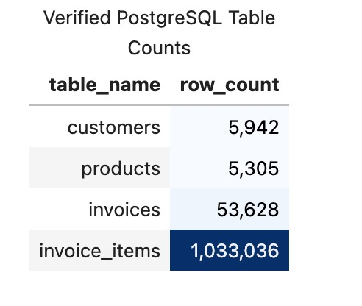
Verified PostgreSQL table counts — 1,033,036 invoice-item rows ingested
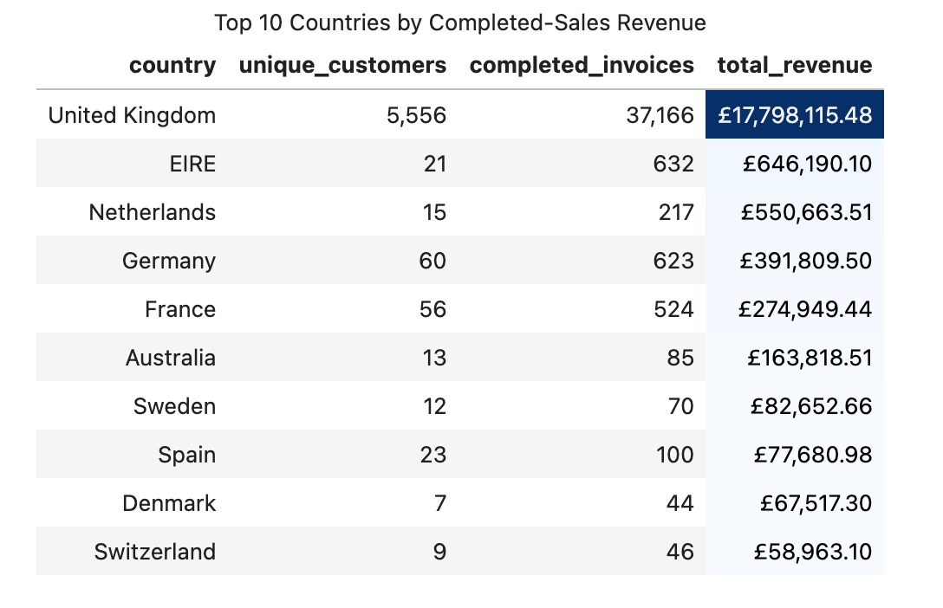
Top 10 countries by completed-sales revenue — the UK dominates at £17.8M
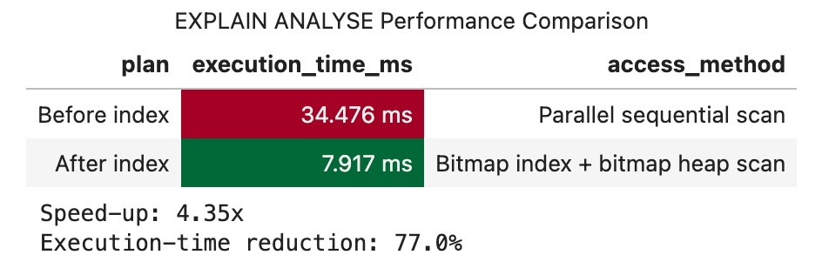
EXPLAIN ANALYSE before vs after indexing — a 4.35× speed-up (77% less time)
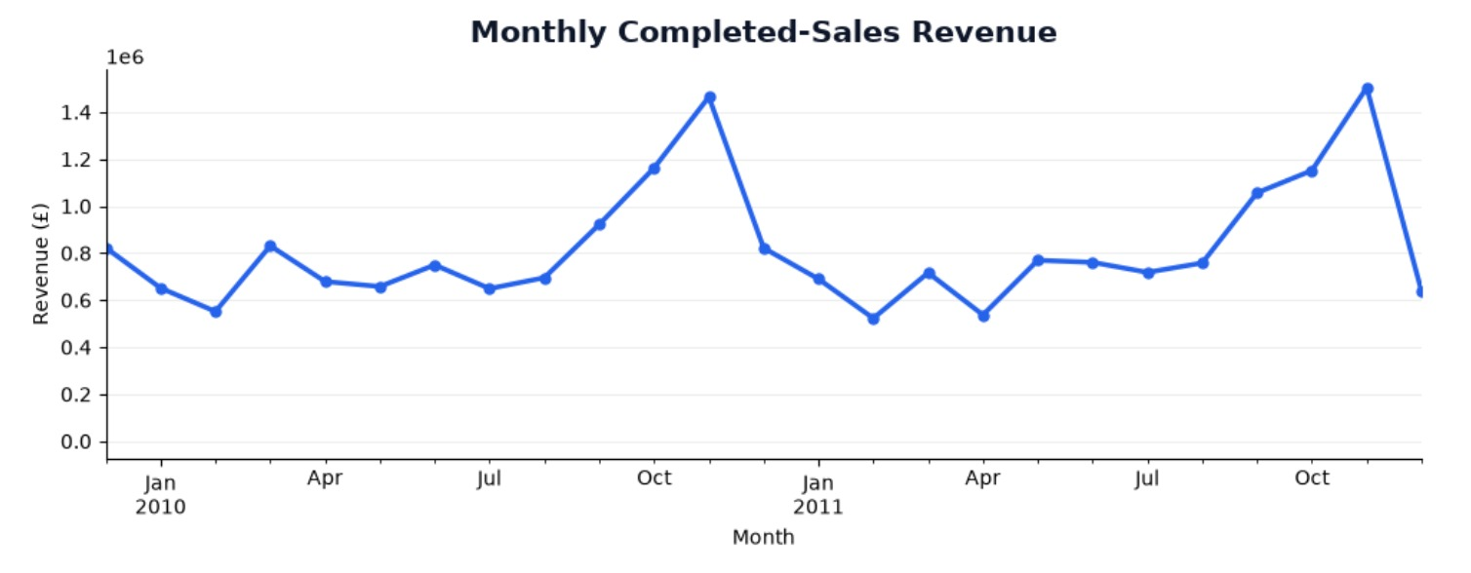
Monthly completed-sales revenue — clear October–November peaks each year
Interpretation: revenue is heavily concentrated in the UK (£17.8M, over 27× the next market), a single appropriate index cut query time by 77%, and revenue peaks every October–November — the Christmas run-up expected of an all-occasion gift-ware seller.
NoSQL (MongoDB) design brief
A MongoDB document model was proposed as a complement to the relational database. The design decision is to store one invoice per document with its line items embedded in an items array, because an invoice header and its lines are normally read together — so a complete invoice can be returned directly as JSON without joining four collections. PostgreSQL remains the authoritative analytical database, while MongoDB provides a flexible, invoice-centred read model.
The document uses the invoice number as _id, with invoice-level fields (date, cancellation status), a small customer snapshot (customer ID and country), and the embedded items. Descriptions and countries are stored as historical snapshots so a later change to a product name does not rewrite earlier invoices. Suggested indexes support time, customer, country, product and cancellation queries.
MongoDB vs PostgreSQL: MongoDB suits application-facing invoice retrieval and a flexible schema, while PostgreSQL is stronger for this project's authoritative analytics — foreign keys prevent orphaned records, normalisation avoids duplication, and joins, CTEs and window functions suit cross-invoice financial analysis. MongoDB complements rather than replaces PostgreSQL.
CAP theorem: during a network partition the design favours consistency and partition tolerance using majority write concern — if the primary loses contact with a majority it stops accepting writes rather than risk conflicting invoice records, which is appropriate for retail data where contradictory totals are more harmful than a short delay. Secondary reads can improve read availability at the cost of possibly stale data. The full brief, indexes and example aggregation are included in the repository.

5. Task 2 — PySpark Big-Data Processing
● Section lead: Muhammad Vahaj Ur Rehman
Brief and implementation logic
Task 2 reads the four normalised Task 1 tables out of PostgreSQL via JDBC, joins them into one flat fact DataFrame in Spark, cleans and transforms it, computes five business KPIs, and demonstrates a Spark-specific performance technique. The combined fact table has 1,033,036 rows, comfortably clearing the 500,000-row requirement.
A SparkSession is created in local mode with the PostgreSQL JDBC driver, and each of the four tables (customers, products, invoices, invoice_items) is read into a Spark DataFrame with row counts and schema printed as a sanity check. invoice_items is then joined to invoices, customers and products to reconstruct one flat fact_raw DataFrame — the Spark-native equivalent of the original flat file, rebuilt from the cleaned relational tables.
At least three meaningful transformations are applied with Spark DataFrame operations: a revenue field (quantity × unit price), date parts (year, month, day, hour) extracted from the invoice date, and a country_clean standardisation that maps abbreviations and placeholders to full country names so country-level KPIs do not fragment across variant spellings. Major processing uses Spark DataFrame operations rather than Pandas; each KPI is aggregated in Spark and only the small, already-aggregated result is passed to Matplotlib for charting.
Business KPIs
Five KPIs were computed with Spark: revenue by month, average order value, top 10 customers by spend, revenue by country, and cancellation rate.
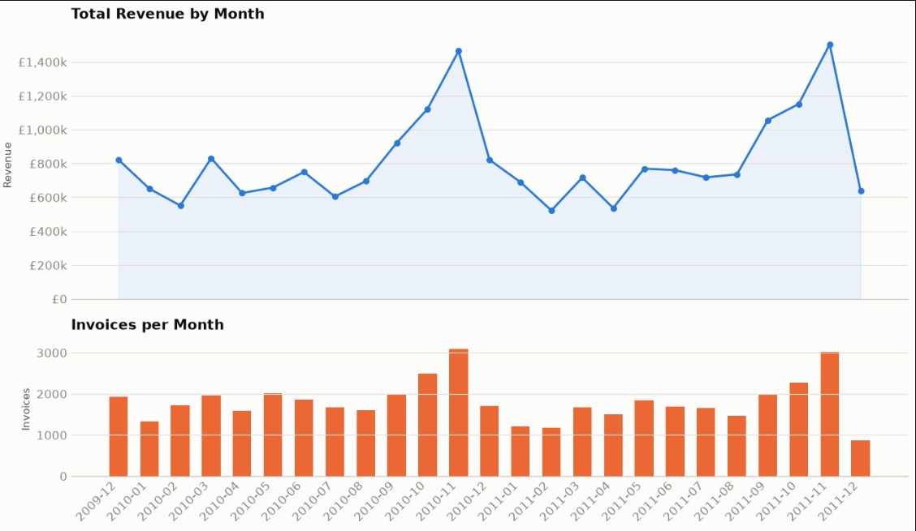
KPI 1 — total revenue and invoices by month (peaks each November)
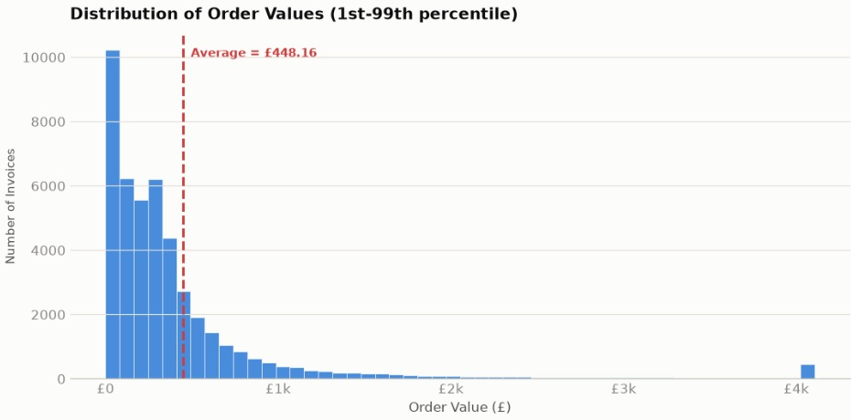
KPI 2 — distribution of order values, average £448.16
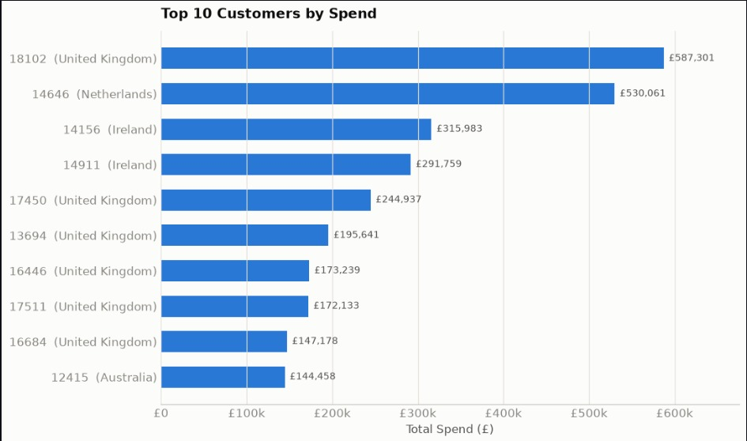
KPI 3 — top 10 customers by spend (top customer £587,301)
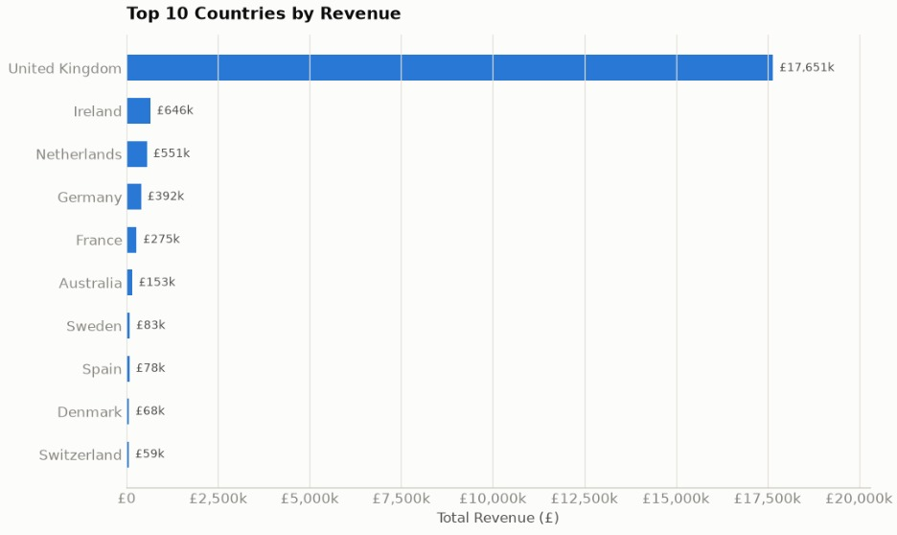
KPI 4 — revenue by country (UK £17.65M)
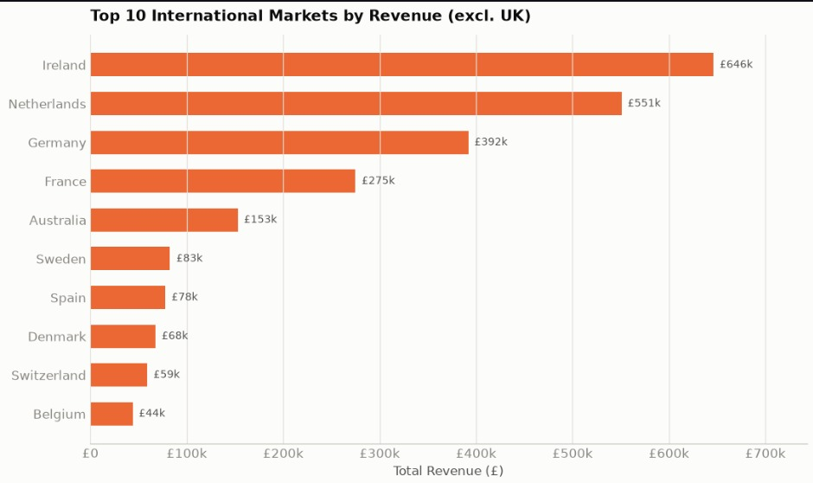
KPI 4 — top international markets excluding the UK (Ireland £646k)
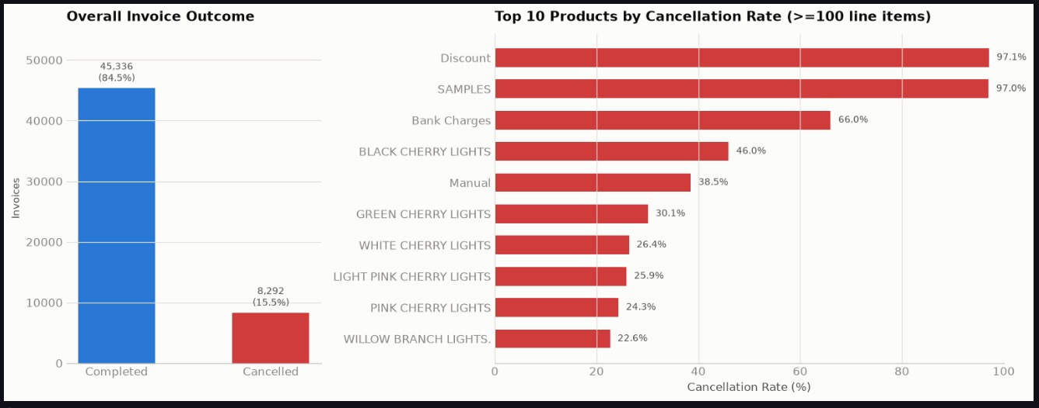
KPI 5 — overall invoice outcome (15.5% cancelled) and worst products by cancellation rate
Performance evidence — partitioning and partition pruning
The fact DataFrame was written to Parquet partitioned by year and month. A single-month filter (year 2011, month 11) was timed against the unpartitioned scan, and .explain() on the partitioned read shows PartitionFilters pushed down to the file-listing step, so Spark opens only the one target directory. The Spark UI was captured while the query ran: the Scan parquet node reports that only one partition was read.
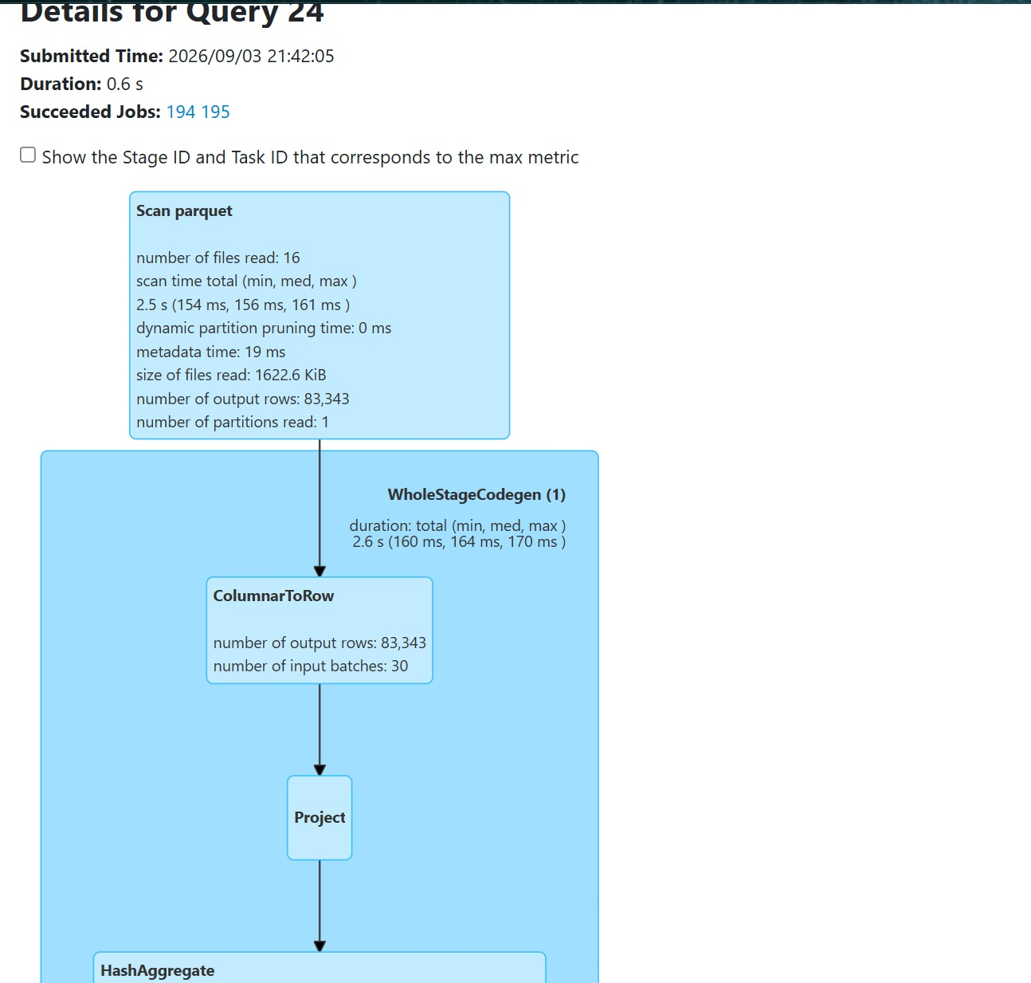
Spark UI — DAG / execution plan; the Scan parquet node reports “number of partitions read: 1”
Short Spark justification
Spark fits this workload because the fact table is over a million rows with multiple wide joins and aggregations, and the same lazy DataFrame code would scale to a real cluster unchanged. The partitioning exercise demonstrates a concrete benefit — partition pruning — that compounds at real production scale. The honest trade-off is that Spark's JVM and shuffle overhead is arguably not worth it for a one-off dataset this small; the value is in demonstrating an approach that scales, rather than in raw speed on this particular data.

6. Task 3 — Containerisation, Airflow & Kafka
● Section lead: Amal Alkaff
Brief and implementation logic
Task 3 implements a containerised retail data pipeline using Docker, Apache Airflow, PostgreSQL and Apache Kafka. Docker Compose was used to deploy the required services in separate containers, providing a consistent and reproducible environment for both batch ETL and real-time streaming.
The Airflow DAG, retail_etl_to_postgres, follows four dependent stages: Extract → Validate → Transform → Load. The extract_retail task reads the retail CSV data, validate_retail checks the required fields, transform_retail calculates a Revenue attribute from quantity and unit price, and load_retail_to_postgres stores the processed records in the retail_transactions table. Successful execution was confirmed in the Airflow interface, and a PostgreSQL SELECT query verified that the transformed records had loaded correctly.
Apache Kafka demonstrated real-time processing in the same retail scenario. A topic named retail_transactions carries the events; a Python producer serialises transactions into JSON and publishes example events, and Kafdrop monitors the environment and confirms the messages were received. A Python consumer subscribes to the topic and classifies any transaction with a Revenue of 20 or more as high-value, generating an alert, while also counting messages received within a 10-second window to demonstrate basic real-time event counting.
Overall, each technology has a specific role: Docker provides a reproducible environment, Airflow orchestrates the batch ETL, PostgreSQL persists the transformed data, Kafka handles real-time streaming, and the consumer performs rule-based processing and counting — showing how batch and streaming can be integrated in one consistent scenario.
Evidence summary
# | Component | Evidence
1 | Docker environment | Docker Compose ran the containerised services; Docker Desktop confirms the Airflow and Kafka containers are active.
2 | Airflow retail ETL DAG | A retail_etl_to_postgres DAG with separate Extract, Validate, Transform and Load tasks.
3 | Airflow ETL execution | The pipeline ran successfully; the latest run confirms completion with zero failed tasks or runs.
4 | PostgreSQL output | The retail_transactions table holds the processed records, including the calculated Revenue field.
5 | Kafka environment & topic | Kafka, ZooKeeper and Kafdrop deployed via Docker Compose; the retail_transactions topic was created and is visible in Kafdrop.
6 | Kafka producer | A Python producer published retail transaction events to the topic and confirmed completion.
7 | Kafka topic verification | Kafdrop shows the topic with available messages and the JSON events with their offsets.
8 | Kafka consumer & processing | A Python consumer flags transactions with Revenue ≥ 20 as high-value and counts messages within a 10-second window.

Screenshots
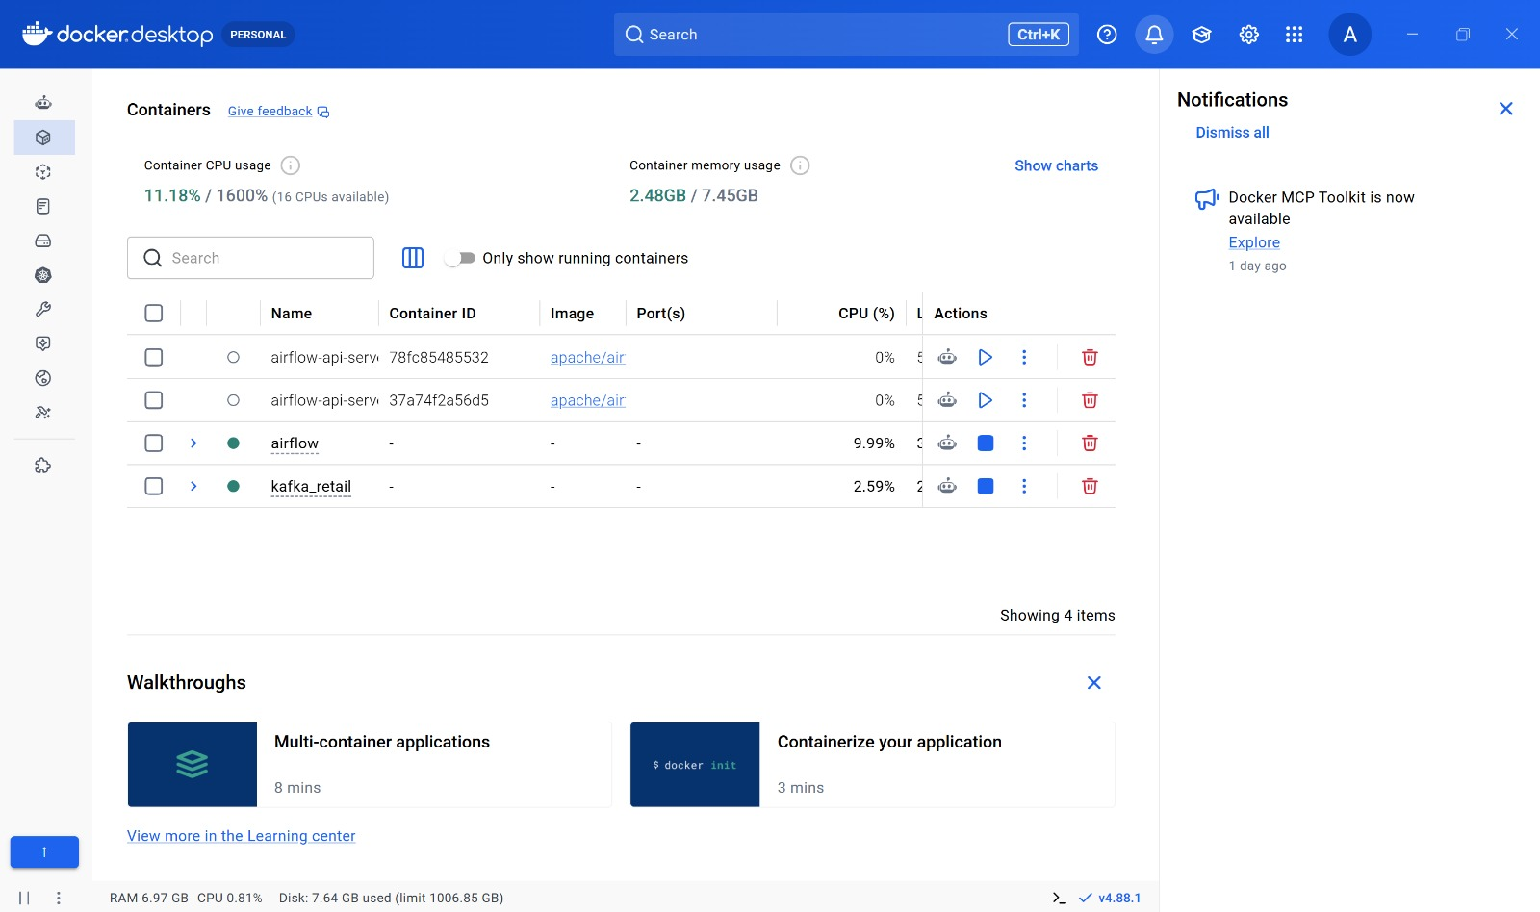
Docker Desktop — Airflow and Kafka containers running
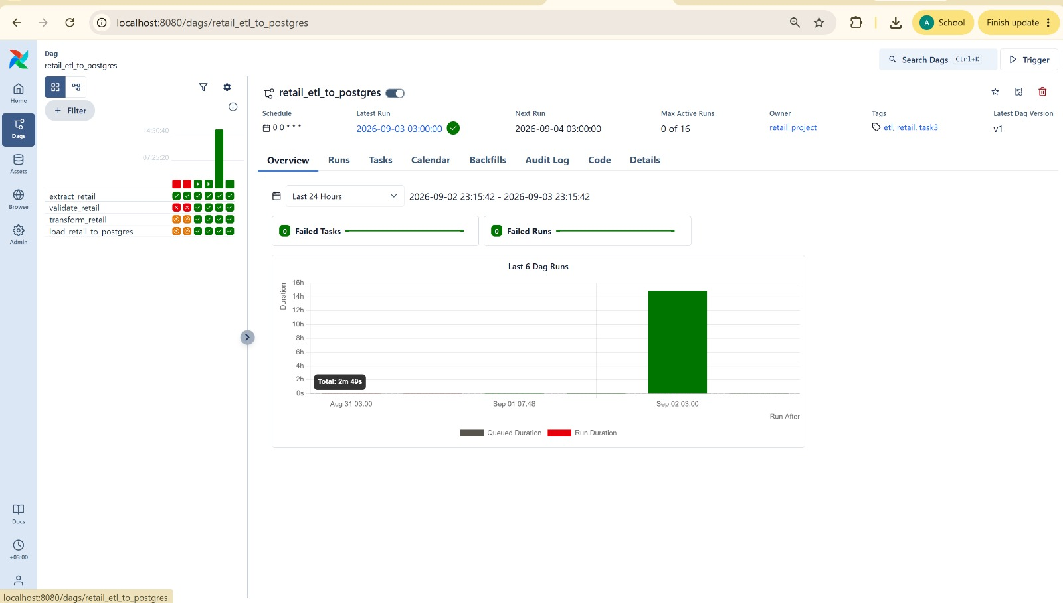
Airflow — retail_etl_to_postgres completed with zero failed runs
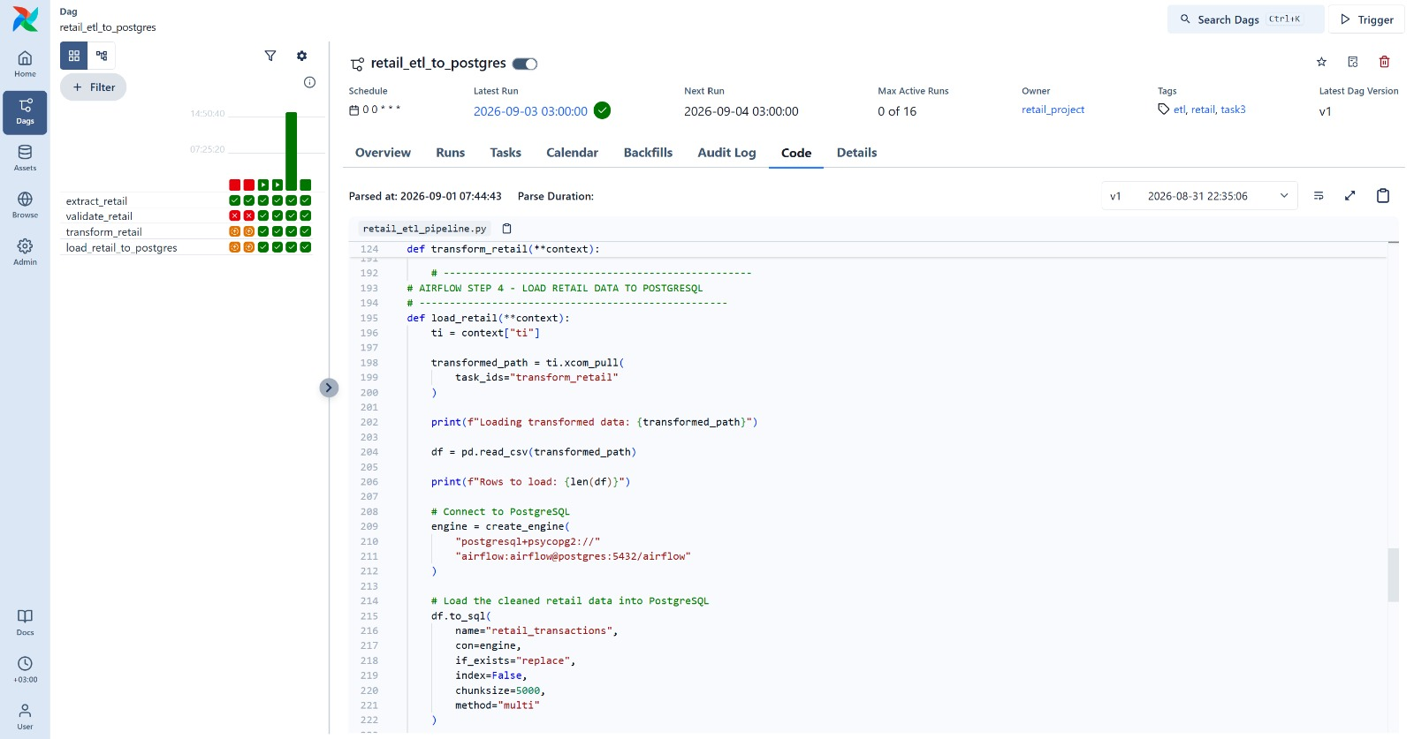
Airflow DAG code — Extract → Validate → Transform → Load
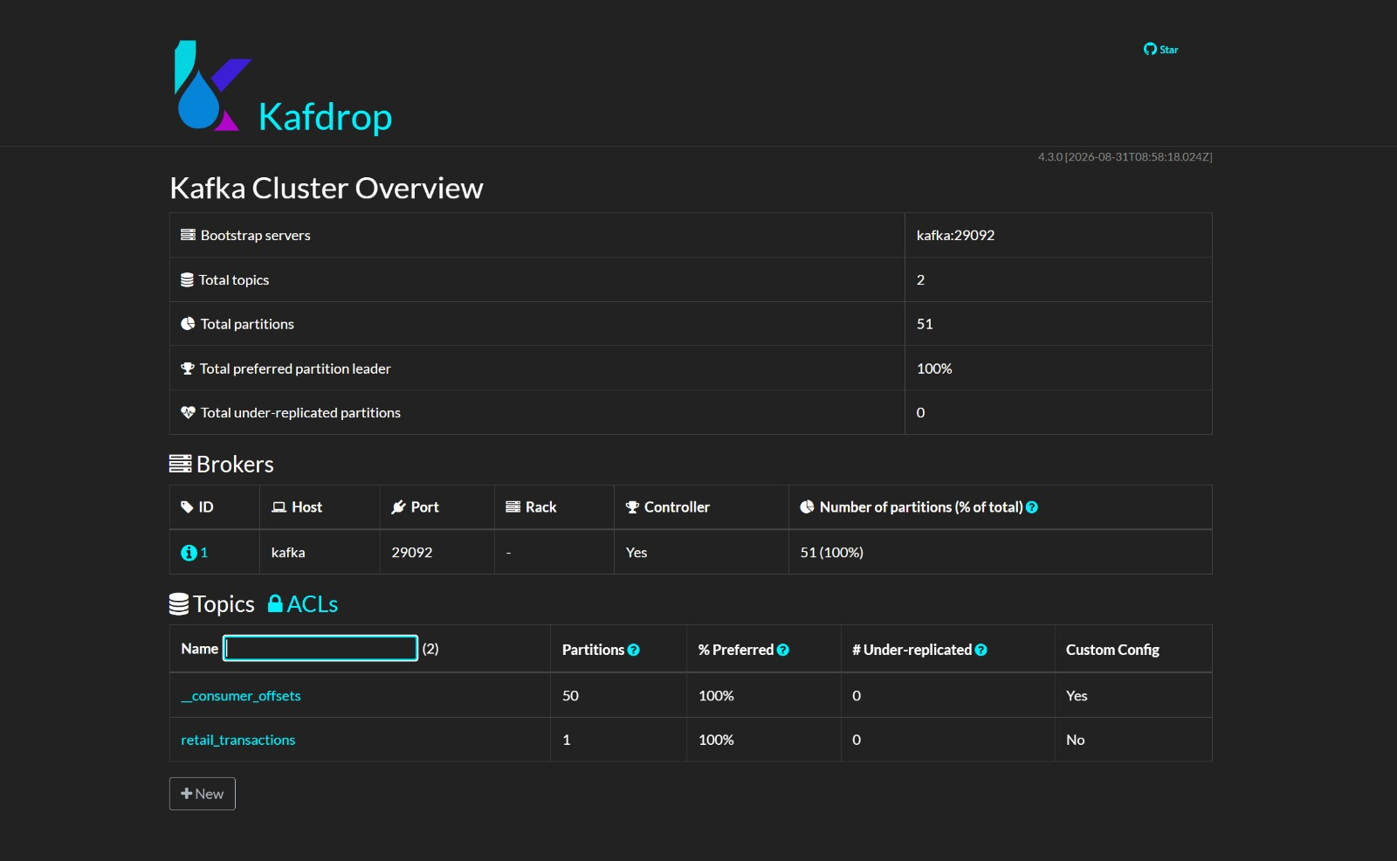
Kafdrop — the retail_transactions topic and its messages

7. The 5Vs of Big Data in Our Project
● Section lead: Amal Alkaff
The five characteristics of Big Data are visible across the complete retail pipeline rather than belonging to individual technologies. The table below shows how each project task contributes to multiple Vs. This reflects the integrated architecture described in the project, where the same retail data moves through storage, PySpark processing, Airflow orchestration and Kafka streaming.
Project Task | Volume | Velocity | Variety | Veracity | Value
Task 1 – SQL & NoSQL | ✓ | — | ✓ | ✓ | ✓
Task 2 – PySpark | ✓ | — | ✓ | — | ✓
Task 3 – Airflow & Kafka | — | ✓ | — | ✓ | ✓
Volume is demonstrated by the 1,033,036 cleaned transaction records, particularly through database storage and PySpark processing.
Velocity is represented by Kafka, where retail events move from the producer through the topic to the consumer.
Variety comes from the different retail attributes and structures used across SQL tables, Spark DataFrames and streaming events.
Veracity is addressed through data cleaning and the validation stage of the Airflow ETL pipeline. Finally, Value appears across all three tasks: SQL provides business analysis, PySpark generates KPIs and trends, and the streaming component demonstrates rule-based identification of high-value retail events.
Therefore, the 5Vs overlap across the system and together show how the project applies Big Data concepts to a single end-to-end retail scenario.

8. Cross-Cutting Sustainability & GDPR Reflection
● Section lead: Ayesha
Working with the Online Retail II dataset made me think carefully about how our technical decisions connect to cost, sustainability, and data protection, even on a project of this scale.
On cost, we chose to run the whole pipeline locally inside Docker rather than on a paid cloud platform. The dataset is only around 43.5 MB and roughly one million rows, which is small by big-data standards, so provisioning cloud compute would have added expense and setup time for no real benefit. Running locally kept the cost at effectively zero and gave us full control of the environment. The trade-off is that a local setup does not scale the way a managed cloud service would; if the data grew to hundreds of millions of rows, a cloud cluster would become the more sensible and cost-effective choice.
This links directly to sustainability. Because the workload is light, keeping it on a single local machine avoids the energy footprint of leaving cloud resources running. Choosing compute that matches the actual size of the problem, rather than over-provisioning, is a simple but genuine sustainability decision.
On data protection, the dataset is already pseudonymised, which shaped our approach. There are no names, emails, or addresses; each customer is represented only by a numeric CustomerID. This let us complete every query and KPI using an anonymous identifier and a country field, so we practised data minimisation by design and never handled directly identifying information. On data residency, the data originates from a UK retailer and, being historic and anonymised, does not raise the cross-border transfer concerns that live customer data would raise under GDPR.
Where relevant, we protected the environment through access control on the PostgreSQL database and by keeping credentials out of the GitHub repository, using configuration rather than hard-coded passwords, alongside basic logging of pipeline runs in Airflow.
The main limitation I would flag is re-identification risk. Even pseudonymised data can sometimes be linked back to individuals when combined with other sources, so in a production system the CustomerID mapping would need to be stored separately and its access tightly controlled.
8. Limitations & Improvements
- Limitation: The entire pipeline runs locally on a single machine inside Docker. This proves every concept end to end but would not scale to genuine big-data volumes without a distributed cloud cluster. The data is also historic (2009–2011), so the insights are illustrative rather than a reflection of current trading.
- Improvement: Deploy the same containerised stack to a managed cloud service running a multi-node Spark cluster to demonstrate true horizontal scaling, and add automated data-quality checks inside the Airflow DAG so invalid records are caught before they reach the database.
9. Conclusion
Together, the three tasks demonstrate a coherent big-data pipeline: relational and document database design in Task 1, distributed processing in Task 2, and containerised orchestration and streaming in Task 3, all applied to a single real retail dataset. The cross-cutting reflection shows that the design also considered cost, sustainability and data protection. The main opportunity for future work is to scale the same reproducible stack to a managed cloud cluster.

