Homework report
Note: In all of the problems for counting the execution time for CUDA I included the memcpy calls to and from device, because the execution time of the kernel only does not paint the whole picture.

1. Counting number of occurrences

First I'll note that I could have passed the string encoded as numbers already, but I didn't want to do that since translating of the characters to integers (and using the proper indices of arrays) in a way to avoid divergence is a task itself. So I didn't cheat.

I also avoided using any mechanisms like mutex or atomic counters because I think those would slow the calculation down. So there are no collisions of threads accessing the same index/resource at the same time at all.

My solution was to pretty much translate this problem into reduction of sums.

I used shared memory to speed things up.

To avoid having shared resources I would have to store data for each 4 letters for each thread. But this would mean I would need to store 4 times the size of the given string in shared memory, which is itself a very limited resource. Also note that my access pattern to the shared memory needs to avoid bank collisions.

My solution to these problems is: each thread is responsible to counting 4 elements from the string. This means I need equal space in shared memory as the string. I could have easily made this number to 8 or 16 or more, but I used 4. I create 2D array in shared memory with column size equal to the block x dimension, and 4 rows: 1 row for each character.

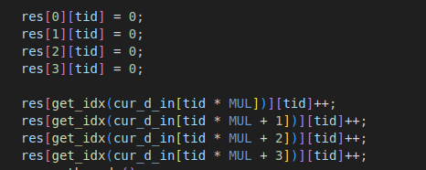
Here the get_idx returns the int of each character. So for each thread, I increment the correct row for 4 elements from the string. Notice, here the loop is unrolled. Also notice, that there are no collisions of shared memory banks here. At each line, the thread is incrementing it's corresponding bank.

get_idx has no divergence, it returns 0 for A, 1 for C, 2 for G, 3 for T

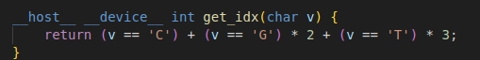
Not sure if divergence would make much of a difference here, but I avoided it either way.

The rest of the code is just reduction with interleaved approach, just for each character there's a different array. The loop is again unrolled.

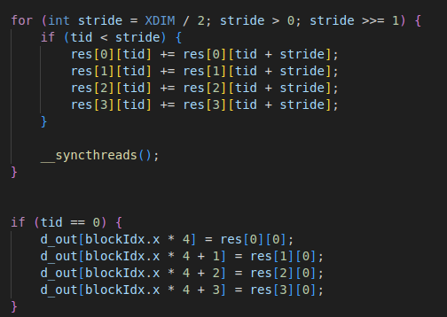
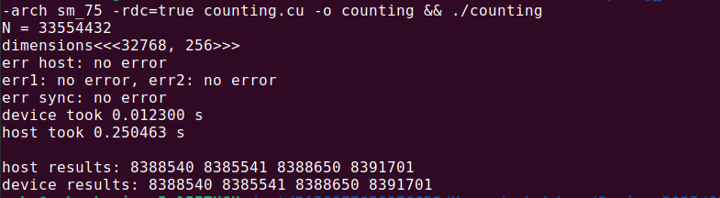
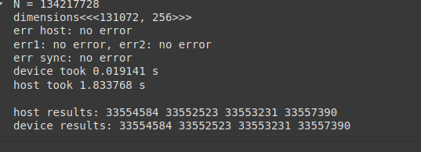
Then in main I just add these up. That's it. On my PC, I got about 20 times performance boost, on google colab, it's closer to 100

2. Transcribing DNA to RNA
Nothing fancy here. Every thread calculates 4 entries from the array. I wanted to use all 128 bytes of read transaction for each warp. Since char is 1 byte, I needed 128 / 32 entries for each thread.

I realized that copying from device to pinned host memory is also much faster, so I'm reusing the same pinned input array for getting the result.

This is the kernel, the loop is unrolled.

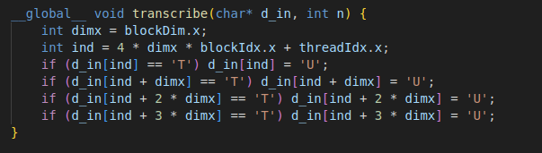

On my pc, I'm getting ~17 times performance boost, on Colab it's close to 30.

