Outputs
Github repo: https://github.com/VaheHayrapetyan24/CS331_operating_systems

1 thread creation
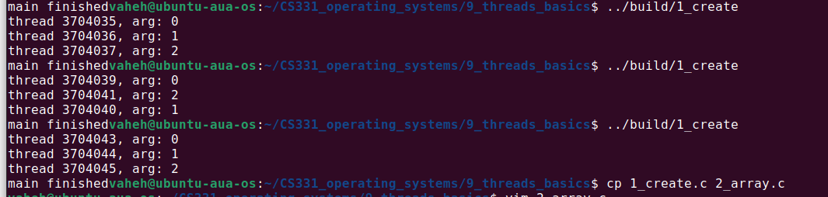

2 array processing
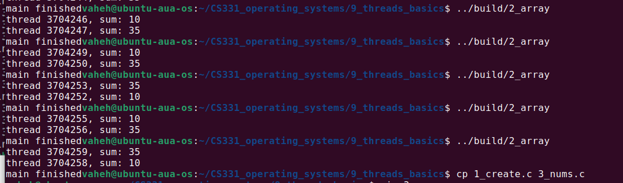

3 printing numbers
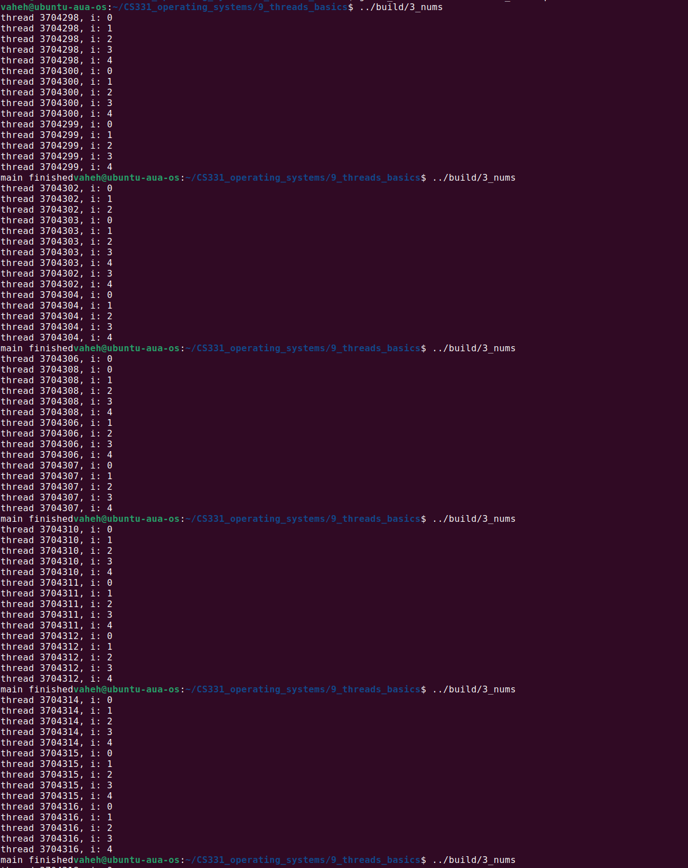

4 squares
