Linking report

Assignment 1,2: Done as described
Assignment 3: Here's the output
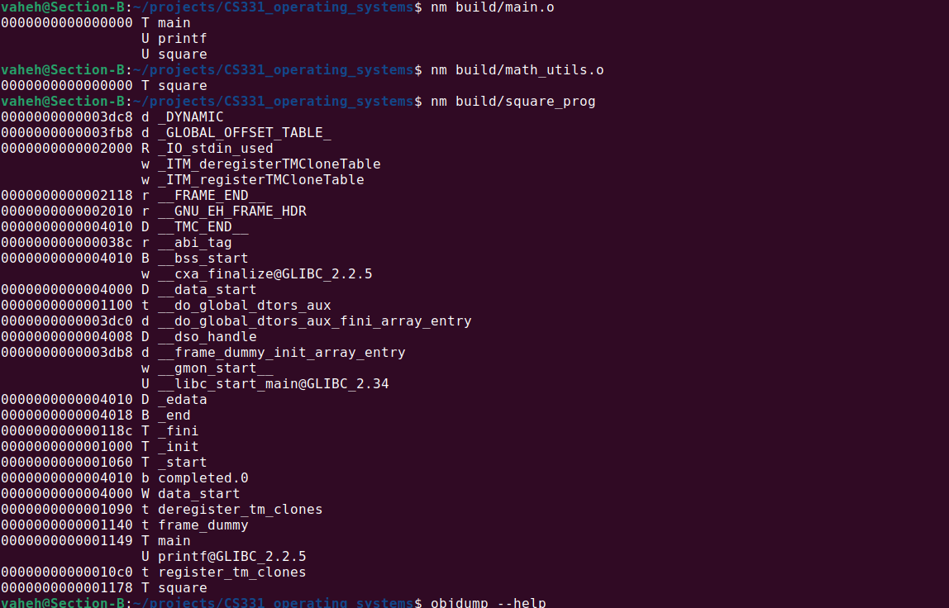

Assignment4: Output is below. After the image I included the assembly for the final executable in text, because it was too long for a screenshot.

For main.o, we see that the main function starts from address 0, which is also the case for math_utils.o square function. Both are relocatable object files, which means they cannot be independently run. If we pay attention to the "d" row in the main file, we'll see that there's a call to a function, the address of which is not actually resolved yet (same with print call). This will happen after we run the linking stage. From both of these files the required functions are missing, which initialize the environment and actually start the program.
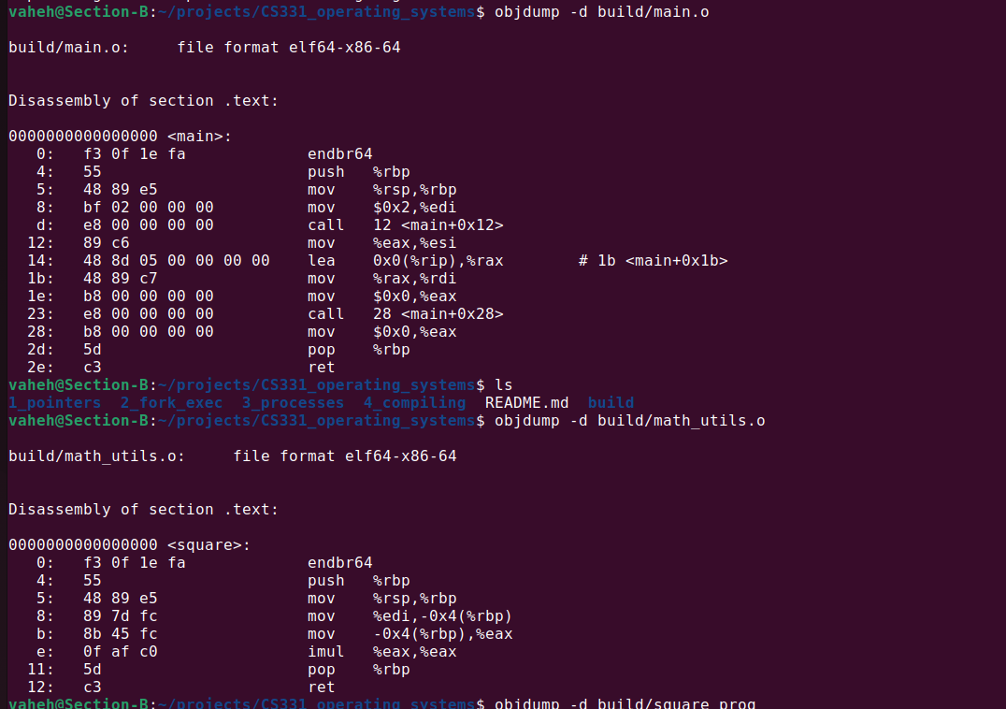
Now if we look at the objdump of the square_prog file, all the required functionality is already here. The addresses of main and square functions are set to relative addresses from the start of the text segment. The call to the square function actually has the address of the square function. The call to the printf function also points to the address of the printf function, which now will resolve the printf function from the global offset table as far as I understand, during runtime.
build/square_prog: file format elf64-x86-64

Disassembly of section .init:

0000000000001000 <_init>:
1000: f3 0f 1e fa endbr64
1004: 48 83 ec 08 sub $0x8,%rsp
1008: 48 8b 05 d9 2f 00 00 mov 0x2fd9(%rip),%rax # 3fe8 <__gmon_start__@Base>
100f: 48 85 c0 test %rax,%rax
1012: 74 02 je 1016 <_init+0x16>
1014: ff d0 call *%rax
1016: 48 83 c4 08 add $0x8,%rsp
101a: c3 ret

Disassembly of section .plt:

0000000000001020 <.plt>:
1020: ff 35 9a 2f 00 00 push 0x2f9a(%rip) # 3fc0 <_GLOBAL_OFFSET_TABLE_+0x8>
1026: f2 ff 25 9b 2f 00 00 bnd jmp *0x2f9b(%rip) # 3fc8 <_GLOBAL_OFFSET_TABLE_+0x10>
102d: 0f 1f 00 nopl (%rax)
1030: f3 0f 1e fa endbr64
1034: 68 00 00 00 00 push $0x0
1039: f2 e9 e1 ff ff ff bnd jmp 1020 <_init+0x20>
103f: 90 nop

Disassembly of section .plt.got:

0000000000001040 <__cxa_finalize@plt>:
1040: f3 0f 1e fa endbr64
1044: f2 ff 25 ad 2f 00 00 bnd jmp *0x2fad(%rip) # 3ff8 <__cxa_finalize@GLIBC_2.2.5>
104b: 0f 1f 44 00 00 nopl 0x0(%rax,%rax,1)

Disassembly of section .plt.sec:

0000000000001050 <printf@plt>:
1050: f3 0f 1e fa endbr64
1054: f2 ff 25 75 2f 00 00 bnd jmp *0x2f75(%rip) # 3fd0 <printf@GLIBC_2.2.5>
105b: 0f 1f 44 00 00 nopl 0x0(%rax,%rax,1)

Disassembly of section .text:

0000000000001060 <_start>:
1060: f3 0f 1e fa endbr64
1064: 31 ed xor %ebp,%ebp
1066: 49 89 d1 mov %rdx,%r9
1069: 5e pop %rsi
106a: 48 89 e2 mov %rsp,%rdx
106d: 48 83 e4 f0 and $0xfffffffffffffff0,%rsp
1071: 50 push %rax
1072: 54 push %rsp
1073: 45 31 c0 xor %r8d,%r8d
1076: 31 c9 xor %ecx,%ecx
1078: 48 8d 3d ca 00 00 00 lea 0xca(%rip),%rdi # 1149 <main>
107f: ff 15 53 2f 00 00 call *0x2f53(%rip) # 3fd8 <__libc_start_main@GLIBC_2.34>
1085: f4 hlt
1086: 66 2e 0f 1f 84 00 00 cs nopw 0x0(%rax,%rax,1)
108d: 00 00 00

0000000000001090 <deregister_tm_clones>:
1090: 48 8d 3d 79 2f 00 00 lea 0x2f79(%rip),%rdi # 4010 <__TMC_END__>
1097: 48 8d 05 72 2f 00 00 lea 0x2f72(%rip),%rax # 4010 <__TMC_END__>
109e: 48 39 f8 cmp %rdi,%rax
10a1: 74 15 je 10b8 <deregister_tm_clones+0x28>
10a3: 48 8b 05 36 2f 00 00 mov 0x2f36(%rip),%rax # 3fe0 <_ITM_deregisterTMCloneTable@Base>
10aa: 48 85 c0 test %rax,%rax
10ad: 74 09 je 10b8 <deregister_tm_clones+0x28>
10af: ff e0 jmp *%rax
10b1: 0f 1f 80 00 00 00 00 nopl 0x0(%rax)
10b8: c3 ret
10b9: 0f 1f 80 00 00 00 00 nopl 0x0(%rax)

00000000000010c0 <register_tm_clones>:
10c0: 48 8d 3d 49 2f 00 00 lea 0x2f49(%rip),%rdi # 4010 <__TMC_END__>
10c7: 48 8d 35 42 2f 00 00 lea 0x2f42(%rip),%rsi # 4010 <__TMC_END__>
10ce: 48 29 fe sub %rdi,%rsi
10d1: 48 89 f0 mov %rsi,%rax
10d4: 48 c1 ee 3f shr $0x3f,%rsi
10d8: 48 c1 f8 03 sar $0x3,%rax
10dc: 48 01 c6 add %rax,%rsi
10df: 48 d1 fe sar %rsi
10e2: 74 14 je 10f8 <register_tm_clones+0x38>
10e4: 48 8b 05 05 2f 00 00 mov 0x2f05(%rip),%rax # 3ff0 <_ITM_registerTMCloneTable@Base>
10eb: 48 85 c0 test %rax,%rax
10ee: 74 08 je 10f8 <register_tm_clones+0x38>
10f0: ff e0 jmp *%rax
10f2: 66 0f 1f 44 00 00 nopw 0x0(%rax,%rax,1)
10f8: c3 ret
10f9: 0f 1f 80 00 00 00 00 nopl 0x0(%rax)

0000000000001100 <__do_global_dtors_aux>:
1100: f3 0f 1e fa endbr64
1104: 80 3d 05 2f 00 00 00 cmpb $0x0,0x2f05(%rip) # 4010 <__TMC_END__>
110b: 75 2b jne 1138 <__do_global_dtors_aux+0x38>
110d: 55 push %rbp
110e: 48 83 3d e2 2e 00 00 cmpq $0x0,0x2ee2(%rip) # 3ff8 <__cxa_finalize@GLIBC_2.2.5>
1115: 00
1116: 48 89 e5 mov %rsp,%rbp
1119: 74 0c je 1127 <__do_global_dtors_aux+0x27>
111b: 48 8b 3d e6 2e 00 00 mov 0x2ee6(%rip),%rdi # 4008 <__dso_handle>
1122: e8 19 ff ff ff call 1040 <__cxa_finalize@plt>
1127: e8 64 ff ff ff call 1090 <deregister_tm_clones>
112c: c6 05 dd 2e 00 00 01 movb $0x1,0x2edd(%rip) # 4010 <__TMC_END__>
1133: 5d pop %rbp
1134: c3 ret
1135: 0f 1f 00 nopl (%rax)
1138: c3 ret
1139: 0f 1f 80 00 00 00 00 nopl 0x0(%rax)

0000000000001140 <frame_dummy>:
1140: f3 0f 1e fa endbr64
1144: e9 77 ff ff ff jmp 10c0 <register_tm_clones>

0000000000001149 <main>:
1149: f3 0f 1e fa endbr64
114d: 55 push %rbp
114e: 48 89 e5 mov %rsp,%rbp
1151: bf 02 00 00 00 mov $0x2,%edi
1156: e8 1d 00 00 00 call 1178 <square>
115b: 89 c6 mov %eax,%esi
115d: 48 8d 05 a0 0e 00 00 lea 0xea0(%rip),%rax # 2004 <_IO_stdin_used+0x4>
1164: 48 89 c7 mov %rax,%rdi
1167: b8 00 00 00 00 mov $0x0,%eax
116c: e8 df fe ff ff call 1050 <printf@plt>
1171: b8 00 00 00 00 mov $0x0,%eax
1176: 5d pop %rbp
1177: c3 ret

0000000000001178 <square>:
1178: f3 0f 1e fa endbr64
117c: 55 push %rbp
117d: 48 89 e5 mov %rsp,%rbp
1180: 89 7d fc mov %edi,-0x4(%rbp)
1183: 8b 45 fc mov -0x4(%rbp),%eax
1186: 0f af c0 imul %eax,%eax
1189: 5d pop %rbp
118a: c3 ret

Disassembly of section .fini:

000000000000118c <_fini>:
118c: f3 0f 1e fa endbr64
1190: 48 83 ec 08 sub $0x8,%rsp
1194: 48 83 c4 08 add $0x8,%rsp
1198: c3 ret

Assignment5: I do not entirely understand all the data that is shown in the readelf -S output, but I'll describe everything that I (sort of) understand at the moment.

1. The sizes of the segments differ. For example the text segment size in the final executable is much bigger than the ones in the object files, which is expected because in the final executable in text segment there are more instructions.
2. The offsets of the segments are adjusted. Again, for example the text segment now starts from a bigger address, because it's been readjusted and now has other segments before it.
3. I also notice the "align" values are different in the final file. For object files it's 1, and in the final executable it's 16. I'm thinking this is because since the object files are relocatable, the alignment does not really matter, and is left to be chosen after the linking is done. So each section that is loaded into the memory from the text segment needs to be aligned (padded when needed) to 16 bytes.
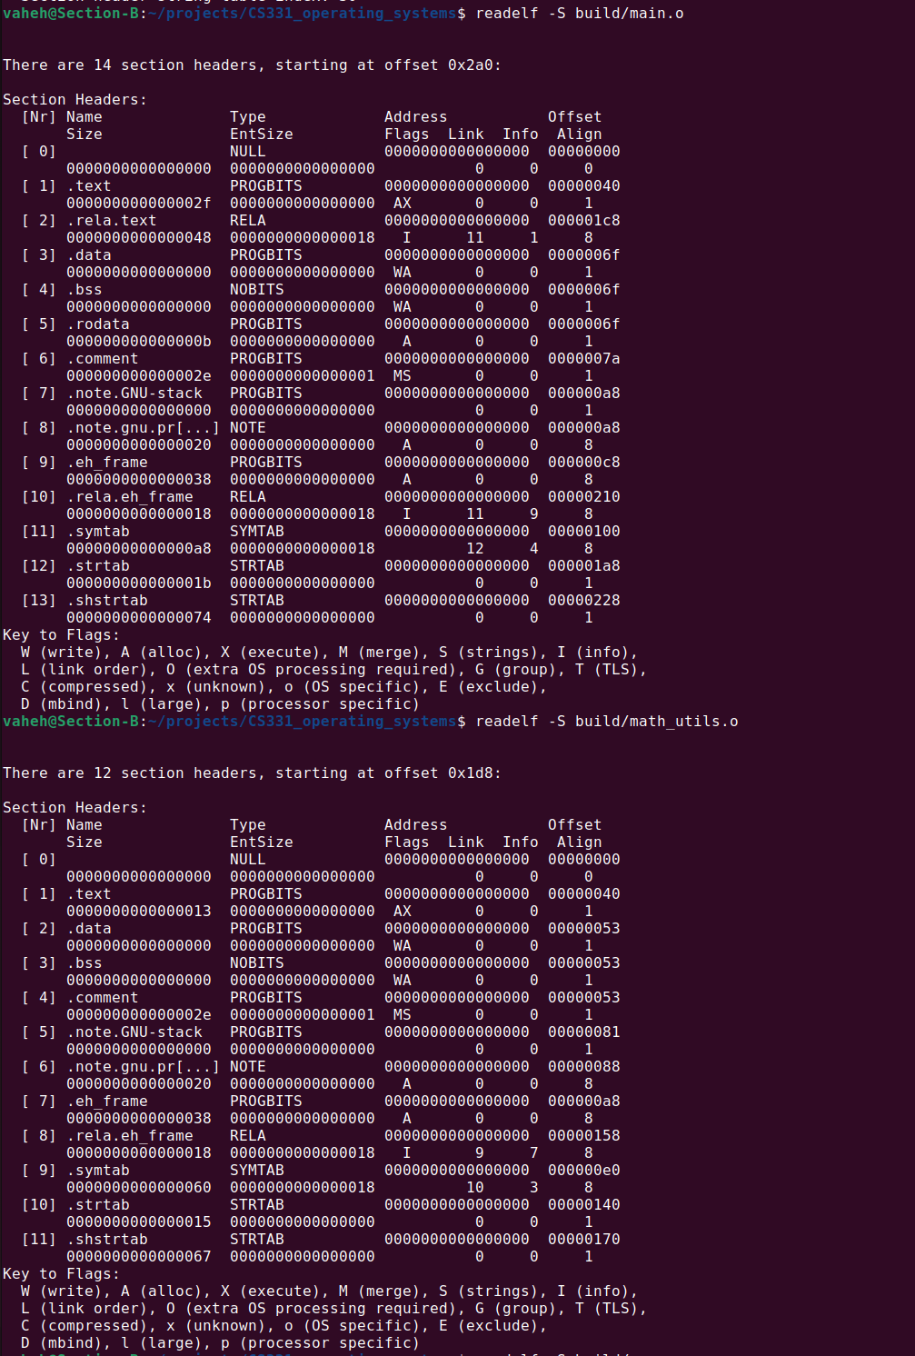

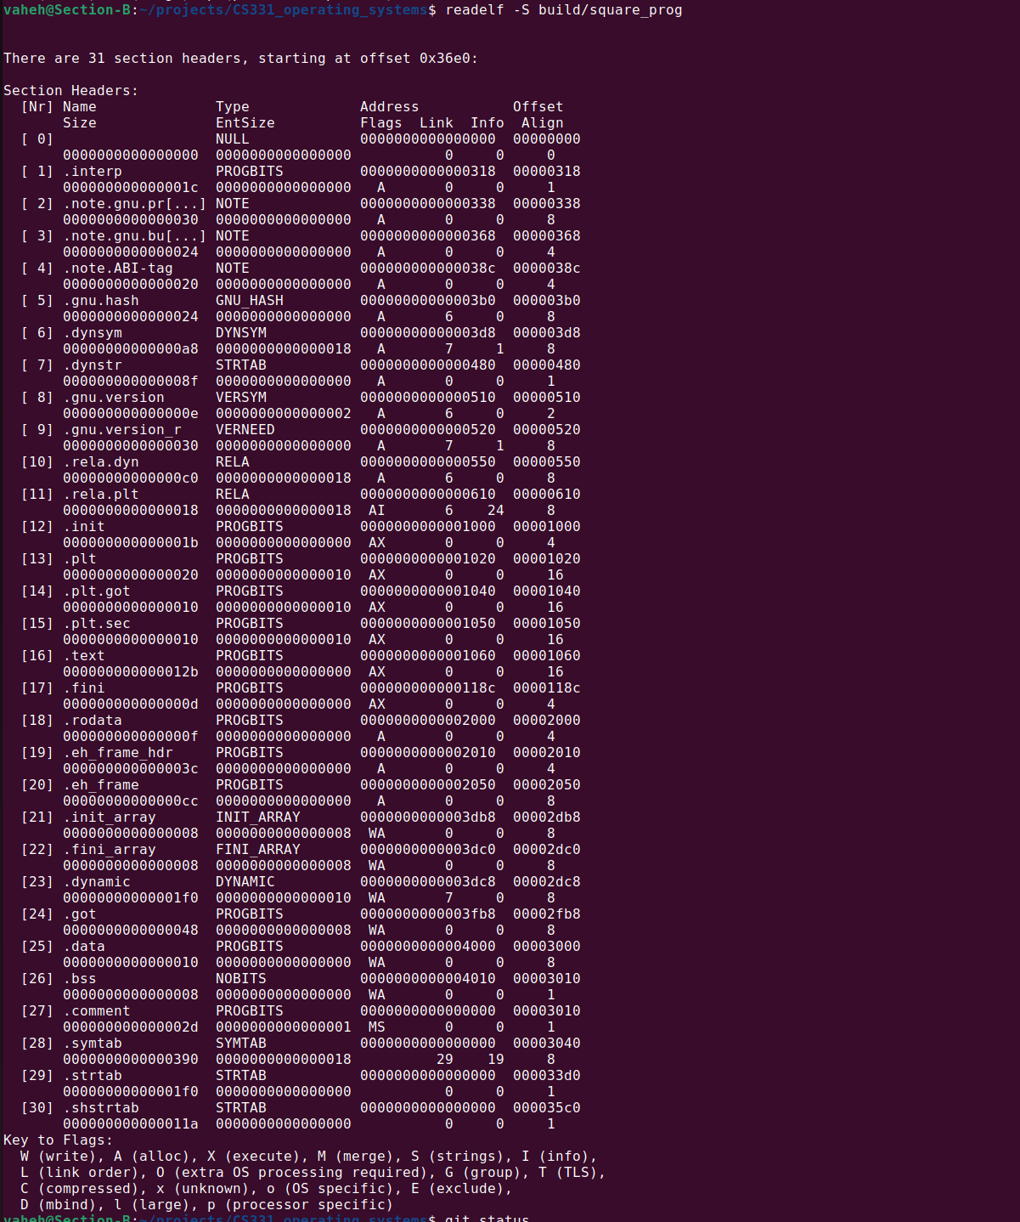

Assignment6:
In the math_utils object file, the only symbol is square, and it's in text segment, which makes sense, because we don't have other functions or calls to them.
In the main object file, apart from main, which is in text segment, we see also two functions with U (undefined) segments, which is because the actual definitions/addresses of the functions are not defined, and need to be resolved after the linking.
In the final executable, we see many more functions, and many more segments. We see that the square function already is in the text segment, because the linking stage included the definition of it in the final executable. But the printf is still in U segment, which is because it's linked dynamically, and will be resolved during the runtime.

Github repo: https://github.com/VaheHayrapetyan24/CS331_operating_systems

