Report

For task 1 - 5 I'll just include screenshots of the output since the assignment didn't ask for a report in the first place. For 6,7 I'll briefly describe what I did
1.
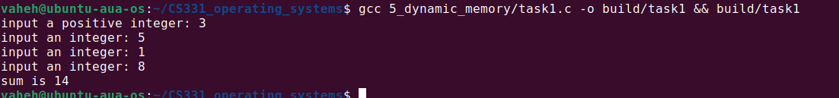
2.
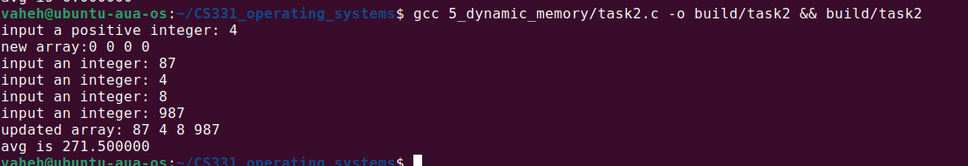
3.
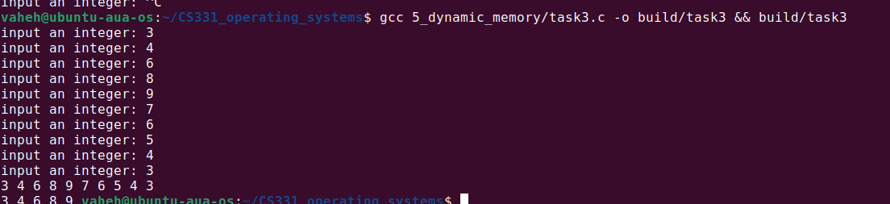
4.
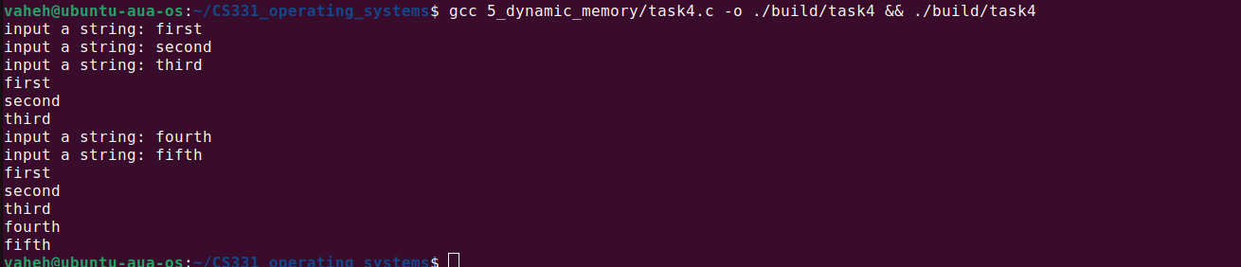
5.
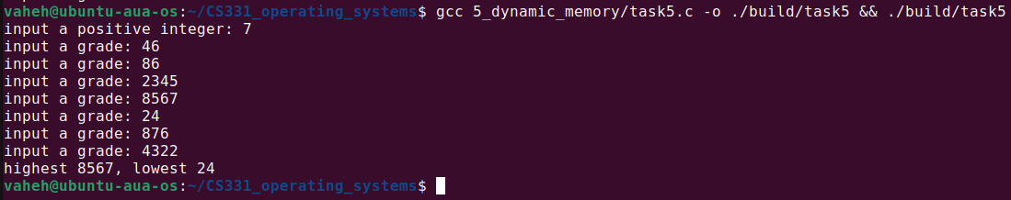

6. The easiest way to do this was to use the built in malloc_usable_size, so that I didn't have to store additional information about the actual length the user asked for.
I take the smaller size of the two: new size and malloc_usable_size.
Dynamically allocate the required size, copy the contents from the original using the calculated size.

7. To get aligned memory, I needed to allocate more than what was requested, and find the closest aligned address to the start, then return that. To do this we need at least (size + alignment - 1) amount of memory. And I also needed to store the actual start of the memory that was allocated. In most of the cases, this could be fitted in the already allocated additional memory, but there are edge cases that need to be taken care of, and this most likely will add more instructions to the execution, which we don't want.
So I opted for allocating sizeof(uintptr_t) more bytes of memory. This is a type that can be used to store the pointer value as an integer (unsigned long int). Size is 8 bytes. So my overall allocated size is (size + alignment + 8 - 1)

After allocating I find the nearest alignment starting from (start + 8), because I want to have enough space to store the actual start of the allocated memory. After finding the closest aligned start, I store the actual start in (aligned start - 8) address.
So when I do aligned_free, I take the provided pointer, -8 from it, and call free on the address stored in that location.

Github repo: https://github.com/VaheHayrapetyan24/CS331_operating_systems

