Report

1. As expected, every variable is aligned according to the size of it's type. I included prints for showing that the address is aligned to the type (num of address % sizeof(type))
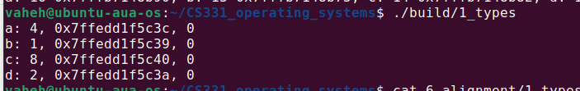
2. Since the biggest element is of type double, all the elements are aligned by 8 bytes, and also according to their own type.
struct {
char a;
int b;
double c;
} typedef struct_a;

In this case char starts from 0 offset, then has 3 bytes padding, then comes the int, then the double. Overall we have 16 bytes.
struct {
char a;
double c;
int b;
} typedef struct_b;
But here, we start with char at 0 offset again, then we have 7 bytes of padding so that double can be 8-aligned. Then comes the int, which overall results in 24 bytes.

3. Without pragma pack , we have the same result as in previous assignment: 16 bytes.
When we do pragma pack(1), we set the alignment to 1, effectively avoiding having any padding. So all elements will be aligned with 1: char starts from 0, int starts from 1, double starts from 5, leaving us with 13 bytes overall.

If we do pragma pack(2), we align everything with 2. char starts from 0, int starts from 2, double starts from 6, so we have 14 bytes.

Then pragma pack(4). char starts from 0, int starts from 4, double starts from 8, leaving us with the original 16 bytes. It should be noted however that if we switch to having char, double, int, we'll have 16 bytes (char: 0, double: 4, int: 12), instead of 24 bytes without alignment.

pragma pack(8) gives the same result as pragma pack(4). But is effectively the same thing as if we didn't include pragma pack at all. Because the original alignment is also 8 because of the double.
Github repo: https://github.com/VaheHayrapetyan24/CS331_operating_systems

