Synchronization report

P1
In the 1a case the value is almost never the same as the expected, because there's a race condition on the counter. So this is a critical section and needs to be protected.


P2
The experiments I did were using 20 threads. In all cases spinlock was slower (especially when using sleep). It seems that spinlock would be useful when thread count is small AND the critical section is small too. Otherwise too many threads take up processor's time unnecessarily. Mutex allows the running thread(s) to have more chance for running, because no unnecessary threads "pollute" the scheduler.
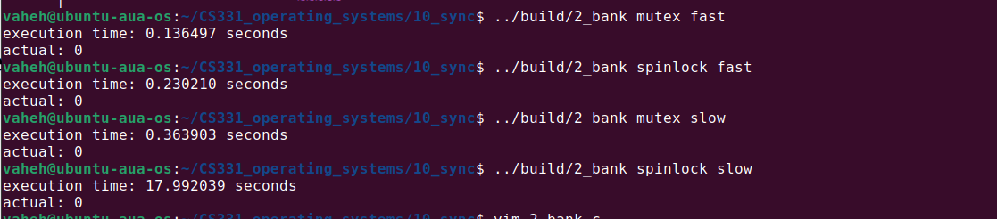

P3
For this one I decided to make my life a bit harder and not share a mutex between the producer and consumer, to theoretically not block the one or the other, when there are slots available.
We still need mutexes here because the semaphor just guarantees that there are resources available, so when they're available multiple threads may start executing. And they'll access memory that is shared: critical sections. So we still need locking mechanisms to protect those.
Also note: I didn't include all the error checking here because it was making hard to read and debug.
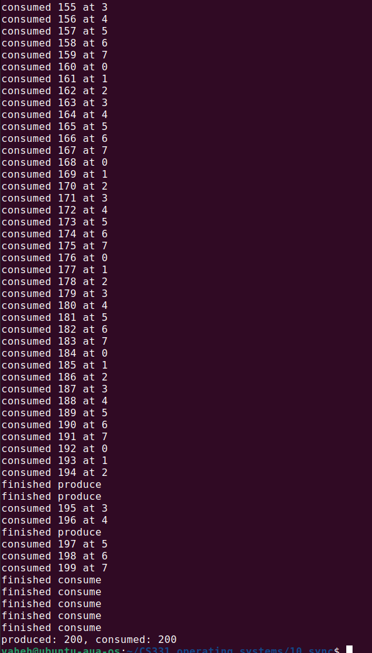

P4
Sleep is not reliable in this case because we have no guarantees about the order of execution. Semaphore solves this because we're kind of using it as an inter-thread communication here and one thread unlocks the other when it's done.

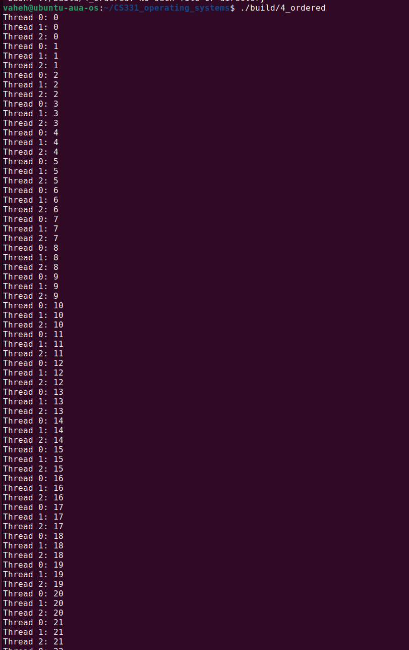

P5
If we initialize the semaphore to 1, we'll effectively have a mutex-like lock on the resource. Only one thread will print at a time. If we have too large of a value (e.g. >= thread count), we'll just remove all restrictions because any number of threads can print at a time.

Here I'm using getvalue function after sem_wait. Initial value was 3 so maximum that can be printed is 2 because at that point at least current thread will have decremented 1 from the 3.

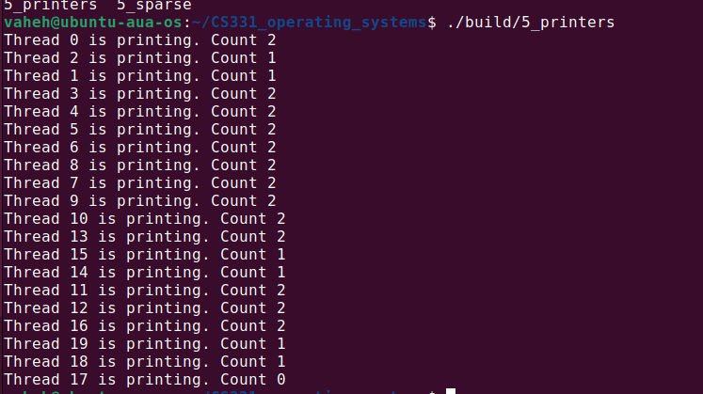

Github repo: https://github.com/VaheHayrapetyan24/CS331_operating_systems

