**Virtual machines (VM)**

Vms are basically machines inside real machines. We realize it with the hypervisor. Hypervisor is just an application.

Virtualization is the process of creating a software-based, or "virtual" version of a computer, with dedicated amounts of CPU, memory, and storage that are "borrowed" from a physical host computer—such as your personal computer— and/or a remote server—such as a server in a cloud provider's datacenter. A virtual machine is a computer file, typically called an image, that behaves like an actual computer. It can run in a window as a separate computing environment, often to run a different operating system—or even to function as the user's entire computer experience—as is common on many people's work computers. The virtual machine is partitioned from the rest of the system, meaning that the software inside a VM can't interfere with the host computer's primary operating system.

Hypervisor virtualizes hardware components (cpu,ram,storage…) from the host machine.

A hypervisor, also known as a virtual machine monitor or VMM, is software that creates and runs virtual machines (VMs). A hypervisor allows one host computer to support multiple guest VMs by virtually sharing its resources, such as memory and processing.

This type of hypervisor is called the type 2 hypervisor. Host os allows guest os’s to use his resources.

So the type 2 hypervisor asks the host’s os for the resources whereas the type 1 hypervisor has direct full control to the host’s hardware.

In type 2 hypervisor the os of the host shares its resources for vms meaning that if there are many vms it has to share its resources for all of them.

We install ISO files of the os that we want. An ISO file (often called an ISO image), is an archive file that contains an identical copy (or image) of data found on an optical disc, like a CD or DVD (so when we install an os we use cds here it is an image of the disk). They are often used for backing up optical discs, or for distributing large file sets that are intended to burned to an optical disc.

ISO image as a complete copy of everything stored on a physical optical disc like CD, DVD, or Blu-ray disc—including the file system itself. So we install iso images to have vms. Kali linux iso and etc.

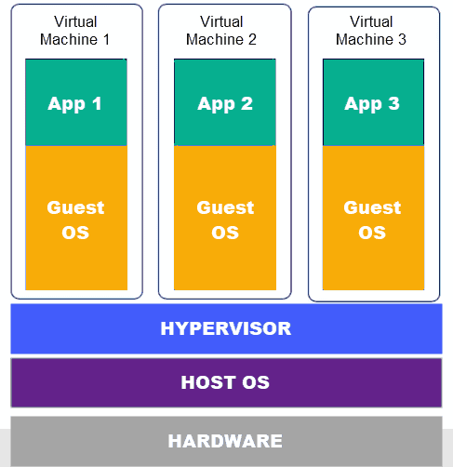

**Docker**

Docker replaces vms. Vms virtualize hardware whereas docker virtualizes os. In docker, you have a single OS, and the resources are shared between the containers. Hence it is lightweight and boots in seconds.

In docker, all of the containers share the same os but it is appearing for each container as if they have their own os.

A container is a way to package application with all the necessary dependencies and configuration and this package is portable, meaning that it can run on any platform.

Containers live in a special repository called container repository.

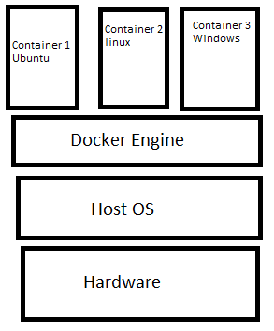

Containers are made up of layers. We have linux image layer, application image layer and so on. Images are just binary numbers representing the exact copy of the software.