Capstone Project - Environmental Data Analytics(Team 14)

Week 1 – Data Collection & Initial Exploration

1. Project Overview
This project focuses on analyzing global temperature trends and air quality data to understand environmental changes and potential correlations.

2. Project Objective
To analyze environmental datasets including temperature, air quality and geospatial data to identify trends and patterns related to climate change.

3. Datasets Used
- Temperature Dataset (NASA GISTEMP)
- Global temperature anomaly dataset
- Monthly and yearly data from 1880 onwards
- Time-series structured dataset
- Air Quality Dataset (India AQI Dataset)
- City-level air pollution data
- Includes PM2.5, PM10, NO₂, CO, SO₂, O₃
- Contains AQI values for pollution assessment
- Geospatial Dataset (UN Environmental Data)
- Land-use and environmental indicators
- Includes forest cover, agricultural land, and land area
- Data organized by region and year
Note: The datasets used operate at different geographic levels (global, national, and regional). Future analysis will focus on aligning these datasets for meaningful comparison.

4. Data Source Links
https://data.giss.nasa.gov/gistemp/
https://www.kaggle.com/datasets/rohanrao/air-quality-data-in-india
https://github.com/CraderF/UN-ENVIRONMENTAL-DATA

5. Completed Work for Week 1
- Identified and selected relevant public datasets
- Documented dataset structure and attributes
- Loaded datasets into Python environment
- Performed initial exploratory data analysis (EDA)
- A structured data inventory was created documenting dataset sources, formats, attributes, and temporal coverage.
- Generated visualizations:
Temperature trend over time
Air pollution trend across cities
Environmental indicators from geospatial dataset
-Analyzed dataset characteristics:
Missing values
Data types
Time coverage

6. Observations
- Global temperature data shows a clear long-term increasing trend, indicating global warming patterns
- Air pollution levels vary significantly across cities, highlighting urban pollution hotspots
- Geospatial data shows variations in land use, such as forest cover and agricultural land distribution
- Differences in dataset granularity (global vs city-level) indicate the need for proper data alignment in future phases

7. Next Steps
- Clean datasets and handle missing values
- Standardize data formats across datasets
- Align time-series frequency for comparison
- Perform feature engineering
- Begin integration of datasets for combined analysis

8. Results/Visual Outputs
The following outputs were generated during Week 1:
- Temperature trend graph
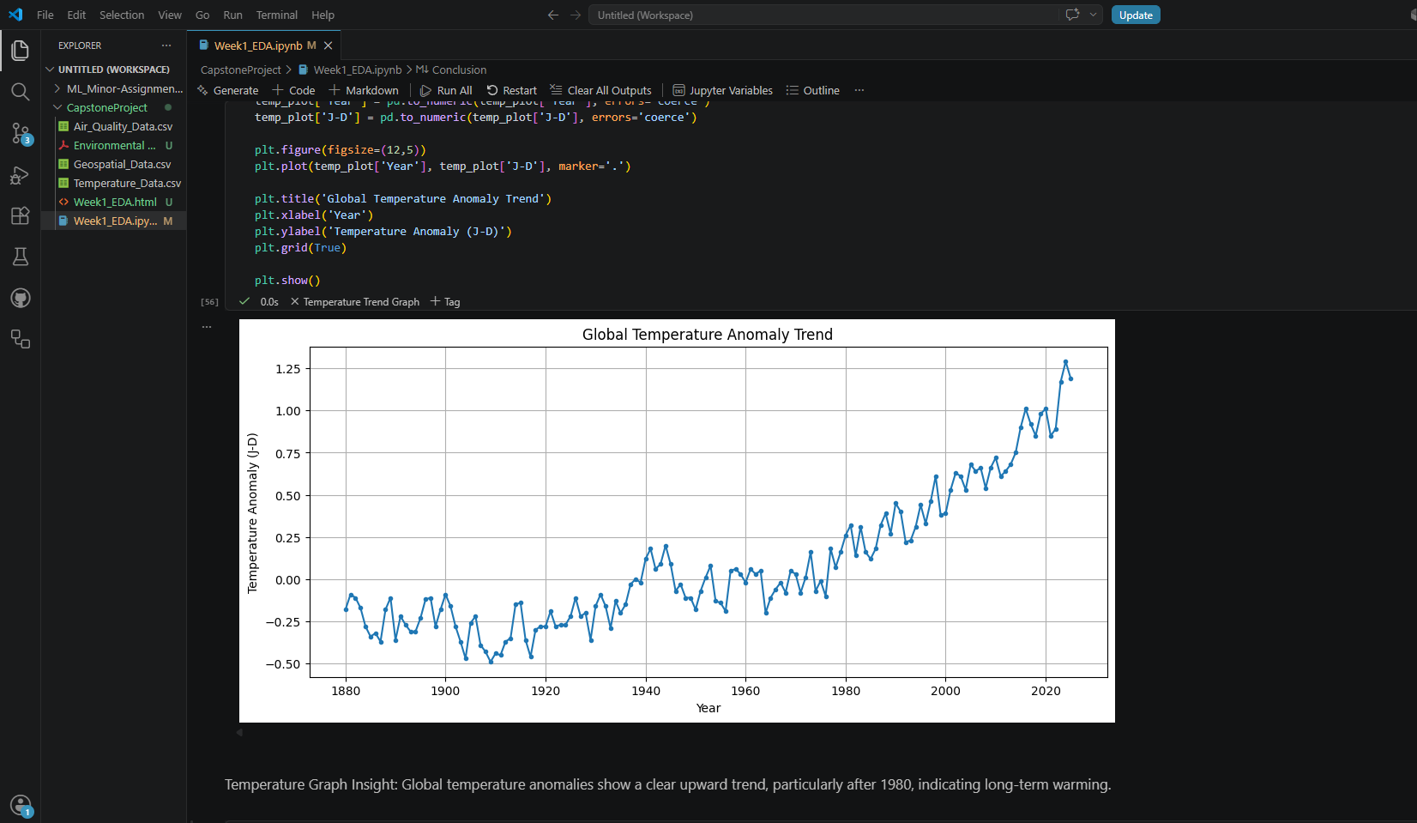
- Air quality (PM2.5 / AQI) visualization
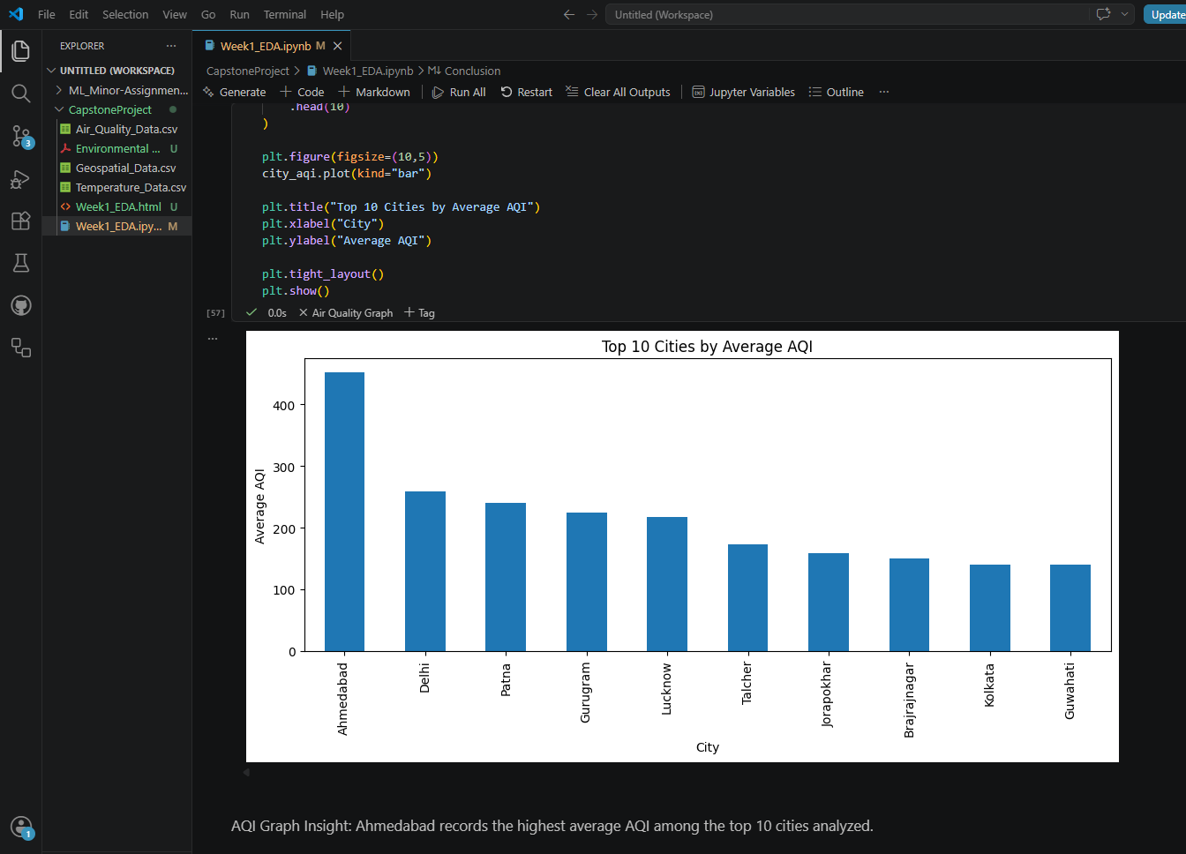
- Geospatial bar chart analysis
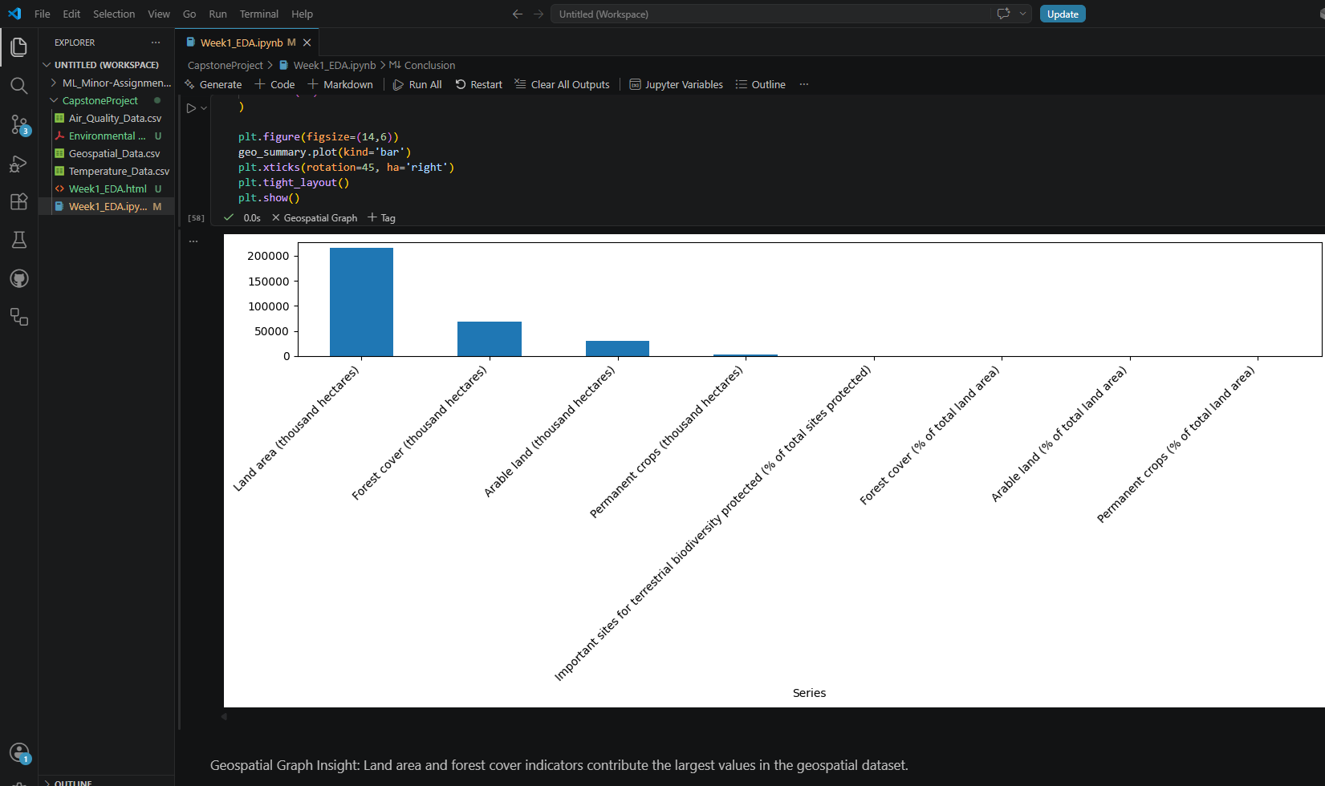

9. Use of Generative AI
ChatGPT/Claude/Copilot was used to assist in generating Python code for data loading, visualization, and exploratory data analysis. It also helped in debugging errors and suggesting appropriate analysis techniques. This significantly improved efficiency and understanding of environmental data analytics concepts.

10. Conclusion
Week 1 successfully established a strong foundation by collecting and exploring multiple environmental datasets. Initial analysis revealed key trends in temperature, air pollution, and land use, setting the stage for data cleaning, integration, and deeper analysis in the upcoming phases.
Week 2 will focus on data cleaning, handling missing values, standardizing formats, and integrating datasets for combined analysis.

11.Google Drive link
https://drive.google.com/drive/u/1/folders/15FRK8ErVL9vvUqc0ocuAngPXZdyHZ7h2

12. Github Repository
https://github.com/VahidaSS/CapstoneProject

