ENVIRONMENTAL DATA ANALYTICS CAPSTONE PROJECT

Week 4 Progress Report – Team 14

Feature Engineering and Data Transformation Pipeline

Github URL – https://github.com/VahidaSS/CapstoneProject

Google Drive URL - https://drive.google.com/drive/folders/15FRK8ErVL9vvUqc0ocuAngPXZdyHZ7h2?usp=sharing

1. Introduction
Environmental datasets collected from different organizations often contain raw measurements that are not directly suitable for predictive analytics or machine learning. Before such datasets can be used for advanced environmental analysis, meaningful features must be engineered to represent temporal patterns, cumulative environmental changes, and relationships among different indicators.
During Weeks 1 to 3 of this capstone project, environmental datasets were collected from multiple public sources, cleaned, standardized, integrated, and stored in PostgreSQL. These datasets included global temperature anomalies obtained from NASA GISTEMP, India's Air Quality Index (AQI) dataset containing PM2.5 and AQI measurements, and a United Nations geospatial dataset representing forest cover indicators.
The objective of Week 4 was to transform the integrated environmental dataset into a feature-rich analytical dataset through a production-inspired feature engineering pipeline. Rather than performing feature creation manually, an automated Python pipeline was developed to generate engineered features, validate data quality, normalize numerical variables, create metadata documentation, generate execution reports, and update PostgreSQL automatically.
The implementation follows production-oriented software engineering practices including modular programming, configuration management, logging, exception handling, automated validation, and reusable pipeline execution. These practices improve reproducibility, maintainability, scalability, and reliability of the analytical workflow while ensuring that future environmental datasets can be processed with minimal manual intervention.
The resulting feature-engineered dataset forms the analytical foundation for future predictive modeling, trend forecasting, environmental monitoring, and machine learning tasks that will be carried out during the subsequent phases of the capstone project.
2. Project Objectives
The primary objective of Week 4 was to implement an automated feature engineering pipeline capable of transforming cleaned environmental datasets into analytical datasets suitable for downstream modelling and advanced environmental analysis.
The specific objectives of the implementation are listed below.
• Develop a modular Python-based feature engineering pipeline.
• Read the integrated environmental dataset directly from PostgreSQL.
• Validate dataset quality before processing.
• Generate rolling average features representing long-term environmental trends.
• Generate trend features that capture year-to-year environmental changes.
• Create lag features representing previous observations.
• Generate cumulative environmental indicators.
• Calculate environmental ratios and composite indices.
• Perform normalization using StandardScaler and MinMaxScaler.
• Automatically generate feature metadata documentation.
• Produce execution and data quality reports.
• Store the engineered dataset into PostgreSQL.
• Validate successful database updates.
• Export engineered datasets for future analytics and predictive modelling.
3. Dataset Description
The Week 4 feature engineering pipeline uses the integrated environmental dataset prepared during Week 3. The merged dataset combines climate, air quality, and geospatial information obtained from multiple authoritative sources.
Dataset | Source | Purpose
NASA GISTEMP | NASA | Global temperature anomaly analysis
India AQI Dataset | CPCB / Kaggle | Air Quality Index and PM2.5 analysis
UN Environmental Dataset | United Nations | Forest cover and land indicators
Environment_Merged | PostgreSQL | Integrated dataset generated during Week 3
The merged dataset contains environmental observations aligned across common years and includes the following primary variables:
• Year
• Temperature Anomaly
• Moving Average Temperature
• PM2.5 Concentration
• Air Quality Index (AQI)
• Forest Cover
• Forest Moving Average
These variables form the basis for generating advanced engineered features during the Week 4 implementation.
4. Week 4 Methodology
The Week 4 implementation follows a modular production-inspired pipeline consisting of multiple sequential stages. Each stage performs a specific responsibility while maintaining complete separation of concerns. Such modularity improves code maintainability and simplifies future enhancements.
The overall workflow consists of the following stages:
Step 1 – Configuration Loading
Database credentials, file locations, output directories, and runtime parameters are loaded from an external configuration file to eliminate hard-coded values and improve portability.
Step 2 – PostgreSQL Connection
A secure connection is established with PostgreSQL using SQLAlchemy. The integrated dataset created during Week 3 is retrieved directly from the database for processing.
Step 3 – Dataset Validation
Before feature engineering begins, multiple validation checks are performed:
• Dataset availability
• Required columns
• Duplicate records
• Missing values
• Memory utilization
• Data types
These validation checks ensure that only clean and reliable datasets enter the feature engineering stage.
Step 4 – Feature Engineering
Advanced environmental features are generated using statistical transformations, cumulative calculations, trend analysis, lag variables, and environmental indices.
Step 5 – Feature Normalization
Numerical variables are standardized using StandardScaler and MinMaxScaler to improve comparability among environmental indicators.
Step 6 – Metadata Generation
The pipeline automatically documents each generated feature by recording its name, datatype, and description.
Step 7 – Data Quality Reporting
A comprehensive data quality report summarizing missing values, duplicate records, memory usage, data types, and statistical summaries is generated automatically.
Step 8 – Database Update
The engineered dataset is stored in PostgreSQL within the feature_engineered table.
Step 9 – Validation
The database row count is compared against the exported CSV file to verify successful storage.
Step 10 – Execution Reporting
Execution statistics including runtime, processed rows, generated features, and pipeline status are documented automatically.
5. Pipeline Architecture
The feature engineering pipeline follows a production-style workflow as illustrated below.
Figure 1: Week 4 Feature Engineering Pipeline Architecture
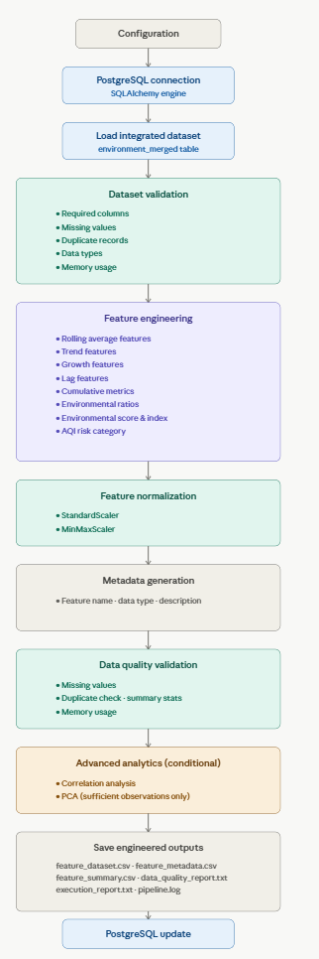
The pipeline begins by loading configuration parameters and establishing a connection with PostgreSQL. The integrated environmental dataset is retrieved and validated to ensure data quality before processing. Feature engineering techniques generate rolling averages, trend indicators, cumulative metrics, lag features, and environmental indices. The transformed dataset is normalized, documented through automatically generated metadata, validated using quality checks, and stored back into PostgreSQL. Finally, execution reports, metadata files, and engineered datasets are exported to the output directory for future analytics.
6. Feature Engineering Overview
Feature engineering represents the most important component of Week 4. Rather than relying solely on original environmental measurements, the pipeline derives additional analytical variables capable of revealing long-term environmental behaviour and improving predictive modelling performance.
The implemented pipeline automatically generates multiple categories of engineered features.
Rolling Average Features
Rolling averages smooth short-term fluctuations and highlight long-term environmental trends.
Implemented Features
• Temperature 5-Year Rolling Average
• AQI 3-Year Rolling Average
• Forest Cover 3-Year Rolling Average
Trend Features
Trend features capture annual environmental change.
Implemented Features
• Temperature Trend
• AQI Trend
• Forest Cover Trend
Growth Features
Growth percentages quantify relative environmental changes.
Implemented Features
• Temperature Growth Percentage
• AQI Growth Percentage
Lag Features
Lag variables retain information from previous observations.
Implemented Features
• Previous Year Temperature
• Previous Year AQI
Cumulative Features
Cumulative indicators represent long-term environmental accumulation.
Implemented Features
• Cumulative Temperature
• Cumulative PM2.5
• Cumulative AQI
• Cumulative Forest Cover
Environmental Ratios
The pipeline generates meaningful environmental relationships.
Implemented Features
• AQI-to-Temperature Ratio
• PM2.5-to-AQI Ratio
Composite Environmental Indicators
Composite indicators summarize multiple environmental measurements.
Implemented Features
• Environmental Score
• Environmental Index
Environmental Classification
The pipeline automatically classifies air quality using AQI thresholds.
Implemented Feature
• AQI Risk Category
7. Feature Engineering Summary
Category | Features Implemented
Rolling Averages | Temperature, AQI, Forest Cover
Trend Features | Temperature, AQI, Forest Cover
Growth Features | Temperature Growth, AQI Growth
Lag Features | Previous Temperature, Previous AQI
Cumulative Metrics | Temperature, AQI, PM2.5, Forest Cover
Environmental Ratios | AQI/Temperature, PM2.5/AQI
Composite Indicators | Environmental Score, Environmental Index
Classification | AQI Risk Category
Normalization | StandardScaler, MinMaxScaler
The pipeline generated approximately 30 engineered features, expanding the integrated dataset from 7 original columns to approximately 40 analytical columns, thereby significantly improving its suitability for advanced analytics and predictive modelling.
8. Transformation Documentation
Feature engineering transforms raw environmental observations into meaningful analytical variables that improve data interpretation and predictive modelling. Instead of relying only on original environmental measurements, additional statistical, temporal, cumulative, and composite features were generated automatically through the developed Python pipeline.
The transformation process follows a modular approach in which each category of engineered features captures a different aspect of environmental behaviour. This approach improves feature richness while maintaining reproducibility and scalability for future datasets.
8.1 Rolling Average Features
Rolling averages smooth short-term fluctuations and reveal long-term environmental trends. These features reduce noise present in yearly observations and provide a more stable representation of environmental changes over time.
Engineered Feature | Description | Purpose
Temp_5yr_Avg | Five-year rolling average of temperature anomaly | Captures long-term climate trends
AQI_3yr_Avg | Three-year rolling average of Air Quality Index | Smooths pollution fluctuations
Forest_3yr_Avg | Three-year rolling average of forest cover | Represents long-term vegetation trends
These rolling averages improve trend analysis by reducing annual variability and highlighting persistent environmental changes.
8.2 Trend Features
Trend features measure year-to-year changes in environmental indicators.
Engineered Feature | Description | Purpose
Temp_Trend | Annual change in temperature anomaly | Detects warming or cooling trends
AQI_Trend | Annual AQI change | Measures pollution increase or decrease
Forest_Trend | Annual forest cover change | Identifies vegetation gain or loss
Trend features are particularly useful for identifying environmental deterioration or improvement over time.
8.3 Growth Percentage Features
Growth features quantify relative environmental changes instead of absolute differences.
Feature | Description
Temp_Growth_Pct | Percentage growth in temperature anomaly
AQI_Growth_Pct | Percentage growth in AQI
These features normalize environmental change, enabling comparison across variables with different scales.
8.4 Lag Features
Lag variables preserve historical environmental information.
Feature | Description
Temp_Previous_Year | Previous year's temperature anomaly
AQI_Previous_Year | Previous year's AQI
Lag variables are commonly used in predictive modelling because previous environmental conditions often influence future observations.
8.5 Cumulative Metrics
Cumulative features measure long-term environmental accumulation.
Feature | Description
Cumulative_Temperature | Running total of temperature anomaly
Cumulative_PM25 | Running total of PM2.5
Cumulative_AQI | Running total of AQI
Cumulative_Forest | Running total of forest cover
These variables provide an overall measure of environmental exposure over time.

8.6 Environmental Ratios
Environmental ratios combine multiple variables to identify relationships among environmental indicators.
Feature | Formula | Purpose
AQI_to_Temp_Ratio | AQI ÷ Temperature | Pollution relative to temperature
PM25_to_AQI_Ratio | PM2.5 ÷ AQI | Pollutant contribution to AQI
These ratios improve interpretation of environmental interactions.
8.7 Composite Environmental Indicators
Composite indicators summarize multiple environmental variables into a single analytical measure.
Feature | Description
Environmental Score | Composite environmental quality score
Environmental Index | Overall environmental condition indicator
These features simplify environmental assessment by combining multiple indicators into unified metrics.
8.8 AQI Risk Classification
Air quality observations were automatically classified into categorical risk levels according to AQI values.
The generated Risk Category feature provides an intuitive representation of pollution severity and can be directly used in visualization or classification tasks.
9. Feature Normalization
Environmental datasets contain variables measured on different numerical scales. For example, temperature anomalies are measured in fractions of degrees, while forest cover is represented using much larger numerical values. Direct comparison of such variables may introduce bias into analytical models.
To address this issue, two normalization techniques were implemented within the feature engineering pipeline.
9.1 StandardScaler
StandardScaler transforms numerical variables so that they have:
• Mean = 0
• Standard Deviation = 1
This transformation is useful for machine learning algorithms that assume standardized input distributions.
Generated standardized features include:
• Temperature_Anomaly_ZScore
• AQI_ZScore
• PM2.5_ZScore
• Forest_Cover_ZScore
9.2 MinMaxScaler
MinMaxScaler rescales numerical variables into the range: 0 to 1
This technique preserves relative differences while allowing variables with different units to be compared directly.
Generated normalized features include:
• Temperature_Anomaly_MinMax
• AQI_MinMax
• PM2.5_MinMax
• Forest_Cover_MinMax
The implementation of both scaling techniques improves compatibility with future machine learning models while preserving numerical consistency.
10. Metadata Generation
The feature engineering pipeline automatically generates metadata describing every engineered feature.
The metadata file serves as technical documentation for the transformed dataset and improves interpretability and reproducibility.
The generated metadata contains:
• Feature Name
• Data Type
• Feature Description
The metadata generation process eliminates manual documentation effort and ensures that newly created analytical features remain well documented throughout the project lifecycle.

Figure 2: Automatically Generated Feature Metadata
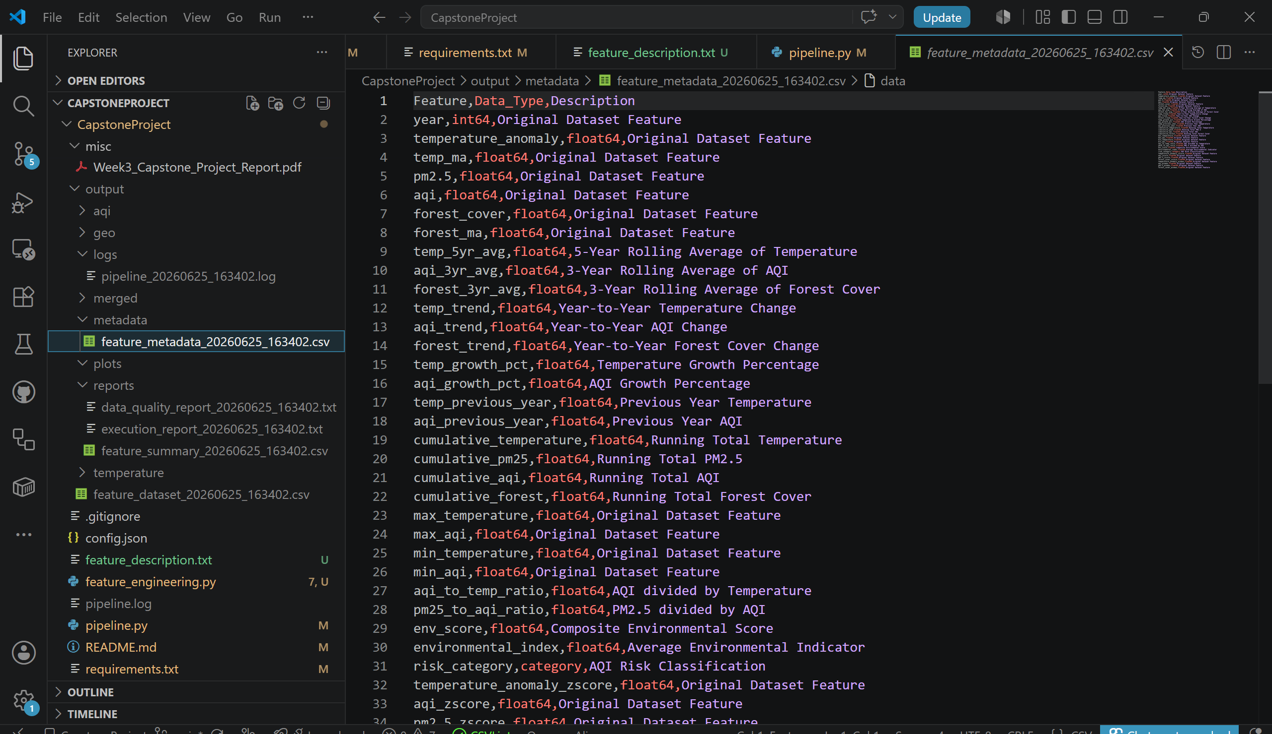
The figure presents the automatically generated metadata file containing feature names, corresponding data types, and descriptive information. This documentation enables future users of the dataset to understand the purpose of every engineered variable without inspecting the source code.
11. Data Quality Validation
Maintaining data quality is essential before engineered datasets are used for analytical tasks.
The developed pipeline performs multiple validation checks before and after feature engineering.
The implemented validation process includes:
• Missing value detection
• Duplicate record identification
• Dataset size verification
• Column validation
• Data type verification
• Memory usage calculation
• Numerical summary generation
These validation checks ensure that the engineered dataset remains accurate, complete, and suitable for downstream analysis.

Figure 3: Data Quality Validation Report
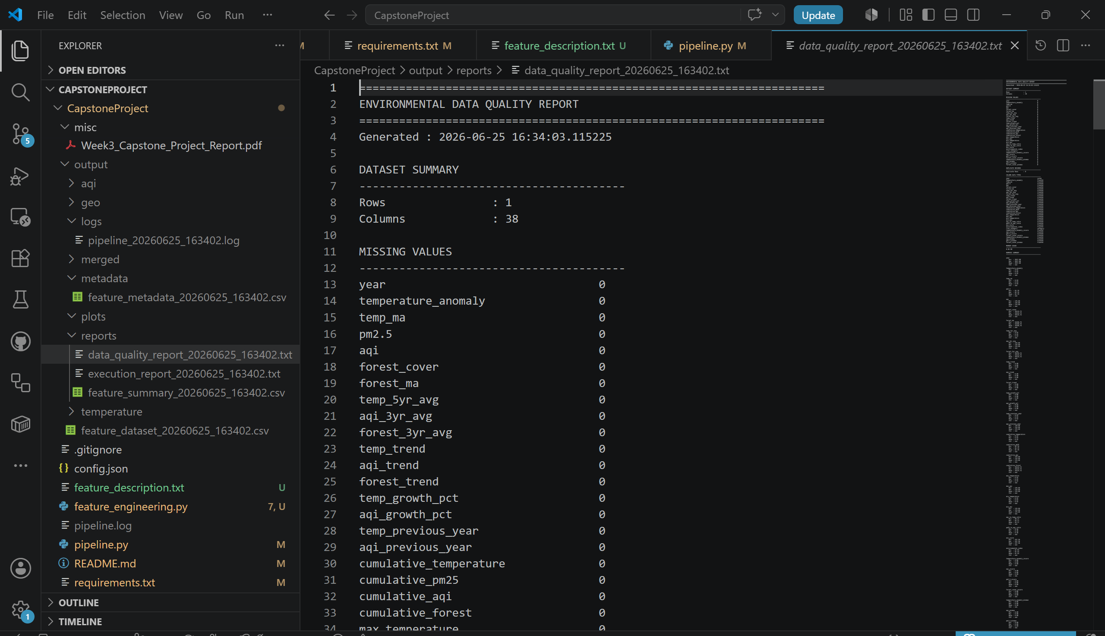
The data quality report summarizes dataset characteristics including row count, column count, missing values, duplicate records, data types, memory utilization, descriptive statistics, and validation status. The report demonstrates that the engineered dataset passed all quality checks before being stored in PostgreSQL.
12. PostgreSQL Integration
After feature engineering and validation, the transformed dataset is automatically stored within PostgreSQL.
The pipeline uses SQLAlchemy to establish the database connection and update the feature_engineered table.
The automated database integration process offers several advantages:
• Centralized data storage
• Reproducible pipeline execution
• Elimination of manual data loading
• Improved scalability
• Easy integration with future analytical workflows
The database update process is fully automated and executed immediately after feature generation.

Figure 4: PostgreSQL Feature Engineered Table
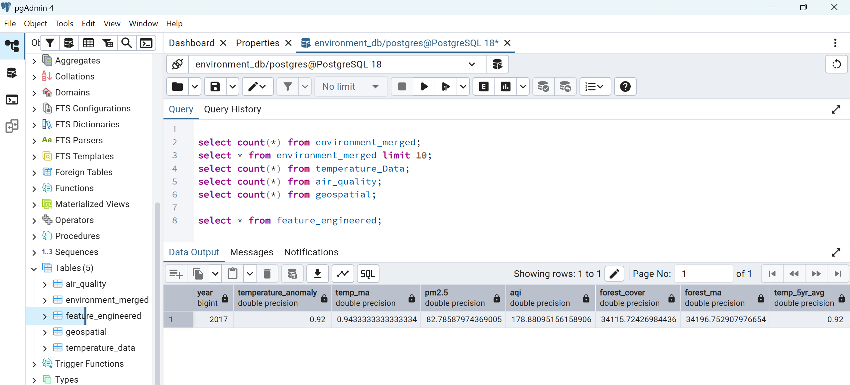
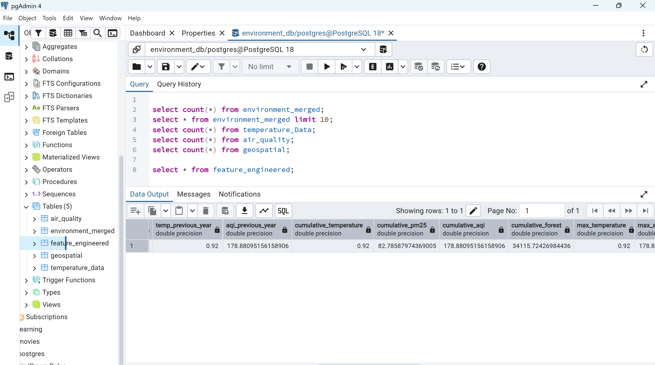
The figure illustrates the PostgreSQL table containing the engineered environmental dataset. The table includes original environmental variables together with approximately forty engineered analytical features generated during Week 4.
13. Database Validation
Following database insertion, the pipeline performs automatic validation to ensure that the exported dataset and PostgreSQL table remain synchronized.
The validation process compares:
• Number of rows in CSV
• Number of rows stored in PostgreSQL
The validation completed successfully, confirming that the feature_engineered table accurately reflects the generated dataset.
This verification step improves data reliability and prevents incomplete database updates.
Figure 5: Database Validation
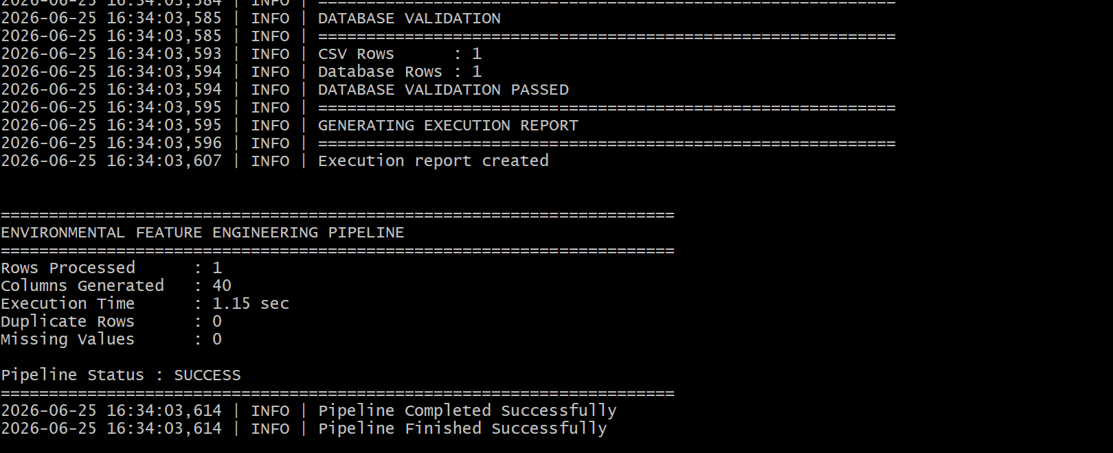
The figure demonstrates successful validation between the exported CSV dataset and the PostgreSQL database. Both sources contain identical row counts, confirming successful data storage.
14. Results
The Week 4 feature engineering pipeline successfully transformed the integrated environmental dataset into a production-ready analytical dataset.
The execution produced the following outputs:
• Approximately 30 engineered analytical features
• Final dataset expanded from 7 original variables to approximately 40 analytical variables
• Automatic metadata generation
• Automated data quality report
• Feature summary report
• Execution report
• PostgreSQL database update
• Database validation
The complete pipeline executed successfully without runtime failures, demonstrating the robustness of the implemented workflow.
During execution, the pipeline automatically detected that the merged environmental dataset contained only one aligned observation after integration. Consequently, Principal Component Analysis (PCA) and correlation analysis were intentionally skipped because statistically meaningful results cannot be produced from a single observation.
This behaviour reflects good engineering practice by preventing misleading analyses while maintaining pipeline scalability. As additional aligned environmental observations become available, the implemented pipeline will automatically perform these analyses without requiring further code modifications.
Figure 6: Successful Pipeline Execution
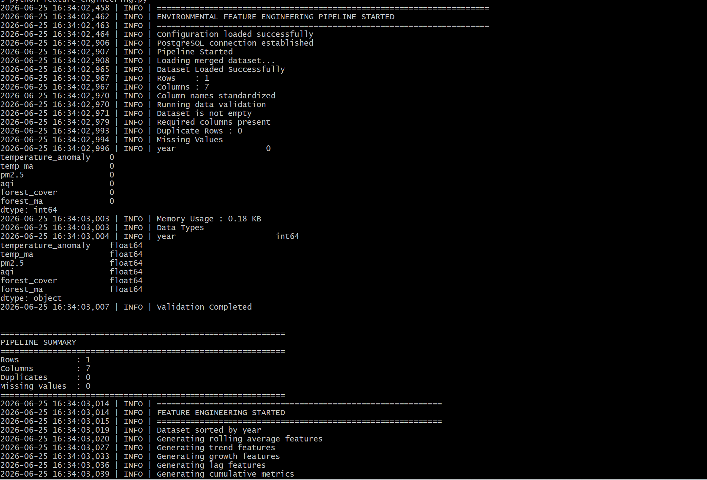
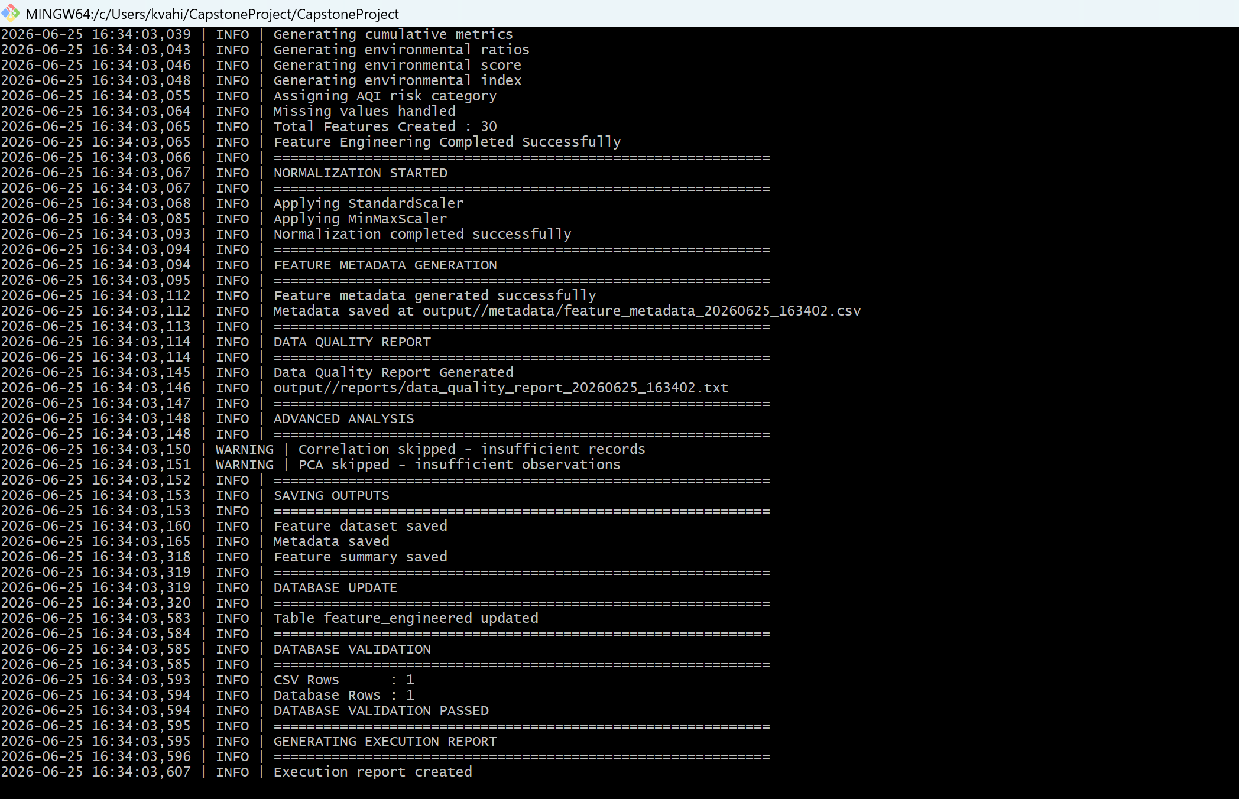
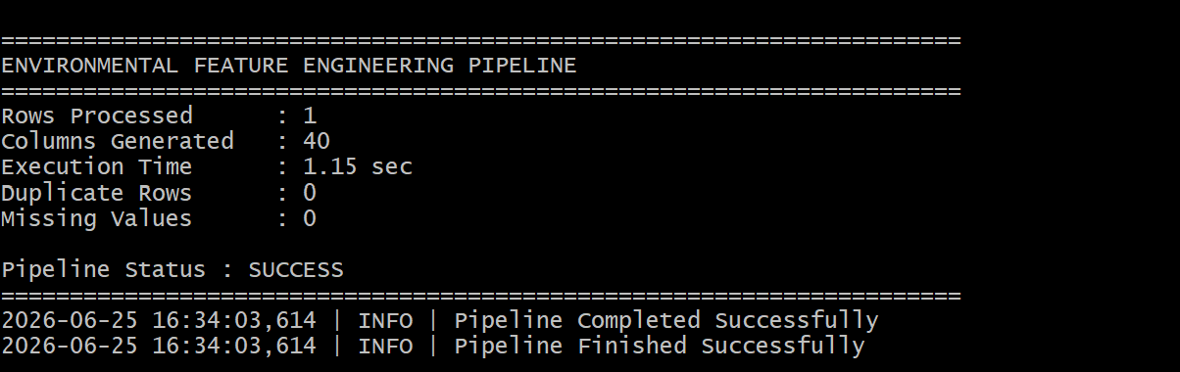
The figure presents the final execution summary of the Week 4 pipeline. It confirms successful completion of feature engineering, normalization, metadata generation, PostgreSQL integration, database validation, and report generation, demonstrating that the complete workflow executed successfully from start to finish.
15. Challenges Faced
During the implementation of the Week 4 feature engineering pipeline, several technical and data-related challenges were encountered. These challenges primarily originated from the heterogeneous nature of the environmental datasets, differences in temporal coverage, and the requirement to develop a reusable production-style pipeline rather than a one-time analytical script.
15.1 Limited Overlapping Observations
The integrated dataset created during Week 3 consisted of only one common observation after aligning multiple environmental datasets across the available years.
Although this reduced the number of records available for advanced statistical analysis, it accurately reflected the overlap among the selected public datasets. Instead of forcing artificial data generation, the pipeline was designed to detect insufficient observations automatically and avoid statistically invalid analyses.
This design decision improves the reliability and integrity of the analytical workflow.
15.2 Feature Engineering Across Multiple Environmental Domains
The project combines environmental information from three different domains:
• Climate Data
• Air Quality Data
• Forest Cover Data
Each dataset follows different formats, scales, and temporal resolutions.
Designing generalized feature engineering methods that work consistently across all variables required careful preprocessing, standardization, and validation.
15.3 Production Pipeline Design
Unlike traditional notebooks where feature engineering is performed manually, the objective of this project was to develop a reusable production pipeline.
Additional engineering effort was required to implement:
• Configuration management
• Logging
• Exception handling
• Automatic report generation
• Metadata creation
• Database validation
These improvements significantly enhanced maintainability and reproducibility.
15.4 Statistical Validation
Principal Component Analysis (PCA) and Correlation Analysis require multiple observations to generate statistically meaningful results.
Since only one aligned observation was available, the pipeline automatically skipped these analyses instead of producing misleading visualizations.
This behaviour demonstrates responsible engineering practices and ensures future scalability.
16. AI Tools Used
Artificial Intelligence tools were used to improve software development efficiency while maintaining complete understanding and verification of the implemented solution.
The following AI tools assisted during development:
• ChatGPT
- Python programming support
- Feature engineering suggestions
- Documentation refinement
- Pipeline architecture recommendations
- Debugging assistance
• GitHub Copilot
- Code completion
- Function generation
- Syntax suggestions
• Claude
- Alternative implementation ideas
- Documentation improvements
- Code review suggestions
All generated code, documentation, and analytical outputs were manually reviewed, modified, tested, and validated before inclusion in the final submission.
17. Deliverables Generated
The Week 4 implementation successfully generated the following outputs.
Source Code
• feature_engineering.py
• config.json
• requirements.txt
• README.md
• feature_description.txt
Generated Reports
• feature_dataset.csv
• feature_metadata.csv
• feature_summary.csv
• data_quality_report.txt
• execution_report.txt
• pipeline.log
PostgreSQL Database
• feature_engineered table
• Database validation report
18. Project Outcomes
The implemented pipeline successfully achieved all objectives defined for Week 4.
The major outcomes include:
• Automated feature engineering pipeline
• Production-style modular implementation
• Rolling averages
• Trend analysis
• Lag features
• Growth percentage features
• Cumulative environmental metrics
• Environmental ratios
• Composite environmental indicators
• AQI Risk Classification
• Feature normalization
• Metadata generation
• Automated validation
• PostgreSQL integration
• Database validation
• Execution reporting
• Reusable analytical dataset
The engineered dataset now contains approximately forty analytical variables that provide significantly richer information than the original merged dataset.

19. Future Scope
Although the implemented pipeline successfully satisfies the Week 4 deliverables, several enhancements can further improve the project.
Future work includes:
• Integration of additional environmental datasets.
• Incorporation of satellite imagery.
• Automatic feature selection techniques.
• Machine learning model development.
• Environmental forecasting.
• Interactive dashboards using Power BI or Tableau.
• Automated cloud deployment.
• Real-time environmental monitoring.
The modular architecture developed during Week 4 allows these enhancements to be incorporated with minimal code modification.
20. Conclusion
Week 4 successfully transformed the integrated environmental dataset into a feature-rich analytical dataset through the implementation of a production-inspired feature engineering pipeline.
Unlike conventional assignment implementations, the developed solution follows modern software engineering principles by incorporating modular architecture, configuration management, automated validation, comprehensive logging, metadata generation, PostgreSQL integration, and execution reporting.
The pipeline automatically performs feature engineering, normalization, quality validation, database storage, and report generation without requiring manual intervention. Approximately thirty engineered features were created, expanding the original dataset into an analytical dataset containing approximately forty variables suitable for advanced environmental analysis and future predictive modelling.
Although the merged dataset currently contains only one aligned observation, the implemented pipeline remains fully scalable. Advanced analytical components such as Principal Component Analysis (PCA) and Correlation Analysis were implemented with validation checks and automatically skipped due to insufficient observations, thereby preventing statistically invalid results while preserving future extensibility.
Overall, the Week 4 implementation successfully satisfies the project objectives and establishes a robust analytical foundation for future machine learning, forecasting, and environmental decision-support applications.

Figure 7 – Engineered Feature Dataset
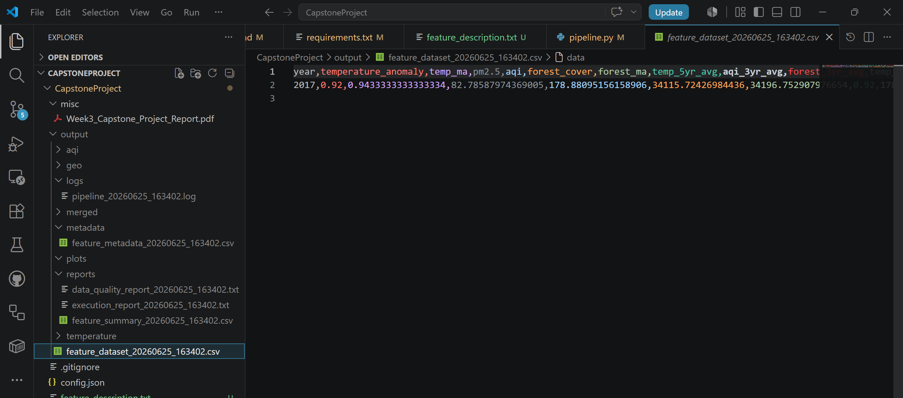
This figure presents the final engineered dataset generated by the feature engineering pipeline. The dataset includes both original environmental attributes and newly engineered analytical features such as rolling averages, cumulative metrics, trend indicators, normalized variables, and environmental indices.
Figure 8 – Feature Summary Report
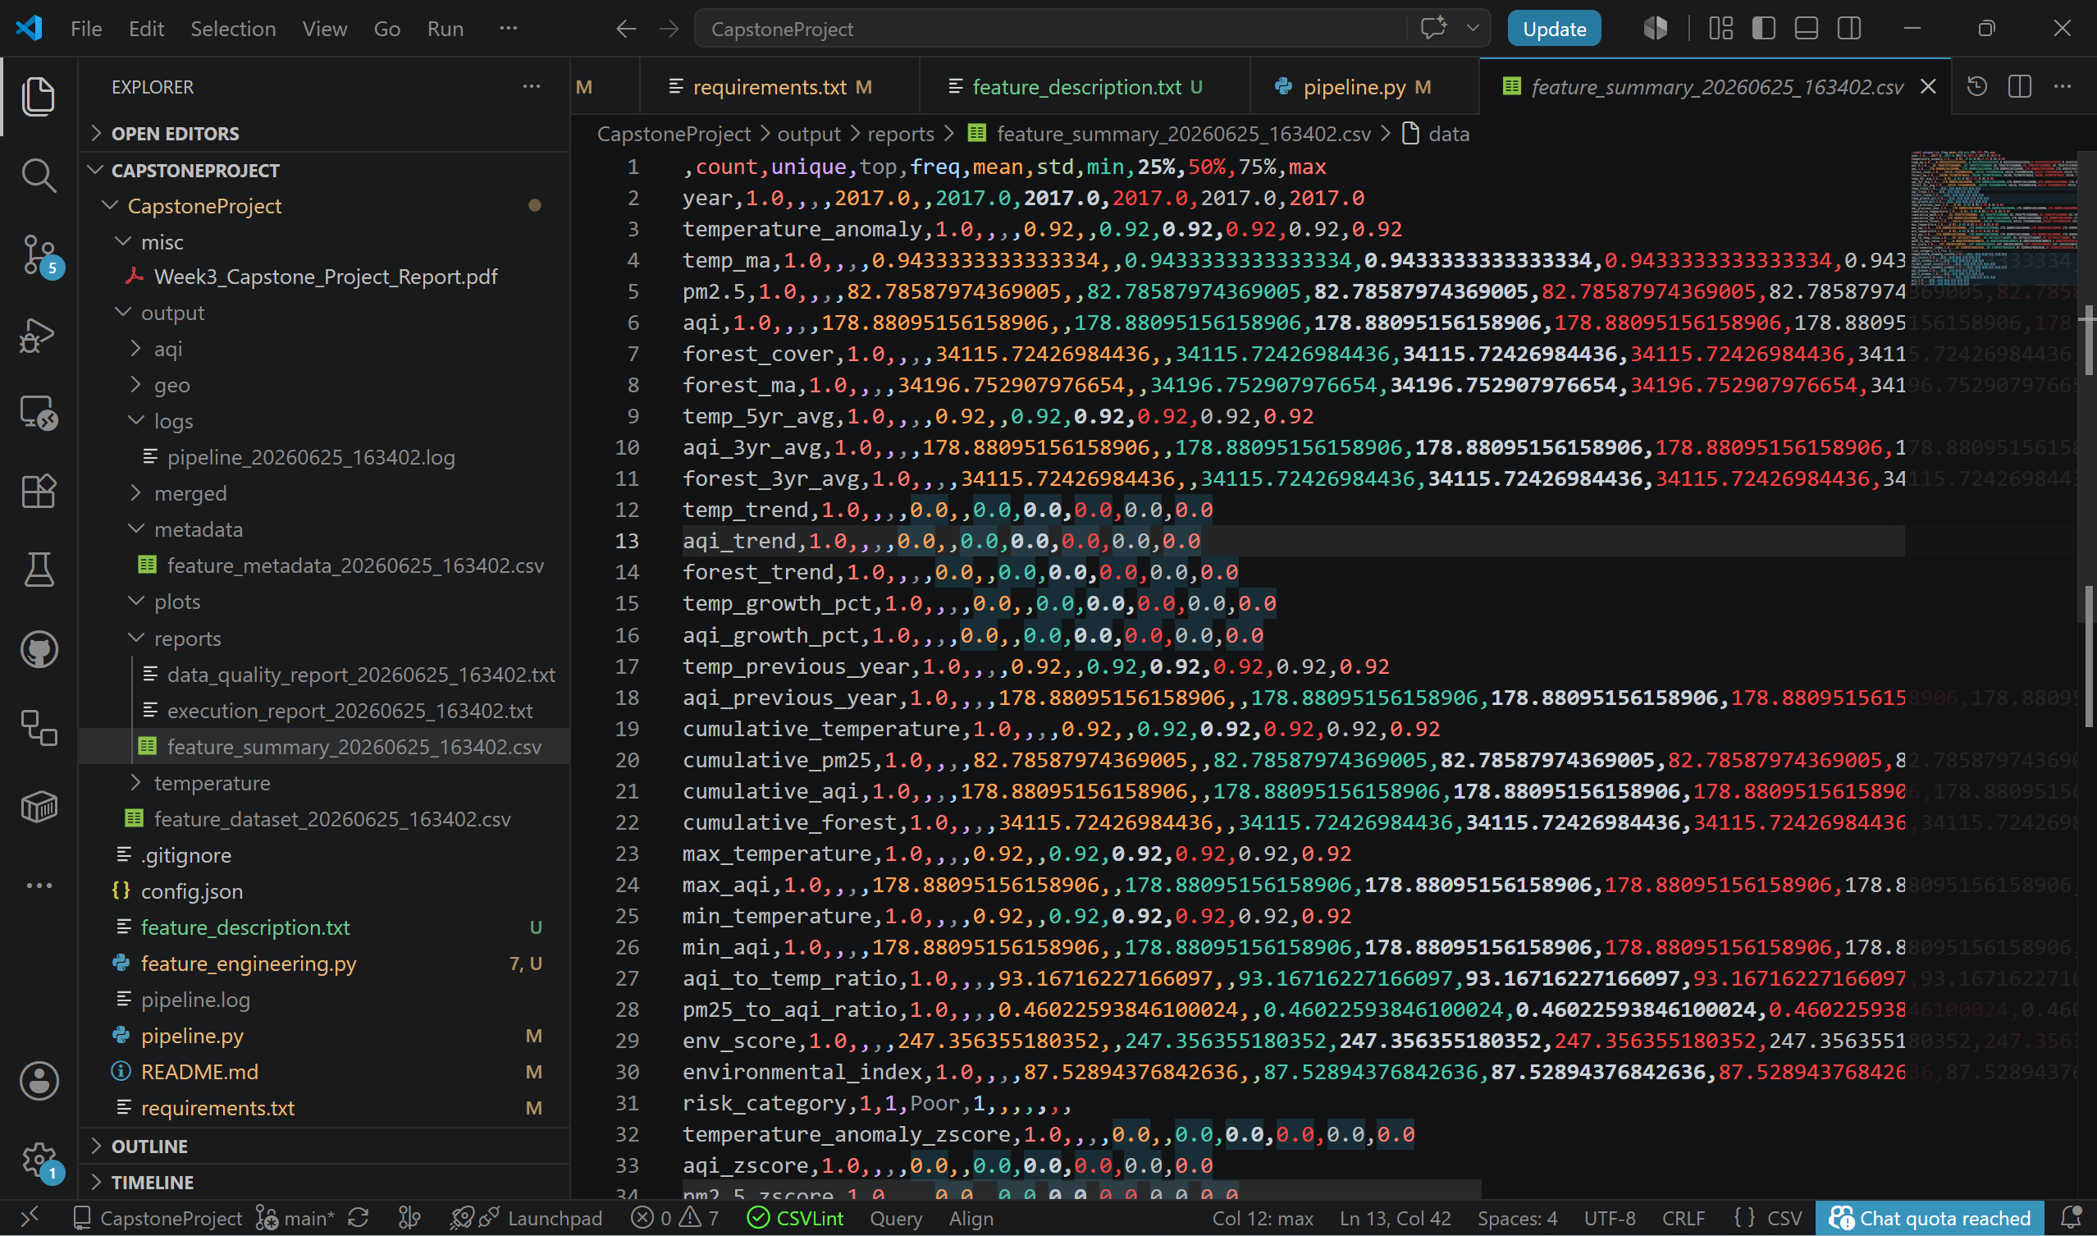
The feature summary report provides descriptive statistics for the engineered dataset. It enables rapid inspection of numerical distributions and supports validation of generated features before analytical modelling.
Figure 9 – Pipeline Log
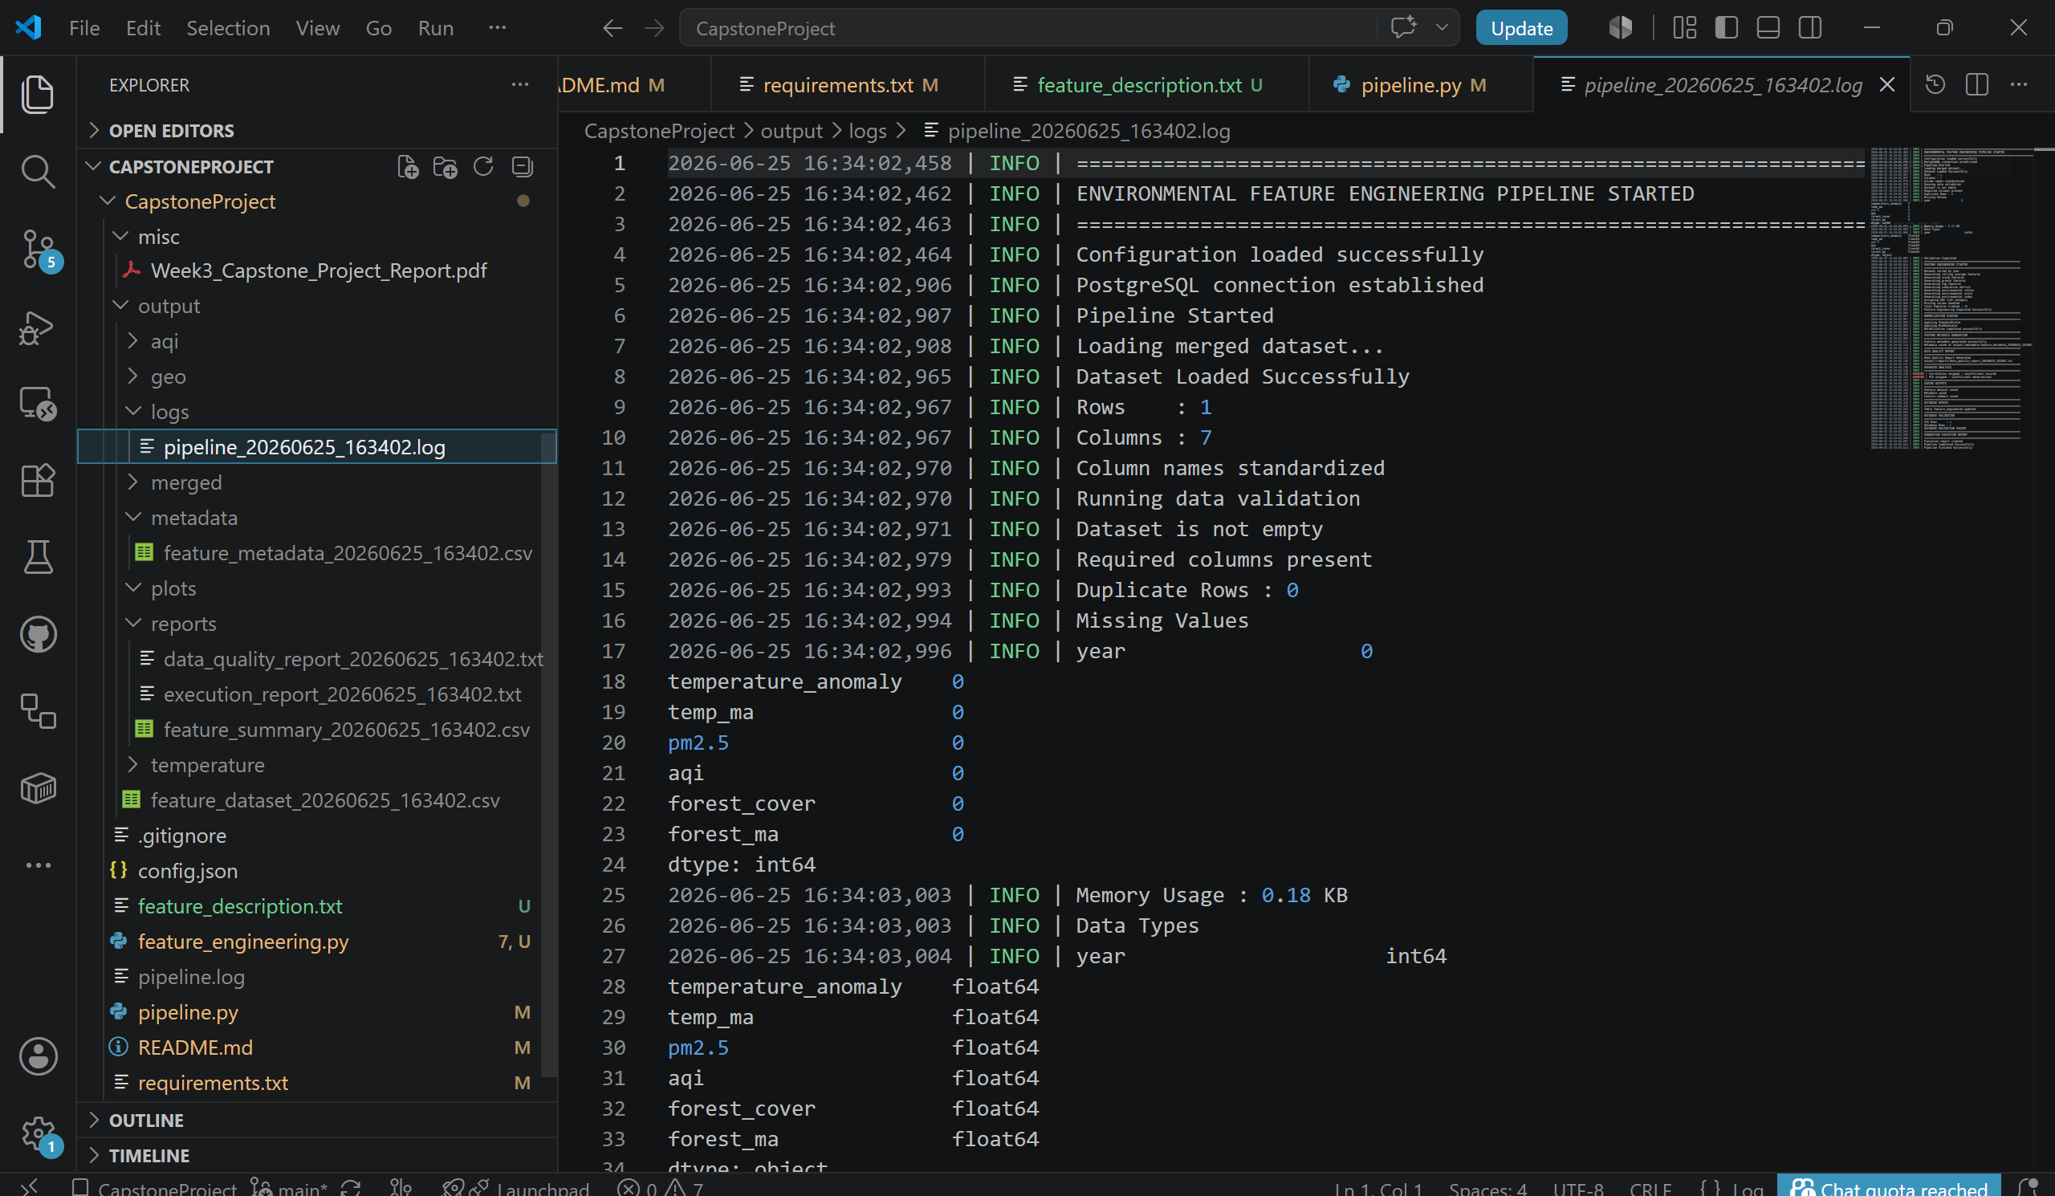
The pipeline log records each stage of execution, including configuration loading, database connection, feature engineering, normalization, report generation, PostgreSQL updates, and validation. Logging improves reproducibility and simplifies debugging.
Figure 10 – Project Folder Structure
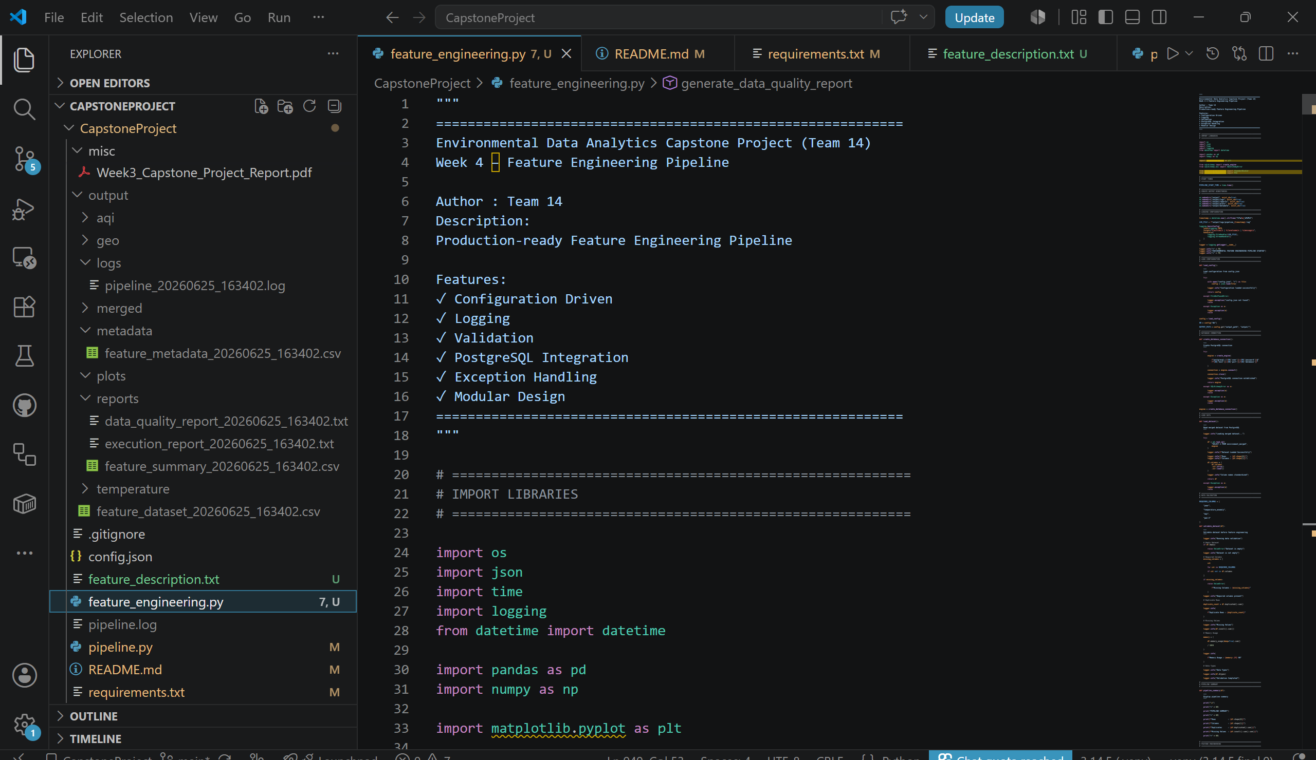
The project structure demonstrates the modular organization of the developed pipeline. Separate directories for outputs, reports, metadata, logs, and source code improve maintainability and align with production software engineering practices.

