Capstone Project - Environmental Data Analytics(Team 14)

Week 2 – Data Cleaning & Transformation

1. Project Summary
In Week 2, the focus was on cleaning, transforming, and preparing environmental datasets for integration and analysis. The datasets included temperature data (NASA), air quality data (India AQI), and geospatial environmental data.
The objective was to convert raw and unstructured datasets into a consistent and analysis-ready format, enabling integration across multiple data sources.

2. Work Completed
The following tasks were completed during this phase:
- Cleaned datasets and handled missing values using appropriate techniques
- Converted date formats and extracted Year and Month features from time-series data
- Aggregated air quality data from daily observations into monthly and yearly summaries
- Filtered and processed geospatial data focusing on forest cover indicators
- Applied moving average techniques to smooth trends in temperature and geospatial data
- Standardized formats across datasets to ensure compatibility
- Aligned datasets from different sources based on common time periods
- Merged processed datasets into a unified environmental dataset
- Generated visualizations including:
- Temperature trends
- AQI trends
- PM2.5 trends
- Forest cover trends
- Correlation heatmaps and scatter plots
- Performed preliminary trend analysis and correlation analysis
- Missing values were handled using median imputation and removal of invalid records where appropriate.
Dataset | Records | Features
Temperature | 148 | 2
Air Quality | 29207 | 18
Geospatial | 6159 | 4
Integrated Dataset | 1 | 5

3. Data Quality Improvement
Data quality was significantly improved by handling missing values, removing inconsistencies, standardizing formats, and validating merged records.

4. Use of AI Tools
AI tools such as ChatGPT, GitHub Copilot, and Claude were used to assist in:
- Writing and optimizing code
- Debugging errors during data preprocessing
- Suggesting appropriate data transformation techniques
- Improving analytical approach and documentation
These tools helped improve efficiency and ensured accurate implementation of data processing steps.

5. Challenges Faced
The following challenges were encountered:
- Handling missing and inconsistent values in the air quality dataset
- Cleaning and restructuring the NASA temperature dataset, which contained metadata rows and non-numeric values
- Aligning datasets with different temporal granularities (daily, monthly, and yearly)
- Identifying common years across datasets for meaningful integration
- Managing data consistency and avoiding duplication during merging
- Limited overlapping time period across datasets, which restricted combined analysis

6. Correlation Analysis Limitation
Limited overlapping data across datasets resulted in only a single common year (2017) after alignment.
Since correlation analysis requires multiple data points, meaningful correlation could not be performed on the merged dataset.
To address this limitation:
- Correlation analysis was separately performed using the full air quality dataset, which contained multiple years of data
- This allowed identification of meaningful relationships, such as the strong positive correlation between PM2.5 and AQI

7. Next Steps
The next phase of the project will focus on:
- Performing advanced feature engineering on the integrated dataset
- Building automated data preprocessing pipelines
- Conducting deeper correlation and trend analysis
- Developing predictive models for environmental indicators
- Creating interactive dashboards for visualization and insights

8. Conclusion
Week 2 successfully transformed raw environmental datasets into structured and analysis-ready formats.
The datasets were cleaned, standardized, aligned, and merged to create a unified dataset for further analysis.
The cleaned, transformed, and integrated datasets are now fully prepared for advanced analytics and model development in the next phase of the project.

9. Results/Visual Outputs
The following outputs were generated during Week 2:
Missing Value Analysis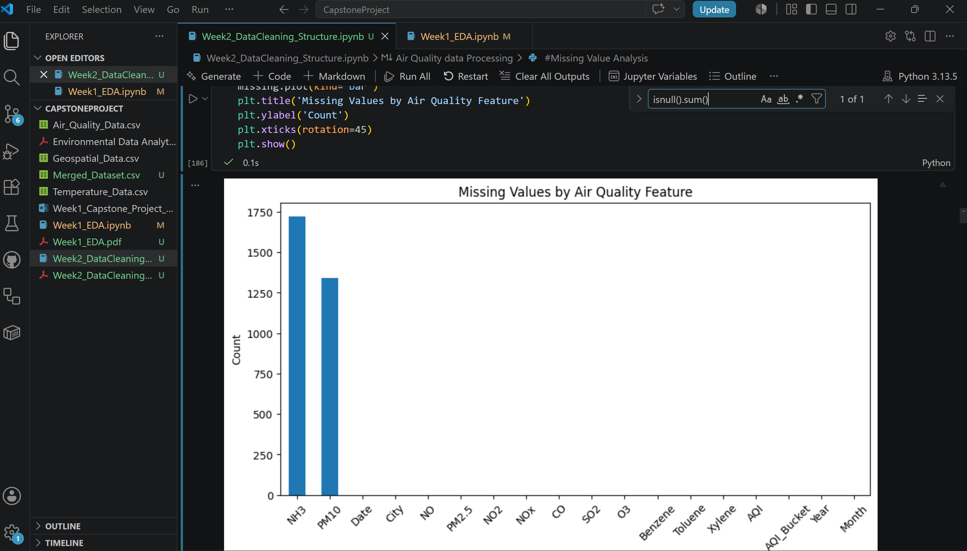
Missing value analysis performed on environmental datasets to identify data quality issues before preprocessing.
Cleaned NASA Temperature Dataset
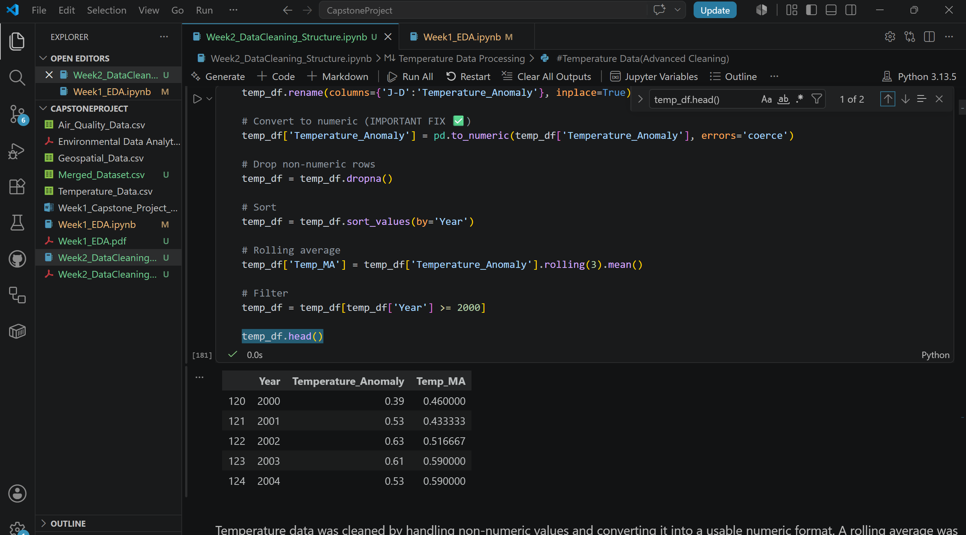
NASA temperature dataset after cleaning, restructuring, and conversion into analysis-ready format.

Air Quality Aggregation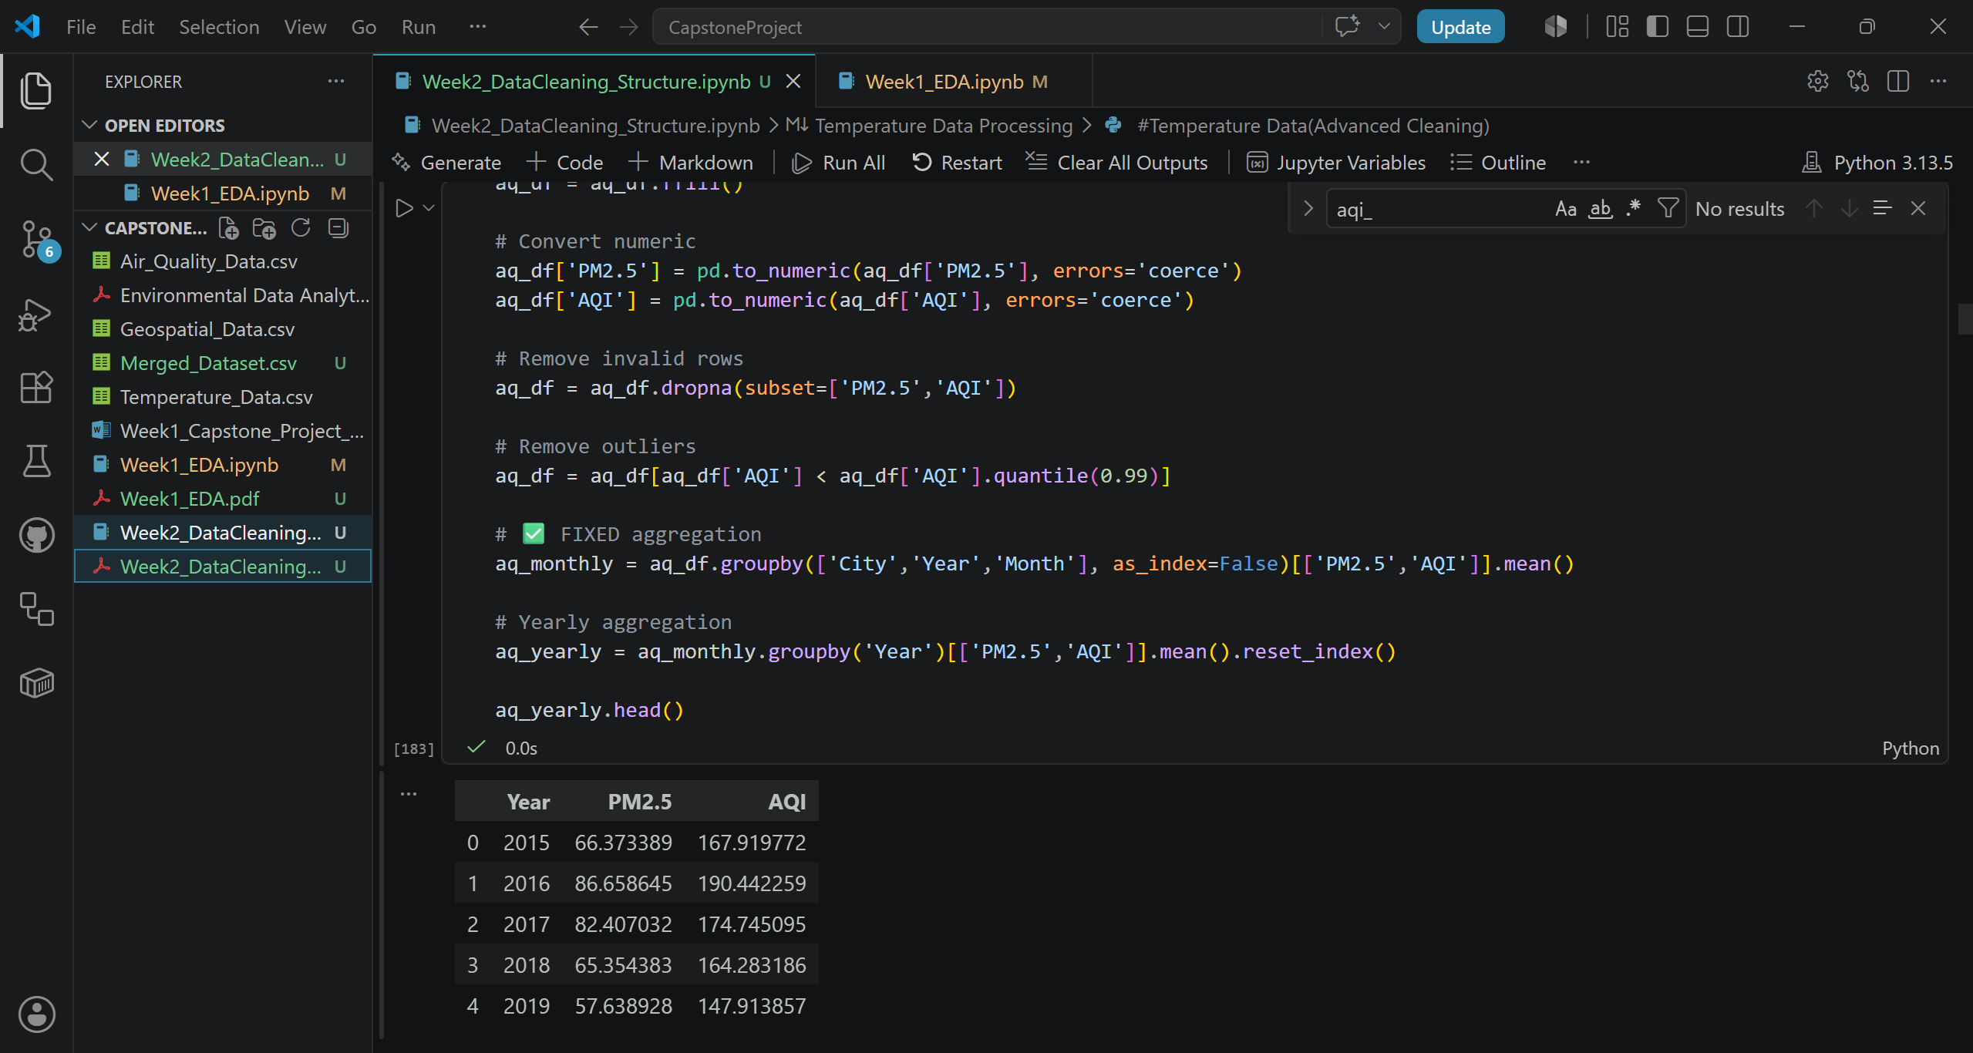
Air quality dataset after preprocessing, feature extraction, and yearly aggregation.
Missing Value Distribution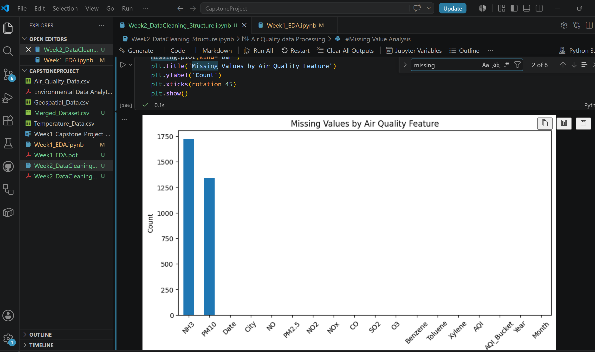
Distribution of missing values across major air quality indicators.
Temperature Trend
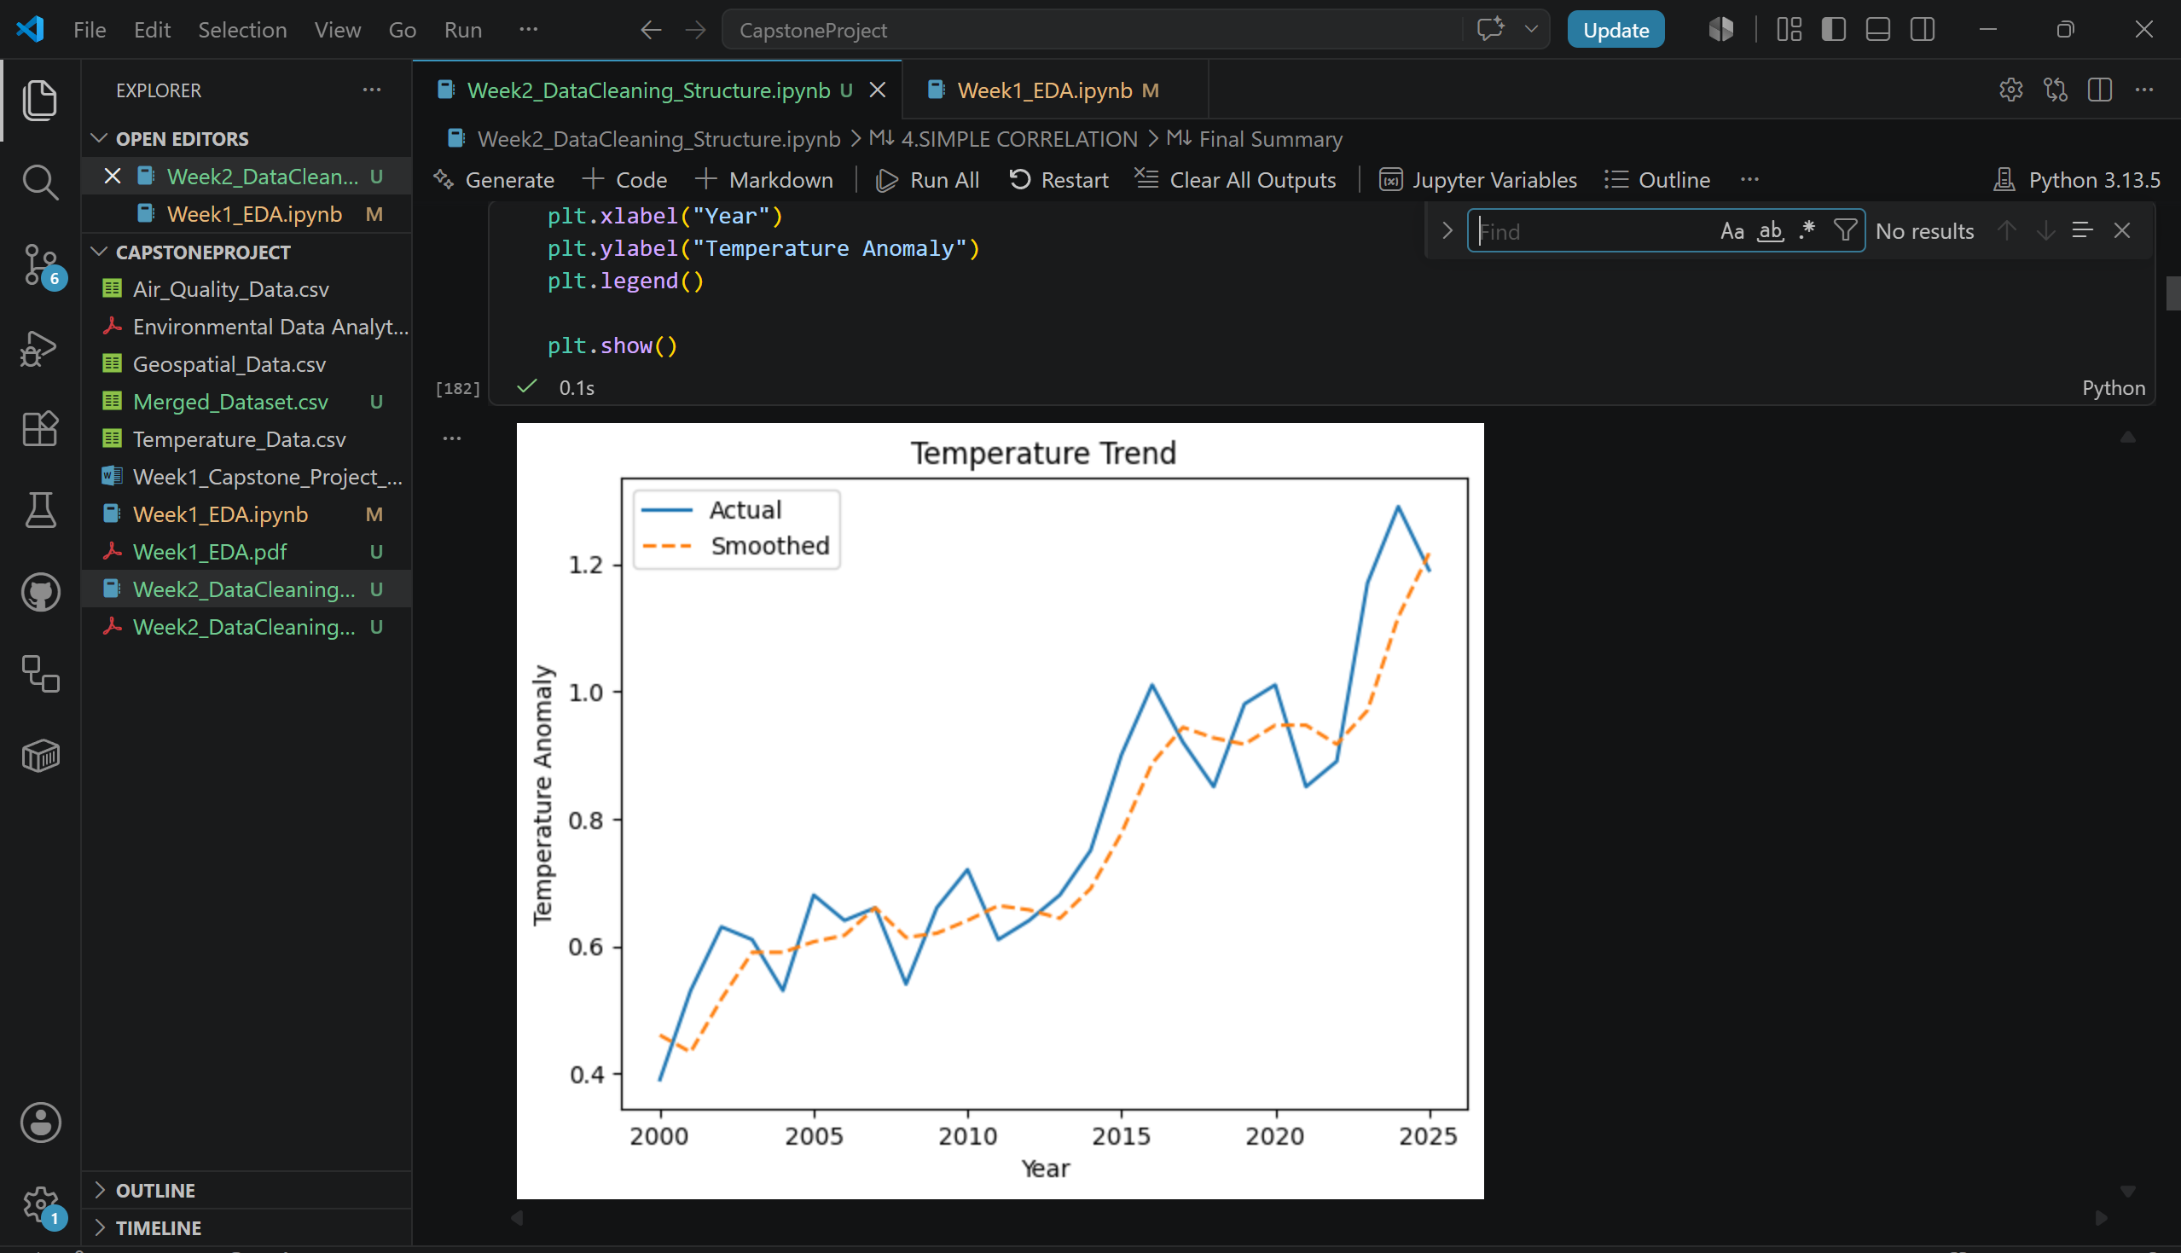
Global temperature anomaly trend showing a long-term increase in global temperatures.
Average annual AQI trend
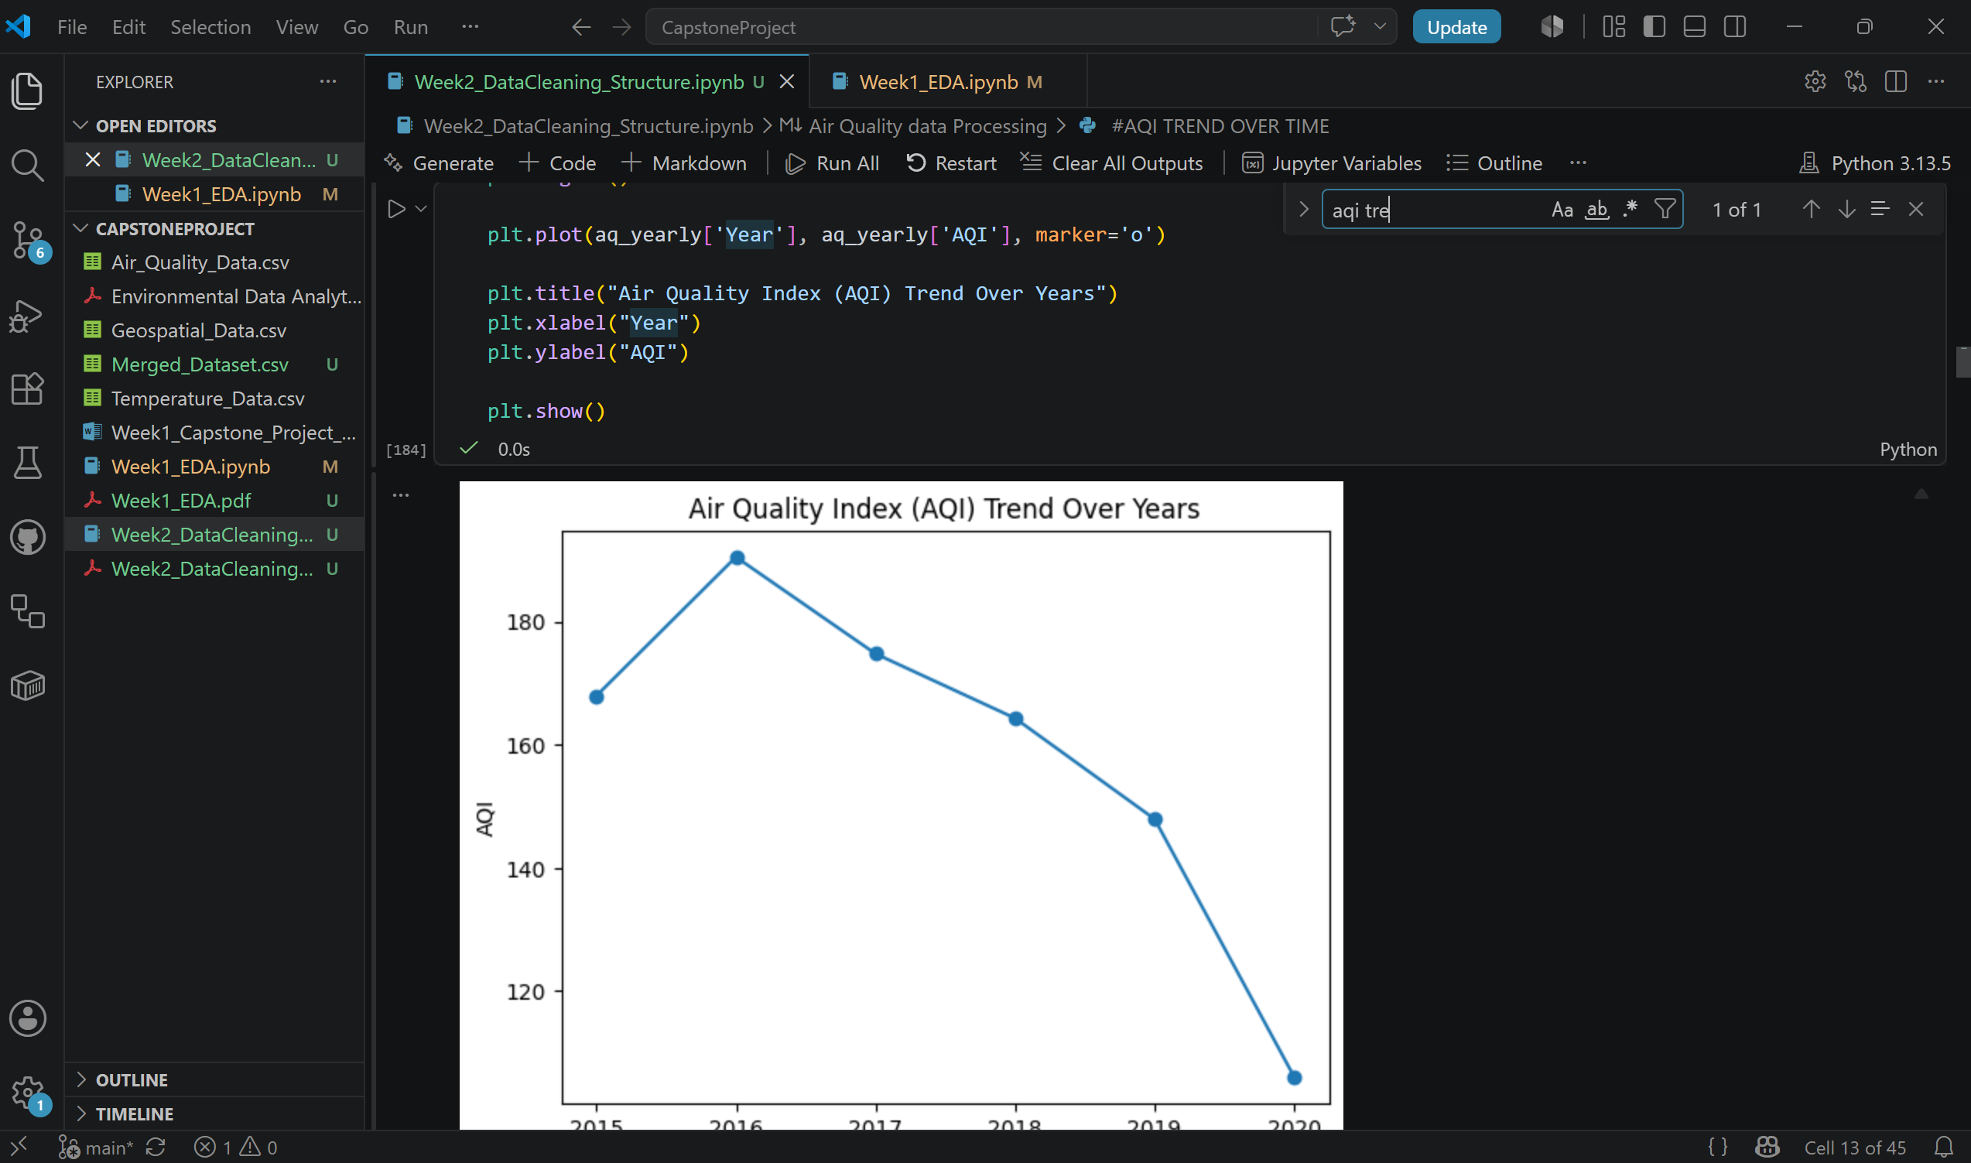
Average annual Air Quality Index trend generated from cleaned and aggregated air quality data.
PM2.5 vs Air Quality Index Relationship.
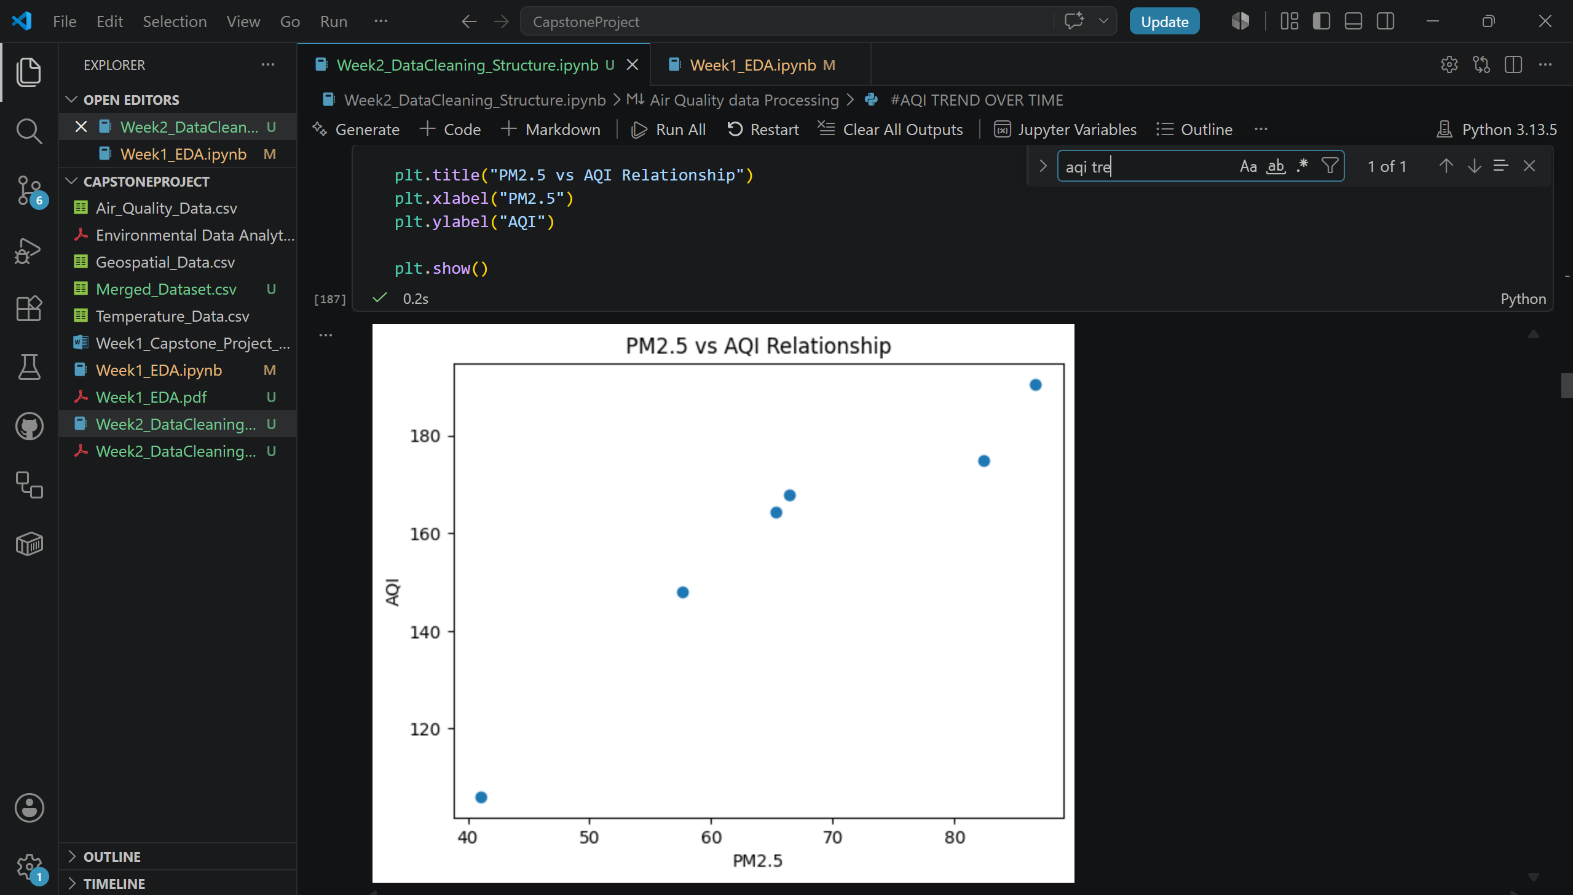
Scatter plot illustrating the relationship between PM2.5 concentration and overall air quality levels.
Correlation Heatmap
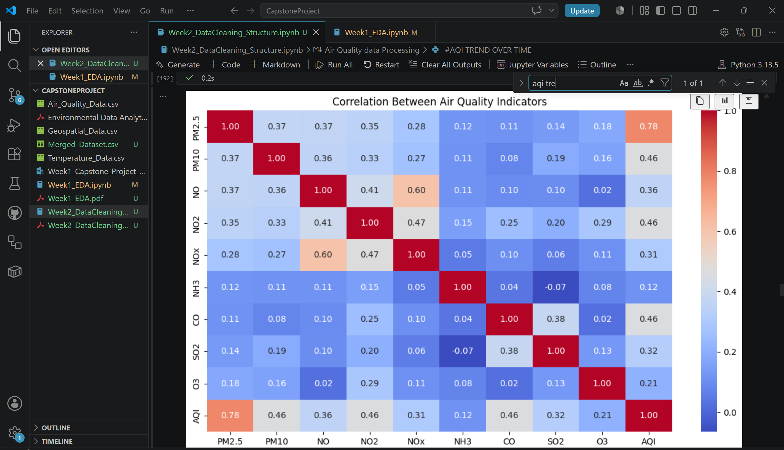
Correlation heatmap showing relationships among major air quality pollutants and AQI.
Forest cover trend
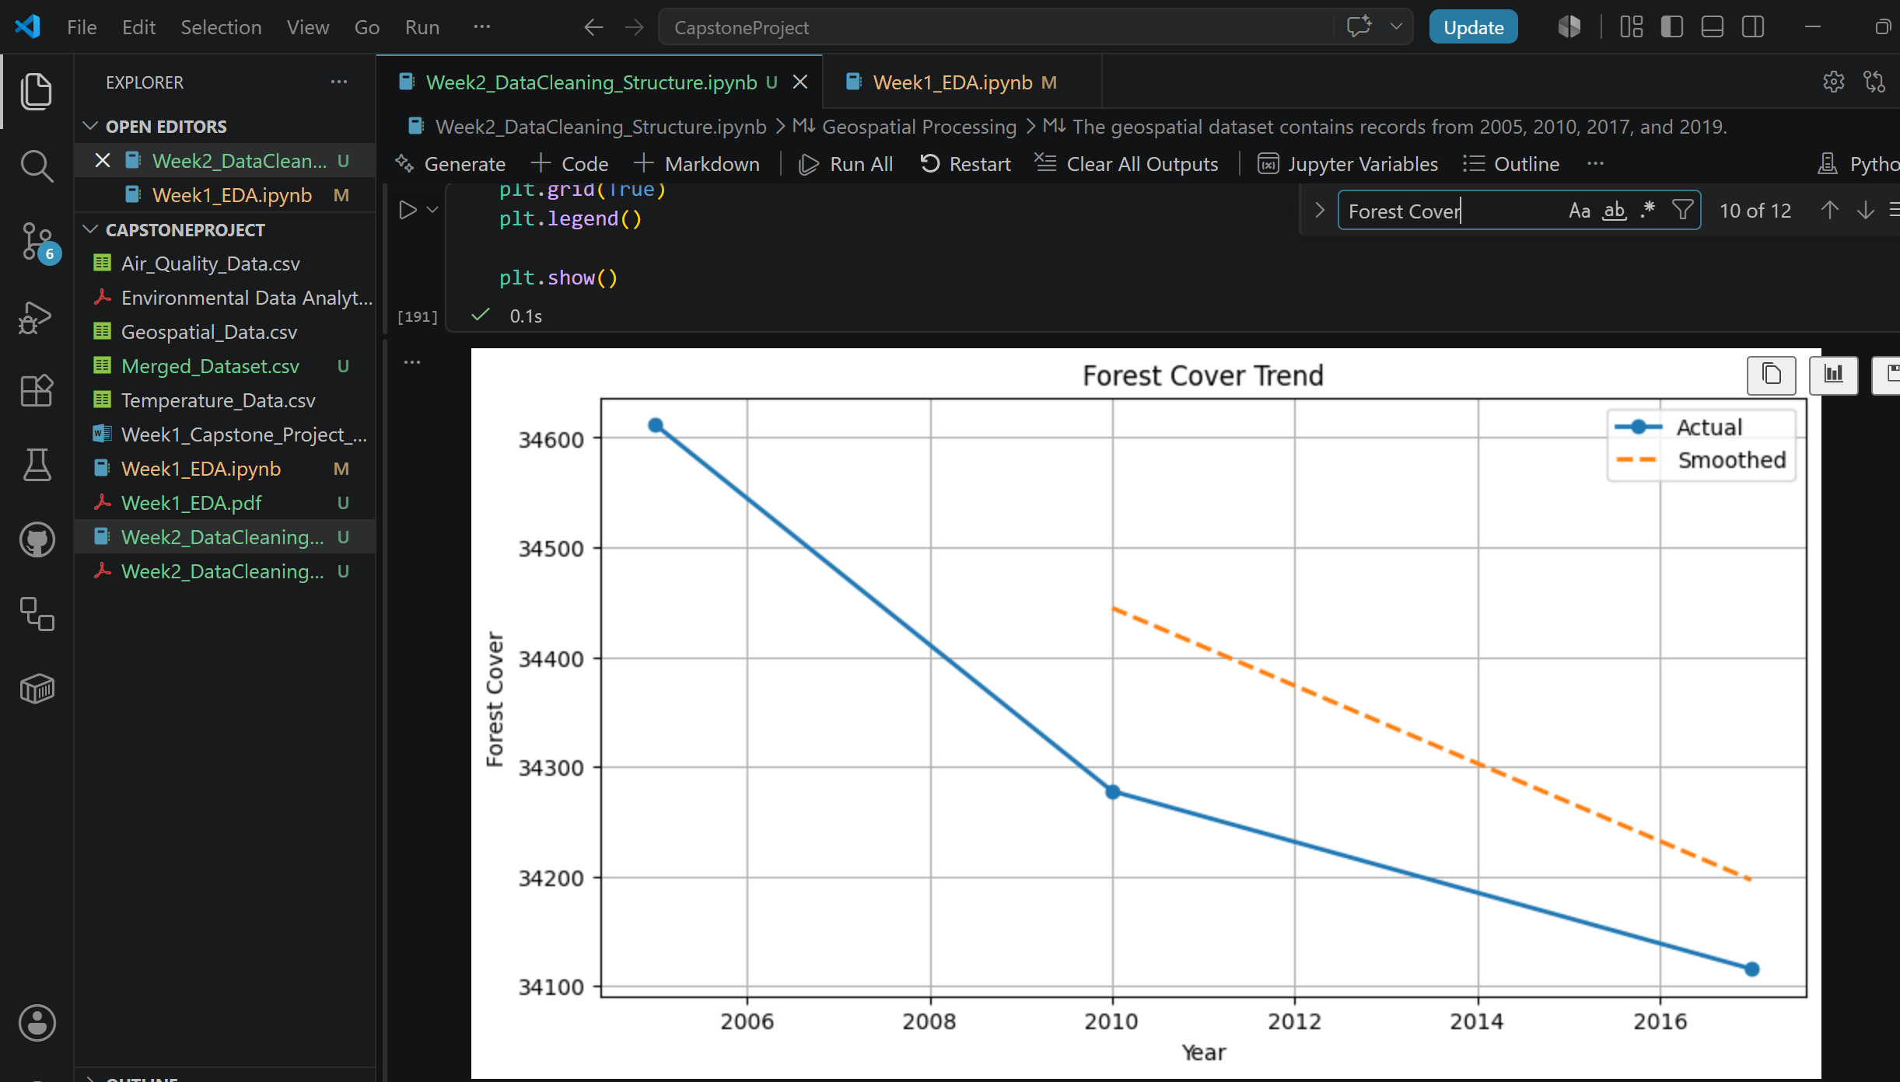
Forest cover trend derived from geospatial environmental indicators across available observation years.
Integrated Environmental Dataset
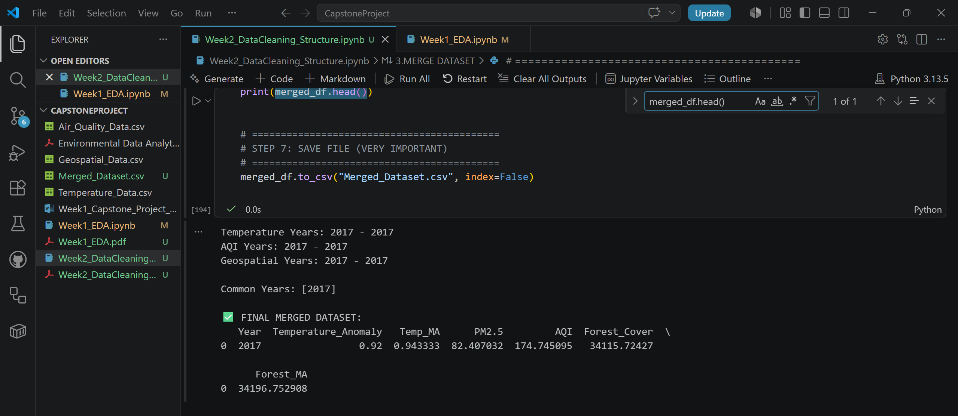
Final integrated dataset created by aligning and merging temperature, air quality, and geospatial datasets.

10.Project Reference Links
Google Drive Link: Capstone Project_Team14_Workspace - Google Drive
Github Repository: https://github.com/VahidaSS/CapstoneProject

