Sign Language Detection

Added hand segmentation for detected image in web cam and in below screen you can see that output

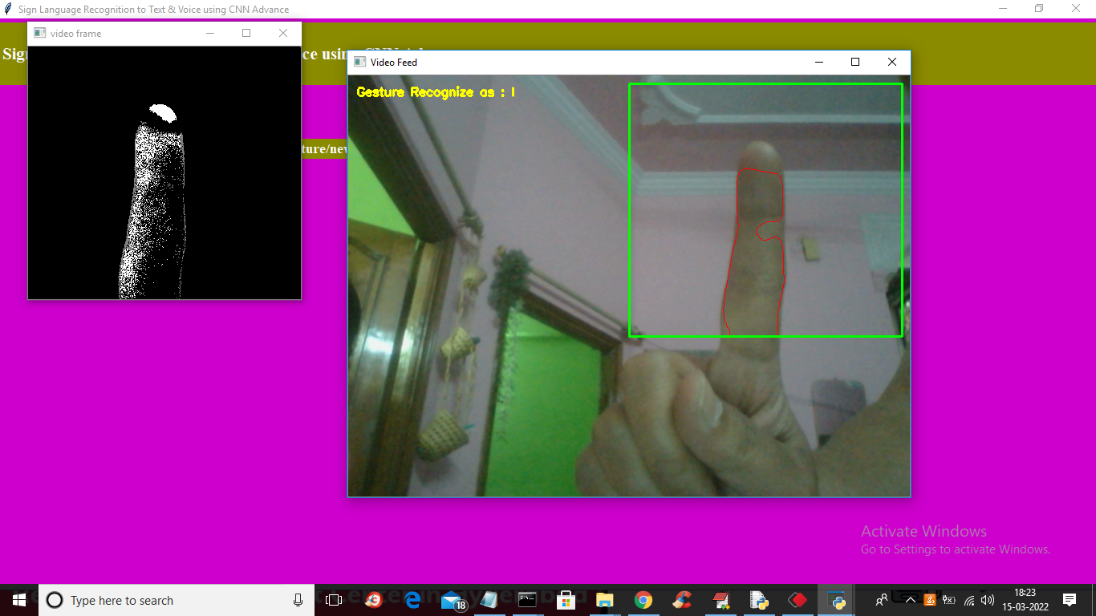

In above screen in black screen you can see segmented image and similarly whatever sign you show that will be segmented. To recognize digit press ‘Q’ key from keyboard to close webcam if its running. Now click on ‘Digit Recognition from Image’ button to upload digit image like below screen

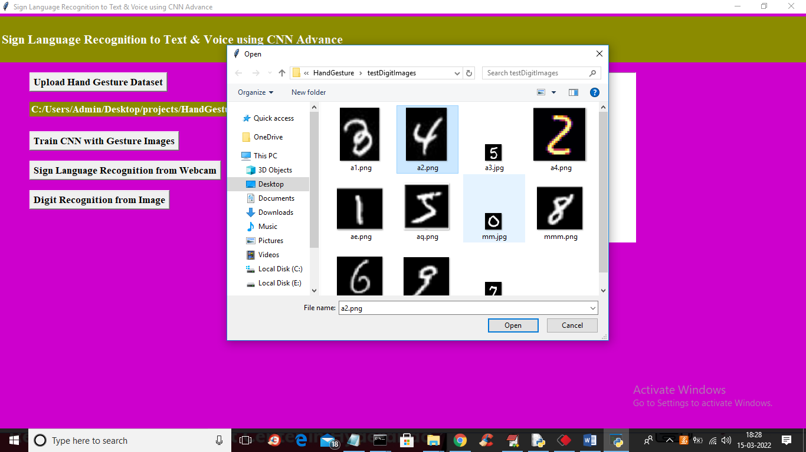

In above screen selecting and uploading ‘a2.png’ file which contains 4 digit and then click on “open” button to get below output

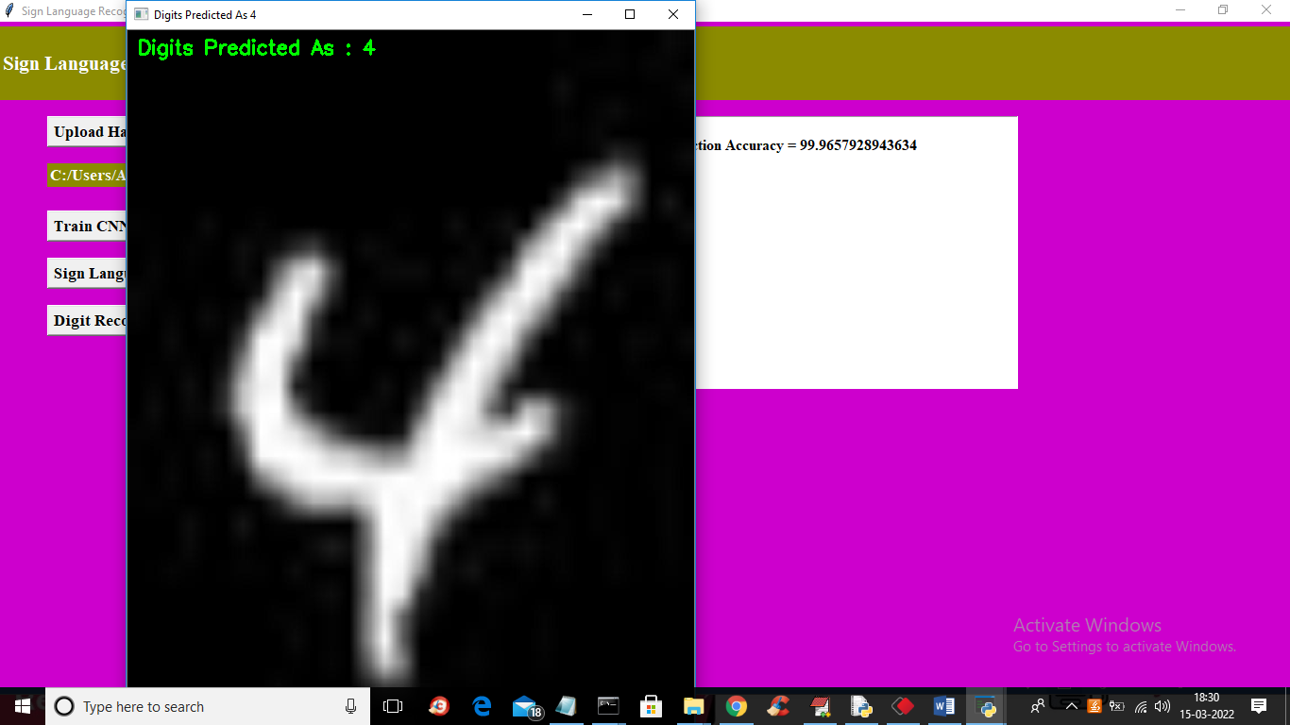

In above screen in green colour text we can see the predicted output and similarly you can upload other images and test

