Practical No: 5

Aim: Perform a BLAST search on a specific gene sequence of a specify

organism.

Steps:

Go to the National Center for Biotechnology Information Site

https://www.ncbi.nlm.nih.gov/

Select Nucleotide from All Databases and find any organism in a search bar.

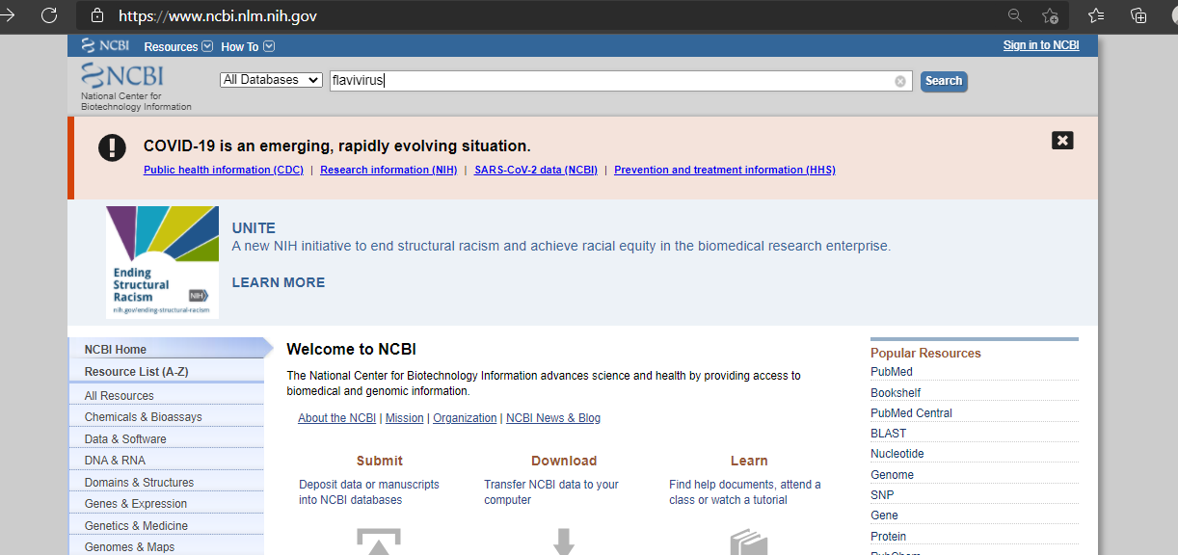

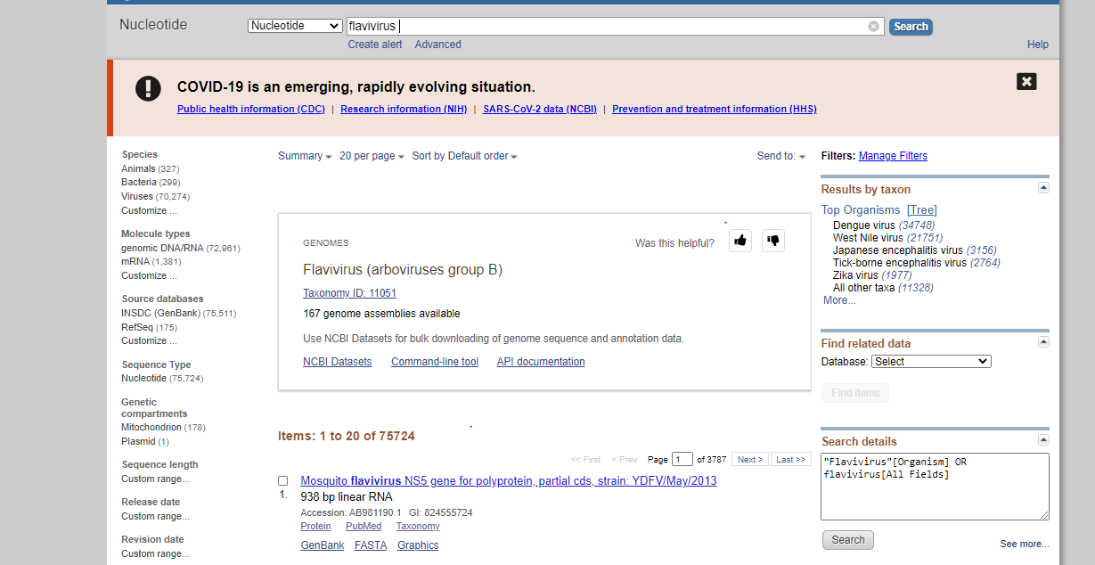

Run BLAST option we have to select

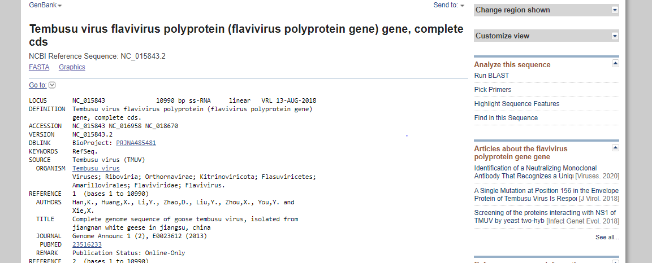

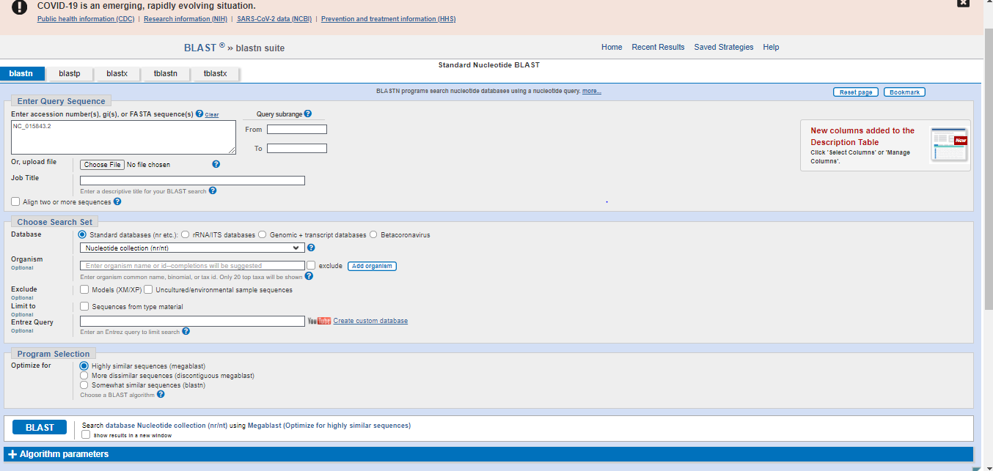

BLAST

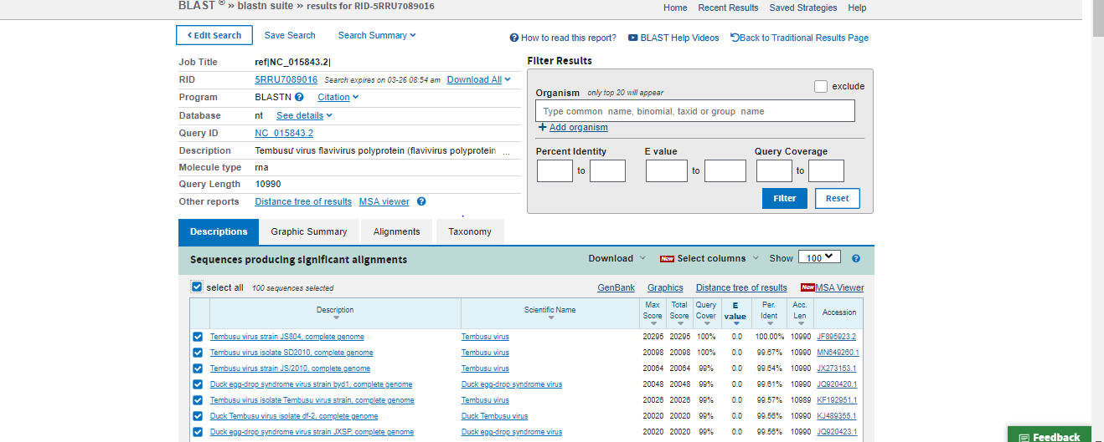

Here the result will be display

