NAME: - VAIBHAV S. BISEN

ROLL.NO:- 233230

PRN.NO:-230341220217

QUES 1:-

**EMPLOYEE RECURITMENT SYSTEM**

**Objectives:-**

The main objective of developing the system is to provide the deserving candidate to get shortlist. All the jobseeker can apply and register himself in the portal. They can able to view the organization requirement and according to that they can apply for the suitable job to them. Candidates are allowed to upload there CV and on the mean time they can apply for that particular job. Also it also makes it possible for organization to post their staffing requirement and can be able to view the profile of interested candidates.

Any deserving candidate can apply for the particular job all over the India, the shortlisted candidate can be have a virtual interview with respective HR. All the further process after getting shortlisted can be provide by the mail.

**Scope** :-

The main scope of developing this system is a well-qualified candidate can be able to get a good job and a respective company will be able to have a potential employee. By developing this system the firm can be able to have a bundle set of employee and can shortlist them according to their business requirement and core need.

Ques no2:-

**Functional- Requirement** :-

It should follow the User management skills, the candidate data their schedule interview timing should manage in the proper manner so that all the shortlisted employee can have a proper interview timings.

The Result after the interview shall be provided through the mail and call so it will make easier for the HR’s to connect with maximum candidates. The after result waiting process will be maximum of 15 days.

The System should follow a pattern that if there is need of any staff so they can also post the requirement in the system and required staff member can also apply over for the desired job according to there qualification.

There should be working hierarchy so that company can move ahead in a good speed and achieve greater heights.

**Non-Functional Requirement** :-

1. The System show be secured and provide full privacy to candidate Resume and personal information. (ex:- Bank Details, Phone no, Address etc).
2. Candidate should be able to see the log in page and all necessary information related to desire job properly if they have a quarry related to that then some HR contact details should be mentioned over there.
3. It should be bug free and can be able to handle the pressure of number of application. Because many candidates from different city will fill the form.
4. The company address, name of the board of members and all the certificate showed in available online. Only the following company can be able to enter in this system which satisfied all the rules and condition.

Ques no:-3

**Business Entity & Operations** :- Company should move in such a manner that they should evaluated the employee performance in quarterly basic and according to that company gives the promotion to demotion to the employee.

The Company should have a proper record of the belonging of the organization which employee are having like laptops, chargers etc.

It should be located in the well know location so it will be easier for the employee to serve their daily timing properly. Company should have a positive work culture and good vibes around the office. It will help employee to give their best performance.

Company should follow a culture like 5 days a week working. So that It will be easier for the employee to keep their private and professional life separate and work throughout the week with best potential.

All the public holiday and week off will be a holiday for the employee.

The System should follow a pattern that if there is need of any staff so they can also post the requirement in the system and required staff member can also apply over for the desired job according to there qualification.

Ques.no:-6

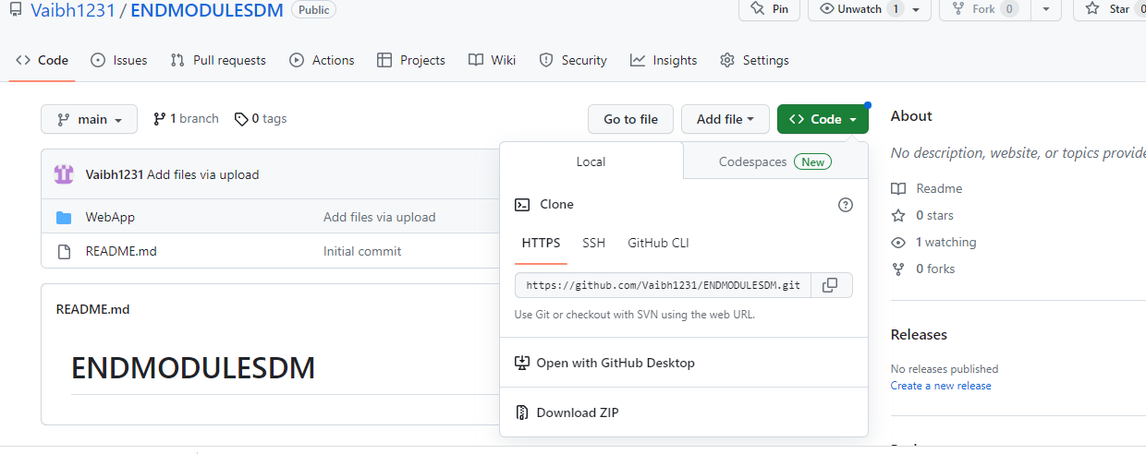

Ques no:-7

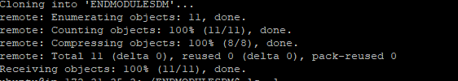

Ques no.8

Ques no:-9



Q10:-

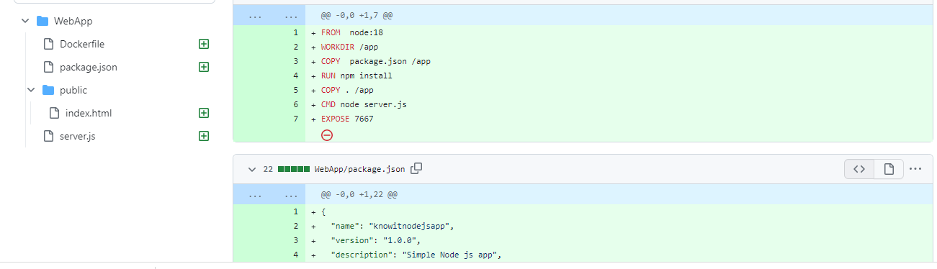

Ques.no:-11

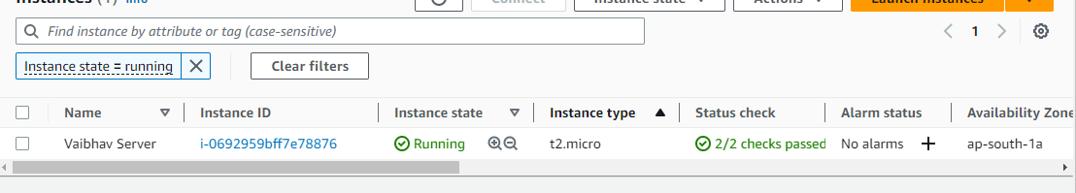

Q12:-

`

Ques.NO:- 13 

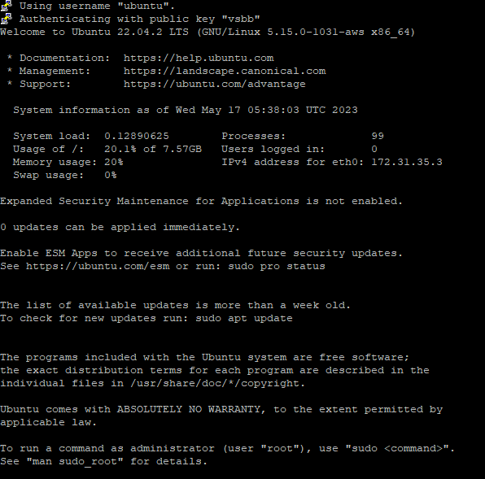

Q14



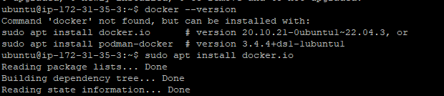

Q15 

Q16

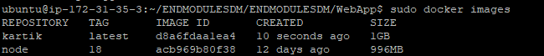

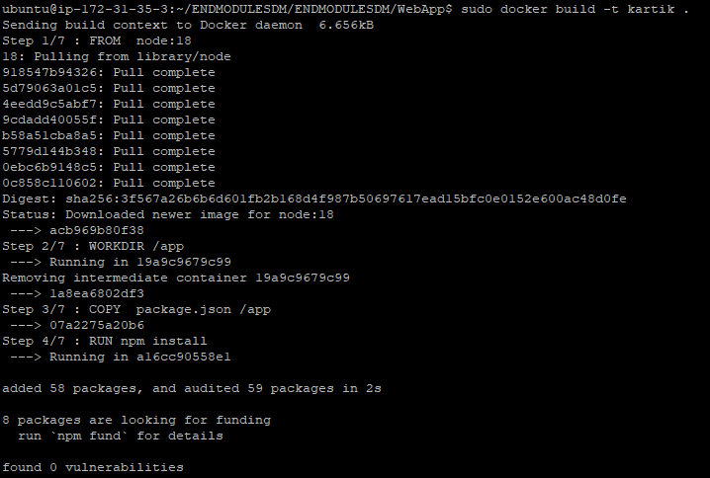

Q17



Q18

Ques.no:-19 