PROJECT REPORT
Predicting Open-Source Package Abandonment: A MongoDB, PyMongo and Machine Learning Study
Release histories of PyPI and npm packages used to forecast which packages will stop being maintained, and why
Submitted by: Vaibhav Tripathi
Registration No: 12326345
B.Tech Computer Science and Engineering
Lovely Professional University
October 2026

Contents
1. Introduction
2. Project Objective
3. Dataset Description
4. MongoDB / PyMongo Implementation
5. Data Preprocessing
6. Model Implementation
7. Evaluation Results
8. Conclusion
References
Appendix A. Project Structure and How to Run
Appendix B. Presentation Notes

1. Introduction
Almost every modern application is built on open-source packages from registries such as PyPI (Python) and npm (JavaScript). A package that is no longer maintained stops receiving bug fixes, security patches and compatibility updates, but teams usually find out only when something breaks. The question this project asks is: can the public release history of a package predict whether it will still be maintained two years from now?
Why someone would use this. A development team can list its dependencies and see, for each one, a risk score for abandonment together with the reasons behind it (for example, “unusually long time since the last release compared with its normal pace”). Packages with a high score can be replaced or monitored before they become a problem, instead of after.
Why MongoDB. A package is naturally one document that contains a list of releases. That list has anywhere from 1 to more than 9,000 entries, which is awkward in a fixed-column table but natural in a document database. PyMongo is used to load the data, clean it, query it with aggregation pipelines, store the engineered features, and store the model results and the risk scores.
What “abandoned” means here. Abandonment cannot be observed directly, so it is defined operationally: a package is abandoned if it publishes no new release during a 24-month window. This is a proxy – some finished, stable packages legitimately need no updates – and Section 8 discusses this limitation.

2. Project Objective
The objective is to design and implement an end-to-end MongoDB + machine-learning project that predicts the future maintenance status of open-source packages. The specific goals are:
- Download real release histories from the PyPI and npm registries and load them into MongoDB with PyMongo, keeping a raw layer and a cleaned layer.
- Validate the data inside the pipeline and keep an audit trail (cleaning log and quarantine collection).
- Demonstrate CRUD operations, indexes (including a unique compound index), queries and aggregation pipelines with $unwind on nested release arrays.
- Classify whether a package will be abandoned within the next 24 months (Accuracy, Precision, Recall, F1-score).
- Regress the number of releases a package will publish in the next 24 months (R² Score and MAE).
- Compare Logistic/Linear Regression, Decision Tree and Random Forest against simple rule-of-thumb baselines, using a split that separates the past from the future and training packages from test packages.
- Explain every risk score, and store the results, predictions and risk scores in MongoDB.

3. Dataset Description

3.1 Source and sampling
The data come from the public APIs of the two registries and were collected on 17 October 2026. Only the release timeline of each package is stored: the version string and the time the version was published. No source code, README text or download counts are used.
- PyPI: a random sample of 7,000 project names from the registry index (about 916,000 projects on the collection date, fixed random seed). 6,733 of them returned release data. Because the sample is random, it contains many small hobby projects, which makes it representative of PyPI as a whole.
- npm: 2,505 packages gathered through registry searches on 40 keywords (api, cli, react, parser, …). This is not a random sample: search results favour packages that are easy to discover, so npm packages in the dataset are on average more active than npm as a whole.

3.2 Structure
The dataset has 9,238 packages and 298,821 releases. Packages in the sample have very different histories: the average number of releases is 10.7 for PyPI and 90.5 for npm, the largest history has 9,148 releases, and 2,443 packages (26%) have only a single release.
Field | Type | Meaning
_id | string | ecosystem:name, e.g. pypi:requests (unique)
ecosystem, name | string | Registry and package name
releases | array of sub-documents | One entry per published version: {version, published / released_at}
n_releases, first_release, last_release | number, date, date | Derived in the clean layer
metadata | sub-document | Source and collection (or cleaning) time

Two properties of the data matter for interpretation. First, only packages that still exist in the registry can be downloaded, so packages that were deleted in the past are missing (survivorship bias); the sharp rise in releases per year in Figure 1 is partly a result of this and of the growth of the registries. Second, the dataset describes release activity, not code quality or popularity.
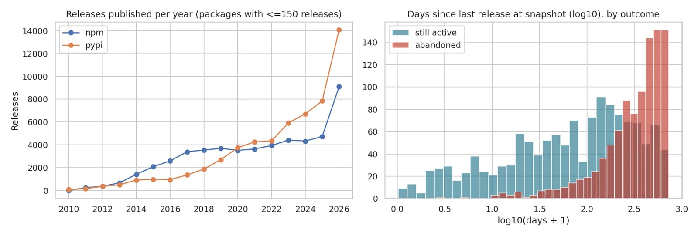
Figure 1: Releases published per year (left) and time since last release at the snapshot date, by outcome (right).

4. MongoDB / PyMongo Implementation

4.1 Architecture and collections
The pipeline has five stages. Each is a Python module that receives the same PyMongo database handle, and data move between stages through MongoDB collections. The database is called package_risk_analytics.
Stage | Module | Reads | Writes
0. Collect (optional) | collect_data.py | PyPI / npm APIs | data/package_releases.jsonl
1. Load | load_data.py | JSONL file | packages_raw (9,238)
2. Clean | clean_data.py | packages_raw | packages_clean (9,238), packages_quarantine (0), cleaning_log
3. Explore | explore_data.py | packages_clean | Indexes, aggregation results (JSON)
4. Features | preprocess.py | packages_clean | model_features (5,721)
5. Model | train_evaluate.py | model_features | model_results (8), predictions (1,252), risk_scores (2,798)

4.2 Connecting to MongoDB
db.py creates a MongoClient from the MONGO_URI environment variable (default mongodb://localhost:27017, or a MongoDB Atlas connection string) and checks the connection with a ping command.
client = MongoClient(MONGO_URI, serverSelectionTimeoutMS=3000)
client.admin.command("ping")
db = client["package_risk_analytics"]

4.3 Document design and loading
The raw layer stores each package as one document whose releases are an array of sub-documents. Publish times stay exactly as the registry returned them (strings). The clean layer holds validated dates (stored as real BSON dates), sorted by time, with derived summary fields.
{ "_id": "pypi:example-package",
"ecosystem": "pypi", "name": "example-package",
"releases": [ {"version": "0.1.0", "released_at": ISODate("2019-03-04...")},
{"version": "0.2.0", "released_at": ISODate("2019-08-19...")}, ... ],
"n_releases": 14, "first_release": ISODate(...), "last_release": ISODate(...),
"metadata": {"cleaned_at": ISODate(...), "collected_at": "2026-10-17T..."} }

coll = db["packages_raw"]
coll.drop() # makes the script re-runnable
for i in range(0, len(docs), 1000):
coll.insert_many(docs[i:i + 1000]) # batches of 1000 documents

4.4 CRUD operations
A scratch collection demonstrates the four CRUD operations without touching the project data:
coll.insert_one({"_id": "demo:pkg-a", "n_releases": 12}) # Create
coll.find({"n_releases": {"$gt": 10}}) # Read
coll.update_one({"_id": "demo:pkg-a"},
{"$set": {"n_releases": 13}}) # Update
coll.delete_one({"_id": "demo:pkg-c"}) # Delete

4.5 Indexes and queries
A unique compound index on (ecosystem, name) guarantees one document per package; further indexes support sorting by last release and filtering by number of releases.
clean.create_index([("ecosystem", 1), ("name", 1)], unique=True)
clean.create_index([("last_release", -1)]); clean.create_index("n_releases")
clean.count_documents({"last_release": {"$lt": datetime(2024, 10, 17)}}) # no release for 2+ years

4,749 of the 9,238 packages (51%) have not published a release since 17 October 2024: 3,453 of 6,733 PyPI packages and 1,296 of 2,505 npm packages.

4.6 Aggregation pipelines
The $unwind stage turns every element of the nested releases array into its own record, so releases can be counted per year and ecosystem directly in the database:
clean.aggregate([
{"$match": {"n_releases": {"$lte": 150}}},
{"$unwind": "$releases"},
{"$group": {"_id": {"y": {"$year": "$releases.released_at"}, "e": "$ecosystem"},
"releases": {"$sum": 1}}},
{"$sort": {"_id.y": 1, "_id.e": 1}}])

Year | PyPI releases | npm releases
2012 | 376 | 372
2015 | 986 | 2,092
2018 | 1,887 | 3,550
2021 | 4,269 | 3,643
2024 | 6,715 | 4,338
2025 | 7,856 | 4,732
Table 1: Releases published per year (aggregation result; the 277 packages with more than 150 releases are left out of this query to keep $unwind light).
A second pipeline groups packages by ecosystem and reports the number of packages, the average number of releases and the maximum:
Ecosystem | Packages | Avg. releases | Max. releases
npm | 2,505 | 90.5 | 9,148
pypi | 6,733 | 10.7 | 1,132
Table 2: Packages per ecosystem (aggregation result).

4.7 Storing features, results and risk scores
The engineered features are written to MongoDB as documents (one per package and snapshot date) and read back for training, so the model genuinely depends on the database. After training, metrics go to model_results, test predictions to predictions, and a risk score with reasons for every package that is active today to risk_scores:
{ "_id": "pypi:example-package", "ecosystem": "pypi", "risk": 0.94, "risk_band": "high",
"reasons": [ {"factor": "time since last release vs usual gap", "value": 595.5,
"effect": "raises risk", "weight": 0.964}, ... ] }

5. Data Preprocessing

5.1 Cleaning the release timelines
clean_data.py reads the raw layer from MongoDB, validates every release, writes the clean layer and records every change in the cleaning_log collection. Registry data are fairly clean, so the number of problems found is small – but each rule is checked and counted.
Check | Result | Treatment
Publish date cannot be parsed | 98 releases | Release dropped
Date outside 1995 … collection date | 0 releases | Would be dropped
Duplicate version entries | 0 | Would keep the earliest
Package without any valid release | 0 packages | Would be moved to packages_quarantine
Packages with a single release | 2,443 packages | Kept in the clean layer, but not modelled (a gap between releases needs at least two)
Extremely large histories | 421 packages with more than 100 releases (up to 9,148) | Kept; the regression target is capped at 50 releases
Sampling bias and survivorship | npm sample is search-based; deleted packages are absent | Documented as a limitation; ecosystem is a model feature and results are reported per ecosystem

5.2 Defining the prediction problem without leaking the future
The models must predict the future from the past. For a chosen snapshot date T, every feature is computed only from releases published before T, and the outcome is read from the following 24 months (730 days):
- Eligible packages at T: at least two releases before T, first release at least 180 days before T, and at least one release in the 24 months before T. Packages that were already dead are excluded because predicting that they stay dead would be trivial.
- Classification target: abandoned = 1 if the package publishes no release in the 24 months after T, otherwise 0.
- Regression target: releases_next_24m = number of releases in the 24 months after T, capped at 50 (6.57% of training rows exceed the cap).
Information that exists only in today’s registry (for example the current “Development Status” classifier, download counts, or the current maintainer list) is deliberately not used, because it would leak knowledge from after the snapshot date into the features.

5.3 Features
22 features describe the release history before T:
Group | Features
Age and volume | age_days, n_releases, releases_per_year_life
Recency | since_last_days (days since the last release)
Recent activity | n_90d, n_180d, n_365d, n_730d (releases in the last 90/180/365/730 days), active_months_24m, trend_ratio (last 12 months vs the 12 before)
Rhythm | mean_gap, median_gap, std_gap, max_gap, last_gap (days between releases), overdue_ratio and overdue_ratio_recent (time since last release relative to the usual and the recent gap)
Version maturity | major_version, n_major_versions, is_stable (version ≥ 1.0), prerelease_share_recent
Ecosystem | is_npm

5.4 Train/test split
The split separates both time and packages. Training rows come from two snapshots (2021-10-17 and 2022-10-17) of 70% of the packages: 2,297 rows from 1,464 packages. Test rows come from a later snapshot (2024-10-17) of the other 30% of packages: 626 rows from 626 packages whose 24-month outcome window ends on the collection date. No package appears in both sets, and the test outcomes lie in the future of every training outcome. The share of abandoned packages is 42.7% in training and 45.8% in testing (287 abandoned test packages), so the classes are well balanced. The rate differs strongly between ecosystems: 58.6% for PyPI and 26.5% for npm in the test set.

5.5 Scaling and cross-validation
Counts and day-gaps are heavy-tailed, so Logistic and Linear Regression receive log(1 + x) transformed and then standardised features, inside a scikit-learn Pipeline so that the scaling is fitted on training data only. Decision Trees and Random Forests are insensitive to monotone transformations and use the raw features. Hyperparameters are tuned with 5-fold GroupKFold cross-validation in which all rows of one package stay in the same fold, so a package never appears in both a training and a validation fold.
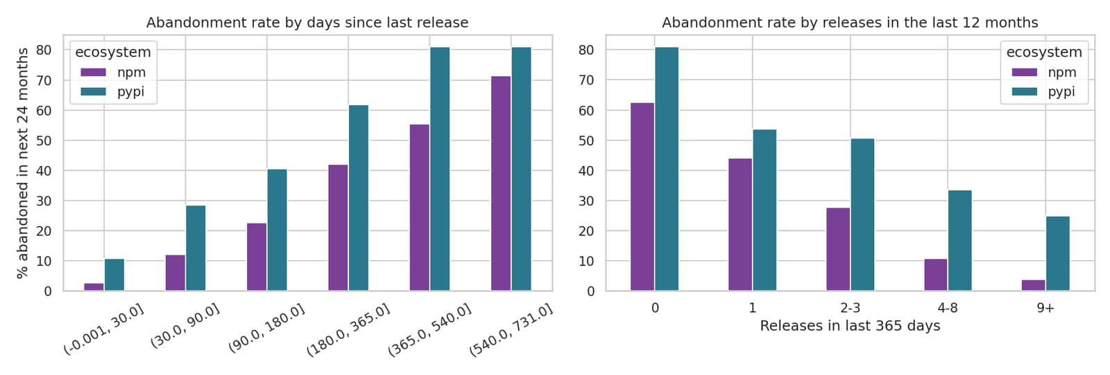
Figure 2: Abandonment rate by days since the last release (left) and by number of releases in the last 12 months (right), training data.
Figure 2 shows that the signal is strong and intuitive: the longer a package has been silent and the fewer releases it published recently, the more likely it is to publish nothing in the following two years. It also shows that PyPI packages are abandoned much more often than npm packages in this sample, at every level of recent activity.

6. Model Implementation

6.1 Models and baselines
Task | Model | Description
Classification | Baseline | Predict “abandoned” if the package had no release in the last 12 months (no learning).
Classification | Logistic Regression | Regularised linear model; log-transformed, standardised inputs; its coefficients make it explainable.
Classification | Decision Tree | Learns if/else splits on feature thresholds.
Classification | Random Forest | Ensemble of decision trees trained on bootstrap samples.
Regression | Baseline | Predict that the next 24 months will bring as many releases as the last 24 months (capped at 50).
Regression | Linear Regression | Least-squares fit on log-transformed, standardised inputs.
Regression | Decision Tree | Regression tree predicting the mean of each leaf.
Regression | Random Forest | Average of many regression trees.

The baselines encode what a developer would do without machine learning. A learned model is only worth using if it clearly beats them.

6.2 Training and tuning
pipe = Pipeline([("prep", scaled_prep()),
("model", LogisticRegression(max_iter=5000, random_state=42))])
gs = GridSearchCV(pipe, {"model__C": [0.01, 0.1, 1, 10, 100]}, cv=GroupKFold(5),
scoring="f1", n_jobs=-1).fit(X_train, y_train, groups=train["package"])
pred = gs.best_estimator_.predict(X_test) # future snapshot, unseen packages, used once

Model | Task | Best hyperparameters
Logistic Regression | Classification | C=0.1
Decision Tree | Classification | max_depth=4, min_samples_leaf=40
Random Forest | Classification | max_depth=5, min_samples_leaf=5, n_estimators=300
Linear Regression | Regression | –
Decision Tree | Regression | max_depth=5, min_samples_leaf=20
Random Forest | Regression | max_depth=12, min_samples_leaf=5, n_estimators=300
Table 3: Hyperparameters chosen by grouped cross-validation (classification tuned for F1, regression for R²).

6.3 Evaluation metrics
Metric | Task | Meaning
Accuracy | Classification | Share of packages whose outcome (abandoned or active) is predicted correctly.
Precision | Classification | Of the packages predicted as abandoned, the share that really were abandoned.
Recall | Classification | Of the packages that really were abandoned, the share that were found.
F1-score | Classification | Harmonic mean of precision and recall; the main metric for model selection.
R² Score | Regression | Share of the variance of the number of releases that the model explains.
MAE | Regression | Average absolute error, in releases per 24 months.

7. Evaluation Results

7.1 Classification: will the package be abandoned?
Model | Accuracy | Precision | Recall | F1-score | ROC-AUC
Baseline: no release in last 12 months | 70.45% | 75.25% | 52.96% | 62.17% | –
Logistic Regression | 74.28% | 72.83% | 70.03% | 71.40% | 0.8326
Decision Tree | 73.00% | 70.34% | 71.08% | 70.71% | 0.8154
Random Forest | 74.12% | 71.33% | 72.82% | 72.07% | 0.8432
Table 4: Classification results on the test set (626 packages, 287 abandoned).
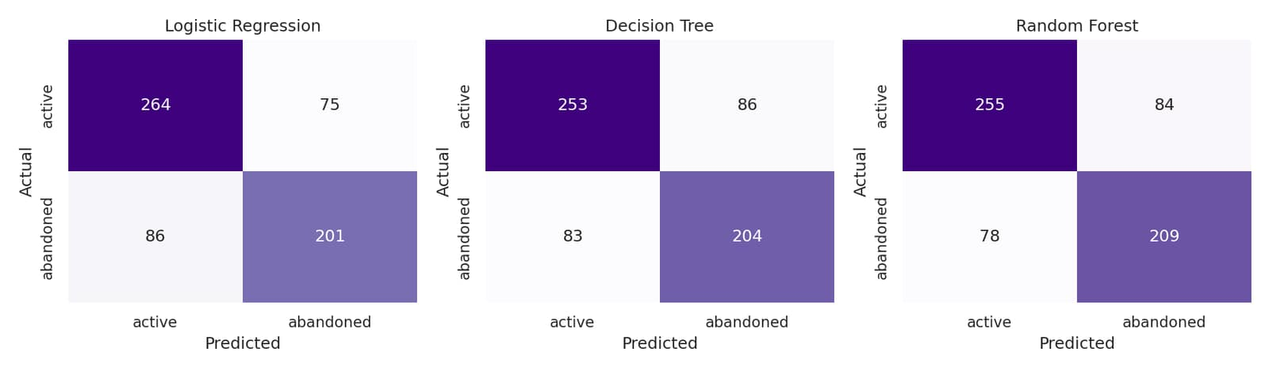
Figure 3: Confusion matrices of the three classifiers on the test set.
Model | True neg. | False pos. | False neg. | True pos.
Baseline: no release in last 12 months | 289 | 50 | 135 | 152
Logistic Regression | 264 | 75 | 86 | 201
Decision Tree | 253 | 86 | 83 | 204
Random Forest | 255 | 84 | 78 | 209
Table 5: Confusion-matrix counts (positive class = abandoned).
Interpretation. Random Forest has the best F1-score (72.07%) and ROC-AUC (0.8432); Logistic Regression has the best accuracy (74.28%) and is almost as good on every metric; the single Decision Tree is slightly behind (F1 70.71%). The learned models beat the rule “no release in 12 months” (F1 62.17%, accuracy 70.45%) mainly through recall: the rule is precise (75.25%) but misses almost half of the abandoned packages (recall 52.96%, 135 missed), whereas Random Forest finds 72.82% of them (78 missed) at the cost of more false alarms (84 instead of 50).
What the numbers do not say. An accuracy of about 74% means that roughly one prediction in four is wrong, so a high score is a warning sign and not a verdict. The improvement over the baseline is real but moderate (about 10 F1 points).
Ecosystem | Test packages | Abandoned | Best model: accuracy / F1 | Baseline: accuracy / F1
pypi | 377 | 58.6% | 73.47% / 76.64% | 65.52% / 64.29%
npm | 249 | 26.5% | 75.10% / 59.21% | 77.91% / 56.00%
Table 6: Results by ecosystem for the best classifier (Random Forest) and the baseline.
The model helps most on PyPI (F1 76.64% against 64.29% for the rule). On npm, where only 26.5% of packages are abandoned, the model improves F1 only slightly (59.21% against 56.00%) and its accuracy (75.10%) is actually lower than that of the simple rule (77.91%). This is a useful limitation to state openly.
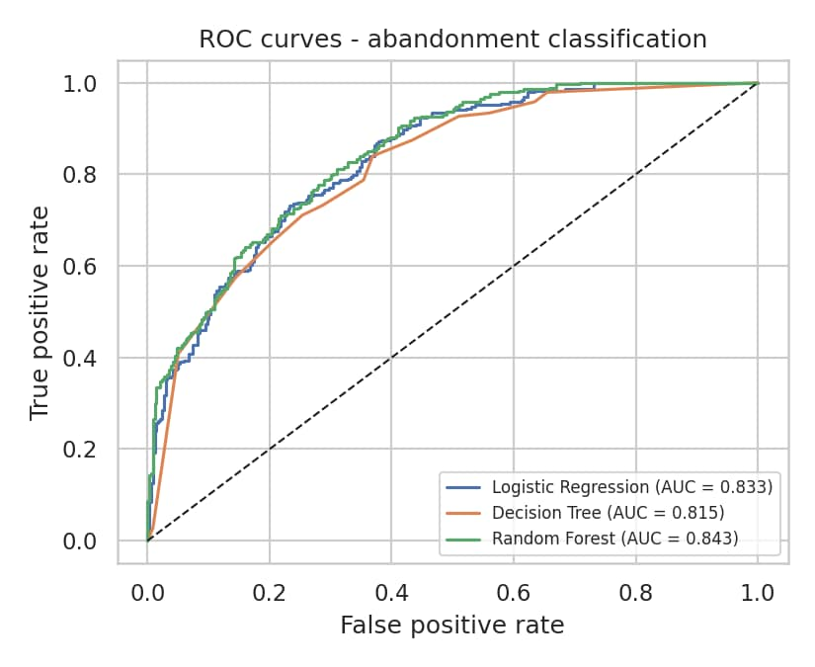
Figure 4: ROC curves of the three classifiers.

7.2 Regression: how many releases will the package publish?
Model | R² Score | MAE (releases) | RMSE (releases) | CV R²
Baseline: releases in last 24 months | 0.4210 | 6.52 | 11.21 | –
Linear Regression | 0.7050 | 4.68 | 8.00 | 0.6628
Decision Tree | 0.6816 | 4.40 | 8.31 | 0.6457
Random Forest | 0.7332 | 4.11 | 7.61 | 0.7183
Table 7: Regression results on the test set (mean target 7.72 releases, standard deviation 14.74, capped at 50).
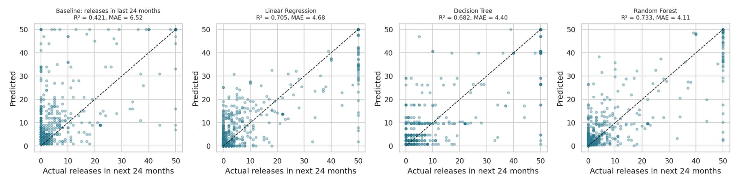
Figure 5: Actual versus predicted number of releases in the next 24 months (test set).
Interpretation. Random Forest is the best regressor (R² = 0.7332, MAE = 4.11 releases), followed by Linear Regression (R² = 0.7050, MAE = 4.68) and the Decision Tree (R² = 0.6816, MAE = 4.40). All three beat the baseline “the next 24 months will look like the last 24” (R² = 0.4210, MAE = 6.52) by a clear margin, which shows that the engineered features capture more than raw persistence. Figure 5 shows the main weakness: the capped target forms a column of packages at 50 releases, and a package that publishes dozens of releases (often automatically) is hard to forecast exactly.

7.3 Which features matter, and why a package is flagged
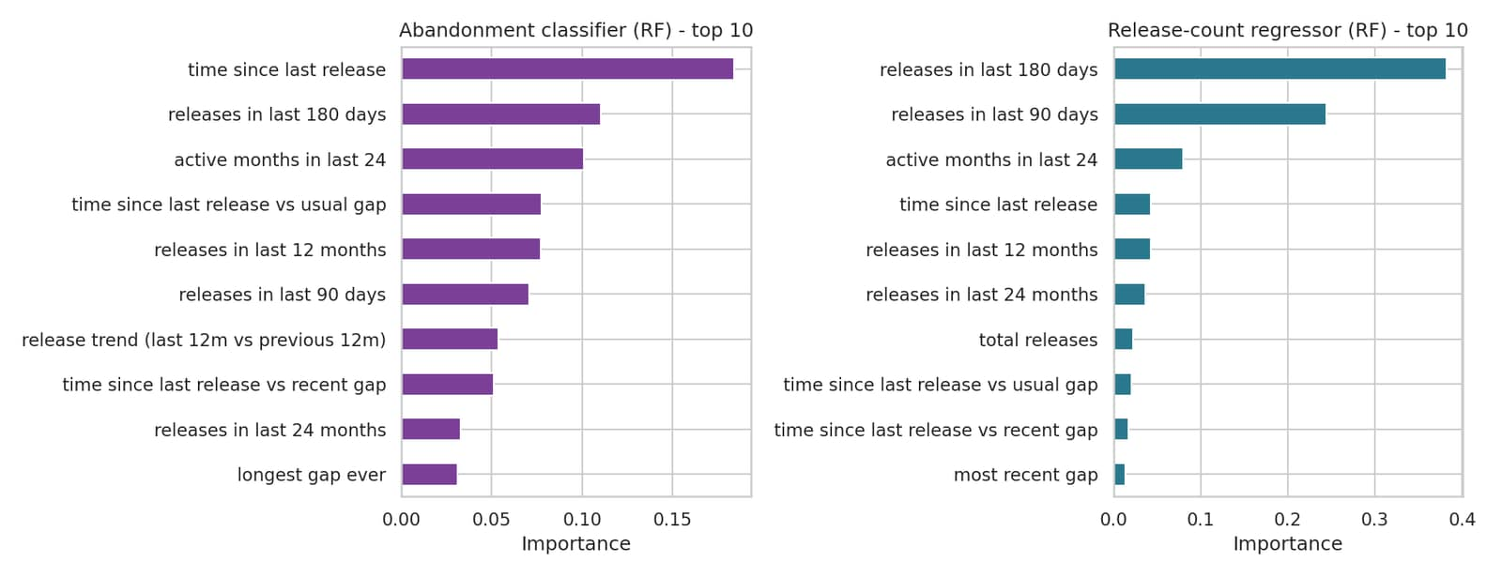
Figure 6: Random Forest feature importances for classification (left) and regression (right).
For abandonment, the most important Random Forest features are the time since the last release (importance 0.1845), the releases in the last 180 days (0.1106) and the number of active months in the last two years (0.1011). For the release count, recent activity dominates (releases in the last 180 days 0.3818, in the last 90 days 0.2444). The Logistic Regression coefficients, which can be read directly, agree: more active months lower the risk (coefficient -0.819), while being overdue relative to the usual release gap (0.505) and a long silence (0.377) raise it. Importance describes what the model uses, not what causes abandonment.

7.4 Risk scores for packages that are active today
The best classifier was applied to the 2,798 packages in the sample that are active today (a release in the last 24 months). The scores are stored in the risk_scores collection together with the three factors that contribute most to each score, taken from the Logistic Regression (coefficient × scaled feature value). A score of at least 0.66 is called high risk and below 0.33 low risk. 908 packages are high risk, 814 medium and 1,076 low. The shares differ strongly by ecosystem: 815 of 1,824 PyPI packages (45%) are high risk against 93 of 974 npm packages (10%), which reflects both the real difference in the data and the npm sampling bias described in Section 3.
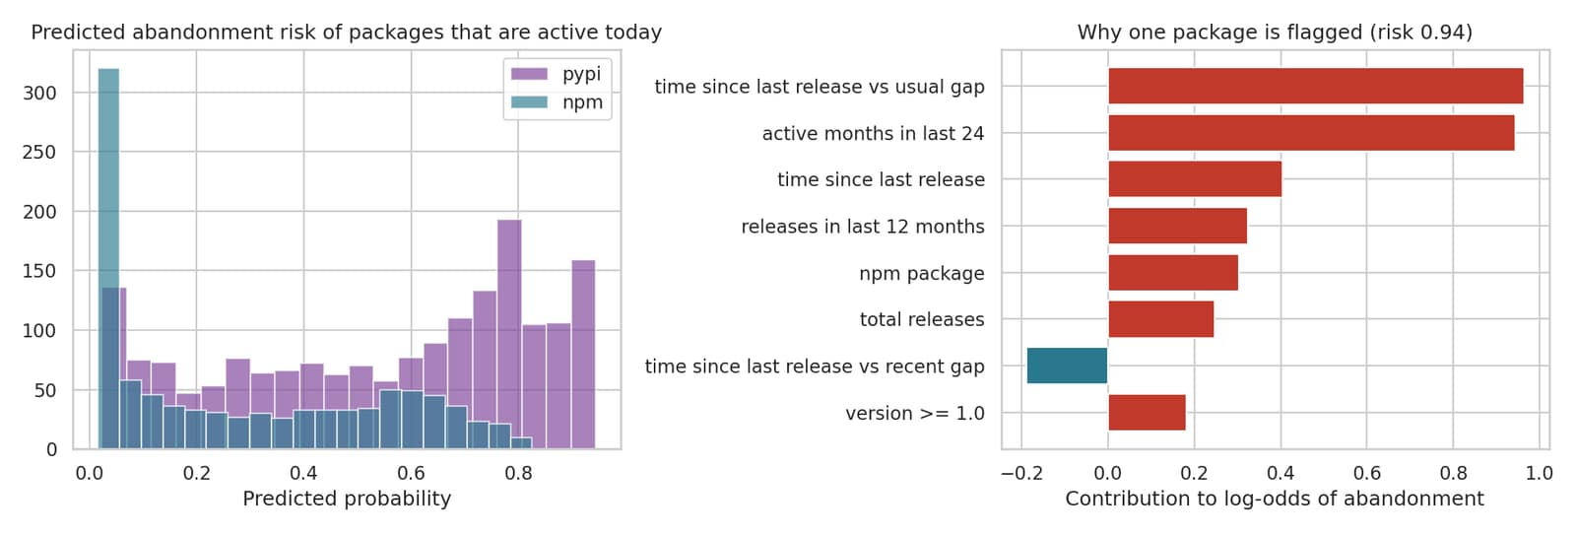
Figure 7: Distribution of risk scores (left) and the explanation of one flagged package (right; red bars raise the risk).
The right panel of Figure 7 shows the explanation for the package with the highest score (risk 0.9449, a pypi package). The strongest factors are: “time since last release vs usual gap” (value 595.49, raises risk); “active months in last 24” (value 1, raises risk); “time since last release” (value 635.44, raises risk). In plain words: the package has been silent for much longer than its own usual rhythm and was active in very few months of the last two years. Package names and scores are in outputs/risk_scores_all.csv; the scores are statistical estimates based on release history only and should be treated as a prompt to look more closely, not as a judgement about any project or its maintainers.

8. Conclusion
This project built a complete pipeline in which MongoDB stores the release histories of PyPI and npm packages as nested documents, keeps an audited raw-to-clean flow, answers questions with aggregation pipelines (including $unwind on the release arrays), stores the engineered features, and receives the model results, predictions and explainable risk scores.
- Classification: Random Forest predicted abandonment within 24 months with 74.12% accuracy, 71.33% precision, 72.82% recall and 72.07% F1-score on future snapshots of packages it had never seen; Logistic Regression was almost identical (accuracy 74.28%, F1 71.40%) and is easier to explain.
- Regression: Random Forest forecast the number of releases in the next 24 months with R² 0.7332 and MAE 4.11 releases, far better than the persistence baseline (R² 0.4210).
- Against the baselines: both tasks improved over the simple rules, but modestly for classification, and the classifier adds little on npm, where abandonment is rarer.
- Explainability: every score comes with its three main reasons, so a developer can judge whether a flag makes sense.
Limitations. Abandonment is defined as 24 months without a release, which is a proxy: some mature packages are finished and need no updates, while others are maintained without releasing. Only release timelines are used – no commits, issues, maintainer changes, dependents or download history – so signals that matter in practice are missing. The npm sample is search-based and the registries only contain packages that survived, so the abandonment rates are not estimates for the ecosystems as a whole. The test set is a single future snapshot of 626 packages. Accuracy around 74% means the scores are indicators, not verdicts.
Future work. Adding repository activity (commits, issue response times) and historical dependents, which would need authenticated API access; training per-ecosystem models; using MongoDB time-series collections to refresh the data automatically; and exposing the risk scores through a small API that scans a project’s requirements file or package.json.

References
Python Software Foundation. PyPI JSON API and Simple Index (project index and release metadata). https://pypi.org
npm, Inc. npm registry API (package metadata, version publish times and search). https://registry.npmjs.org
Pedregosa, F., et al. (2011). Scikit-learn: Machine Learning in Python. Journal of Machine Learning Research, 12, 2825–2830.
MongoDB Inc. MongoDB Manual – CRUD operations, indexes and aggregation pipeline ($unwind, $group). https://www.mongodb.com/docs/manual/
MongoDB Inc. PyMongo documentation. https://pymongo.readthedocs.io/

Appendix A. Project Structure and How to Run
package_risk_project/
data/package_releases.jsonl downloaded release timelines (9,238 packages)
config.py settings (URI, collections, snapshot dates)
db.py PyMongo connection
collect_data.py step 0 (optional): download from PyPI / npm
load_data.py step 1: JSONL -> raw documents
clean_data.py step 2: validation, quarantine, cleaning log
explore_data.py step 3: CRUD, indexes, aggregations ($unwind)
preprocess.py step 4: snapshot features stored in MongoDB
train_evaluate.py step 5: models, metrics, risk scores -> MongoDB
run_all.py runs steps 1-5
outputs/ results (CSV, JSON, text), risk_scores_all.csv, figures
report/ this report

pip install -r requirements.txt
export MONGO_URI="mongodb://localhost:27017" # start mongod first
python run_all.py # about 5-10 minutes
python collect_data.py # optional: refresh the data from the registries

The random seed is fixed (42). The dataset file is included, so results are reproducible without downloading anything.

Appendix B. Presentation Notes
One-sentence pitch: “It tells a development team which of their open-source dependencies are likely to stop being maintained within two years, and explains why.”
Likely question | Short answer
Why MongoDB? | Each package has a variable-length list of releases (1 to 9,000+). A document holds it naturally and $unwind analyses it without joins.
Why is this not just a generic dataset? | The data were collected live from two public registries and built into a forecasting problem; it was not downloaded from a competition site.
How do you avoid cheating with future information? | Features use only releases before the snapshot date; the test snapshot is later than all training snapshots; test packages are never in training; today-only metadata is not used.
How good is it? | Classification accuracy 74.12%, F1 72.07%; regression R² 0.7332. Better than simple rules, but not perfect – scores are warnings, not verdicts.
What is the biggest weakness? | Abandonment is defined by missing releases only, and the npm sample is biased towards discoverable packages.
What would you add next? | Commit and issue activity from GitHub, historical dependents, and a small API to scan a requirements file.

