DOCUMENT UPLOAD MANUAL

Step 1: Open url: <http://copyright.gov.in/UserRegistration/frmLoginPage.aspx>

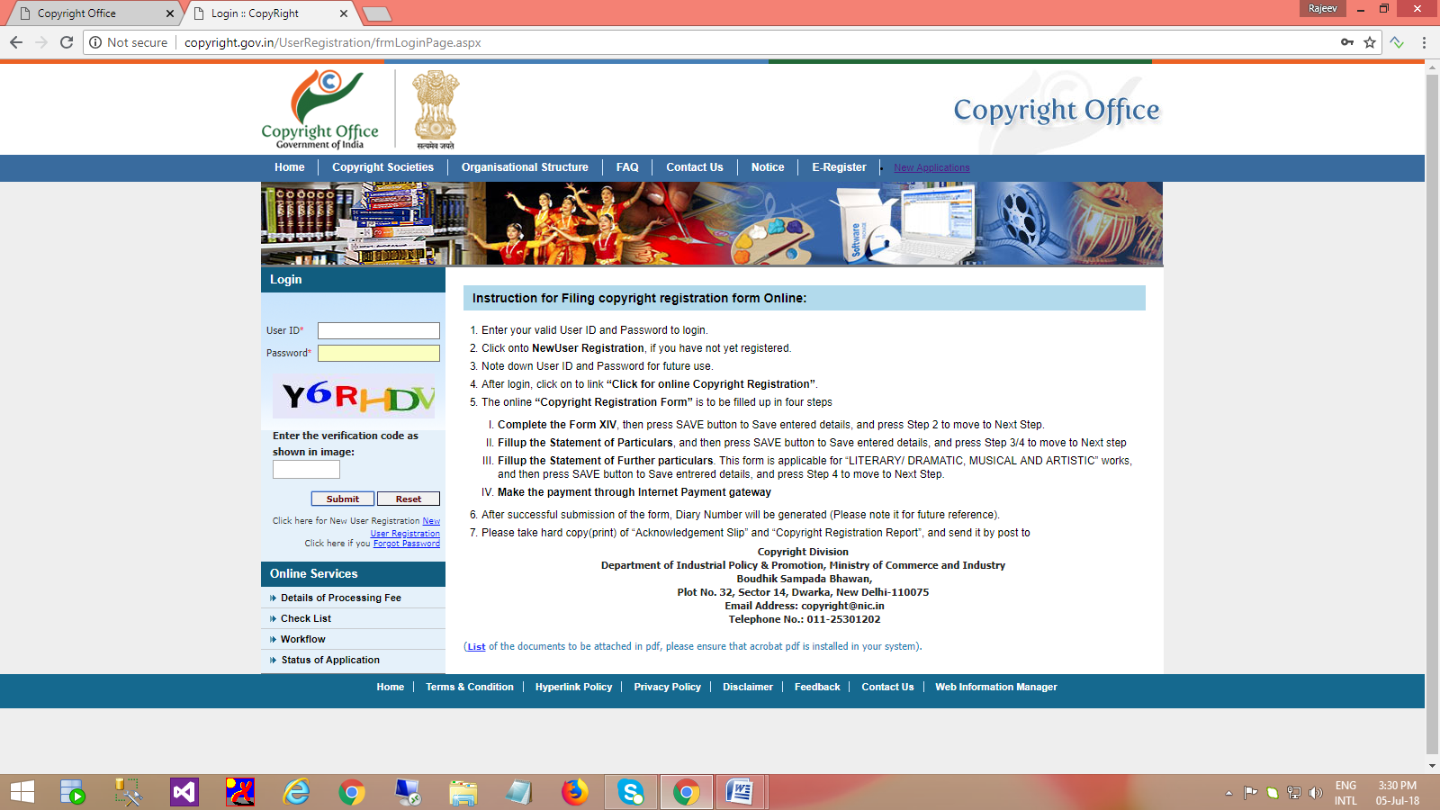

Step 2: Login with valid credential, Click on [**Upload Discrepancy Reply**](http://10.199.2.15/copyright/Discrepancy_Reply/Upload_Discrepancy_Reply.aspx) (left side menu list)

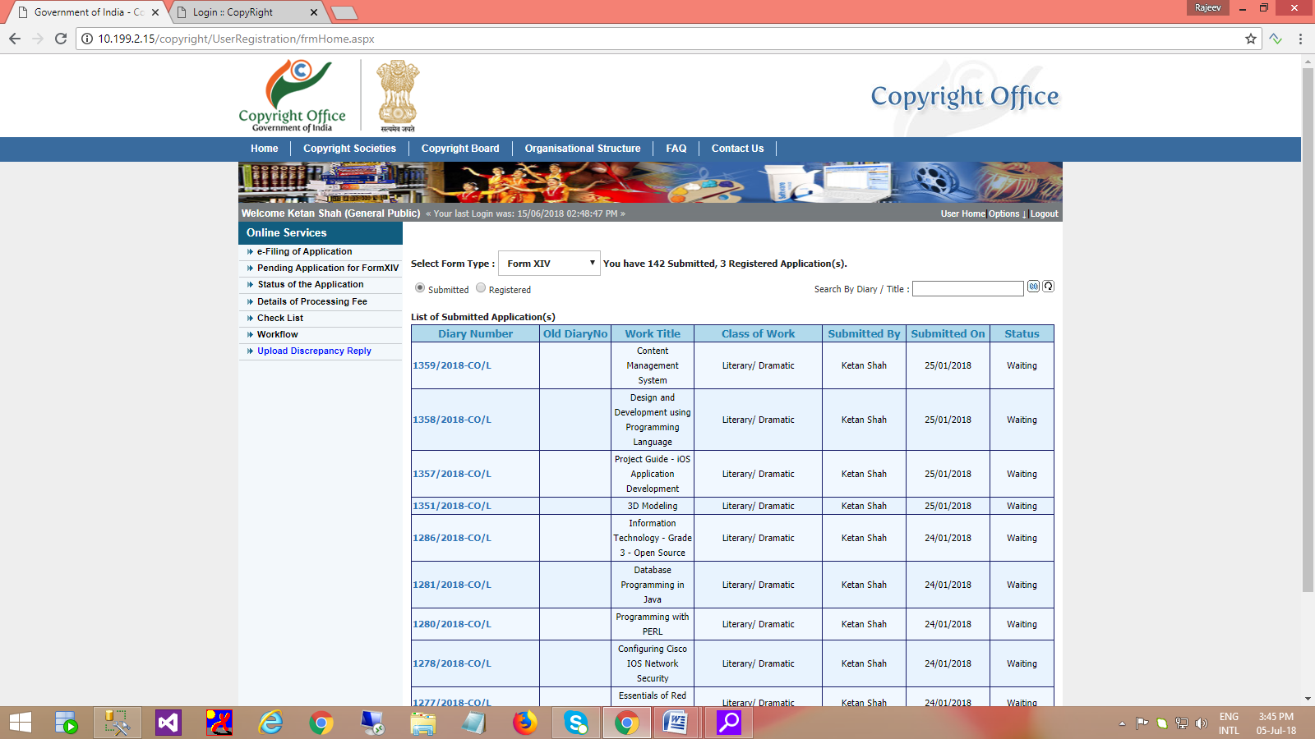

Step 3 : Applicant can view discrepancy letter using [View D.L.](javascript:__doPostBack('ctl00$ContentPlaceHolder1$gvDiscrepancyDetails$ctl02$btnTimeLap','')) Link

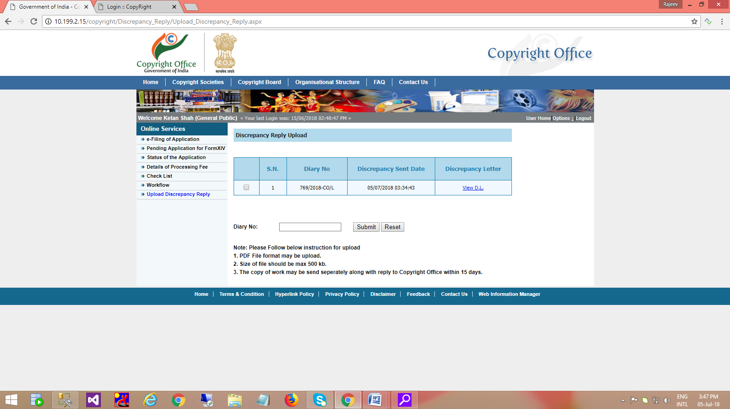

Step 4: Click check box for upload document for particular diary number

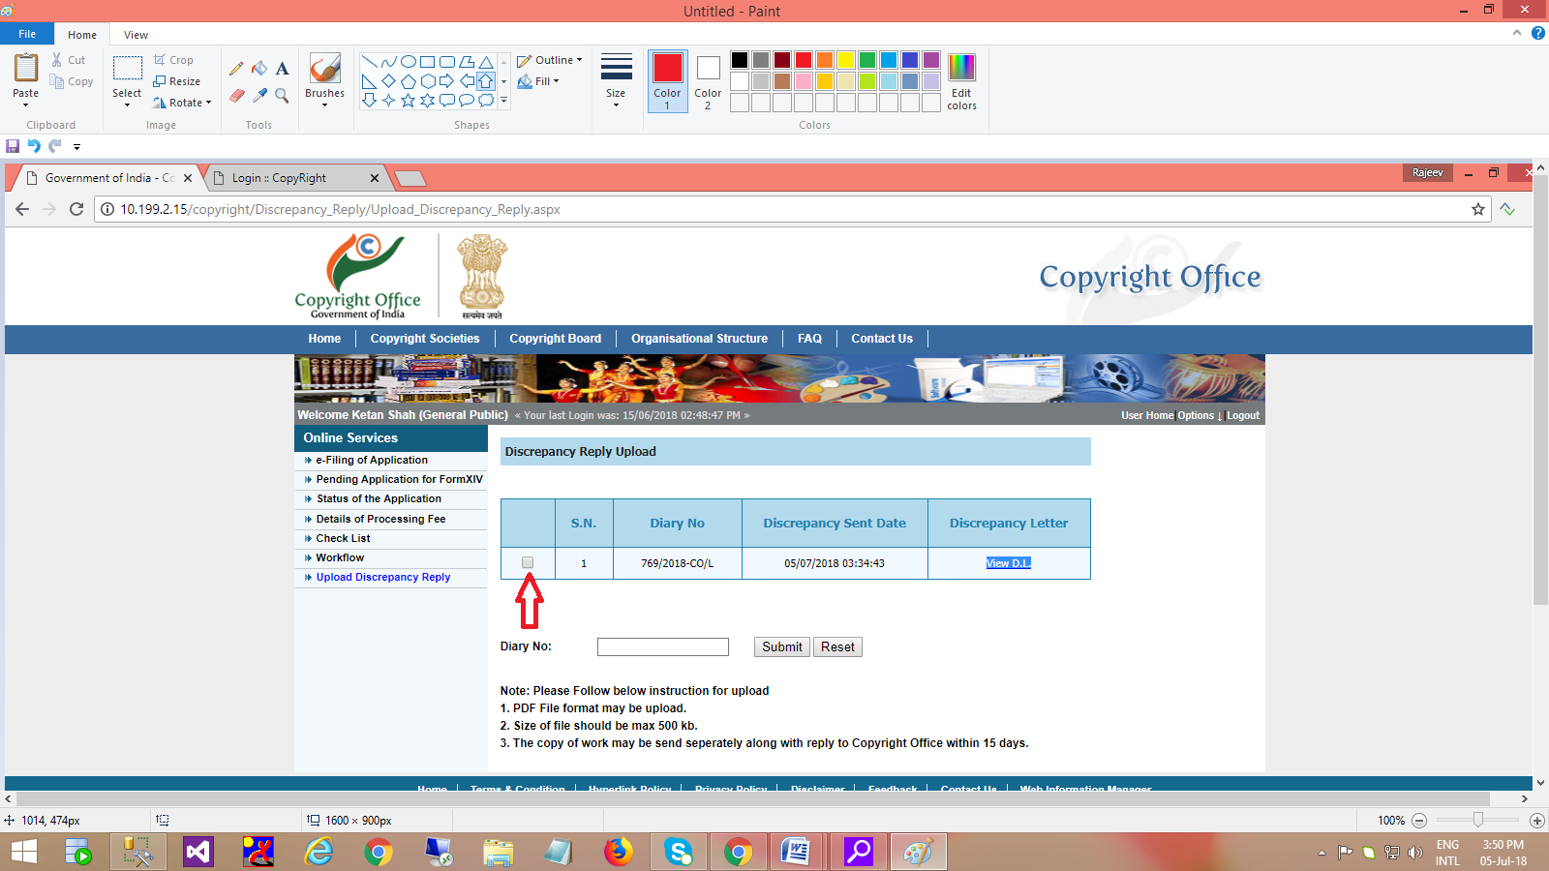

Step 5: After clicking on the check box, open option to upload document.

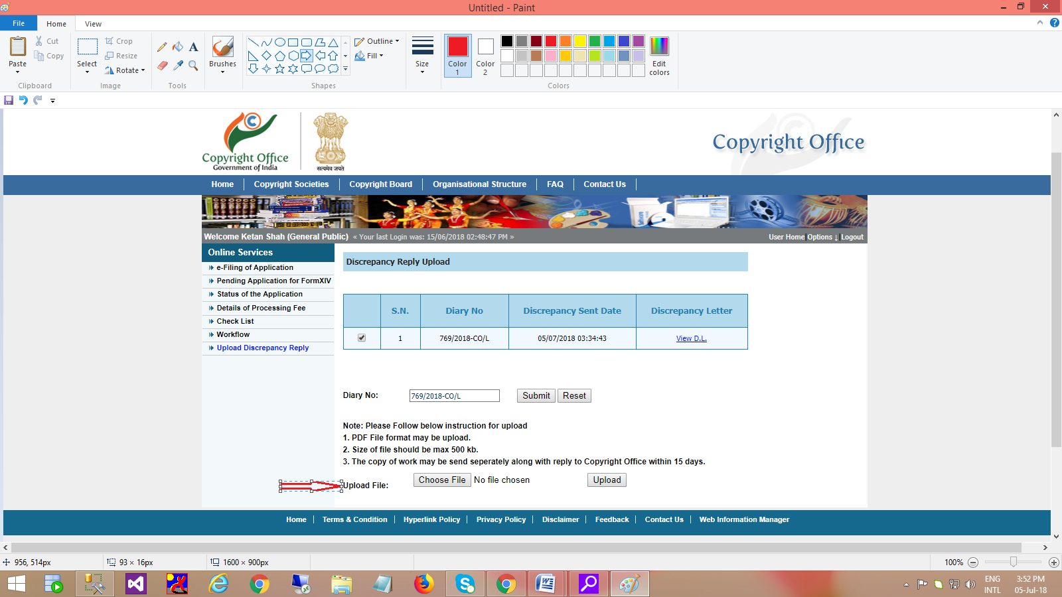

Step 6: Choose appropriate pdf document and click on upload button to upload the document.



