Report on What I Learned in My First Lecture on Power BI

* **What is Power BI?**

**Power BI** is a business analytics tool developed by Microsoft that allows users to visualize data and share insights across an organization. It connects to various data sources, transforms data, and creates interactive dashboards and reports to help in decision-making.

* **Uses of Power BI:**
* **Data Visualization**: Create compelling dashboards and reports with interactive charts and graphs.
* **Data Transformation**: Clean and shape raw data to prepare it for analysis.
* **Integration**: Connect to various data sources like Excel, SQL Server, APIs, and more.
* **Collaboration**: Share dashboards and reports with others in your organization via the Power BI Service.
* **Real-Time Analytics**: Monitor real-time data streams to make instant decisions.
* **ETL (Extract, Transform, Load)**

ETL is a process used in data integration to prepare data for analysis.

**Extract**: Data is gathered from various sources like databases, files, or APIs.

**Transform**: The data is cleaned, formatted, and structured to meet business or analysis requirements.

**Load**: The processed data is stored in a target system like a data warehouse or Power BI for further analysis.

* **Introduction to the Power BI Interface**

1. **Canvas (Report View):**

* **Purpose**: This is where you build and design your visualizations (charts, graphs, tables, etc.).
* **How to Use**: Drag fields from the data pane onto the canvas to create visuals like bar charts, pie charts, or maps.

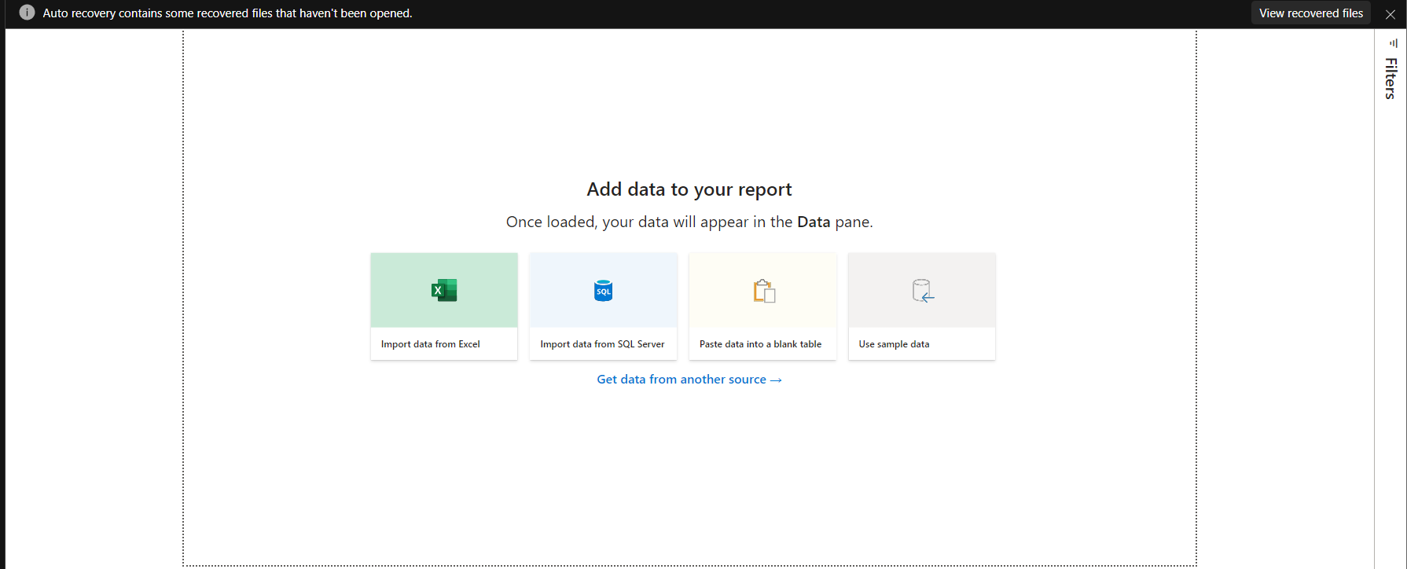

1. **Table View:**

* **Purpose**: Displays the raw data tables you imported into Power BI.
* **How to Use**: Navigate to the **Table icon** on the left. You can view data row by row.

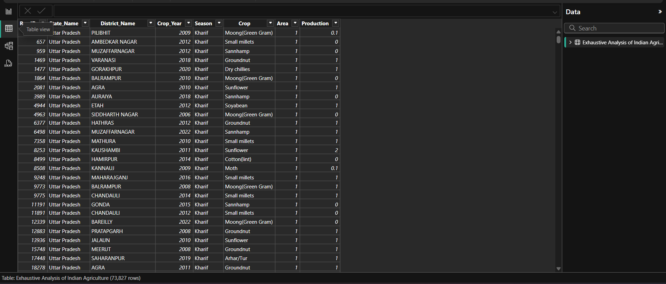

1. **Model View:**

* **Purpose**: Shows the relationships between different tables in your data model.
* **How to Use**: Use this view to define relationships between tables (e.g., one-to-many).
* **Key Tabs and Their Functions**

1. **Visualization Pane:**

* Contains all the available visualizations.

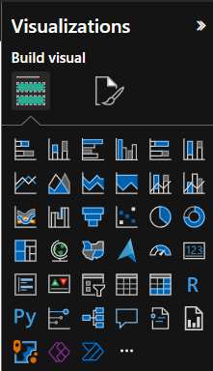

1. **Get Data Tab:**

* **Purpose**: Import data from various sources like Excel, databases, or online services.
* **How to Use**: Click on **Get Data**, select the source, and follow the prompts to import the data.

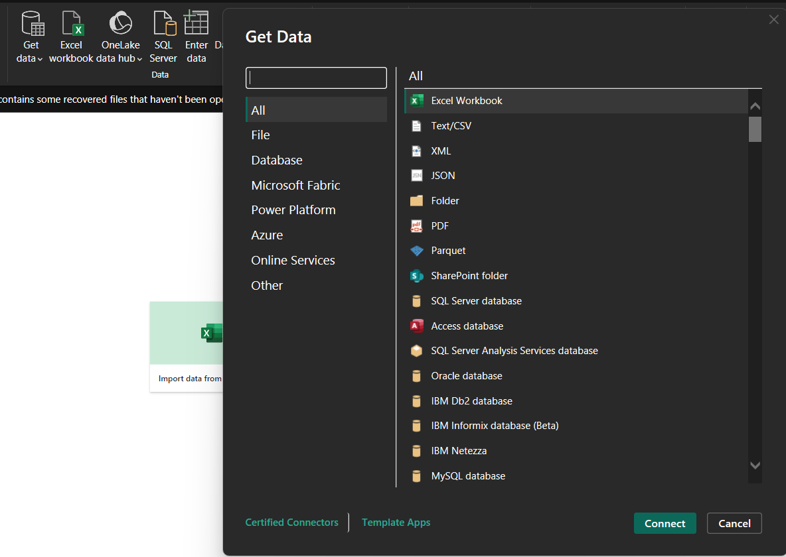

1. **Transform Data Tab:**

* **Purpose**: Opens the Power Query Editor for cleaning and transforming raw data.
* **How to Use**: Click **Transform Data**, then apply various operations like removing columns, filtering rows, or changing data types.

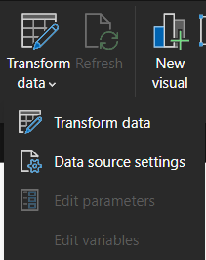

* **Important Data Transformation Tasks**
  1. **Remove Unnecessary Columns:**
* **How to Use:**
  1. Go to Transform Data in Power Query Editor.
  2. Right-click on the column you don’t need and select Remove.
  3. **Save ETL Data:**
* **ETL (Extract, Transform, Load):** A process of extracting data from source systems, transforming it (cleaning, aggregating), and loading it into a target system for analysis.
* **How to Save:** Click Close & Apply after transformations. This saves the changes to your Power BI model.
  1. **Applied Steps Pane:**
* **Purpose:** Tracks all the transformation steps you perform on your data (e.g., removing columns, filtering rows).
* **How to Use:**
  + You can edit or delete specific steps to adjust transformations.

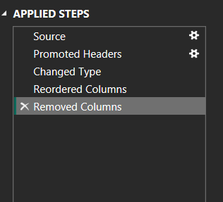

* 1. **Restore Deleted Columns:**
* **How to Use:**
  1. Go to the Applied Steps pane.
  2. Locate the step where the column was removed.
  3. Delete or modify that step to restore the column.
  4. **Check for Null Values:**
* **How to Check:**
  1. Use the Column Quality feature in Power Query Editor (visible at the top).
  2. It shows percentages of valid, error, and null data for each column.

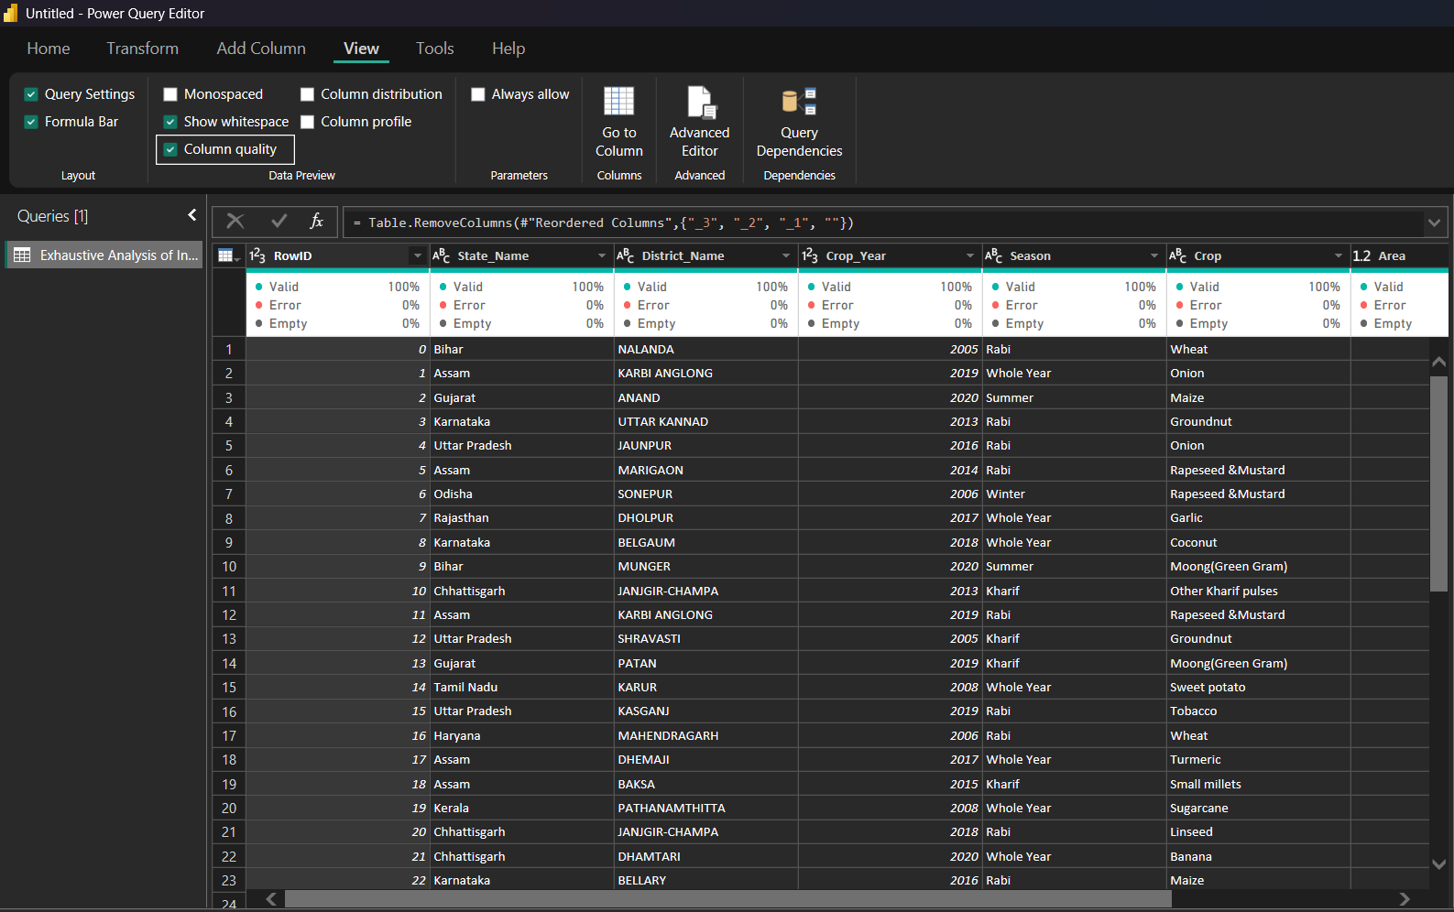

* 1. **Remove Rows Tab:**
* **How to Use:**
  1. Go to Transform Data.
  2. Select rows to remove (e.g., blank rows or rows with specific conditions).
  3. **Remove Duplicate Values:**
* **How to Use:**
  1. Highlight the column(s) where duplicates may exist.
  2. Right-click and choose Remove Duplicates.
  3. **Change Data Type:**
* **How to Use:**
  1. Select the column in Power Query Editor.
  2. Choose the appropriate data type (e.g., text, number, or date) from the ribbon at the top.
  3. **Close & Apply Option:**
* **Purpose:** Saves all transformation changes and applies them to the data model.
* **How to Use:**
  + After making transformations, click Close & Apply to load the cleaned data into the report view.