NIP Project — Submission Template
Pega Platform project · This document is your complete submission
Read this before you start:
1. Fill in Section 1 completely. The Pega application name must follow the format NIP-[Project]-[YourName].
2. Create a new Operator in Pega with your full name and log in as that operator before taking any screenshot.
3. When you create your test case, enter YOUR FULL NAME in the Issue Description (Vehicle) or Movie Name (Movie) field.
4. Complete only the section for your chosen project. Delete the other project section.
5. Paste one screenshot per user story (10 total). Follow the screenshot rules in your selected project section.
6. Answer every question in Sections 3 and 4 in your own words.
7. Save the file using this format: ProjectName_FirstName_LastName.docx. Use VehicleService or MovieTicket as the ProjectName. Examples: VehicleService_Ravi_Kumar.docx or MovieTicket_Ravi_Kumar.docx.

Section 1 — Your Details
Full Name | Vikash Vaibhav
Email ID (registered on NIP) | Vikashvaibhav66@gmail.com
Phone Number | 9263895214
College Name | Siksha O Anusandhan University
Course (e.g. IT, CS) | CSE
State | Odisha
Project Chosen (Vehicle Service OR Movie Ticket Booking) | Vehicle Service
Pega Application Name (e.g. NIP-VehicleService-YourName) | NIP-VehicleService-VikashVaibhav
Case Type Name (exact) | Vehicle Service Request, Vehicle Inspection, Generate Service Estimate, Approve Service Estimate, Maintain Vehicle Data, Review Service Estimate, Auto Assign Technician, Notify Service Completion, SLA Service, Route Service Request by Vehicle Type
Pega Instance URL | https://mqpi14on.pegaacademy.net/prweb/app/vehicle-service-management-application-1/
Operator Name (created in Pega with your full name) | VikashVaibhav

Section 2A — Vehicle Service Management Application
Complete this section only if you selected this project. Delete the other project section before submitting.

Screenshot rules — IMPORTANT before you start:
1. Name your Pega application as: NIP-VehicleService-YourName OR NIP-MovieTicket-YourName
2. Create a new Operator in Pega with your full name (Security → Operators) and log in as that operator.
3. When you create your test case, enter YOUR FULL NAME in the Issue Description (Vehicle) or Movie Name (Movie) field.
4. The logged-in operator name must be visible in every screenshot wherever the Pega interface displays it.
5. The student's full name must be visible in all running-case screenshots.
6. Configuration screenshots must clearly show the relevant application or rule name.
Screenshots that do not show these will not be accepted.

US-001 — Submit Vehicle Service Request
What is expected:
Case created, customer submits Vehicle ID, Vehicle Model, Issue Description. Validation applied.
Screenshot — paste your screenshot below this line:
[ Paste screenshot here - follow the screenshot rules above ]

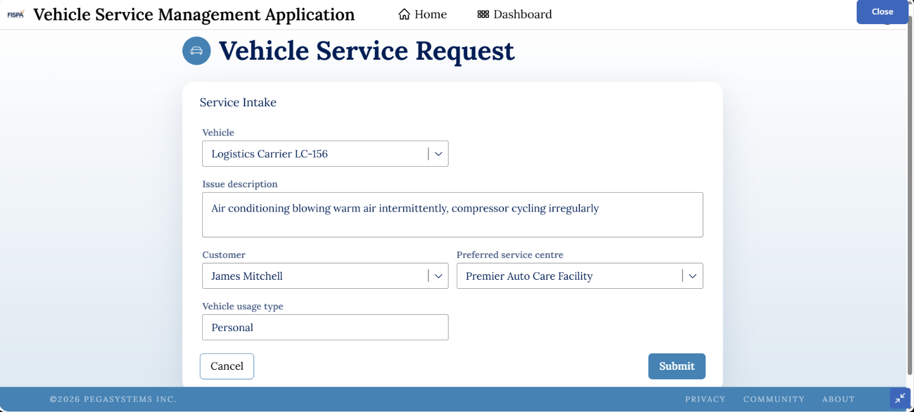

What I built for this (1–2 lines in your own words):
Built a service request case where customers enter Vehicle ID, Vehicle Model, and Issue Description to raise a service request.

US-002 — Perform Vehicle Inspection
What is expected:
Inspection stage with Service Advisor step. Inspection Notes and Condition Rating captured.
Screenshot — paste your screenshot below this line:
[ Paste screenshot here - follow the screenshot rules above ]
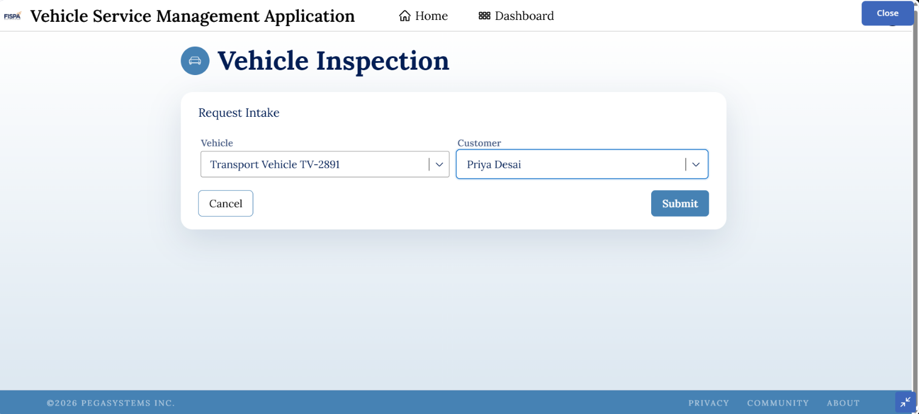

What I built for this (1–2 lines in your own words):
Added an Inspection stage where the Service Advisor records Inspection Notes and Condition Rating before the estimate is generated.

US-003 — Generate Service Estimate
What is expected:
Labor Cost and Parts Cost captured. Total Cost calculated automatically by declare expression.
Screenshot — paste your screenshot below this line:
[ Paste screenshot here - follow the screenshot rules above ]

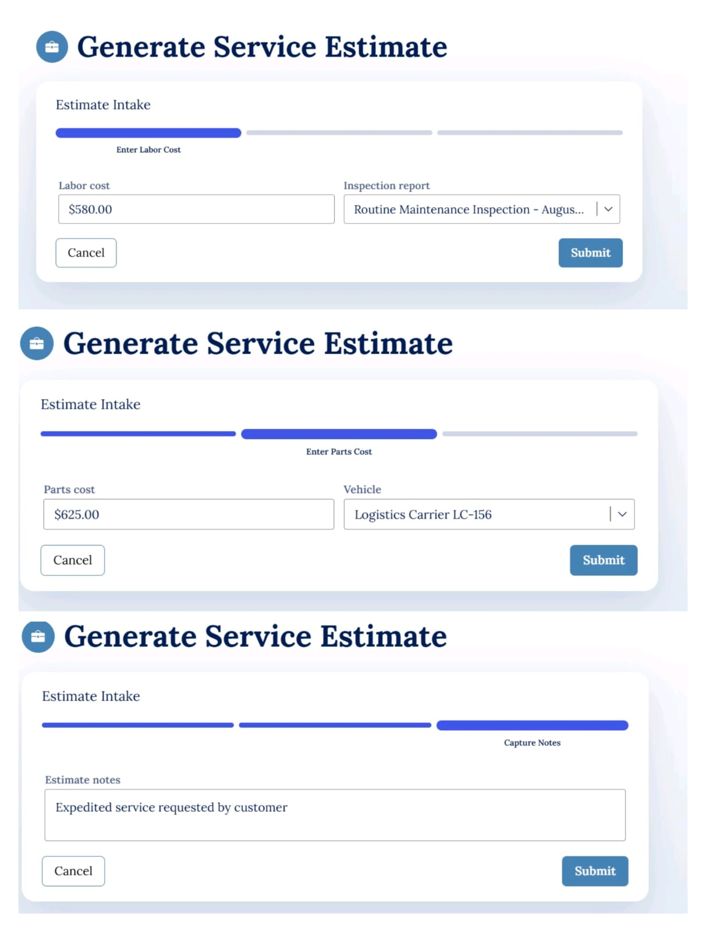

What I built for this (1–2 lines in your own words):
Added a service estimate step to capture Labor Cost and Parts Cost, with Total Cost calculated automatically.

US-004 — Approve Service Estimate
What is expected:
Approval stage assigned to Customer. Approval Status captured. Flow branches on approve/reject.
Screenshot — paste your screenshot below this line:
[ Paste screenshot here - follow the screenshot rules above ]

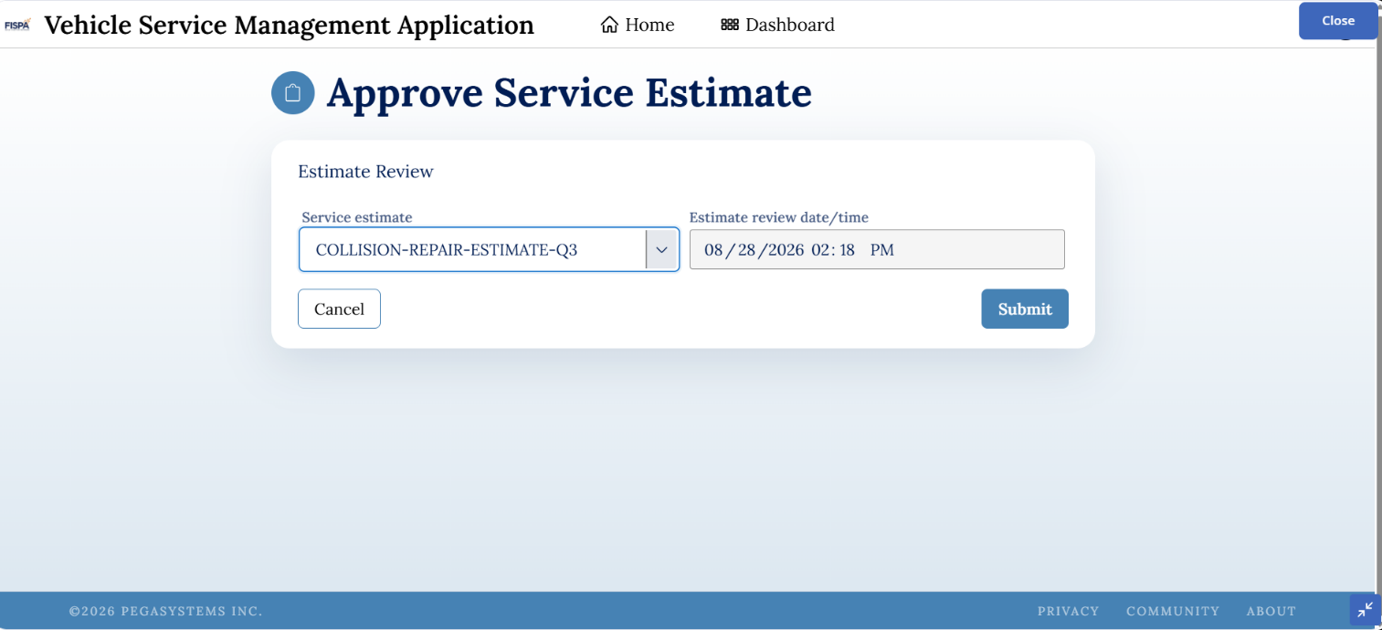

What I built for this (1–2 lines in your own words):
Added an Approval stage where the customer can approve or reject the service estimate, controlling whether the service proceeds.

US-005 — Maintain Vehicle Data
What is expected:
Reusable Vehicle data object created with Vehicle ID, Model, Type — linked to case.
Screenshot — paste your screenshot below this line:
[ Paste screenshot here - follow the screenshot rules above ]

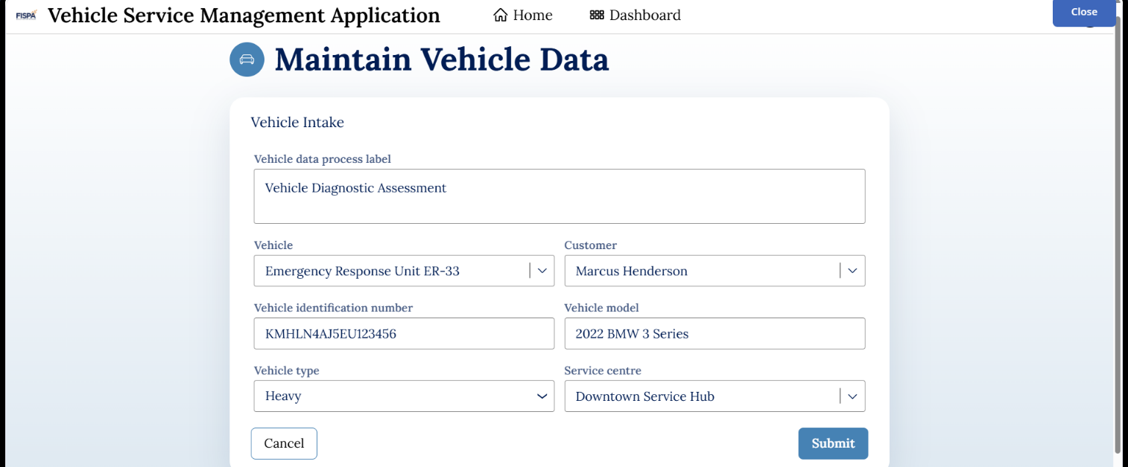

What I built for this (1–2 lines in your own words):
Created a reusable Vehicle data object containing details such as Vehicle ID, Model, and Type for use across service requests.

US-006 — Review Service Estimate
What is expected:
Approval screen shows Labor Cost, Parts Cost and Total Cost clearly to the Customer persona.
Screenshot — paste your screenshot below this line:
[ Paste screenshot here - follow the screenshot rules above ]

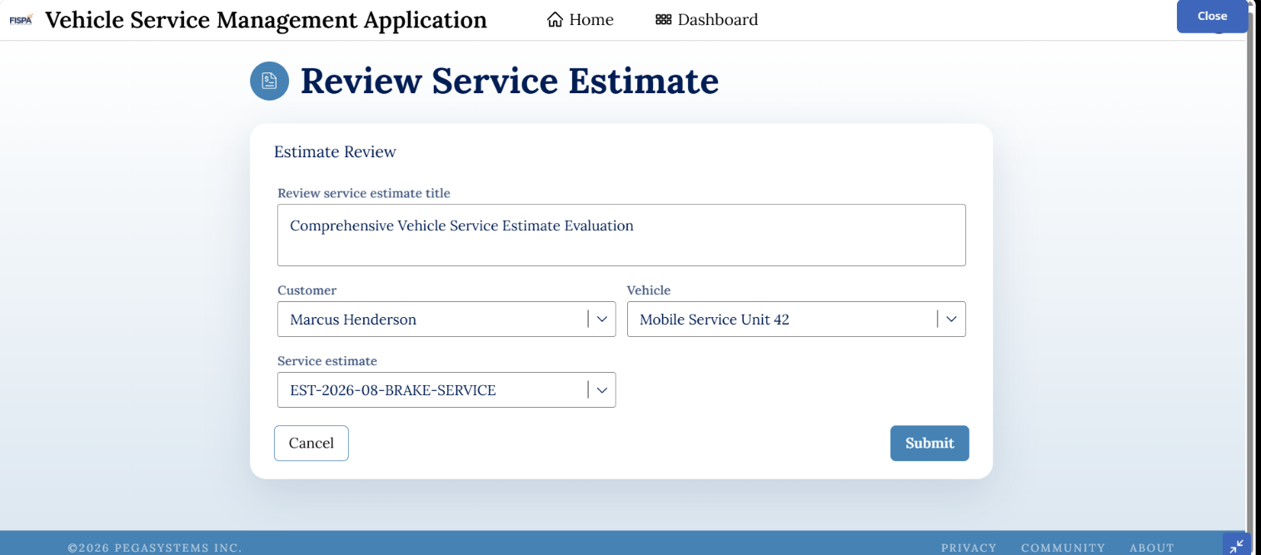

What I built for this (1–2 lines in your own words):
Configured the approval step to display Labor Cost, Parts Cost, and Total Cost clearly for customer review.

US-007 — Auto Assign Technician
What is expected:
Service Execution stage with routing to HeavyVehicleQueue or LightVehicleQueue. Assigned Technician and Service Status properties maintained.
Screenshot — paste your screenshot below this line:
[ Paste screenshot here - follow the screenshot rules above ]

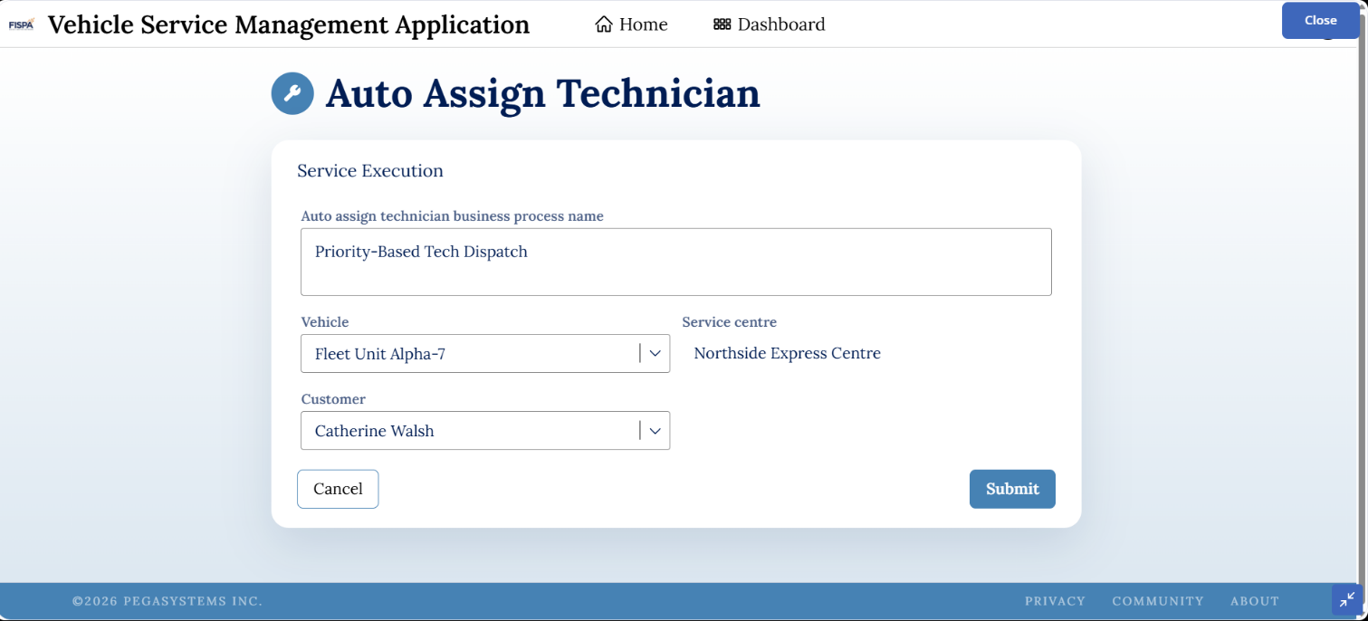

What I built for this (1–2 lines in your own words):
Added a Service Execution stage with automatic assignment of service tasks to a Technician or technician work queue.

US-008 — Notify Service Completion
What is expected:
Correspondence rule created and triggered on case resolution. Email includes case and vehicle details.
Screenshot — paste your screenshot below this line:
[ Paste screenshot here - follow the screenshot rules above ]

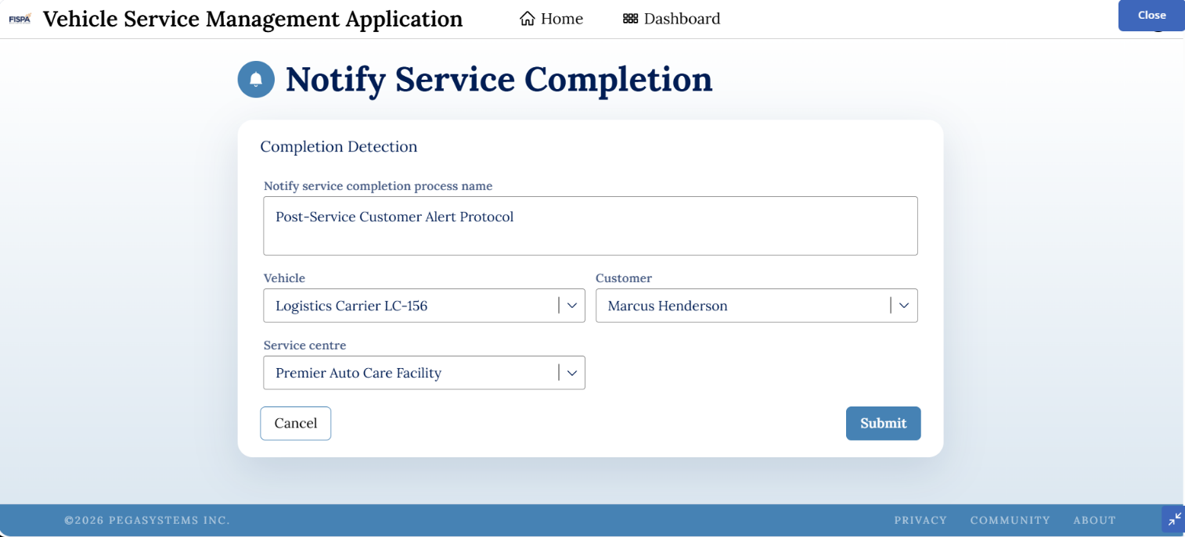

What I built for this (1–2 lines in your own words):
Configured a completion notification to the customer containing details such as Case ID, Vehicle ID, Vehicle Model, Service Summary, and Total Cost.

US-009 — Define Service SLA
What is expected:
SLA configured on the case type. Goal: 2 days. Deadline: 3 days. Priority increases on breach.
Screenshot — paste your screenshot below this line:
[ Paste screenshot here - follow the screenshot rules above ]

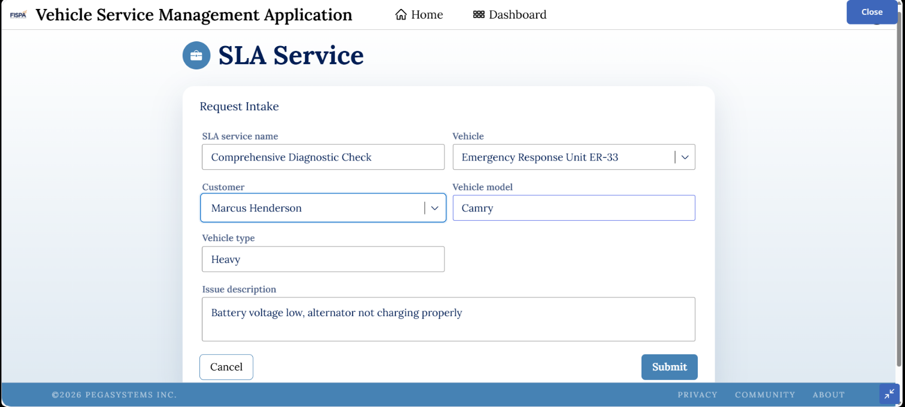

What I built for this (1–2 lines in your own words):
Configured an SLA with a 2-day goal and 3-day deadline, with priority increasing when the deadline is missed.

US-010 — Route by Vehicle Type
What is expected:
Routing rule or Decision Table routes to HeavyVehicleQueue or LightVehicleQueue based on Vehicle Type property.
Screenshot — paste your screenshot below this line:
[ Paste screenshot here - follow the screenshot rules above ]

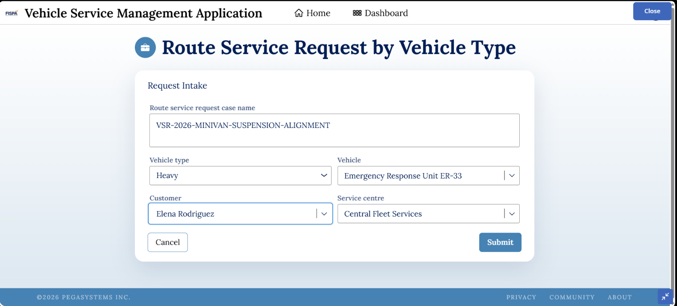

What I built for this (1–2 lines in your own words):
Configured automatic routing based on Vehicle Type, sending heavy vehicles to HeavyVehicleQueue and other vehicles to LightVehicleQueue.

