Department of Computer Science and Engineering
19CSE212 – Data Structures and Algorithms
Batch: 2021 – 2025

Semester: 4

_____________________________________

Case Study: FreeRTOS Analysis Report
_____________________________________

Team Name:Hash Heroes

Team Members:
Sl. No | Roll No. | Name
1. | CB.EN.U4CSE21401 | P.ABHIRAM
2. | CB.EN.U4CSE21414 | C.SAHITHEE VAIBHAV
3. | CB.EN.U4CSE21430 | K.MAHAMMAD SAMI
4. | CB.EN.U4CSE21439 | M.RAHUL
5. | CB.EN.U4CSE21458 | M.SRI MANJUNADH

Table of Contents

S.NO | Content | Page No
1. | Introduction | 3
2. | Overview of FreeRTOS Scheduler | 3-4
3. | Understanding the Ready List | 4-5
4. | Analyzing the Implementation of the Ready List | 5-7
5. | Detailed Examination of Ready List Operations | 8-10
6. | Integration of the Ready List with the Scheduler | 10-11
7. | Conclusion | 12
8. | References | 12

INTRODUCTION AND SIGNIFICANCE OF FREERTOS
FreeRTOS is a free and open-source real-time operating system (RTOS) designed for microcontrollers and small microprocessors. It is widely used in various embedded systems, including industrial control, medical devices, automotive systems, and consumer electronics. Developed by Richard Barry in 2003, FreeRTOS was created to meet the need for a lightweight, open-source RTOS capable of multitasking in resource-constrained environments.
The primary need for an RTOS arises from the limitations of general-purpose operating systems (GPOS). While GPOS handle task scheduling, resource management, and device drivers, they lack determinism in task scheduling. In real-life scenarios with strict deadlines, such as medical devices or engine controllers, missing a deadline can have catastrophic consequences. GPOS use a super loop architecture, which does not allow concurrent execution of tasks and can result in lag when handling user inputs or sensor data.
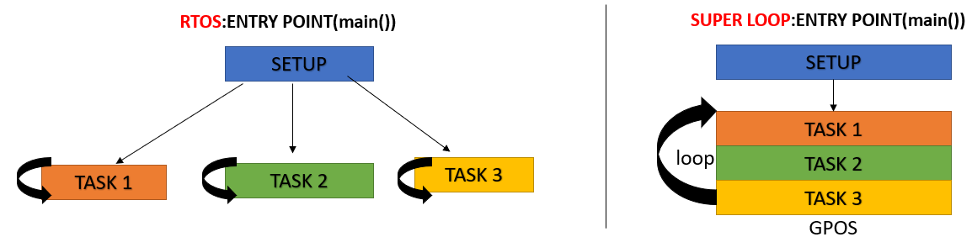
FreeRTOS overcomes these limitations by providing a real-time task scheduler, allowing multiple tasks to run concurrently. It also ensures:
- Multitasking: FreeRTOS allows multiple tasks to run concurrently on the same processor.
- Scheduling: FreeRTOS provides a scheduler that ensures that all tasks are scheduled to run in a timely manner.
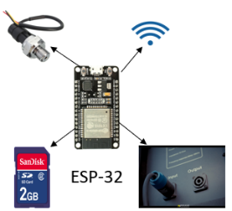
- Inter-task communication: FreeRTOS provides a number of mechanisms for tasks to communicate with each other, such as queues, semaphores etc
- Memory management: FreeRTOS provides a memory management system that ensures that tasks do not access each other's memory.
One real life example is ESP 32,taking input from user, reading into SD card, taking input from sensors etc all need tasks to work concurrently.
The report will begin with an introduction to FreeRTOS, highlighting its significance in real-time embedded systems and explaining key concepts such as multitasking and task scheduling. It will then focus on the implementation of the Ready List in the FreeRTOS scheduler, discussing its purpose and role. The report will provide a detailed analysis of the Ready List implementation, covering the data structure used, algorithms for task insertion and removal, and any optimization techniques employed for improved performance. Code snippets and diagrams may be included to illustrate these concepts.
Finally, the report will conclude by summarizing key findings and emphasizing the importance of understanding the Ready List implementation in FreeRTOS for developing efficient and reliable real-time embedded systems. It may also suggest potential areas for further research or improvements in the Ready List implementation.

- Overview of FreeRTOS Scheduler:

The FreeRTOS scheduler is responsible for managing tasks and their execution in a real-time embedded system. It determines which task should run based on their priorities and scheduling policies. The scheduler maintains a list of ready tasks and selects the highest priority task to execute. It uses preemptive scheduling, allowing critical tasks to interrupt lower priority tasks. The scheduler also handles context switching, ensuring smooth task transitions. Overall, the FreeRTOS scheduler plays a crucial role in efficient task management, prioritization, and resource allocation, enabling optimal system performance and responsiveness.

- Role of Readylist in Scheduler

1. Task Selection: The Ready List maintains a list of tasks that are ready to be executed. It serves as a repository of tasks that are waiting for CPU time. The scheduler uses the Ready List to determine which task should run next based on their priorities. By examining the priorities of the tasks in the Ready List, the scheduler selects the highest priority task for execution, ensuring that critical tasks receive timely CPU attention.

2. Task Prioritization: The Ready List allows tasks to be organized based on their priorities. Each task is assigned a priority level, and the Ready List enables efficient management of tasks with different priorities. The scheduler can quickly identify the task with the highest priority from the Ready List, ensuring that tasks with higher urgency or criticality are executed promptly.

- Preemption and Context Switching: The Ready List is crucial for implementing preemptive scheduling. When a higher priority task becomes ready, it can preempt a lower priority task currently running on the CPU. The Ready List enables efficient context switching between tasks, allowing the scheduler to save the context of the running task and restore the context of the newly selected task from the Ready List. This facilitates seamless switching between tasks and ensures that higher priority tasks can interrupt lower priority ones when necessary.
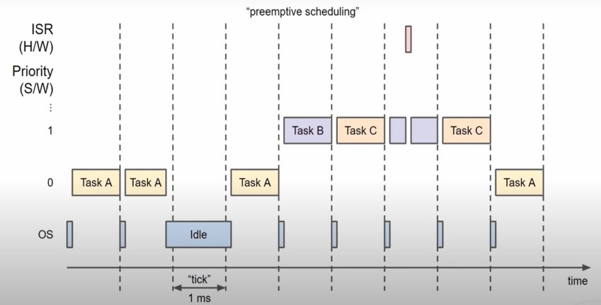
4. Resource Management: The Ready List helps manage system resources effectively. It allows the scheduler to make informed decisions about task execution and resource allocation based on task priorities. By maintaining the Ready List, the scheduler can ensure optimal utilization of system resources, such as CPU time, memory, and I/O devices, by prioritizing and scheduling tasks accordingly.

- Real-Time Responsiveness: The Ready List contributes to the real-time responsiveness of the system. It enables the scheduler to quickly identify the highest priority task that needs to be executed, ensuring that critical tasks meet their timing requirements. By efficiently managing the Ready List and scheduling tasks accordingly, the scheduler can provide a predictable and timely response to events and meet the timing constraints of real-time applications.

3.UNDERSTANDING THE READY LIST

FreeRTOS utilizes a "ready list" to keep track of tasks that are ready to run. The ready list is implemented as an array of task lists, with each list representing tasks of a specific priority.
static xList pxReadyTasksLists[ configMAX_PRIORITIES ]; /* Prioritised ready tasks. */
This data structure allows the scheduler to efficiently determine the highest-priority task for execution. By maintaining the ready list, FreeRTOS ensures that the most critical task with the highest priority is always given control of the processor.
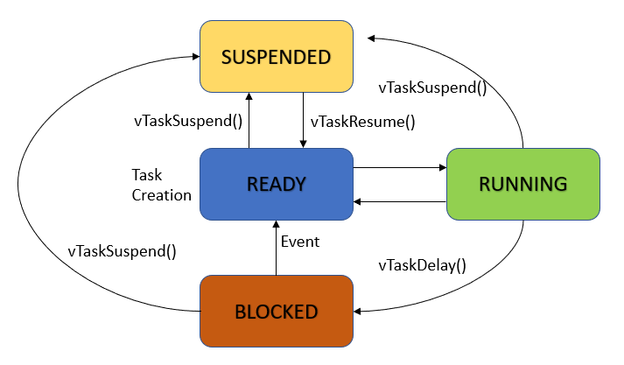
Tasks can either be in ready, running, blocked or suspended states. We might think each task has a variable to indicate what state it is in. But FreeRTOS tracks task state implicitly through four lists: ready, suspended, blocked, and running. Tasks are moved between these lists as their state changes, eliminating the need for explicit state variables. As a task changes from one state to another, FreeRTOS simply moves it from one list to another.
Running State: A task in the running state is currently executing and utilizing the processor. In a single-core system, only one task can be in the running state at a time, while multiple tasks can run simultaneously on different cores in a multi-core system. The running task continues execution until it voluntarily yields the processor or is preempted by a higher-priority task.
Ready State: Tasks in the ready state are prepared and eligible to run but are not currently executing. They are stored in the ready list, organized by priority. Tasks can enter the ready state when created, unblocked from a blocked state, or preempted by higher-priority tasks. The scheduler selects the highest-priority task from the ready list to transition it to the running state.
Blocked State: When a task enters the blocked state, it cannot proceed with execution due to a dependency or condition. Tasks can enter the blocked state for reasons such as waiting for a time delay, synchronization primitives (e.g., semaphore or mutex), or data availability in a queue. Blocked tasks are placed in specific data structures, such as the Delayed Task List, Event List, or Queue List, depending on the blocking condition. When the blocking condition is satisfied, the task transitions back to the ready state.
Suspended State: Suspended tasks are temporarily halted and removed from the task scheduling mechanism. They do not participate in task scheduling and do not consume processing time. Suspended tasks are moved to a separate Suspended Task List, distinct from the ready list and blocked task lists. Tasks can be suspended using the vTaskSuspend() API and resumed using the vTaskResume() API, transitioning them back to the appropriate state based on their conditions.
By effectively managing these different task states and utilizing the ready list, FreeRTOS provides a flexible and efficient task scheduling mechanism. It ensures optimal resource utilization, responsiveness, and meets real-time requirements in embedded systems.

4.Analyzing the Implementation of the Ready List:

In FreeRTOS, the data structure used for the Ready List is an array of linked lists. It represents a set of circular doubly linked lists. As we discussed earlier, the pxReadyTaskLists variable represents the Ready List, where each index corresponds to a specific priority level. For example, pxReadyTaskLists[0] contains the set of all task lists with priority 0, pxReadyTaskLists[1] contains the set of all task lists with priority 1, and so on. The size of pxReadyTaskLists is determined by the user-defined ConfigMaxPriority.

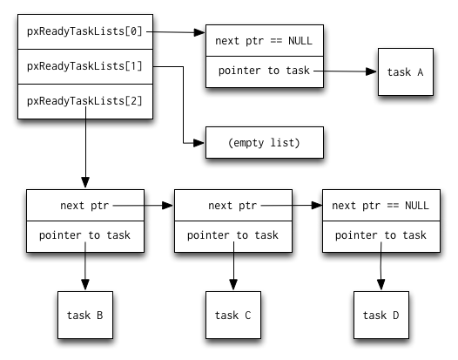

UMl Diag: Overview of the basic readylist
The example involves a Ready List, which represents task scheduling in a system. The Ready List consists of three priority levels: priority 0, priority 1, and priority 2. Each priority level is represented by a separate linked list. Please note that this is a simplified overview, and further details regarding the tasks and their attributes will be covered in subsequent parts of the report.

Set of TaskLists:
The FreeRTOS list is a circular doubly linked list with additional features. Each list element, represented by the xLIST_ITEM structure, contains several fields. The xItemValue field holds a value that typically represents the priority of a task or a timer value for event scheduling. The list is ordered in descending order based on the xItemValue, with the highest-priority item at the front and the lowest-priority item at the end.
The pxNext and pxPrevious fields are standard linked list pointers, establishing the connections between list elements. The pvOwner field is a pointer to the object, usually a Task Control Block (TCB), that contains the list item. This establishes a two-way link between the list item and its owner, enabling fast task switching by quickly accessing the TCB associated with the highest-priority task.
The pvContainer field points to the list in which the item is placed, allowing efficient determination of whether a list item is present in a specific list. Each list element can be included in a list, and the pvContainer field helps identify the list to which an item belongs.
Overall, the FreeRTOS list implementation facilitates efficient management and organization of tasks based on priority levels, enabling rapid task scheduling and control within the real-time operating system.
struct xLIST_ITEM
{
portTickType xItemValue; /* The value being listed. In most cases, this is used to sort the list in descending order. */
volatile struct xLIST_ITEM *pxNext; /* Pointer to the next xListItem in the list. */
volatile struct xLIST_ITEM *pxPrevious; /* Pointer to the previous xListItem in the list. */
void *pvOwner; /* Pointer to the object (normally a TCB) that contains the list item. There is therefore a two-way link between the object containing the list item and the list item itself. */
void *pvContainer; /* Pointer to the list in which this list item is placed (if any). */
};

.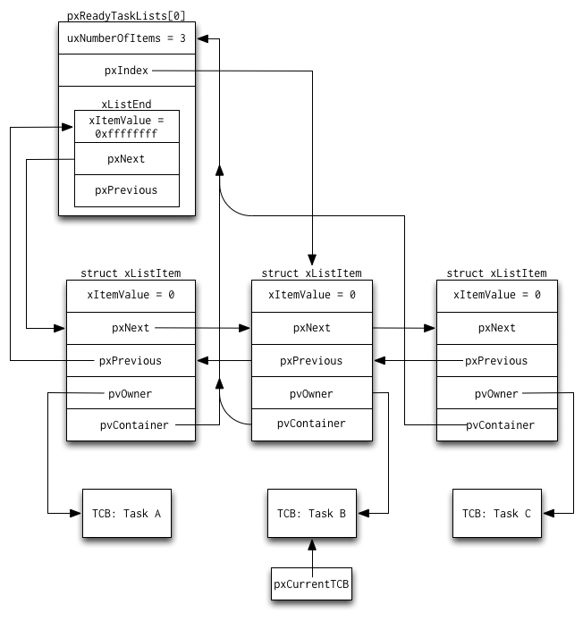
Uml-Diag 2:Complete view of readylist’s inner view
In the given uml diagram there are three tasks in the readylist[0] and each task has a tcb. each task is associated with the type of the doubly linked list the pointers are explained earlier and pxCurrentTCB is a pointer to the currently executing task's Task Control Block (TCB)pv index denotes the current task.

TCB(Task controlled block):
In FreeRTOS, the Task Control Block (TCB) is used to represent each task and contains essential information such as task state, priority, stack pointer, program counter, and context details. TCB enables efficient task switching and execution management by the FreeRTOS scheduler.

In addition to TCBs, FreeRTOS utilizes other data structures for task management, including queues. Queues facilitate data exchange between tasks and interrupts, operating in a First-In-First-Out (FIFO) mode with a defined capacity.
FreeRTOS also provides synchronization primitives like semaphores and mutexes. These primitives enable inter-task communication, coordination, and resource sharing, ensuring thread safety and preventing race conditions in multi-threaded environments.
Overall, FreeRTOS leverages TCBs, queues, semaphores, and mutexes to effectively manage tasks, facilitate inter-task communication, and ensure proper synchronization in real-time embedded systems.

The choice of a linked list data and other structures offers specific advantages.array-based lists allow efficient insertion and removal operations. This improves task management and scheduling in real-time systems. Insertion and removal at the head of the list have constant time complexity (O(1)), ensuring efficient task dispatching. However, operations such as task prioritization or searching for specific tasks may have linear time complexity (O(n)), which could potentially impact the overall efficiency of the scheduler.

5.Detailed Examination of Ready List Operations:
Taskswitchcontext:
The vTaskSwitchContext() function manages task switching in a multitasking system. It takes no arguments .It checks if the scheduler is suspended and sets a flag accordingly. Then it records information about the current task, calculates runtime statistics (if enabled), checks for stack overflow, selects the next task to run, and updates the Newlib reentrancy pointer(_impure_ptr).The time complexity of the function is mostly constant (O(n)), but the impact on scheduler efficiency depends on the specific implementations of undetermined operations.
The functions called/used are
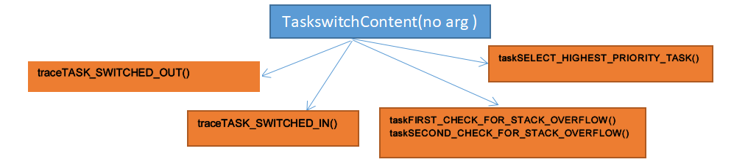
The function traceTASK_SWITCHED_OUT() or IN() in FreeRTOS is a hook or callback function that is called by the RTOS kernel whenever a task is switched out or suspended. It is typically used for system profiling and debugging purposes.complexity o(1)

Stackoverflow():The taskFIRST_CHECK_FOR_STACK_OVERFLOW() function is called periodically by the FreeRTOS kernel to check if the currently running task's stack has exceeded its allocated space. If a stack overflow is detected, the function triggers an error or warning complexity o(1)

When multiple tasks are ready to run, the scheduler needs to determine which task should be given the CPU time. The taskSELECT_HIGHEST_PRIORITY_TASK() function is invoked to identify the task with the highest priority from the Ready List. Complexity-o(n)

TOTAL-O(1)+O(1)+O(n)+O(1)+O(1)=O(n)

TaskRemove:
The `uxListRemove` function is used to remove an item from a linked list in FreeRTOS.The uxListRemove function takes a single parameter:pxItemToRemove: A pointer to the ListItem_t structure that represents the item to be removed from the linked list.
The ListItem_t structure typically contains fields such as pvContainer, pxNext, pxPrevious, and others, which are used to maintain the linked list structure and store information about each item in the list. The pxItemToRemove parameter allows the function to identify and remove the specified item from the list. The function updates the necessary pointers in the list to remove the item while maintaining the list's structure. It also updates the list index if needed and keeps track of the number of items in the list. The function returns the updated count of items in the list.

The time complexity of this function is constant o(1), meaning it is fast regardless of the list's size. With its constant time complexity the removal of an item from the list using uxListRemove does not introduce any significant delays or performance bottlenecks in most scenarios.
However, if the linked list becomes extremely large, the constant-time complexity may still result in a noticeable delay during list removal. In such cases, the impact on the scheduler's efficiency can be more pronounced.
Overall, the function is designed to efficiently remove items from the list while keeping the scheduler running smoothly.
The functions used are
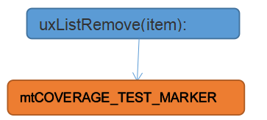

mtCOVERAGE_TEST_MARKER: A placeholder function or macro used for test coverage purposes. It doesn't perform any specific operation o(1)
Total-O(1)

Task Adding:
The prvAddTaskToReadyList macro is used in FreeRTOS to add a task to the appropriate ready list when it becomes ready to run.
It takes a Task Control Block (TCB) pointer pxTCB as a parameter, representing the task to be added.
The macro includes trace hooks or debugging functions to record the task's transition to the ready state and to track its priority.
It calls the vListInsertEnd function to insert the task's item at the end of the corresponding ready list based on its priority.
The prvAddTaskToReadyList macro in FreeRTOS has a constant time complexity, ensuring efficient task insertion regardless of the list size. It has minimal impact on the scheduler's efficiency, allowing for quick task scheduling and avoiding delays. Other factors such as task prioritization and context switching contribute to the overall scheduler's efficiency.
Functions Used:
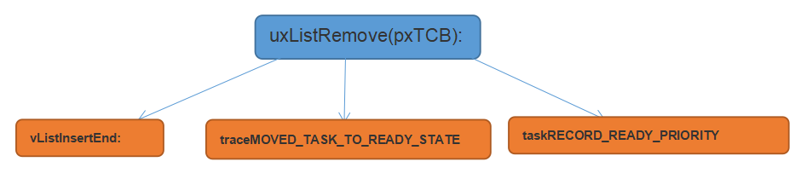

vListInsertEnd: A function used to insert an item at the end of a linked list.
traceMOVED_TASK_TO_READY_STATE: A trace or debugging function that records the event of a task transitioning to the ready state.-O(1)
taskRECORD_READY_PRIORITY: A trace or debugging function that records the priority of a task when it is added to the ready list.O(1)
Total-O(1)

uxTopReadyPriority:
The code declares a static volatile variable uxTopReadyPriority and initializes it with the value of tskIDLE_PRIORITY(The idle task is a special task that runs when no other tasks are ready to run). The variable is used to keep track of the highest priority among the tasks that are ready to run in the system. As tasks are added or removed from the ready list, the value of uxTopReadyPriority may be updated accordingly to reflect the highest priority task ready for execution.

The time complexity analysis reveals that initializing the uxTopReadyPriority variable with a constant value has a constant time complexity, denoted as O(1). This operation, typically executed during system initialization or first access, remains unaffected by the size of the system or the number of tasks. As it involves a simple assignment without complex calculations or iterations, the execution time remains constant.
Regarding the impact on the scheduler's efficiency, it can be considered negligible. Initializing a static variable with a constant value does not introduce significant overhead during task scheduling or execution. The operation is typically performed during system startup or initialization, minimizing its impact on the overall scheduler's efficiency.

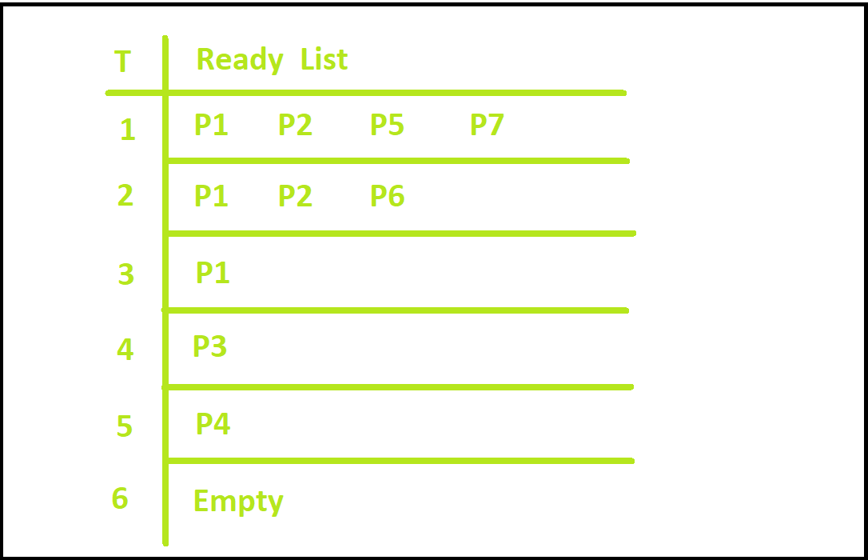
Diag:Overview of readylist processes
Assume p1<p2<p5<p7 in terms of priority
The function will keep track of highest priority
tasks and decides which task will execute next accordingly .
pxCurrentTCB:
The pxCurrentTCB is a pointer of type TCB_t*. It is declared and initialized as NULL. This variable is used to store the pointer to the TCB (Task Control Block) of the currently executing task in the system.
By updating the value of pxCurrentTCB, the scheduler and other parts of the system can access and manipulate the information associated with the currently running task. The volatile keyword ensures that the latest value of pxCurrentTCB is always fetched from memory, even if it is modified by external factors such as interrupts or other tasks.
The time complexity of initializing pxCurrentTCB as NULL is constant, denoted as O(1). It involves a simple assignment of a constant value to a pointer variable and does not depend on the system size or the number of tasks.
The impact on the scheduler's efficiency is minimal. Initializing a static variable with a null value does not introduce significant overhead during task scheduling or execution. It is typically performed during system startup or initialization, where its impact on the overall scheduler's efficiency is negligible.
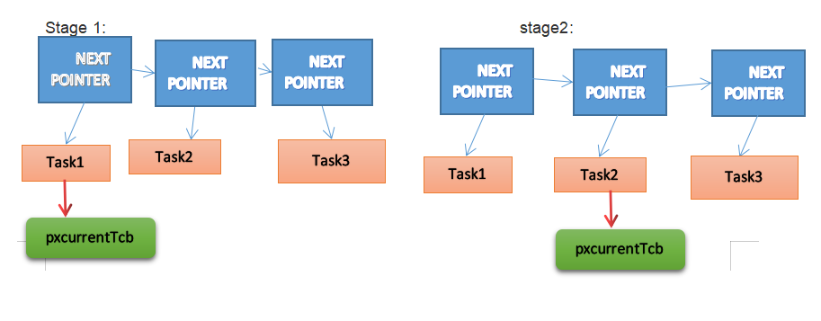

6. INTEGRATION OF THE READY LIST WITH THE SCHEDULER
In an operating system, the Ready List is a fundamental component of the scheduler that plays a crucial role in managing the execution order of tasks or threads. It represents the collection of tasks that are ready to be executed on the CPU. The Ready List interacts with other scheduler components, such as context switching and task preemption, to ensure efficient and fair execution of tasks. Additionally, synchronization mechanisms and algorithms are utilized to ensure thread safety and prevent race conditions.
Context switching is the process of saving the current execution context of a task and restoring the context of another task. It enables multitasking on a single CPU core by allowing the scheduler to switch between tasks. The Ready List provides the scheduler with information about the next task to execute. When a task is scheduled to run, the scheduler selects the highest-priority task from the Ready List and performs a context switch, transferring control to that task.
Task preemption occurs when a higher-priority task interrupts the execution of a lower-priority task. This mechanism ensures that important tasks are promptly executed, even if lower-priority tasks are still running. The Ready List is involved in task preemption by enabling the scheduler to determine if a higher-priority task has become ready to run. When a higher-priority task is available, the scheduler preempts the currently running task and replaces it with the higher-priority task. The Ready List is responsible for maintaining the execution order of tasks and ensuring that the most critical tasks are given priority.
To ensure thread safety and prevent race conditions, various synchronization mechanisms and algorithms are employed in managing the Ready List. These mechanisms include:
- Locks/Mutexes: Locks or mutexes enforce mutual exclusion, allowing only one thread at a time to access and modify the Ready List. Before accessing the Ready List, a thread must acquire the lock, ensuring exclusive access. This prevents race conditions where multiple threads try to modify the list concurrently, ensuring the integrity and consistency of the Ready List.
- Atomic Operations: Atomic operations guarantee that a specific operation completes without interruption. They are used when updating the Ready List to ensure that modifications occur atomically, without interference from other threads. Atomic operations prevent race conditions by providing a consistent and reliable mechanism for updating the Ready List.
- Semaphores: Semaphores provide synchronization and signaling mechanisms. They can be utilized to control access to the Ready List by allowing a limited number of threads to enter a critical section simultaneously. Semaphores help prevent race conditions and manage concurrent access to shared resources, ensuring that the Ready List is accessed and modified in a controlled manner.
- Scheduling Algorithms: The choice of scheduling algorithm significantly impacts how the Ready List is managed. Different algorithms, such as Round Robin, Priority Scheduling, or Multilevel Feedback Queue, employ specific rules to determine the order in which tasks are placed in the Ready List and selected for execution. These algorithms consider factors like task priority, fairness, and responsiveness to ensure efficient utilization of system resources and provide optimal task scheduling.
By combining these synchronization mechanisms and algorithms, the scheduler can ensure that the Ready List remains consistent and tasks are executed in a controlled and orderly manner. This helps prevent race conditions, achieve fairness in task execution, and maximize the overall efficiency of the system.
The algorithms employed to ensure thread safety and prevent race conditions may vary depending on the specific scheduling policy and system requirements. For example, the scheduler may utilize techniques like priority queues or round-robin scheduling to maintain the Ready List. These algorithms are designed to ensure fairness and efficient utilization of system resources by appropriately managing the execution order of threads and tasks.

Conclusion:

In conclusion, FreeRTOS is an open-source real-time operating system designed to overcome the limitations of general-purpose operating systems (GPOS). By introducing the FreeRTOS Scheduler, which enables concurrent execution of multiple tasks, FreeRTOS effectively addresses the shortcomings of GPOS super loop architecture. It employs preemptive scheduling, context switching, and a ReadyList component to manage and execute tasks based on their criticality and priority. The ReadyList, implemented as an array of lists, ensures task selection, prioritization, preemptive and context switching, resource management, and real-time responsiveness. The Task Control Block (TCB) serves as the main data structure in FreeRTOS, containing essential task information. Additionally, FreeRTOS utilizes other data structures like queues, semaphores, and mutexes for intercommunication. Thread safety and race condition prevention are ensured through the use of synchronization mechanisms such as locks/mutexes, atomic operations, semaphores, and scheduling algorithms. FreeRTOS effectively allocates CPU time and memory to high-priority tasks, making it a valuable choice for real-time task management and execution

References:
https://aosabook.org/en/v2/freertos.html

https://oxduke.gitbooks.io/1/content/freertos/33_scheduling_tasks_a_quick_overview.html
https://aws.amazon.com/freertos/faqs/#:~:text=FreeRTOS%20is%20an%20open%20source,secure%2C%20connect%2C%20and%20manage.

https://youtu.be/95yUbClyf3E

