Collections in Java

The **Collection in Java** is a framework that provides an architecture to store and manipulate the group of objects.

Java Collections can achieve all the operations that you perform on a data such as searching, sorting, insertion, manipulation, and deletion.

Java Collection means a single unit of objects. Java Collection framework provides many interfaces (Set, List, Queue, Deque) and classes ([ArrayList](https://www.javatpoint.com/java-arraylist), Vector, [LinkedList](https://www.javatpoint.com/java-linkedlist), [PriorityQueue](https://www.javatpoint.com/java-priorityqueue), HashSet, LinkedHashSet, TreeSet).

What is Collection in Java

A Collection represents a single unit of objects, i.e., a group.

What is a framework in Java

* It provides readymade architecture.
* It represents a set of classes and interfaces.
* It is optional.

What is Collection framework

The Collection framework represents a unified architecture for storing and manipulating a group of objects. It has:

1. Interfaces and its implementations, i.e., classes
2. Algorithm

Hierarchy of Collection Framework

Let us see the hierarchy of Collection framework. The **java.util** package contains all the [classes](https://www.javatpoint.com/object-and-class-in-java) and [interfaces](https://www.javatpoint.com/interface-in-java) for the Collection framework.

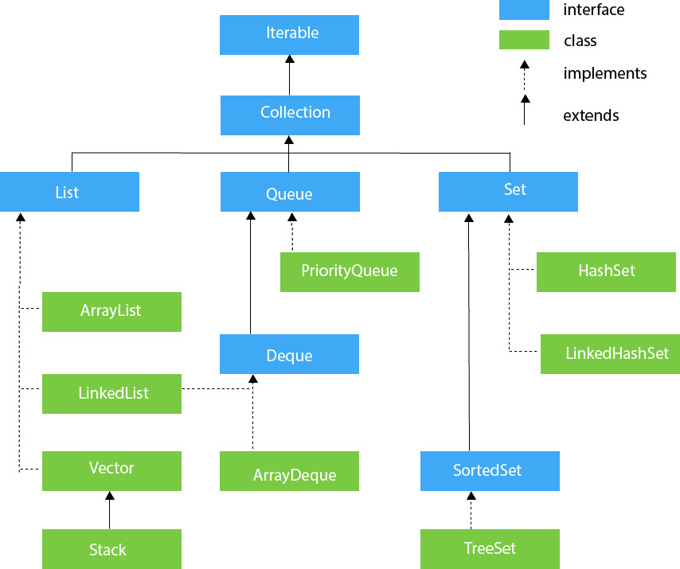

Methods of Collection interface

There are many methods declared in the Collection interface. They are as follows:

|  |  |  |
| --- | --- | --- |
| **No.** | **Method** | **Description** |
| 1 | public boolean add(E e) | It is used to insert an element in this collection. |
| 2 | public boolean addAll(Collection<? extends E> c) | It is used to insert the specified collection elements in the invoking collection. |
| 3 | public boolean remove(Object element) | It is used to delete an element from the collection. |
| 4 | public boolean removeAll(Collection<?> c) | It is used to delete all the elements of the specified collection from the invoking collection. |
| 5 | default boolean removeIf(Predicate<? super E> filter) | It is used to delete all the elements of the collection that satisfy the specified predicate. |
| 6 | public boolean retainAll(Collection<?> c) | It is used to delete all the elements of invoking collection except the specified collection. |
| 7 | public int size() | It returns the total number of elements in the collection. |
| 8 | public void clear() | It removes the total number of elements from the collection. |
| 9 | public boolean contains(Object element) | It is used to search an element. |
| 10 | public boolean containsAll(Collection<?> c) | It is used to search the specified collection in the collection. |
| 11 | public Iterator iterator() | It returns an iterator. |
| 12 | public Object[] toArray() | It converts collection into array. |
| 13 | public <T> T[] toArray(T[] a) | It converts collection into array. Here, the runtime type of the returned array is that of the specified array. |
| 14 | public boolean isEmpty() | It checks if collection is empty. |
| 15 | default Stream<E> parallelStream() | It returns a possibly parallel Stream with the collection as its source. |
| 16 | default Stream<E> stream() | It returns a sequential Stream with the collection as its source. |
| 17 | default Spliterator<E> spliterator() | It generates a Spliterator over the specified elements in the collection. |
| 18 | public boolean equals(Object element) | It matches two collections. |
| 19 | public int hashCode() | It returns the hash code number of the collection. |

Iterator interface

|  |
| --- |
| Iterator interface provides the facility of iterating the elements in a forward direction only. |

Methods of Iterator interface

There are only three methods in the Iterator interface. They are:

|  |  |  |
| --- | --- | --- |
| **No.** | **Method** | **Description** |
| 1 | public boolean hasNext() | It returns true if the iterator has more elements otherwise it returns false. |
| 2 | public Object next() | It returns the element and moves the cursor pointer to the next element. |
| 3 | public void remove() | It removes the last elements returned by the iterator. It is less used. |

Iterable Interface

The Iterable interface is the root interface for all the collection classes. The Collection interface extends the Iterable interface and therefore all the subclasses of Collection interface also implement the Iterable interface.

It contains only one abstract method. i.e.,

1. Iterator<T> iterator()

It returns the iterator over the elements of type T.

Collection Interface

The Collection interface is the interface which is implemented by all the classes in the collection framework. It declares the methods that every collection will have. In other words, we can say that the Collection interface builds the foundation on which the collection framework depends.

Some of the methods of Collection interface are Boolean add ( Object obj), Boolean addAll ( Collection c), void clear(), etc. which are implemented by all the subclasses of Collection interface.

List Interface

List interface is the child interface of Collection interface. It inhibits a list type data structure in which we can store the ordered collection of objects. It can have duplicate values.

List interface is implemented by the classes ArrayList, LinkedList, Vector, and Stack.

To instantiate the List interface, we must use :

1. List <data-type> list1= **new** ArrayList();
2. List <data-type> list2 = **new** LinkedList();
3. List <data-type> list3 = **new** Vector();
4. List <data-type> list4 = **new** Stack();

There are various methods in List interface that can be used to insert, delete, and access the elements from the list.

The classes that implement the List interface are given below.

ArrayList

The ArrayList class implements the List interface. It uses a dynamic array to store the duplicate element of different data types. The ArrayList class maintains the insertion order and is non-synchronized. The elements stored in the ArrayList class can be randomly accessed.

## LinkedList

LinkedList implements the Collection interface. It uses a doubly linked list internally to store the elements. It can store the duplicate elements. It maintains the insertion order and is not synchronized. In LinkedList, the manipulation is fast because no shifting is required.

## Vector

Vector uses a dynamic array to store the data elements. It is similar to ArrayList. However, It is synchronized and contains many methods that are not the part of Collection framework.

## Stack

The stack is the subclass of Vector. It implements the last-in-first-out data structure, i.e., Stack. The stack contains all of the methods of Vector class and also provides its methods like boolean push(), boolean peek(), boolean push(object o), which defines its properties.

Queue Interface

Queue interface maintains the first-in-first-out order. It can be defined as an ordered list that is used to hold the elements which are about to be processed. There are various classes like PriorityQueue, Deque, and ArrayDeque which implements the Queue interface.

Queue interface can be instantiated as:

1. Queue<String> q1 = **new** PriorityQueue();
2. Queue<String> q2 = **new** ArrayDeque();

There are various classes that implement the Queue interface, some of them are given below.

PriorityQueue

The PriorityQueue class implements the Queue interface. It holds the elements or objects which are to be processed by their priorities. PriorityQueue doesn't allow null values to be stored in the queue.

## Deque Interface

Deque interface extends the Queue interface. In Deque, we can remove and add the elements from both the side. Deque stands for a double-ended queue which enables us to perform the operations at both the ends.

Deque can be instantiated as:

1. Deque d = **new** ArrayDeque();

## ArrayDeque

ArrayDeque class implements the Deque interface. It facilitates us to use the Deque. Unlike queue, we can add or delete the elements from both the ends.

ArrayDeque is faster than ArrayList and Stack and has no capacity restrictions.

Set Interface

Set Interface in Java is present in java.util package. It extends the Collection interface. It represents the unordered set of elements which doesn't allow us to store the duplicate items. We can store at most one null value in Set. Set is implemented by HashSet, LinkedHashSet, and TreeSet.

Set can be instantiated as:

1. Set<data-type> s1 = **new** HashSet<data-type>();
2. Set<data-type> s2 = **new** LinkedHashSet<data-type>();
3. Set<data-type> s3 = **new** TreeSet<data-type>();

HashSet

HashSet class implements Set Interface. It represents the collection that uses a hash table for storage. Hashing is used to store the elements in the HashSet. It contains unique items.

## LinkedHashSet

LinkedHashSet class represents the LinkedList implementation of Set Interface. It extends the HashSet class and implements Set interface. Like HashSet, It also contains unique elements. It maintains the insertion order and permits null elements.

## SortedSet Interface

SortedSet is the alternate of Set interface that provides a total ordering on its elements. The elements of the SortedSet are arranged in the increasing (ascending) order. The SortedSet provides the additional methods that inhibit the natural ordering of the elements.

The SortedSet can be instantiated as:

1. SortedSet<data-type> set = **new** TreeSet();

## TreeSet

Java TreeSet class implements the Set interface that uses a tree for storage. Like HashSet, TreeSet also contains unique elements. However, the access and retrieval time of TreeSet is quite fast. The elements in TreeSet stored in ascending order.

Java EnumSet class

Java EnumSet class is the specialized Set implementation for use with enum types. It inherits AbstractSet class and implements the Set interface.

EnumSet class hierarchy

The hierarchy of EnumSet class is given in the figure given below.

EnumSet class declaration

Let's see the declaration for java.util.EnumSet class.

1. **public** **abstract** **class** EnumSet<E **extends** Enum<E>> **extends** AbstractSet<E> **implements** Cloneable

## What is Hashing

It is the process of converting an object into an integer value. The integer value helps in indexing and faster searches.

## What is HashMap

HashMap is a part of the Java collection framework. It uses a technique called Hashing. It implements the map interface. It stores the data in the pair of Key and Value. HashMap contains an array of the nodes, and the node is represented as a class. It uses an array and LinkedList data structure internally for storing Key and Value. There are four fields in HashMap.  
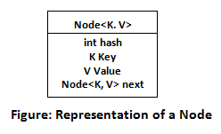

Before understanding the internal working of HashMap, you must be aware of hashCode() and equals() method.

* **equals():** It checks the equality of two objects. It compares the Key, whether they are equal or not. It is a method of the Object class. It can be overridden. If you override the equals() method, then it is mandatory to override the hashCode() method.
* **hashCode():** This is the method of the object class. It returns the memory reference of the object in integer form. The value received from the method is used as the bucket number. The bucket number is the address of the element inside the map. Hash code of null Key is 0.
* **Buckets:** Array of the node is called buckets. Each node has a data structure like a LinkedList. More than one node can share the same bucket. It may be different in capacity.

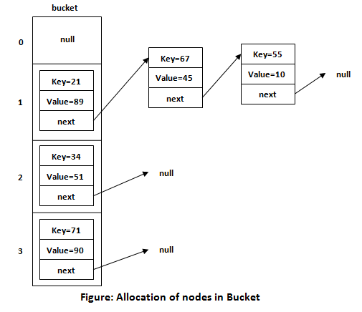

## Insert Key, Value pair in HashMap

We use put() method to insert the Key and Value pair in the HashMap. The default size of HashMap is 16 (0 to 15).

Example

In the following example, we want to insert three (Key, Value) pair in the HashMap.

1. HashMap<String, Integer> map = **new** HashMap<>();
2. map.put("Aman", 19);
3. map.put("Sunny", 29);
4. map.put("Ritesh", 39);

Let's see at which index the Key, value pair will be saved into HashMap. When we call the put() method, then it calculates the hash code of the Key "Aman." Suppose the hash code of "Aman" is 2657860. To store the Key in memory, we have to calculate the index.

Calculating Index

Index minimizes the size of the array. The Formula for calculating the index is:

1. Index = hashcode(Key) & (n-1)

Where n is the size of the array. Hence the index value for "Aman" is:

1. Index = 2657860 & (16-1) = 4

The value 4 is the computed index value where the Key and value will store in HashMap.

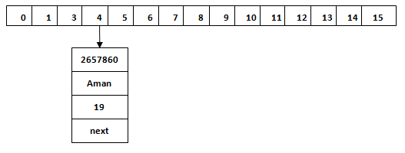

Hash Collision

This is the case when the calculated index value is the same for two or more Keys. Let's calculate the hash code for another Key "Sunny." Suppose the hash code for "Sunny" is 63281940. To store the Key in the memory, we have to calculate index by using the index formula.

1. Index=63281940 & (16-1) = 4

The value 4 is the computed index value where the Key will be stored in HashMap. In this case, equals() method check that both Keys are equal or not. If Keys are same, replace the value with the current value. Otherwise, connect this node object to the existing node object through the LinkedList. Hence both Keys will be stored at index 4.

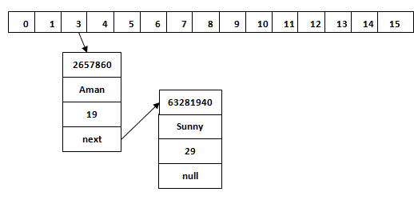

Similarly, we will store the Key "Ritesh." Suppose hash code for the Key is 2349873. The index value will be 1. Hence this Key will be stored at index 1.

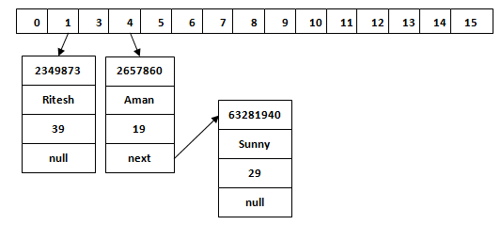

get() method in HashMap

get() method is used to get the value by its Key. It will not fetch the value if you don't know the Key. When get(K Key) method is called, it calculates the hash code of the Key.

Suppose we have to fetch the Key "Aman." The following method will be called.

1. map.get(**new** Key("Aman"));

It generates the hash code as 2657860. Now calculate the index value of 2657860 by using index formula. The index value will be 4, as we have calculated above. get() method search for the index value 4. It compares the first element Key with the given Key. If both keys are equal, then it returns the value else check for the next element in the node if it exists. In our scenario, it is found as the first element of the node and return the value 19.

Let's fetch another Key "Sunny."

The hash code of the Key "Sunny" is 63281940. The calculated index value of 63281940 is 4, as we have calculated for put() method. Go to index 4 of the array and compare the first element's Key with the given Key. It also compares Keys. In our scenario, the given Key is the second element, and the next of the node is null. It compares the second element Key with the specified Key and returns the value 29. It returns null if the next of the node is null.

# Java HashMap

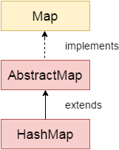

Java **HashMap** class implements the Map interface which allows us to store key and value pair, where keys should be unique. If you try to insert the duplicate key, it will replace the element of the corresponding key. It is easy to perform operations using the key index like updation, deletion, etc. HashMap class is found in the java.util package.

HashMap in Java is like the legacy Hashtable class, but it is not synchronized. It allows us to store the null elements as well, but there should be only one null key. Since Java 5, it is denoted as HashMap<K,V>, where K stands for key and V for value. It inherits the AbstractMap class and implements the Map interface.

### Points to remember

* Java HashMap contains values based on the key.
* Java HashMap contains only unique keys.
* Java HashMap may have one null key and multiple null values.
* Java HashMap is non synchronized.
* Java HashMap maintains no order.
* The initial default capacity of Java HashMap class is 16 with a load factor of 0.75.

### Hierarchy of HashMap class

As shown in the above figure, HashMap class extends AbstractMap class and implements Map interface.

### HashMap class declaration

Let's see the declaration for java.util.HashMap class.

1. **public** **class** HashMap<K,V> **extends** AbstractMap<K,V> **implements** Map<K,V>, Cloneable, Serializable

### HashMap class Parameters

Let's see the Parameters for java.util.HashMap class.

* **K**: It is the type of keys maintained by this map.
* **V**: It is the type of mapped values.

### Difference between HashSet and HashMap

HashSet contains only values whereas HashMap contains an entry(key and value).

# Java Hashtable class

Java Hashtable class implements a hashtable, which maps keys to values. It inherits Dictionary class and implements the Map interface.

### Points to remember

* A Hashtable is an array of a list. Each list is known as a bucket. The position of the bucket is identified by calling the hashcode() method. A Hashtable contains values based on the key.
* Java Hashtable class contains unique elements.
* Java Hashtable class doesn't allow null key or value.
* Java Hashtable class is synchronized.
* The initial default capacity of Hashtable class is 11 whereas loadFactor is 0.75.

### Hashtable class declaration

Let's see the declaration for java.util.Hashtable class.

1. **public** **class** Hashtable<K,V> **extends** Dictionary<K,V> **implements** Map<K,V>, Cloneable, Serializable

### Hashtable class Parameters

Let's see the Parameters for java.util.Hashtable class.

* **K**: It is the type of keys maintained by this map.
* **V**: It is the type of mapped values.

Constructors of Java Hashtable class

|  |  |
| --- | --- |
| **Constructor** | **Description** |
| Hashtable() | It creates an empty hashtable having the initial default capacity and load factor. |
| Hashtable(int capacity) | It accepts an integer parameter and creates a hash table that contains a specified initial capacity. |
| Hashtable(int capacity, float loadFactor) | It is used to create a hash table having the specified initial capacity and loadFactor. |
| Hashtable(Map<? extends K,? extends V> t) | It creates a new hash table with the same mappings as the given Map. |

Methods of Java Hashtable class

|  |  |
| --- | --- |
| **Method** | **Description** |
| void clear() | It is used to reset the hash table. |
| Object clone() | It returns a shallow copy of the Hashtable. |
| V compute(K key, BiFunction<? super K,? super V,? extends V> remappingFunction) | It is used to compute a mapping for the specified key and its current mapped value (or null if there is no current mapping). |
| V computeIfAbsent(K key, Function<? super K,? extends V> mappingFunction) | It is used to compute its value using the given mapping function, if the specified key is not already associated with a value (or is mapped to null), and enters it into this map unless null. |
| V computeIfPresent(K key, BiFunction<? super K,? super V,? extends V> remappingFunction) | It is used to compute a new mapping given the key and its current mapped value if the value for the specified key is present and non-null. |
| Enumeration elements() | It returns an enumeration of the values in the hash table. |
| Set<Map.Entry<K,V>> entrySet() | It returns a set view of the mappings contained in the map. |
| boolean equals(Object o) | It is used to compare the specified Object with the Map. |
| void forEach(BiConsumer<? super K,? super V> action) | It performs the given action for each entry in the map until all entries have been processed or the action throws an exception. |
| V getOrDefault(Object key, V defaultValue) | It returns the value to which the specified key is mapped, or defaultValue if the map contains no mapping for the key. |
| int hashCode() | It returns the hash code value for the Map |
| Enumeration<K> keys() | It returns an enumeration of the keys in the hashtable. |
| Set<K> keySet() | It returns a Set view of the keys contained in the map. |
| V merge(K key, V value, BiFunction<? super V,? super V,? extends V> remappingFunction) | If the specified key is not already associated with a value or is associated with null, associates it with the given non-null value. |
| V put(K key, V value) | It inserts the specified value with the specified key in the hash table. |
| void putAll(Map<? extends K,? extends V> t)) | It is used to copy all the key-value pair from map to hashtable. |
| V putIfAbsent(K key, V value) | If the specified key is not already associated with a value (or is mapped to null) associates it with the given value and returns null, else returns the current value. |
| boolean remove(Object key, Object value) | It removes the specified values with the associated specified keys from the hashtable. |
| V replace(K key, V value) | It replaces the specified value for a specified key. |
| boolean replace(K key, V oldValue, V newValue) | It replaces the old value with the new value for a specified key. |
| void replaceAll(BiFunction<? super K,? super V,? extends V> function) | It replaces each entry's value with the result of invoking the given function on that entry until all entries have been processed or the function throws an exception. |
| String toString() | It returns a string representation of the Hashtable object. |
| Collection values() | It returns a collection view of the values contained in the map. |
| boolean contains(Object value) | This method returns true if some value equal to the value exists within the hash table, else return false. |
| boolean containsValue(Object value) | This method returns true if some value equal to the value exists within the hash table, else return false. |
| boolean containsKey(Object key) | This method return true if some key equal to the key exists within the hash table, else return false. |
| boolean isEmpty() | This method returns true if the hash table is empty; returns false if it contains at least one key. |
| protected void rehash() | It is used to increase the size of the hash table and rehashes all of its keys. |
| V get(Object key) | This method returns the object that contains the value associated with the key. |
| V remove(Object key) | It is used to remove the key and its value. This method returns the value associated with the key. |
| int size() | This method returns the number of entries in the hash table. |

Difference between HashMap and Hashtable

HashMap and Hashtable both are used to store data in key and value form. Both are using hashing technique to store unique keys.

But there are many differences between HashMap and Hashtable classes that are given below.

|  |  |
| --- | --- |
| **HashMap** | **Hashtable** |
| 1) HashMap is **non synchronized**. It is not-thread safe and can't be shared between many threads without proper synchronization code. | Hashtable is **synchronized**. It is thread-safe and can be shared with many threads. |
| 2) HashMap **allows one null key and multiple null values**. | Hashtable **doesn't allow any null key or value**. |
| 3) HashMap is a **new class introduced in JDK 1.2**. | Hashtable is a **legacy class**. |
| 4) HashMap is **fast**. | Hashtable is **slow**. |
| 5) We can make the HashMap as synchronized by calling this code Map m = Collections.synchronizedMap(hashMap); | Hashtable is internally synchronized and can't be unsynchronized. |
| 6) HashMap is **traversed by Iterator**. | Hashtable is **traversed by Enumerator and Iterator**. |
| 7) Iterator in HashMap is **fail-fast**. | Enumerator in Hashtable is **not fail-fast**. |
| 8) HashMap inherits **AbstractMap** class. | Hashtable inherits **Dictionary** class. |

# Java List

**List** in Java provides the facility to maintain the ordered collection. It contains the index-based methods to insert, update, delete and search the elements. It can have the duplicate elements also. We can also store the null elements in the list.

The List interface is found in the java.util package and inherits the Collection interface. It is a factory of ListIterator interface. Through the ListIterator, we can iterate the list in forward and backward directions. The implementation classes of List interface are ArrayList, LinkedList, Stack and Vector. The ArrayList and LinkedList are widely used in Java programming. The Vector class is deprecated since Java 5.

### List Interface declaration

1. **public** **interface** List<E> **extends** Collection<E>

### Java List vs ArrayList

List is an interface whereas ArrayList is the implementation class of List.

### How to create List

The ArrayList and LinkedList classes provide the implementation of List interface. Let's see the examples to create the List:

1. //Creating a List of type String using ArrayList
2. List<String> list=**new** ArrayList<String>();
4. //Creating a List of type Integer using ArrayList
5. List<Integer> list=**new** ArrayList<Integer>();
7. //Creating a List of type Book using ArrayList
8. List<Book> list=**new** ArrayList<Book>();
10. //Creating a List of type String using LinkedList
11. List<String> list=**new** LinkedList<String>();

In short, you can create the List of any type. The ArrayList<T> and LinkedList<T> classes are used to specify the type. Here, T denotes the type.

### Get and Set Element in List

The get() method returns the element at the given index, whereas the set() method changes or replaces the element.

### How to Sort List

There are various ways to sort the List, here we are going to use Collections.sort() method to sort the list element. The java.util package provides a utility class **Collections** which has the static method sort(). Using the **Collections.sort()** method, we can easily sort any List.

## Java ListIterator Interface

ListIterator Interface is used to traverse the element in a backward and forward direction.

### ListIterator Interface declaration

1. **public** **interface** ListIterator<E> **extends** Iterator<E>

# Java ArrayList

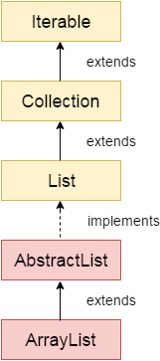

Java **ArrayList** class uses a dynamic *[array](https://www.javatpoint.com/array-in-java)*

for storing the elements. It is like an array, but there is no size limit. We can add or remove elements anytime. So, it is much more flexible than the traditional array. It is found in the java.util package. It is like the Vector in C++.

The ArrayList in Java can have the duplicate elements also. It implements the List interface so we can use all the methods of the List interface here. The ArrayList maintains the insertion order internally.

It inherits the AbstractList class and implements [List interface](https://www.javatpoint.com/java-list)

The important points about the Java ArrayList class are:Java Try Catch

* Java ArrayList class can contain duplicate elements.
* Java ArrayList class maintains insertion order.
* Java ArrayList class is non [synchronized](https://www.javatpoint.com/synchronization-in-java)
* Java ArrayList allows random access because the array works on an index basis.
* In ArrayList, manipulation is a little bit slower than the LinkedList in Java because a lot of shifting needs to occur if any element is removed from the array list.
* We can not create an array list of the primitive types, such as int, float, char, etc. It is required to use the required wrapper class in such cases. For example:

1. ArrayList<**int**> al = ArrayList<**int**>(); // does not work
2. ArrayList<Integer> al = **new** ArrayList<Integer>(); // works fine

* Java ArrayList gets initialized by the size. The size is dynamic in the array list, which varies according to the elements getting added or removed from the list.

### Hierarchy of ArrayList class

As shown in the above diagram, the Java ArrayList class extends AbstractList class which implements the List interface. The List interface extends the [Collection](https://www.javatpoint.com/collections-in-java)

and Iterable interfaces in hierarchical order.

### ArrayList class declaration

Let's see the declaration for java.util.ArrayList class.

1. **public** **class** ArrayList<E> **extends** AbstractList<E> **implements** List<E>, RandomAccess, Cloneable, Serializable

### Java Non-generic Vs. Generic Collection

Java collection framework was non-generic before JDK 1.5. Since 1.5, it is generic.

Java new generic collection allows you to have only one type of object in a collection. Now it is type-safe, so typecasting is not required at runtime.

Let's see the old non-generic example of creating a Java collection.

1. ArrayList list=**new** ArrayList();//creating old non-generic arraylist

Let's see the new generic example of creating java collection.

1. ArrayList<String> list=**new** ArrayList<String>();//creating new generic arraylist

In a generic collection, we specify the type in angular braces. Now ArrayList is forced to have the only specified type of object in it. If you try to add another type of object, it gives a compile-time error.

### How to Sort ArrayList

The java.util package provides a utility class **Collections**, which has the static method sort(). Using the **Collections.sort()** method, we can easily sort the ArrayList.