# **HTML - CSS Web Development Project**

## **Creating a Portfolio Website**

**Header and Navigation bar**

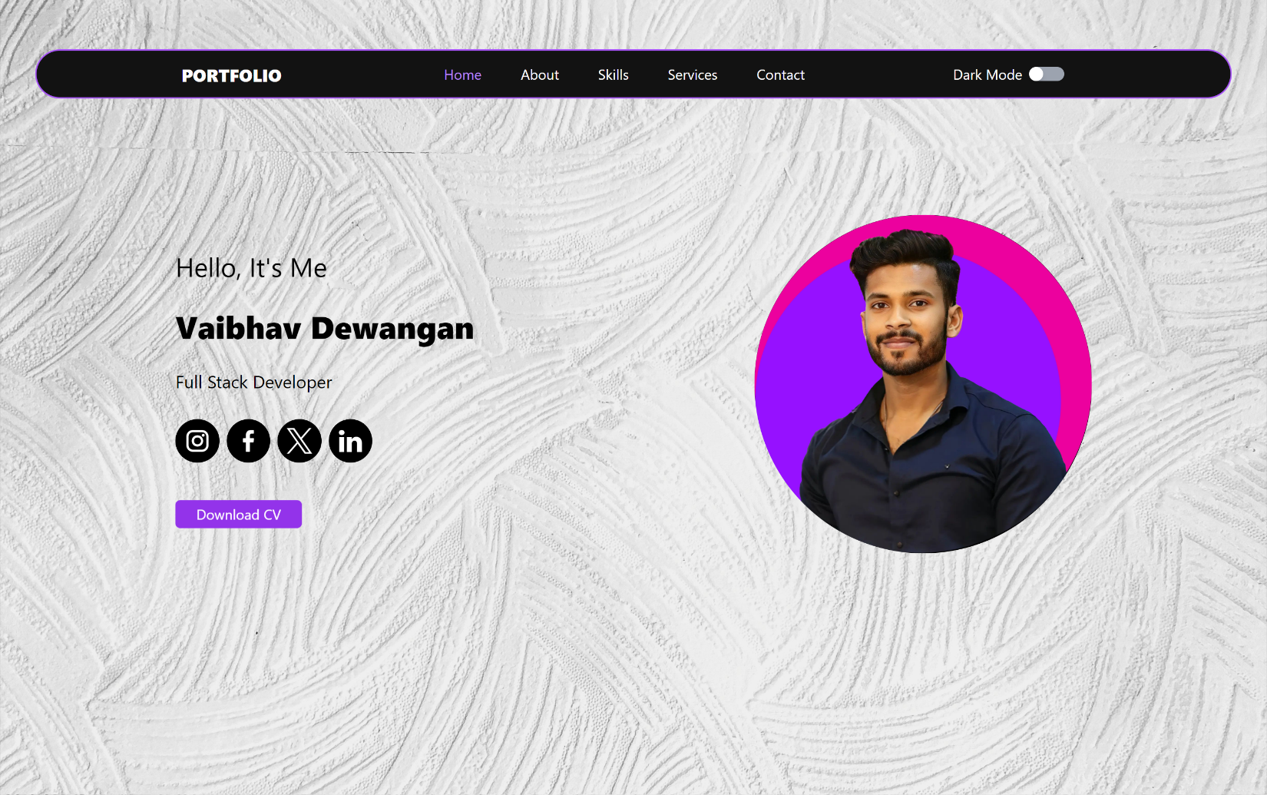

**Home Section**



**About Section**

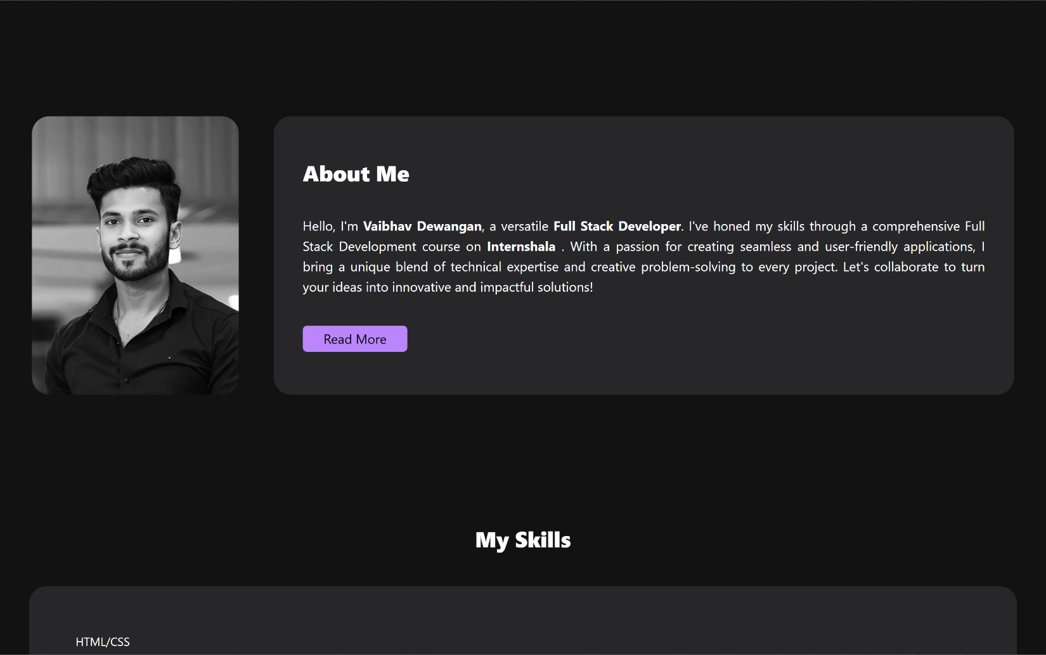

**Skills Section**

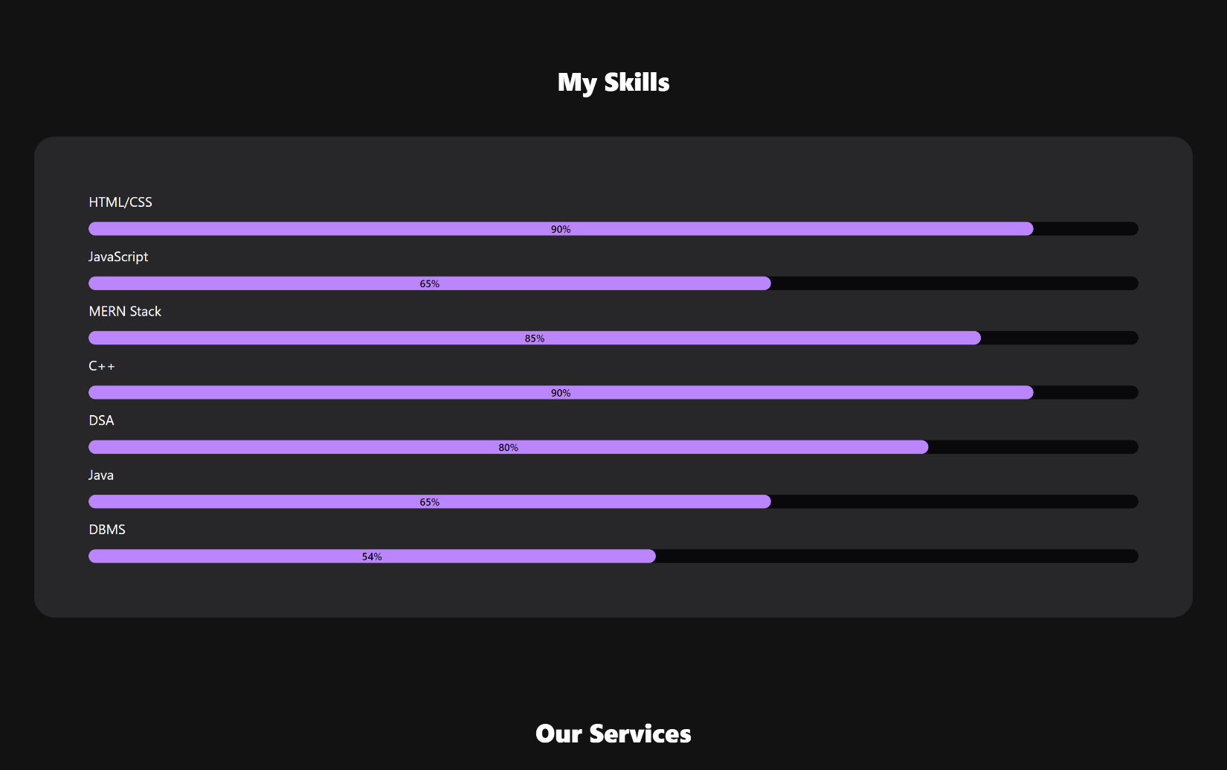

**Certifications/our services Section**

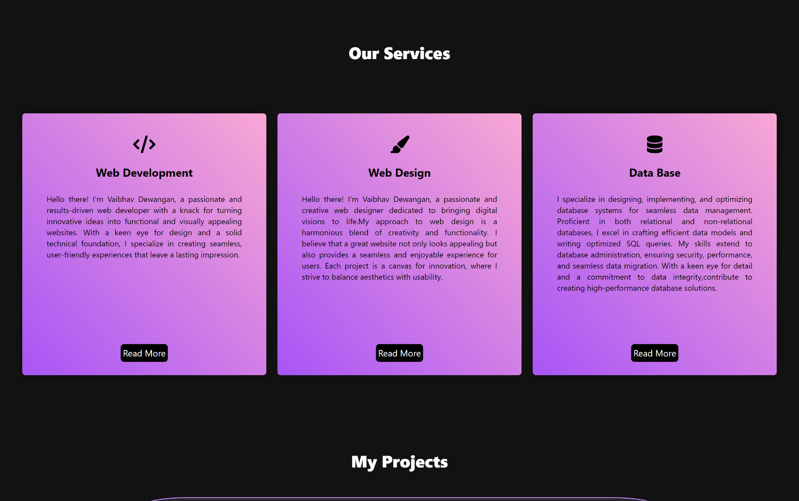

**Project Section**

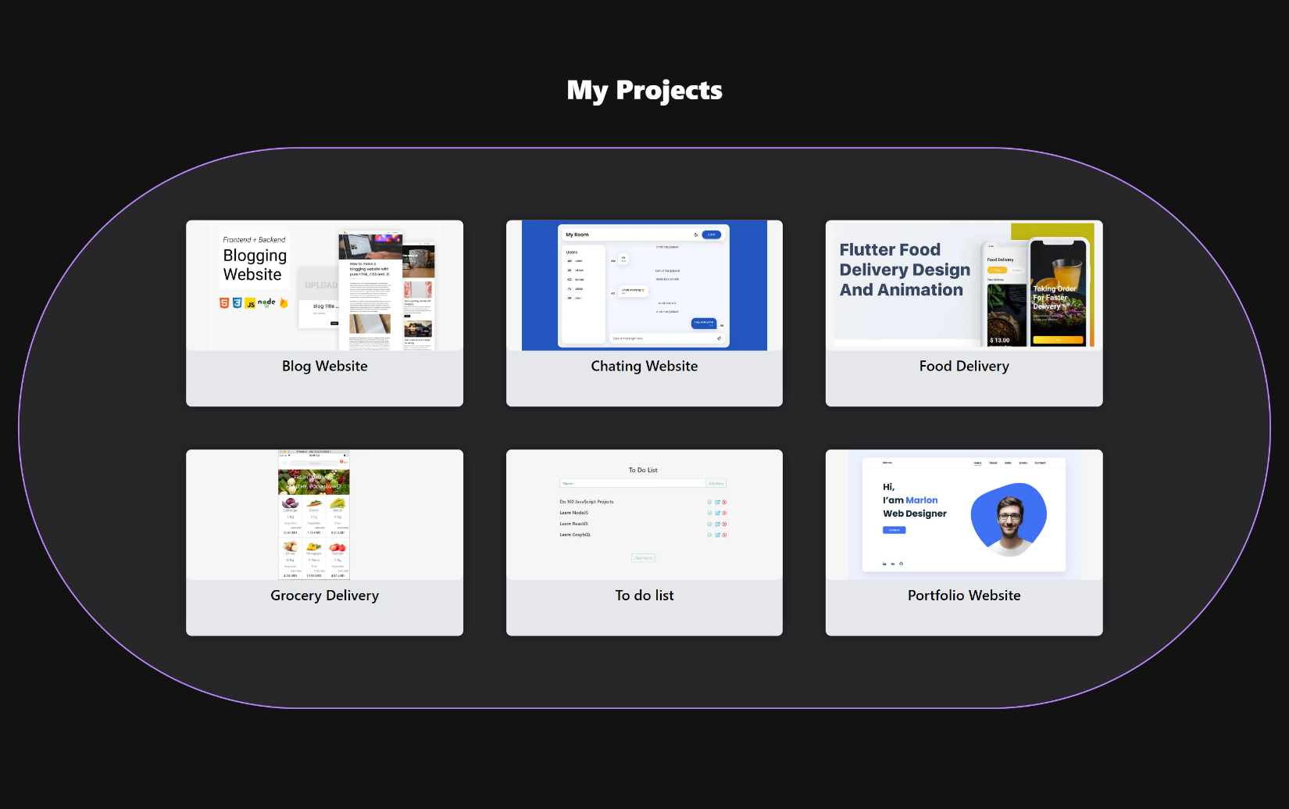

**Footer and Contact**

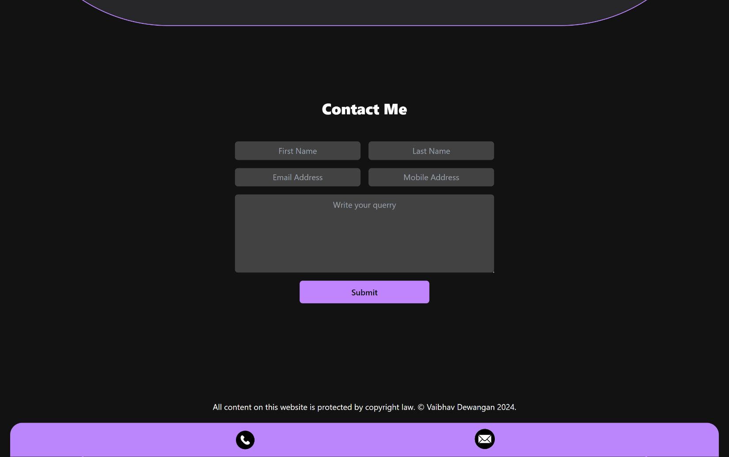

Responsive for the following devices: -

○ For desktop/laptop

○ For iPad Mini

○ For Samsung Galaxy S8+