# **Student Registration System**

## **DOM Project**

**Header**

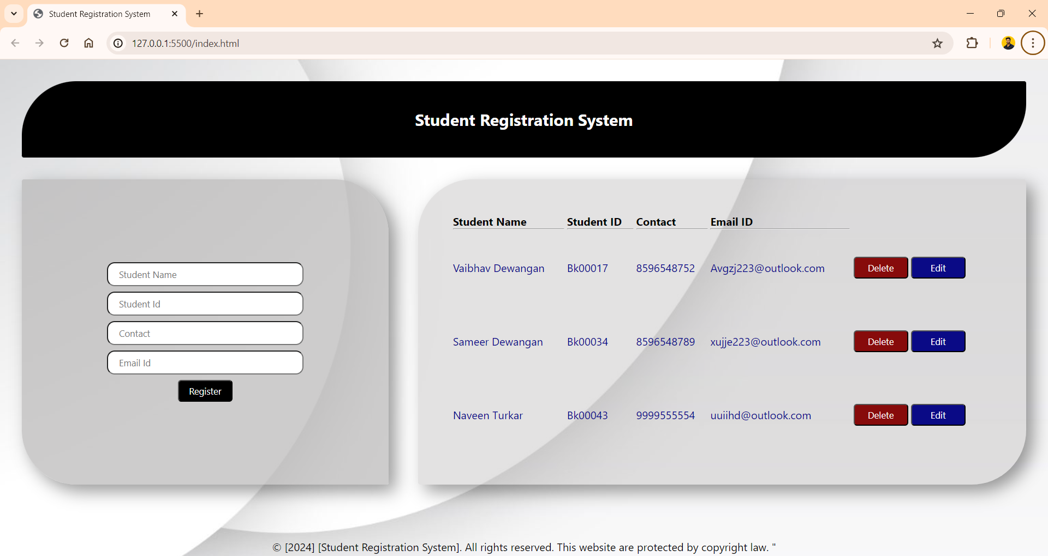

**Home Section**



**Student Registration Form**



**Registered Students Details**



**GitHub Repository Link**

<https://github.com/Vaibhav-Dewangan/Student-Registration-System.git>