# INTRODUCTION

Computer affects our life in a much bigger way then most of us might have thought. It has become a compulsory requirement in most professions to be able to use computer software. Modern computers which are based on integrated circuits are small enough to fit into mobile devices but imagine having a computer that will fit into a pen.

Imagine a world where everybody can use modem IT without being an expert. Imagine using only pen and paper to send e-mails and SMS. Pen-style Personal Networking Gadget are computers in the shape of different pens each having a function of its own and when combined together give us the usage of a full-blown computer It is a computer broken apart into pieces, each the size of a pen. The screen and keyboard are projected onto surfaces.

The P-ISM (Pen-style Personal Networking Gadget Package) is only a prototype under developing stage by NEC Corporation. In 2003, Geneva held the ITU telecom Word exhibition which exhibited a conceptual $30,000 prototype of a P-ISM designed by the Tokyo-based NEC Corporation.

# WORKING PRINCIPLE

* A computer that utilizes an electronic pen (called a stylus) rather than a keyboard for input. Pen computers generally require special operating systems that support handwriting recognition so that users can write on the screen or on a tablet instead of typing on a keyboard.
* Most pen computers are hand-held devices, which are too small for a full-size keyboard.

# HOW DOES IT WORK?

The P-ISM (Pen-style Personal Networking Gadget Package) consists of a package of 5 pens that all have unique functions, combining together to create virtual computing experience by producing both monitor and keyboard on any flat surfaces from where you can carry out functions that you would normally do on your desktop computer. P-ISM’s are connected with one another via a short-range (Bluetooth) wireless technology. The whole set is connected to the Internet through the cellular phone function.

The five components of P-ISM:

1. CPU pen
2. Communication pen
3. Virtual keyboard
4. LED projector
5. Digital camera

How does each component work?

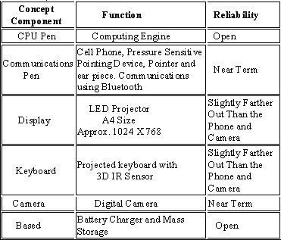

1. CPU pen:

The functionality of CPU is done by one of the pens. It is also called computing engine

1. Communication pen:

P-ISMs are connected with one another through short-range wireless technology. The whole set is also connected to the Internet through the cellular phone function. They are connected through Tri-wireless modes (Bluetooth, 802.11B/G, and Cellular) which are made small and kept in a small pen like device.

1. Virtual keyboard:

The virtual keyboard works on any flat surface which uses a camera to track the finger movements. On this specific keyboard, this is done by a 3D IR sensor technology with laser technology to get a full size keyboard. You can also change the language input and the layout of the keyboard. This is more efficient than normal keyboards because you don’t have to buy a new keyboard for every language. They are also easy to maintain as they are prone to damage by spills, drops and other malfunctions.

1. LED projector:

The role of the monitor is taken by the LED projector. LED projectors use LCD technologies for image creation with a difference as they use an array of Light Emitting Diodes as the light source, negating the need for lamp replacement. Also it would not need as much energy to used and with a longer lifetime. The size of the screen is approximately 1024 × 768 px which is a size of an A4 paper.

1. Digital camera:

We had digital camera in the shape of pen .It is useful in video recording, videoconferencing; simply it is called as web cam. It is also connected with other devices through Bluetooth. The major advantage it is small which is easily portable. It is a 360- Degree Visual Communication Device. We have seen video phones hundreds of times in movies. Conventional visual communications at a distance have been limited due to the display devices and terminals. This terminal enables showing of the surrounding atmosphere and group-to-group communication with a round display and a central super-wide-angle camera.

Battery of P-ISM gadget:

The most important part in the portable type of computer is its battery. Usually batteries must be small in size and work for longer time. It comes with a battery life of 6+. For normal use it can be used for 2 weeks.

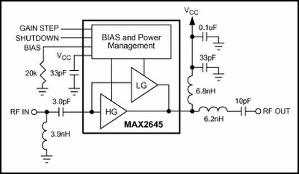Bluetooth connectivity:

Bluetooth is widely used because we can able to transfer data or make connections without wires. This is very effective because we can able to connect whenever we need without having wires. They are used at the frequency band of 2.4 GHz ISM the most efficient and comprehensive solution for the most serious problems can be accomplished by silicon vendors. They can implement information exchange capabilities within the designs of the Bluetooth.

Existing usage of this technology:

Even though clients cannot yet purchase "pen" computers like the P-ISM, all of the parts of this computer already exist. For example the virtual projected keyboard is already available from various companies including Lumio and Virtual Device.

# HOW IT TAKES INPUT

It has two methods for input

1. With the virtual keyboard.
2. With digital camera.

# ADVANTAGES OF P-ISM

# 

1. What makes the P-ISM different from all of the existing parts is that it’s shape like pens. Pens are very common objects that we carry around on everyday basis; by carrying just four pens you can create a PC. So, it’s portable and can be carried easily.
2. As the pen is less visible and it’s easier to take it out with you, the size and weight will be a lot less and it can potentially cost less as it will use less material.
3. Using this technology we can carry out functions that we usually carry out on a desktop computer easily and quickly. So, ubiquitous computing can be done.
4. P-ISM adopts Bluetooth technology for data transfer which is a wireless technology...ods for input

# DISADVANTAGES OF P-ISM

1. The P-ISM is made from 5 loose pens which will move around with any change in the movement of surface area. In a train journey there is a lot of movement which will shake the pens around and shake the projection of the keyboard and screen. So, this can’t be as stable and efficient as a laptop.
2. Also these pens are very small and fragile so they can be damaged easily while handling them or carrying them around. One pen itself costs quite a lat so you cannot risk damaging or losing them.

1. As the pens are small you could lose them easily which would cost you a lot.
2. Also Key board concept is not new. The advantages outweigh the disadvantages as 5-Pen PC technology is very unique and there would be a great demand in the market for the product like this.

# APPLICATIONS

* Many researchers have been made but there is no clear result so far.
* Only one that uses it is E-fingerprinting the gadget will be more secure, which allows only owner to activate the Pc. So even if we lose it, no one else can access the gadget.

# CONCLUSION

The communication devices are becoming smaller and compact. This is only an example for the start of this new technology. We can expect more such developments in future.

# REFERENCES

1. [www.google.com](http://www.google.com)
2. <https://ieeexplore.ieee.org/>
3. [www.studymafia.org](http://www.studymafia.org)