Weekly Progress Report - Enterprise IT Support Copilot
IBM Internship POC | Status through 10 July 2026 | 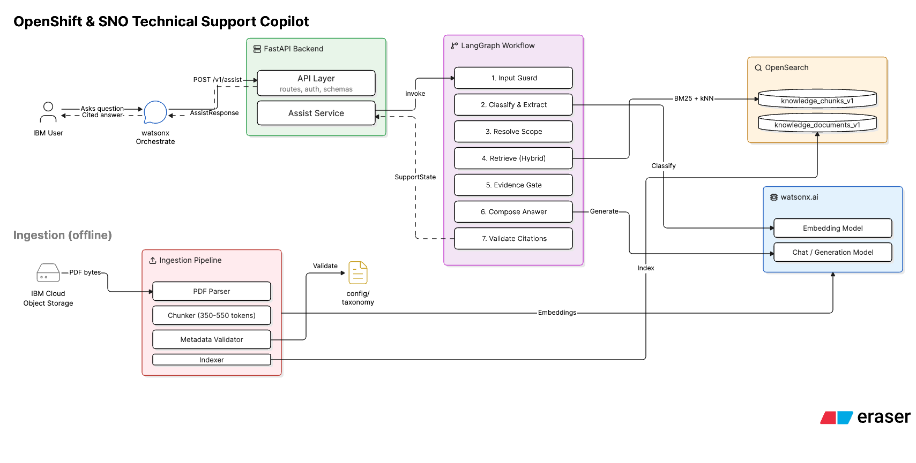

Domains  OCP/SNO + Orchestrate + Bob | Backend  FastAPI + LangGraph |  | Retrieval  OpenSearch BM25 + kNN | Evaluation  38/40 passed = 95% |  | Tests  58+ focused tests passing
Started With  - Built a controlled RAG backend for OpenShift Container Platform and Single Node OpenShift support.  - Created FastAPI service with /v1/assist, /healthz, /readyz, API-key auth, Pydantic schemas, and OpenAPI spec for watsonx Orchestrate.  - Designed a bounded LangGraph workflow for classification, scope resolution, retrieval, evidence checks, answer generation, citation validation, and safety handling.  - Implemented watsonx.ai providers for Slate embeddings and Granite generation. |  | Core Delivery  - Built PDF ingestion from IBM Cloud Object Storage/local files using parsing, chunking, metadata validation, embeddings, and OpenSearch indexing.  - Implemented hybrid retrieval using BM25 keyword search, vector kNN search, and Reciprocal Rank Fusion.  - Indexed the approved OCP/SNO corpus, including installation, networking, storage, troubleshooting, authentication, operators, and update guides.  - Added deterministic refusal/clarification behavior for ambiguous, unsupported, out-of-scope, or insufficient-evidence requests. |  |  | Latest Additions  - Expanded the product into a multi-domain Enterprise IT Support Copilot covering OCP/SNO, IBM watsonx Orchestrate, and IBM Bob.  - Added web documentation ingestion through web source discovery plus HTML, Markdown, and plain-text parsing.  - Added new corpus manifests for watsonx Orchestrate and IBM Bob, plus multi-domain taxonomy, classifier, and scope routing updates.  - Fixed non-OCP source labels and Orchestrate payload normalization so IBM Bob/Orchestrate questions route correctly and return product-aware citations.
Current status: working citation-grounded support backend with validated OpenShift/SNO evaluation, multi-domain expansion, Orchestrate integration guidance, Docker/Code Engine deployment docs, and documented next work for broader Bob/Orchestrate evaluation and cross-version retrieval.

- Additionally: The NCR interns have volunteered to support the management for the SKO Event taking part on 13th June
- Formed teams for the Watsonx Challeng, brainstorming and formulating ideas for the problem statement

