

A

Micro-Project

On

**Landing Page Using HTML-CSS**

Submitted To

**MSBTE**

In Partial Fulfilment of Requirement of Diploma Of

**COMPUTER ENGINEERING**

**Under I Scheme**

Submitted By

Mr. Akash Popat Koli

Mr. Sahil Suresh Gawde

Mr. Vishal Devendra Rane

Mr. Deven Rajendra Jadhav

Mr. Shehbaaz sayyed Usman mujavar

Mr. omkar Vithoba shedge

Mr. Vaibhav Laxman Gosavi

Mr. Tausik Husain Mehboob Baig

**Under the Guidance Of**

Mr. S. S. Zende

**FOR ACADEMIC YEAR 2020-2021**

**YASHWANTRAO BHONSALE POLYTECHNIC,**

**SAWANTWADI.**



**MAHARASHTRA STATE BOARD OF**

**TECHNICAL EDUCATION**

**CERTIFICATE**

This is to certify that,

**Mr. Akash Popat Koli Roll No.16**

**Mr. Sahil Suresh Gawde Roll No.08**

**Mr. Vishal Devendra Rane Roll No.31**

**Mr.Deven Rajendra Jadhav Roll No.11**

**Mr.Shehbaaz sayyed Usman mujavar Roll No.18**

**Mr.Omkar vithoba shedge Roll No.36**

**Mr. Vaibhav Laxman Gosavi Roll No.09**

**Mr Tausik Husain Mehboob Baig Roll No.02**

Of **2nd** semester of diploma in **Computer Engineering** of institute **Yashwantrao Bhonsale Polytechnic (1742)** has completed the **Micro Project** satisfactorily in subject **Web Page Designing (22014)** for the academic year 2020 to 2021 as prescribed in the curriculum.

_______________ _____________ ______________

**Subject Faculty HOD Principal**

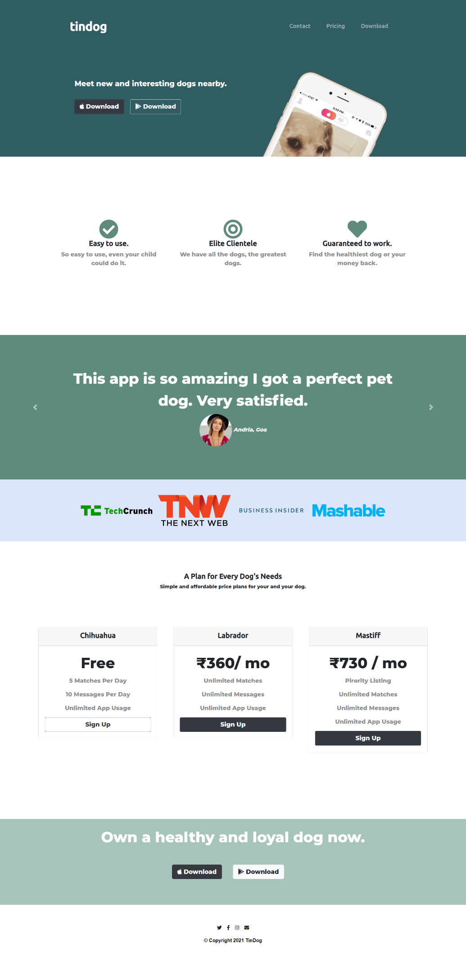**OUTPUT:**

**Index.html**

<!DOCTYPE html>

<html>

  <head>

    <meta charset="utf-8" />

    <title>TinDog</title>

    <link

      rel="stylesheet"

      href="https://maxcdn.bootstrapcdn.com/bootstrap/4.0.0/css/bootstrap.min.css"

      integrity="sha384-Gn5384xqQ1aoWXA+058RXPxPg6fy4IWvTNh0E263XmFcJlSAwiGgFAW/dAiS6JXm"

      crossorigin="anonymous"

    />

    <script

      src="https://code.jquery.com/jquery-3.2.1.slim.min.js"

      integrity="sha384-KJ3o2DKtIkvYIK3UENzmM7KCkRr/rE9/Qpg6aAZGJwFDMVNA/GpGFF93hXpG5KkN"

      crossorigin="anonymous"

    ></script>

    <script

      src="https://cdnjs.cloudflare.com/ajax/libs/popper.js/1.12.9/umd/popper.min.js"

      integrity="sha384-ApNbgh9B+Y1QKtv3Rn7W3mgPxhU9K/ScQsAP7hUibX39j7fakFPskvXusvfa0b4Q"

      crossorigin="anonymous"

    ></script>

    <script

      src="https://maxcdn.bootstrapcdn.com/bootstrap/4.0.0/js/bootstrap.min.js"

      integrity="sha384-JZR6Spejh4U02d8jOt6vLEHfe/JQGiRRSQQxSfFWpi1MquVdAyjUar5+76PVCmYl"

      crossorigin="anonymous"

    ></script>

    <script

      src="https://kit.fontawesome.com/2ca22450d6.js"

      crossorigin="anonymous"

    ></script>

    <link

      href="https://fonts.googleapis.com/css2?family=Montserrat:wght@800&family=Ubuntu:wght@500&display=swap"

      rel="stylesheet"

    />

    <link rel="stylesheet" href="css/styles.css" />

  </head>

  <body>

    <section id="title">

      <div class="container-fluid">

*<!-- Nav Bar -->*

        <nav class="navbar navbar-expand-lg navbar-dark">

          <a class="navbar-brand" href="">tindog</a>

          <button

            class="navbar-toggler"

            type="button"

            data-toggle="collapse"

            data-target="#navbarSupportedContent"

            aria-controls="navbarSupportedContent"

            aria-expanded="false"

            aria-label="Toggle navigation"

          >

            <span class="navbar-toggler-icon"></span>

          </button>

          <div class="collapse navbar-collapse" id="navbarSupportedContent">

            <ul class="navbar-nav ml-auto">

              <li class="nav-item">

                <a class="nav-link" href="#footer">Contact</a>

              </li>

              <li class="nav-item">

                <a class="nav-link" href="#pricing">Pricing</a>

              </li>

              <li class="nav-item">

                <a class="nav-link" href="#cta">Download</a>

              </li>

            </ul>

          </div>

        </nav>

*<!-- Title -->*

        <div class="row">

          <div class="col-lg-6">

            <h1 class="main -title">Meet new and interesting dogs nearby.</h1>

            <button type="button" class="btn btn-lg btn-dark download-btn">

              <i class="fab fa-apple"></i> Download

            </button>

            <button

              type="button"

              class="btn btn-lg btn-outline-light download-btn"

            >

              <i class="fab fa-google-play"></i> Download

            </button>

          </div>

          <div class="col-lg-6">

            <img

              class="titile-img"

              src="images/iphone6.png"

              alt="iphone-mockup"

            />

          </div>

        </div>

      </div>

    </section>

*<!-- Features -->*

    <section id="features">

      <div class="row">

        <div class="col-lg-4 feature-box">

          <i class="fas fa-check-circle fa-4x icon"></i>

          <h3>Easy to use.</h3>

          <p>So easy to use, even your child could do it.</p>

        </div>

        <div class="col-lg-4 feature-box">

          <i class="fas fa-bullseye fa-4x icon"></i>

          <h3>Elite Clientele</h3>

          <p>We have all the dogs, the greatest dogs.</p>

        </div>

        <div class="col-lg-4 feature-box">

          <i class="fas fa-heart fa-4x icon"></i>

          <h3>Guaranteed to work.</h3>

          <p>Find the healthiest dog or your money back.</p>

        </div>

      </div>

    </section>

*<!-- Testimonials -->*

    <section id="testimonials">

      <div id="testimonials-slides" class="carousel slide" data-ride="carousel">

        <div class="carousel-inner">

          <div class="carousel-item active">

            <h2>

              Great, the prices are very affordable. Simply great.

            </h2>

            <img

              class="testimonial-img"

              src="images/dog-img.jpg"

              alt="dog-profile"

            />

            <em>Kevin, Goa</em>

          </div>

          <div class="carousel-item">

            <h2 class="testimonial-text">

              This app is so amazing I got a perfect pet dog. Very satisfied.

            </h2>

            <img

              class="testimonial-img"

              src="images/lady-img.jpg"

              alt="lady-profile"

            />

            <em>Andria, Goa</em>

          </div>

        </div>

        <a

          class="carousel-control-prev"

          href="#testimonials-slides"

          role="button"

          data-slide="prev"

        >

          <span class="carousel-control-prev-icon" aria-hidden="true"></span>

          <span class="sr-only">Previous</span>

        </a>

        <a

          class="carousel-control-next"

          href="#testimonials-slides"

          role="button"

          data-slide="next"

        >

          <span class="carousel-control-next-icon" aria-hidden="true"></span>

          <span class="sr-only">Next</span>

        </a>

      </div>

    </section>

*<!-- Press -->*

    <section id="press">

      <img class="press-img" src="images/techcrunch.png" alt="tc-logo" />

      <img class="press-img" src="images/tnw.png" alt="tnw-logo" />

      <img

        class="press-img"

        src="images/bizinsider.png"

        alt="biz-insider-logo"

      />

      <img class="press-img" src="images/mashable.png" alt="mashable-logo" />

    </section>

*<!-- Pricing -->*

    <section id="pricing">

      <h3>A Plan for Every Dog's Needs</h3>

      <p>Simple and affordable price plans for your and your dog.</p>

      <div class="row">

        <div class="col-lg-4 col-md-6 price-card">

          <div class="card">

            <div class="card-header">

              <h3>Chihuahua</h3>

            </div>

            <div class="card-body">

              <h2>Free</h2>

              <p>5 Matches Per Day</p>

              <p>10 Messages Per Day</p>

              <p>Unlimited App Usage</p>

              <button

                class="btn btn-lg btn-block btn-outline-dark"

                type="button"

              >

                Sign Up

              </button>

            </div>

          </div>

        </div>

        <div class="col-lg-4 col-md-6 price-card">

          <div class="card">

            <div class="card-header">

              <h3>Labrador</h3>

            </div>

            <div class="card-body">

              <h2>&#8377;360/ mo</h2>

              <p>Unlimited Matches</p>

              <p>Unlimited Messages</p>

              <p>Unlimited App Usage</p>

              <button class="btn btn-lg btn-block btn-dark" type="button">

                Sign Up

              </button>

            </div>

          </div>

        </div>

        <div class="col-lg-4 price-card">

          <div class="card">

            <div class="card-header">

              <h3>Mastiff</h3>

            </div>

            <div class="card-body">

              <h2>&#8377;730 / mo</h2>

              <p>Pirority Listing</p>

              <p>Unlimited Matches</p>

              <p>Unlimited Messages</p>

              <p>Unlimited App Usage</p>

              <button class="btn btn-lg btn-block btn-dark" type="button">

                Sign Up

              </button>

            </div>

          </div>

        </div>

      </div>

    </section>

*<!-- Call to Action -->*

    <section id="cta">

      <h3 class="cta-head">Own a healthy and loyal dog now.</h3>

      <button type="button" class="btn btn-lg btn-dark download-btn">

        <i class="fab fa-apple"></i> Download

      </button>

      <button type="button" class="btn btn-lg btn-light download-btn">

        <i class="fab fa-google-play"></i> Download

      </button>

    </section>

    <footer id="footer">

      <i class="fab fa-twitter footer-icon"></i>

      <i class="fab fa-facebook-f footer-icon"></i>

      <i class="fab fa-instagram footer-icon"></i>

      <i class="fas fa-envelope footer-icon"></i>

      <p>© Copyright 2021 TinDog</p>

    </footer>

  </body>

</html>

**Style.css**

body {

  font-family: "Montserrat", sans-serif;

}

h1 {

  font-family: "Montserrat", sans-serif;

  font-size: 1.5rem;

  line-height: 1.5;

}

h2 {

  font-family: "Montserrat", sans-serif;

  font-weight: bolder;

  line-height: 1.5;

  font-size: 3rem;

}

h3 {

  font-family: "Ubuntu", sans-serif;

  font-size: 1.5rem;

  font-weight: bold;

}

div > p {

  font-size: 1.2rem;

  color: #8f8f8f;

}

em {

  font-size: 1.1rem;

  font-weight: lighter;

}

.main-title {

  font-size: 3rem;

}

.download-btn {

  margin: 5% 3% 5% 0;

}

.navbar {

  padding: 0 0 4.5rem;

}

.navbar-brand {

  font-family: "Ubuntu", sans-serif;

  font-size: 2.5rem;

  font-weight: bold;

}

.nav-item {

  padding: 0 18px;

}

.nav-link {

  font-family: "Ubuntu", sans-serif;

  font-weight: normal;

  font-size: 1.2rem;

}

.container-fluid {

  padding: 3.3% 15%;

}

.row {

  margin: 6% auto;

}

.titile-img {

  width: 60%;

  transform: rotate(25deg);

  position: absolute;

  right: 25%;

}

.feature-box {

  text-align: center;

  padding: 2%;

}

.icon {

  color: #5e8b7e;

}

.icon:hover {

  color: #2f5d62;

}

.testimonial-img {

  width: 10%;

  border-radius: 100%;

  line-height: 2.5;

}

.press-img {

  margin: 5px;

  width: 15rem;

}

.carousel-item {

  padding: 7% 15%;

}

.price-card {

  padding: 3% 2%;

}

.cta-head {

  font-family: "Montserrat", sans-serif;

  font-size: 3rem;

  padding: 0 5%;

}

.footer-icon {

  margin: 2% 6px;

}

#title {

  background-color: #2f5d62;

  color: #fff;

}

#features {

  position: relative;

  z-index: 1;

  padding: 7% 10%;

  background-color: #fff;

}

#testimonials {

  z-index: 2;

  bottom: 240px;

  color: #fff;

  background-color: #5e8b7e;

  text-align: center;

}

#press {

  background-color: #dbe6fd;

  text-align: center;

  padding: 3% 2%;

}

#pricing {

  padding: 100px;

  text-align: center;

}

#cta {

  color: #fff;

  text-align: center;

  padding: 2% 15%;

  background-color: #a7c4bc;

}

#footer {

  text-align: center;

  padding: 3% 15%;

  background-color: #fff;

}

#footer > p {

  font-family: "Montserrat-normal", sans-serif;

  font-weight: bold;

  color: #000000;

}

@media (max-width: 1028px) {

  #title {

    text-align: center;

  }

  .titile-img {

    position: static;

    transform: rotate(0);

  }

}