**CHAPTER 1: INTRODUCTION**

The number of vehicles on the road are increasing day by day so it is important to manage the traffic flow efficiently in order to utilize the existing road capacity in the best way possible. Developing a smart traffic management system to optimize traffic flow, reduce congestion, while minimizing the travel time and maximizing mobility. Installation of traffic signals can actually cause a deterioration in overall safety of intersections. Time traffic signals can cause a situation of deadlock1. Metro cities and many majorly populated cities have traffic signals at very short distances which prevent the smooth flow of traffic. Severe traffic can cause phantom traffic jams2. The phantom jam begins when a car in dense traffic slows down even slightly, which causes the car behind that to slow even more and the slowing action spreads backward through the cane of traffic like a wave, getting worse the further it spreads. The present automated traffic control systems work on time-based algorithms. Each lane is allotted a fixed time for traffic to clear off, the times may be equal for all lanes or based on the average vehicle density.

**1.1 LITERATURE REVIEW**

* Traffic congestion is a pressing urban issue with negative economic, environmental, and societal impacts. This literature review aims to explore and evaluate diverse strategies to address traffic congestion.
* Causes and Effects: Traffic congestion stems from factors like population growth, limited road capacity, and car dependency.
* Traffic lights play a pivotal role in managing intersections and regulating traffic. They facilitate the orderly movement of vehicles, pedestrians, and cyclists by assigning right-of-way and controlling signal timing.
* Numerous cities have adopted adaptive signal control systems and coordinated signal timing strategies. Successful implementations have demonstrated reduced travel times, enhanced traffic flow, and minimized congestion.
* Benefits and Challenges: Benefits of traffic light solutions include improved traffic flow, reduced congestion, and potential fuel savings. However, challenges include initial implementation costs, maintenance, and potential disruptions during deployment.

1. Source: https://www.eg.bucknell.edu/~cs315/2013-fall/sec02/notes/13-Deadlock-Intro-print.pdf
2. Source: https://www.livescience.com/61862-why-phantom-traffic-jams-happen.html

**1.2 MOTIVATION**

The motivation behind embarking on this project is multi-faceted, stemming from both personal and societal aspirations. As technology continues to shape our world, it becomes imperative to leverage its power to address pressing urban challenges like traffic problems. Here are some key reasons driving our enthusiasm for this project

* **Learning AI and Applied Machine Learning**: We are deeply intrigued by the potential of Artificial Intelligence and Machine Learning to transform everyday problems into innovative solutions. This project serves as an opportunity to dive into the world of AI, gaining hands-on experience in computer vision, object detection algorithms.
* **Practical Application of Technical Skills**: While theoretical knowledge is valuable, its application in real-world scenarios is where its true impact is felt. By implementing AI-based traffic management, we can apply our technical skills to create tangible results that have the potential to improve the quality of life for city dwellers.
* **Collaborative Git Workflow**: Engaging in this project allows us to explore collaborative development using collaborative coding, and effective teamwork are essential skills that find real-world relevance in software development projects like this.
* **Urban Sustainability and Quality of Life**: As urbanization intensifies, efficient traffic management becomes a key factor in ensuring cities remain sustainable and livable. Our efforts in optimizing traffic flow align with the broader goals of creating smart, efficient, and environmentally conscious urban environments.
* **Hands-on Problem Solving**: Tackling the challenge of traffic congestion isn't just about coding—it requires us to think critically, strategize, and develop creative solutions. This project encourages us to think beyond the conventional and devise innovative approaches to a complex problem.
* **Practical Experience for Future Endeavors**: The knowledge and experience gained from this project are invaluable assets that will serve us well in future endeavors, whether in academia, industry, or further exploration of AI and data science.

**1.3 PROBLEM DEFINITION**

Developing a smart traffic management system using AI to optimize traffic flow, reduce congestion, while minimizing the travel time and maximizing mobility. The problem at hand is to design and implement a solution that effectively reduces traffic congestion. The solution should focus on minimizing congestion-related delays, improving travel times, reducing environmental impact, and enhancing overall urban mobility.

**1.4 OBJECTIVES**

The main objective of this project is to design a traffic light controller based on Computer Vision that can adapt to the current traffic situation. Our proposed system aims to use live video feed from the CCTV cameras at traffic junctions for real- time traffic density calculation by detecting the vehicles at the signal and setting the green signal time accordingly.

It will enhance the efficiency of the transportation system by optimizing traffic management, reducing bottlenecks, and ensuring smoother coordination between various transportation modes.

Increases the safety for pedestrians, cyclists, and drivers by implementing measures that reduce accidents, improve visibility and prioritize pedestrian-friendly infrastructure.

**1.5 EXPECTED OUTCOMES**

* Engaging in a project focused on solutions for traffic congestion using traffic lights can yield a range of expected outcomes.
* Improved Traffic Flow: Implementation of optimized traffic light strategies can lead to smoother traffic flow, reduced stop-and-go patterns, and decreased congestion at intersections.
* Reduced Travel Time: By minimizing waiting times at traffic lights, commuters experience reduced travel time, leading to enhanced efficiency in daily transportation.
* Enhanced Safety: Well-coordinated traffic lights contribute to safer road conditions by reducing abrupt stops and minimizing the risk of collisions at intersections.
* Technological Innovation: Implementing adaptive traffic signal control and intelligent transportation systems showcases the practical application of cutting-edge technologies.
* In summary, the expected outcomes of a solutions-focused traffic light project encompass improved traffic conditions, economic savings, environmental benefits, and positive impacts on urban mobility and quality of life.

**CHAPTER 2: PROPOSED METHODOLOGY**

In this chapter, we outline our approach to tackle the challenges posed by traffic congestion and signal control. Our methodology focuses on developing an adaptive traffic signal system that responds to real-time traffic conditions, promoting efficient traffic flow and congestion reduction.

* Problem Background and Rationale: Traffic congestion is a persistent issue in urban areas due to fixed signal timings that fail to accommodate varying traffic patterns. Conventional signal timing methods result in traffic jams, delays, accidents, and increased pollution. To address these issues, a dynamic approach to signal control is imperative.
* Proposed System Overview: Our approach involves strategically deploying CCTV cameras at key traffic junctions. These cameras capture real-time snapshots of traffic scenarios, which are then subjected to advanced Image Processing and Computer Vision techniques. These methods extract crucial data about traffic density, allowing us to gauge the current traffic situation accurately.
* Traffic Flow Analysis: By analyzing the data obtained from CCTV cameras, we can perform instant traffic flow analysis. This entails identifying lanes with high and low traffic densities. This analysis forms the basis for determining how much green signal time should be allocated to each direction.
* Dynamic Signal Timing Calculation: Leveraging the insights gained from traffic flow analysis, we compute optimal green signal timings dynamically. The direction with higher traffic density receives a longer green signal duration compared to directions with lighter traffic. This adaptability aims to alleviate congestion and enhance traffic flow efficiency.
* Implementation of Control Logic: Our approach includes integrating the computed signal timings with the actual traffic signal hardware. This integration is achieved through microcontrollers or similar technology. By doing so, we enable real-time communication between our dynamic calculations and the physical operation of traffic signals, ensuring synchronization.

**2.1 ALGORITHMS**

Algorithm Name: Object Tracking with YOLO and Tracker

Input: Video Feed

Output: Traffic Signal Control

1. [START] Import required libraries

- Import cv2 (OpenCV)

- Import pandas as pd

- Import YOLO from ultralytics

- Import Tracker class

2. Load YOLO model

- Initialize YOLO model using 'yolov8s.pt'

3. Define RGB Event Handler Function

- Define function RGB(event, x, y, flags, param)

- Capture mouse movement events

- Update colorsBGR with [x, y] coordinates

4. Create Video Capture Object

- Open video capture object for 'veh2.mp4'

5. Read Class List from File

- Read 'coco.txt' file

- Split data into class_list using newline as delimiter

6. Initialize Count and Tracker

- Initialize count as 0

- Initialize Tracker object

7. Set Constants

- Set cy1 to 322

- Set cy2 to 368

- Set offset to 6

8. Start Loop

- Read frame from video capture

- If frame read fails, break loop

- Increment count by 1

- If count is not divisible by 3, continue to the next iteration

- Resize frame to (1020, 500)

- Perform YOLO prediction on the frame:

- Get prediction results

- Extract bounding box data and class indices

- Filter out boxes corresponding to 'car' class

- Update Tracker with the list of bounding box coordinates

- For each tracked bounding box:

- Calculate center coordinates (cx, cy)

- Draw circle at (cx, cy) on the frame

- Display ID next to the circle

- Display frame with tracking information

- If 'Esc' key is pressed, break the loop

9. Release Resources

- Release video capture

- Close all OpenCV windows

10. Exit Program [END]

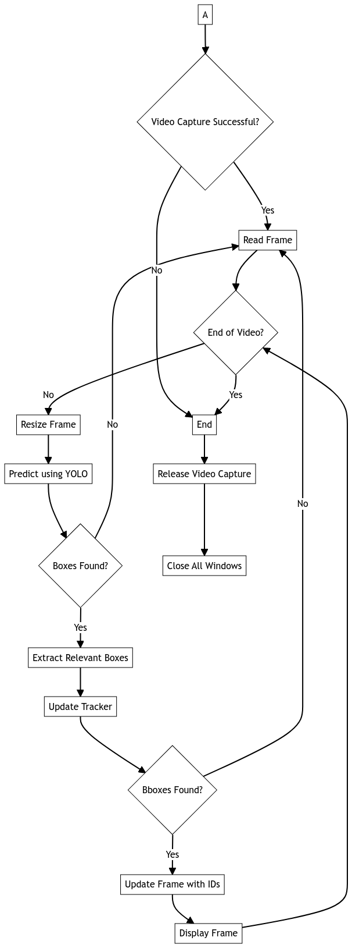**2.2 FLOW CHART**

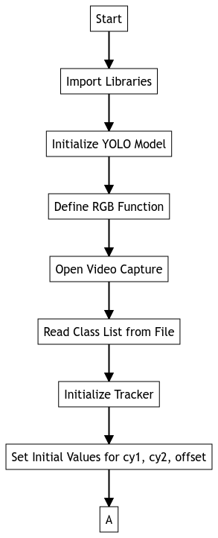

Fig (a). Flow Chart

**2.3 IMPLEMENTATION**

**2.3.1 Detection Code [Python]**

import cv2

import pandas as pd

from ultralytics import YOLO

from tracker import*

model=YOLO('yolov8s.pt')

def RGB(event, x, y, flags, param):

    if event == cv2.EVENT_MOUSEMOVE :

        colorsBGR = [x, y]

cv2.namedWindow('RGB')

cv2.setMouseCallback('RGB', RGB)

cap=cv2.VideoCapture('veh2.mp4')

my_file = open("coco.txt", "r")

data = my_file.read()

class_list = data.split("\n")

cy1,cy2,offset,count,traker=322,368,6,0,Traker()

while True:

    ret,frame = cap.read()

    if not ret:

        break

    count += 1

    frame=cv2.resize(frame,(1020,500))

    results=model.predict(frame)

    a=results[0].boxes.boxes

    px=pd.DataFrame(a).astype("float")

    list=[]

    for index,row in px.iterrows():

        x1=int(row[0])

        y1=int(row[1])

        x2=int(row[2])

        y2=int(row[3])

        d=int(row[5])

        c=class_list[d]

        if 'car' in c:

            list.append([x1,y1,x2,y2])

    bbox_id=tracker.update(list)

    for bbox in bbox_id:

        x3,y3,x4,y4,id=bbox

        cx=int(x3+x4)//2

        cy=int(y3+y4)//2

        cv2.circle(frame,(cx,cy),4,(0,0,255),-1)

        cv2.putText(frame,str(id),(cx,cy),cv2.FONT_HERSHEY_COMPLEX,0.8,(0,255,255),2)

    cv2.imshow("RGB", frame)

    if cv2.waitKey(1)&0xFF==27:

        break

cap.release()

cv2.destroyAllWindows()

* + 1. **Arduino Linker**

import pyfirmata

import time

board = pyfirmata.Arduino('COM4')

it = pyfirmata.util.Iterator(board)

it.start()

red = board.get_pin('d:11:o')

yellow = board.get_pin('d:12:o')

green = board.get_pin('d:13:o')

def RedToGreen(wait_yellow):

    red.write(0)

    yellow.write(1)

    time.sleep(wait_yellow)

    yellow.write(0)

    green.write(1)

def GreenToRed(wait_yellow):

    green.write(0)

    yellow.write(1)

    time.sleep(wait_yellow)

    yellow.write(0)

    red.write(1)

def main():

    pass

**2.4 COMPONENTS**

**1. ARDUINO UNO R3**

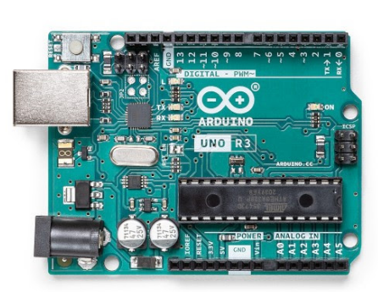

Fig (b). Arduino UNO R3

The Arduino UNO R3 is the perfect board to get familiar with electronics and coding. This versatile development board is equipped with the well-known ATmega328P and the ATMega 16U2 Processor. This board will give you a great first experience within the world of Arduino.

**2. BREADBOARD**

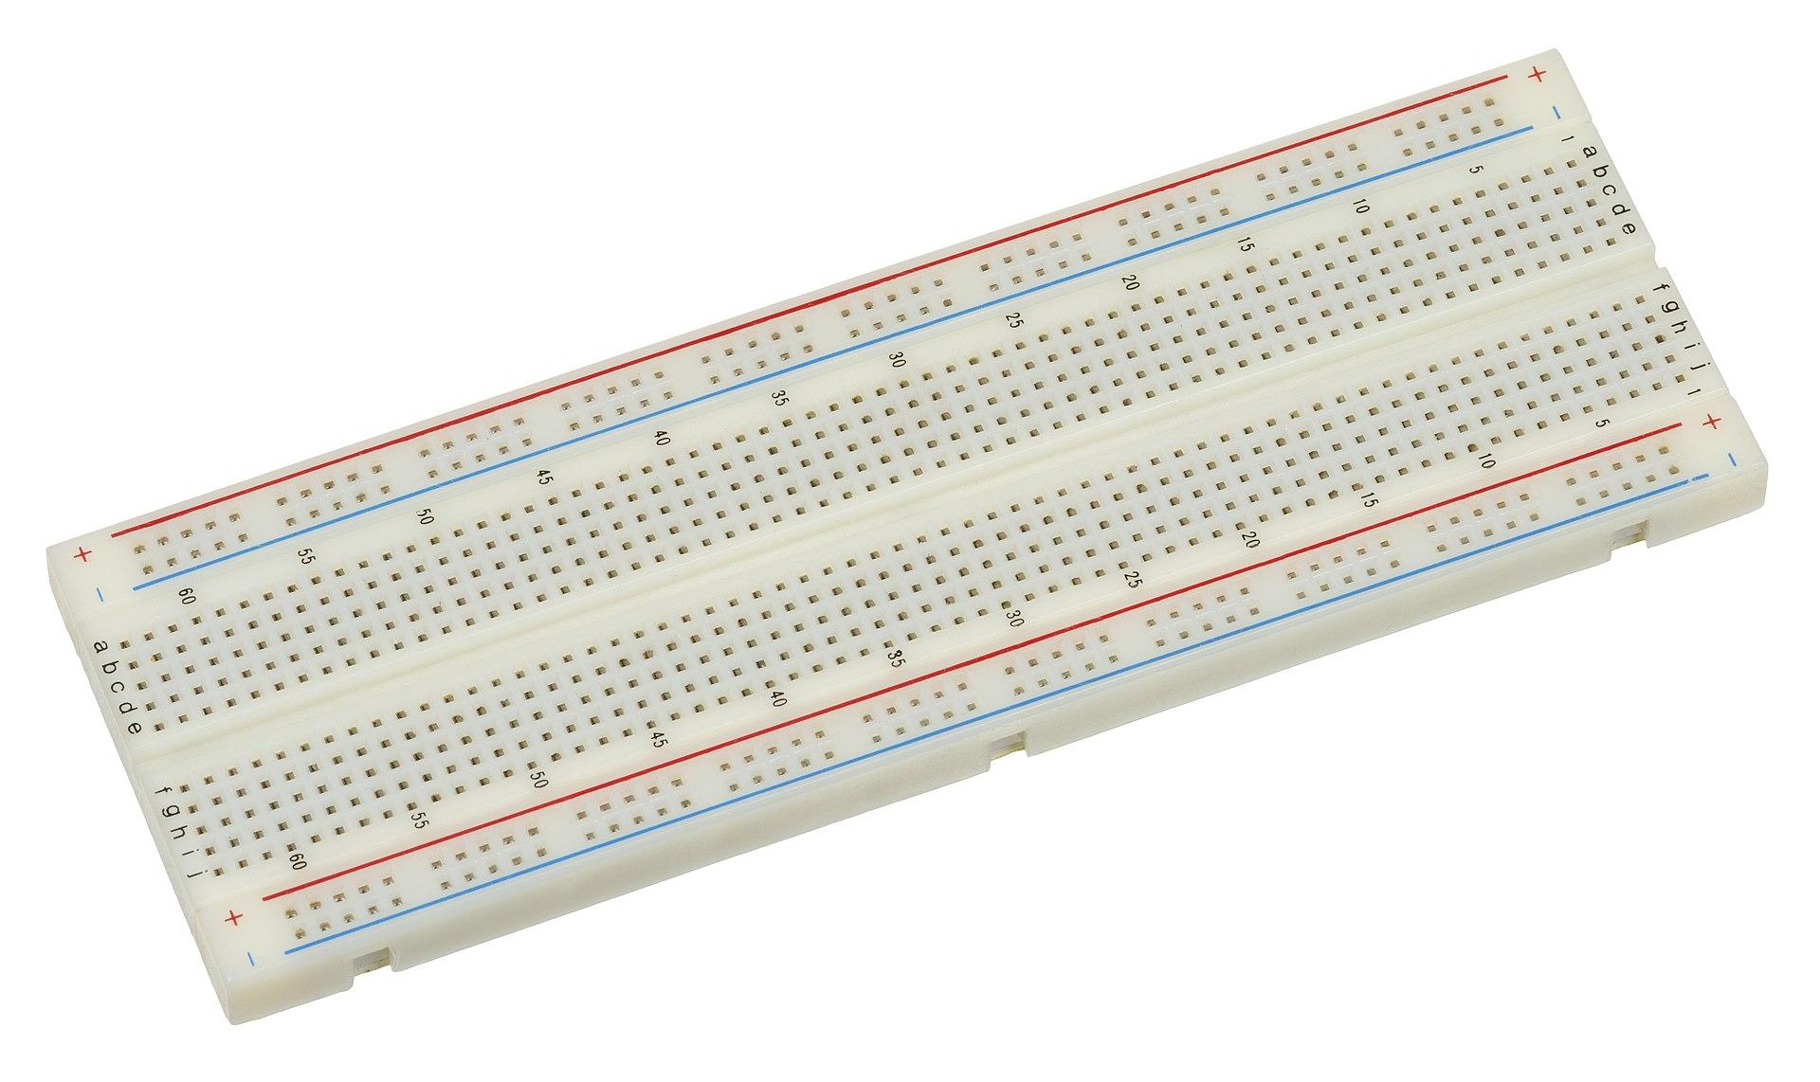

Fig (c). Breadboard

A breadboard, solderless breadboard, or protoboard is a construction base used to build semi-permanent prototypes of electronic circuits. Unlike a perfboard or stripboard, breadboards do not require soldering or destruction of tracks and are hence reusable. For this reason, breadboards are also popular with students and in technological education.

**3. LED LIGHTS**

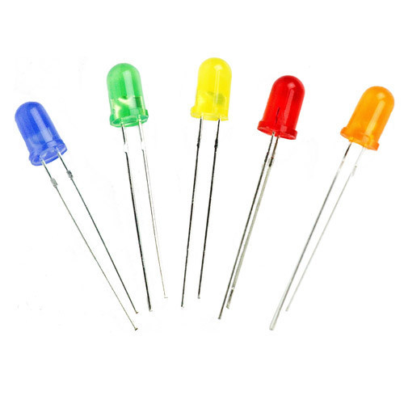

Fig (d). LED’s of Different Colors

LED lights or light emitting diode lights, represent a cutting edge lighting technology that has revolutionized the way we illuminate spaces. It emits light when an electric current passes through semiconductor material.

**4. JUMPER WIRES:**

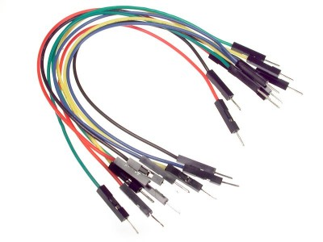

Fig (e). Male to Male Jumper Wires

Jumper wires are simply wires that have connector pins at each end, allowing them to be used to connect two points to each other without soldering. Jumper wires are typically used with breadboard and other prototyping tools in order to make it easy to change a circuit as needed. Fairly simple. In fact, it doesn’t get much more basic than jumper wires.

**5. WEB CAMERA**

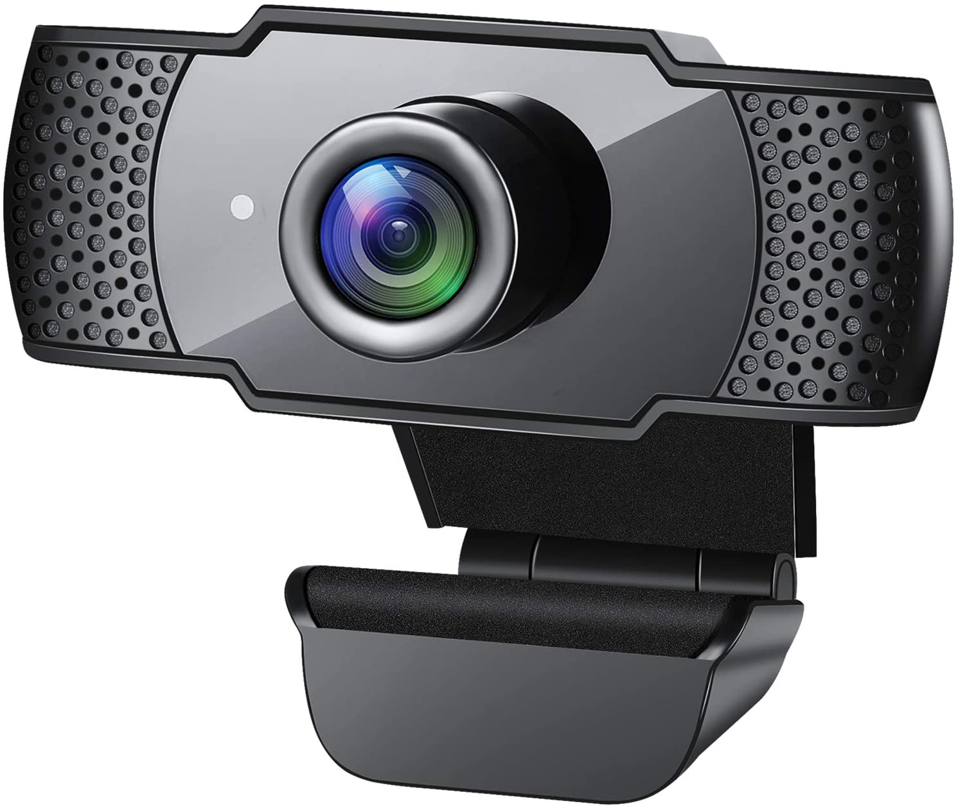

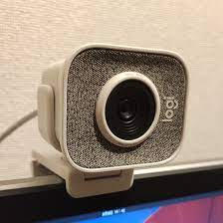

Fig (f). Generic Webcam

A webcam is a video camera which is designed to record or stream to a computer or computer network. They are primarily used in video telephony, live streaming and socialmedia, and security. Webcams can be built-in computer hardware or peripheral devices, and are commonly connected to a device using USB or wirelessprotocols.

**6. ARDUINO USB CABLE**

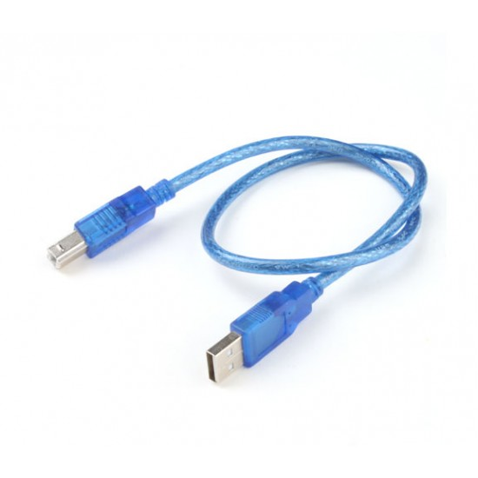

Fig (g). Type A to Type B USB 2.0 Cable

The Arduino USB Cable for UNO and Mega (50 cm) is a type of USB cable designed specifically for the Arduino UNO and Mega microcontroller boards. It has a standard USB connector on one end and a type B USB connector on the other, allowing it to be connected to a computer or other USB device.

**CHAPTER 3. CONCLUSION**

The proposed system sets the green signal time adaptively according to the traffic density at the signal and ensures that the direction with more traffic is allotted a green signal for a longer duration of time as compared to the direction with lesser traffic. This will lower the unwanted delays, and delays, and reduce congestion and waiting time which in turn will reduce the fuel consumption and pollution.

The new system is expected to shows much improvement over the current system in terms of the number of vehicles crossing the intersection, which is a significant improvement. This system can thus be integrated with the CCTV cameras in major cities in order to facilitate better management of traffic.

The solutions explored in the project span a wide spectrum, from short-term interventions like optimizing traffic signals timings to long-term strategies like promoting sustainable transportation modes and urban planning revisions.

The project has significant impacts on traffic congestion, ranging from increased travel times and decreased productivity to heightened pollution levels and compromised public safety.

**3.2 LEARNING OUTCOMES**

* Environmental Awareness: Recognize the role traffic management plays in reducing emissions and promoting sustainable transportation practices.
* Evaluation and Analysis: Develop skills to evaluate the effectiveness of traffic light strategies by analyzing data and making evidence-based decisions.
* Traffic Management Skill: Develop a strong understanding of traffic management principles, including signal timing, intersection design, and traffic flow dynamics.
* Future Relevance: Gain knowledge and skills that are applicable in a rapidly urbanizing world where traffic management solutions are of increasing importance.
* Overall, participation in this project provides a well-rounded learning experience that encompasses technical skills, problem-solving abilities, teamwork, and a broader understanding of urban transportation challenges and solutions.
* Engaging in a project focused on solutions for traffic congestion using traffic lights can result in several valuable learning outcomes.

**REFERENCES**

S. S. R and L. Rajendran (2021), "Real-Time Adaptive Traffic Control System For Smart Cities," 2021 International Conference on Computer Communication and Informatics (ICCCI) (IEEE), pp. 1-6, doi: 10.1109/ICCCI50826.2021.9402597.

Sharon, G. (2021). Alleviating Road Traffic Congestion with Artificial Intelligence. In IJCAI (pp. 4965-4969).

Arnott, R., & Small, K. (1994). The economics of traffic congestion. American Scientist, 82(5), 446-455.

[Mihir Gandhi]. (2020, May 25). *Smart Control of Traffic Light System using Artificial Intelligence* [Video]. YouTube. https://youtu.be/OssY5pzOyo0