**Salesforce NGO Donation & Volunteer Management System  
Daily Development Log**

This document records the day-wise development progress of the Salesforce Capstone Project – NGO Donation & Volunteer Management System. Each day corresponds to a project phase and includes tasks completed, deliverables, and status updates.

# Day 1 – Phase 1: Problem Understanding & Industry Analysis

## Tasks Completed:

• Requirement Gathering: Identified main features – donor registration & donation tracking, volunteer registration & event assignment, event management, automated emails, reporting.

• Stakeholder Analysis: Defined key stakeholders – NGO Admin, Donor Manager, Volunteer Manager, Donors, Volunteers.

• Business Process Mapping: Outlined donor cycle, volunteer cycle, and event cycle; created process flow diagram.

• Industry-specific Use Case Analysis: Researched NGO practices with Salesforce (Nonprofit Success Pack).

• AppExchange Exploration: Reviewed existing solutions like NPSP, Volunteer Management apps.

## Deliverables:

• Requirements_Day1.docx uploaded to GitHub.

• ProcessFlow_Day1.png (business process diagram) uploaded to GitHub.

## Status

• Completed requirement gathering, stakeholder analysis, business process mapping, industry-specific use case analysis, and AppExchange exploration for the NGO Donation & Volunteer Management System. Uploaded requirements document and process flow diagram to GitHub.  
  
  
  
  
  
**Day 2 – Daily Progress Report**

### What I worked on today

Today, I focused on building the **core data model** for our Salesforce NGO Donation & Volunteer Management System.

* I created **four main custom objects**: Donor, Donation, Volunteer, and Event.
* I added the important fields for each object, such as email, phone, donation amount, date, event capacity, skills, etc.
* To connect donations with donors, I set up a **lookup relationship** so that every donation record is linked to the correct donor.
* For volunteers and events, I designed a **many-to-many relationship** using a junction object called **Volunteer Event Assignment**. This allows multiple volunteers to join the same event and the same volunteer to participate in many events.
* I also set up **tabs** for all custom objects and added them to our **NGO Manager app**, so now they are easily accessible from the App Launcher.
* Finally, I tested the junction object by assigning volunteers to events — it worked as expected, confirming the model is functional.

### What I achieved today

* A **complete data model** with all objects, fields, and relationships.
* A **junction object** that enables flexible volunteer-event assignments.
* A **custom app (NGO Manager)** where all objects are visible and easy to use.

### Screenshots:

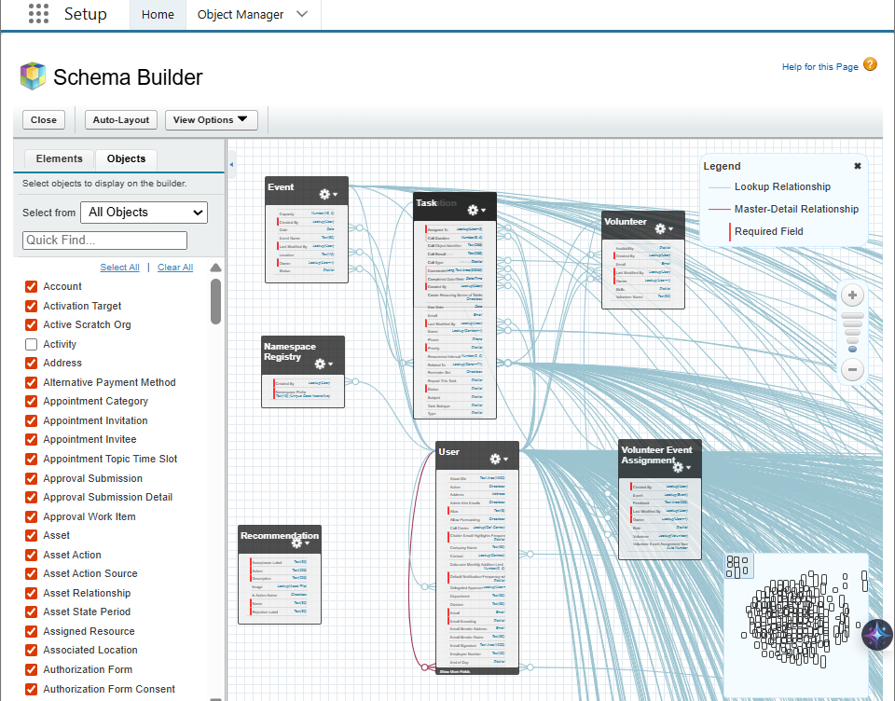

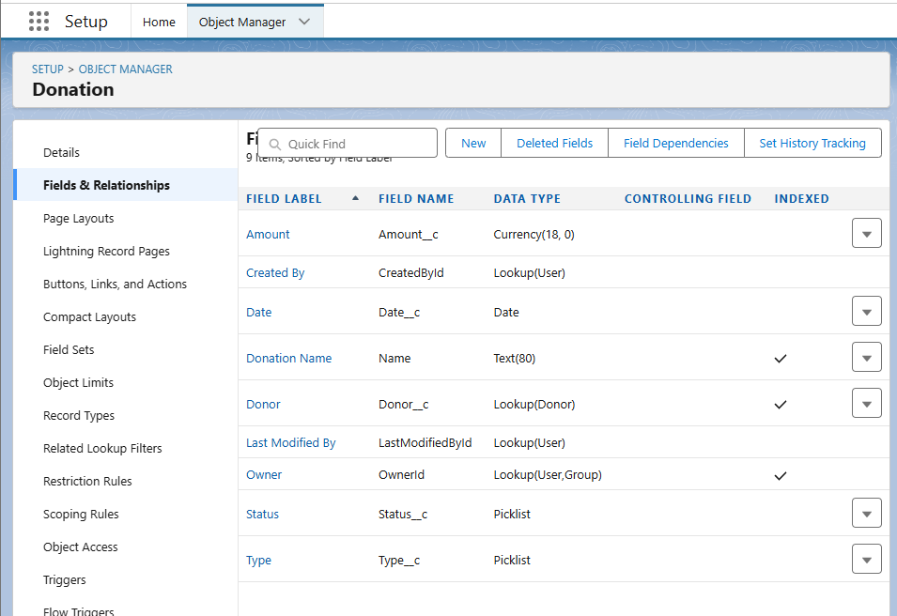

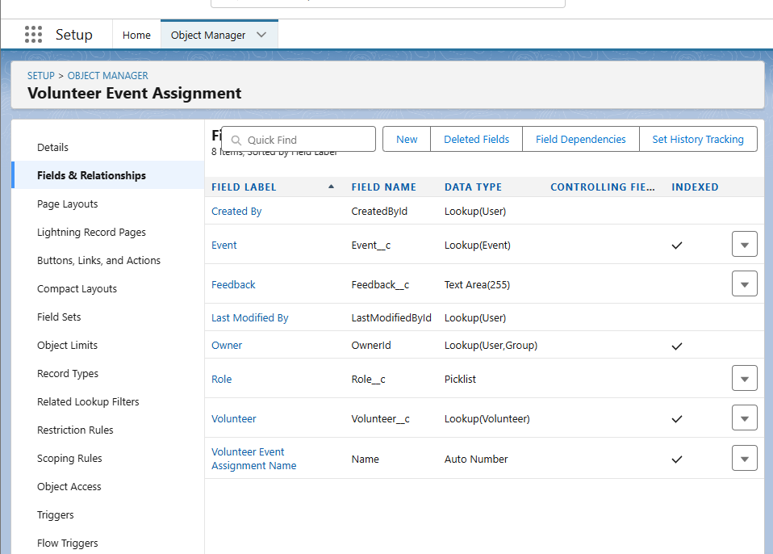

### Day 3 – Daily Progress Report

### What I worked on today

Today, I focused on building **automation and workflows** for our Salesforce NGO Donation & Volunteer Management System.

* I created **validation rules** to improve data quality: one to ensure donation amounts are always greater than zero, and another to stop volunteers from being assigned to events that have no available slots.
* I built two **record-triggered flows**:  
  + The first flow sends a **thank-you email** automatically whenever a new donation is created.
  + The second flow updates the **available slots on an event** whenever a volunteer assignment is made, ensuring event capacity stays accurate.
* I set up an **approval process** for high-value donations (above 50,000). When such donations are entered, they are marked as pending and an email notification is sent to the approver for review.
* Finally, I created two **email templates**: one for thanking donors and another for notifying managers about high-value donations. These templates ensure consistent communication.

What I achieved today

* Data validation to prevent wrong entries.
* Smart automation with flows to reduce manual work.
* Approval process for handling big donations in a professional way.
* Reusable email templates for donor and manager communication.

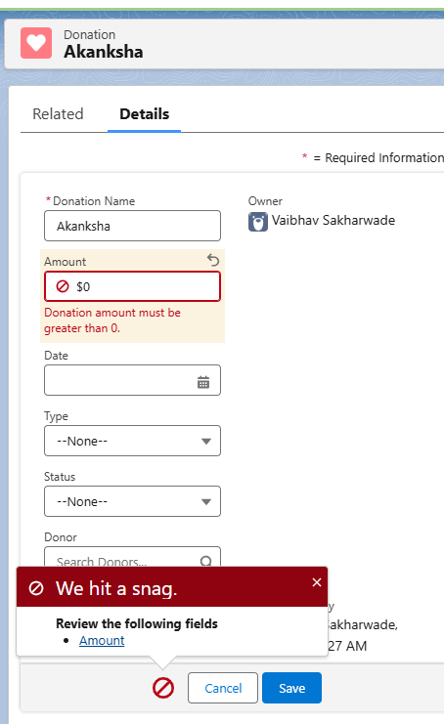

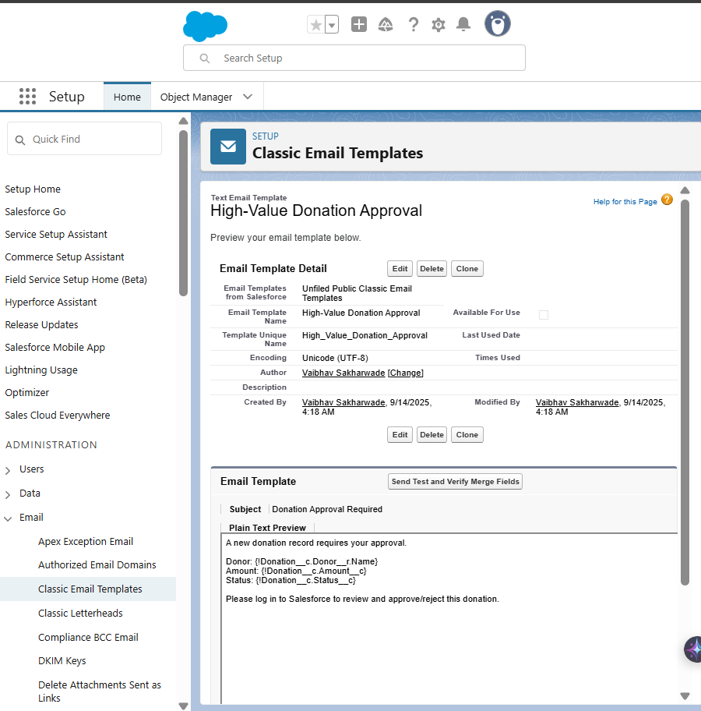

### Day 4 – Daily Progress Report

### What I worked on today

Today, I focused on the **Apex programming phase** of our Salesforce NGO Donation & Volunteer Management project.

* I created an **Apex Trigger** on the Donation object. This trigger automatically updates the status of donations:  
  + Donations above 50,000 are marked as **Pending Approval**.
  + All others are set to **Approved**.
* I developed a reusable **Apex Utility Class (DonationUtils)**. This class calculates the **total amount donated by a specific donor**, which will be useful for reporting and analytics.
* I wrote an **Apex Test Class** to validate the utility method and ensure that the code meets Salesforce’s requirement of at least 75% coverage. The test created sample donors and donations, verified the calculation, and passed successfully.
* I executed the test in Developer Console, checked the **debug logs**, and confirmed correct results and 100% coverage for the utility class.

What I achieved today

* Automated status assignment for donations using Apex Trigger.
* Created a utility method to calculate total donations per donor.
* Verified correctness with Apex test class and achieved full code coverage.
* Successfully tested the functionality with sample data.

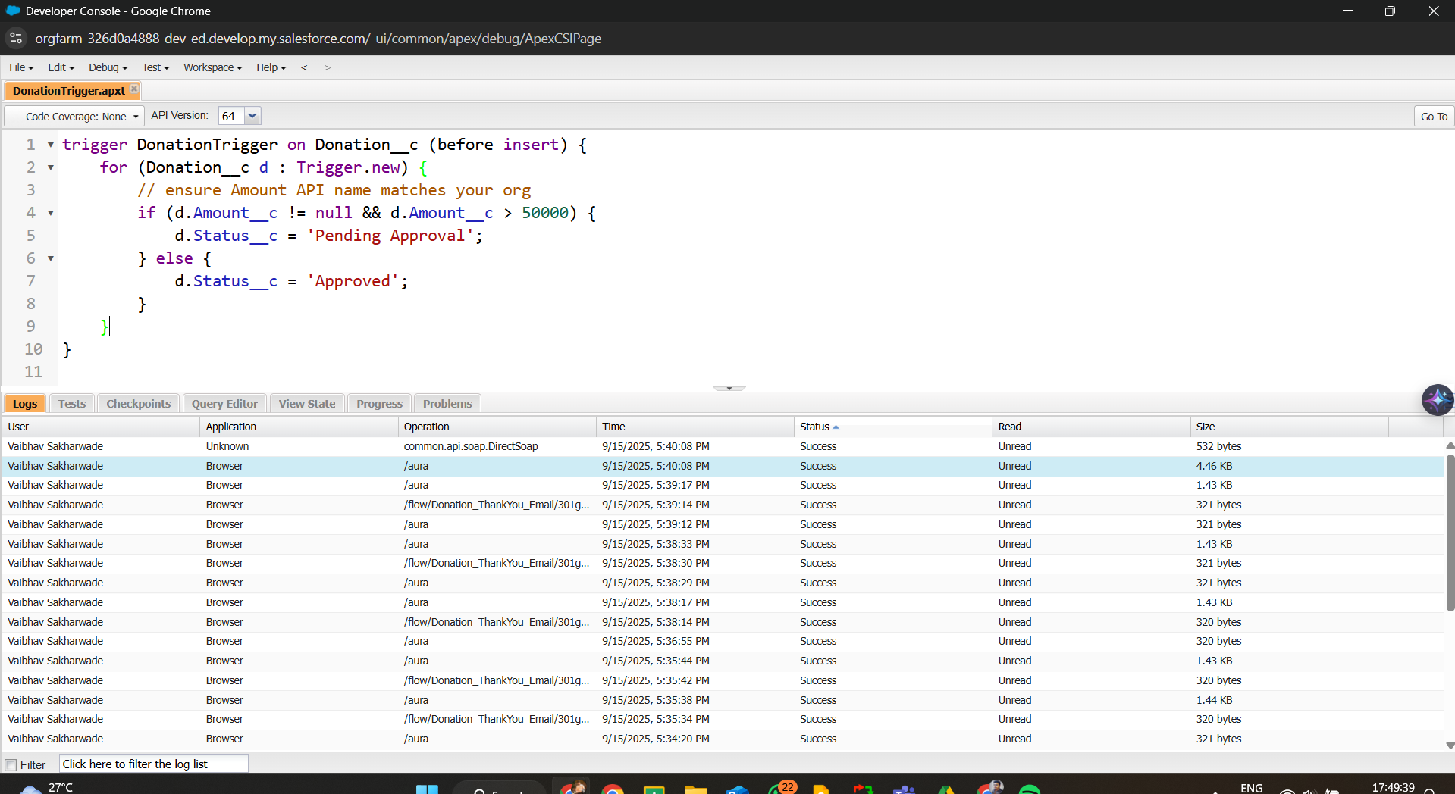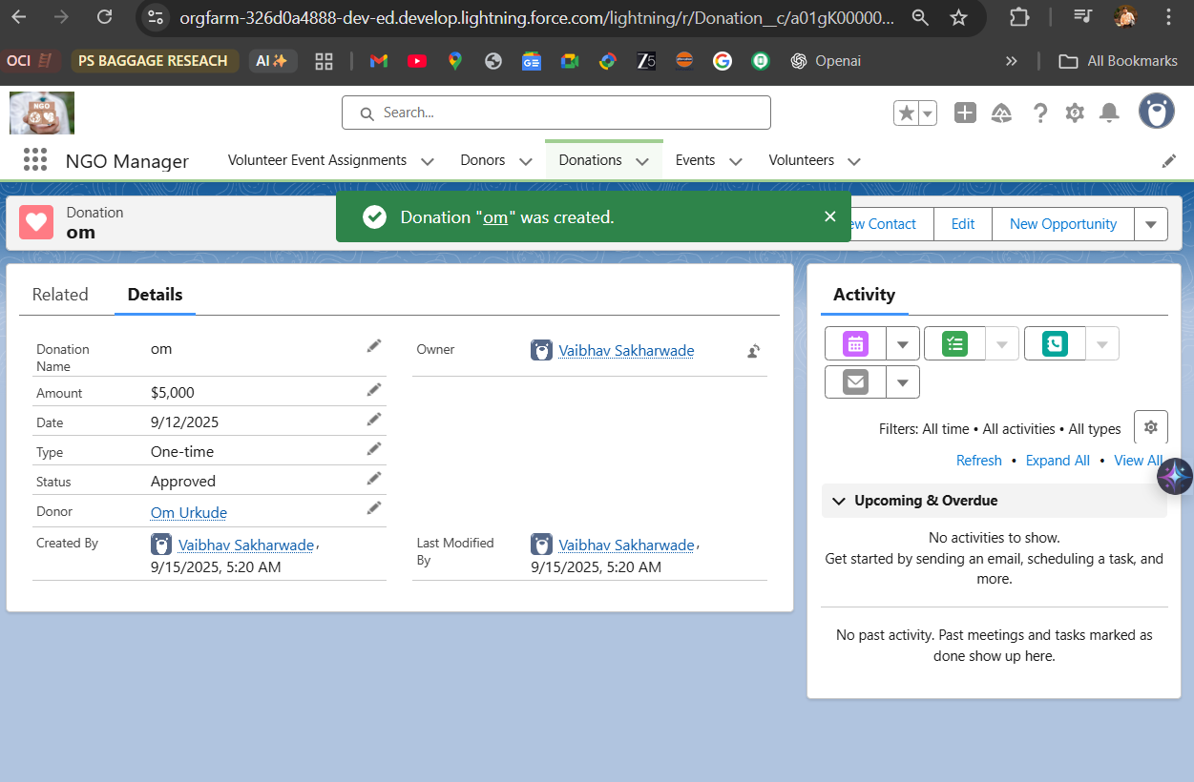

### 

### Day 5 – Daily Progress Report

### What I worked on today

### Today, I worked on improving the user interface (UI) of our Salesforce NGO Donation & Volunteer Management project using Lightning App Builder.

### I customised the record pages for Donor, Donation, Volunteer, and Event objects. Each record page now highlights the most important details at the top, includes related lists for quick navigation, and displays charts where relevant.

### I created a custom Home Page for the NGO Manager app. The Home Page now includes:

### A Report Chart showing donation insights (e.g., donations by donor type).

### Recent Records components for quick access to Donations and Events.

### A List View for Pending Approvals to help managers review high-value donations faster.

### The Assistant Component for reminders and tasks.

### I updated the NGO Manager app navigation bar by adding the Home tab, ensuring users have a central dashboard when they open the app.

### 

### 

### What I achieved today

### Improved user experience with intuitive, clean record pages.

### Set up a central Home dashboard with charts, lists, and tasks.

### Made the NGO Manager app more professional and user-friendly.

### 

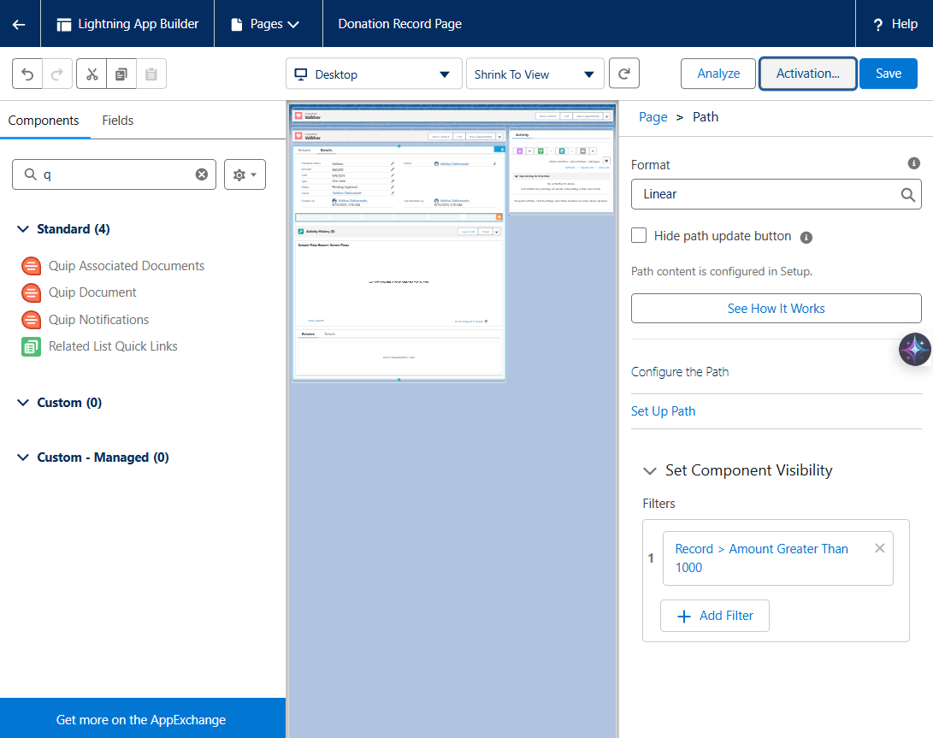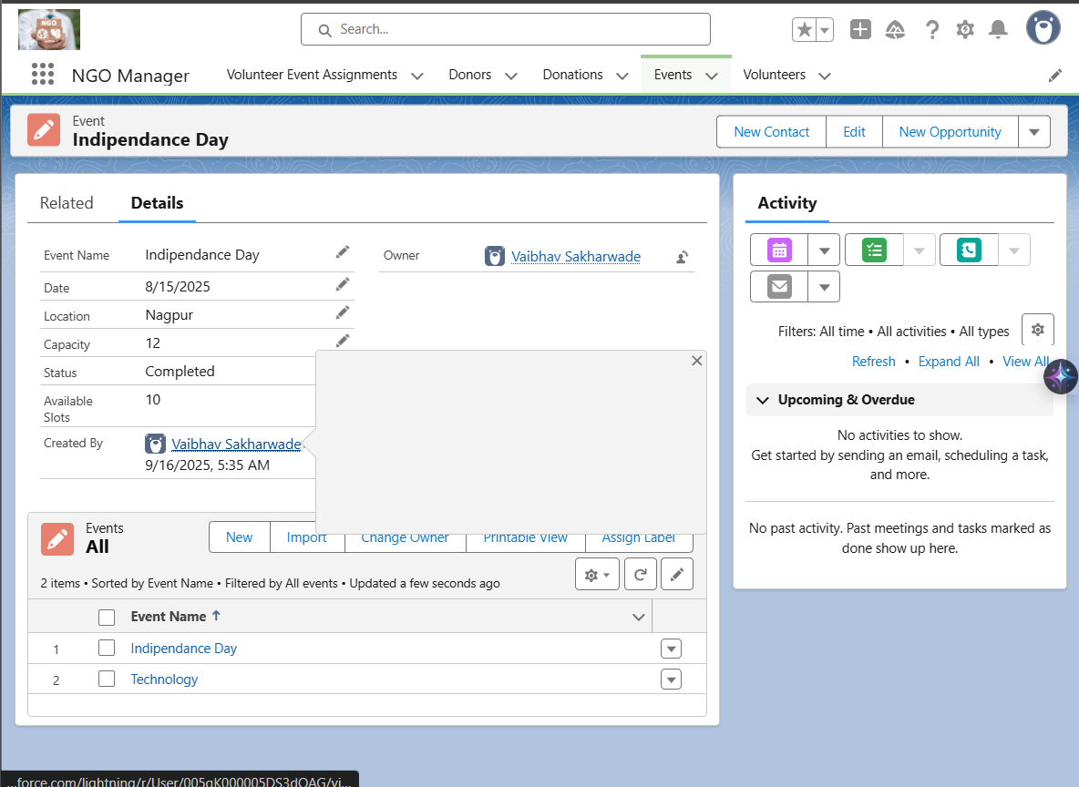



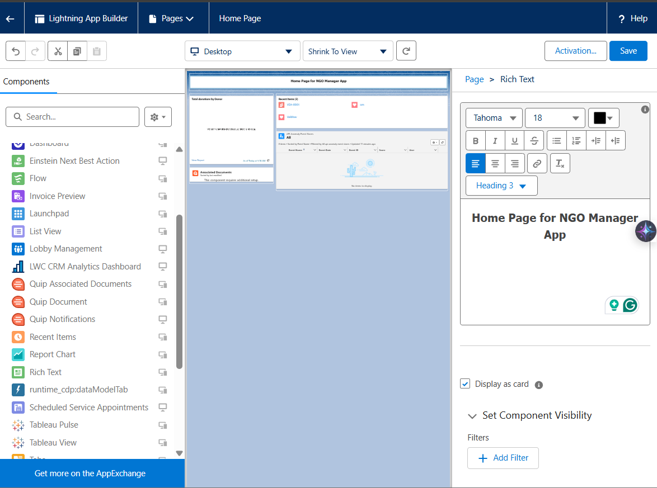

# 

# Day 6 – Daily Progress Report

### What I worked on today

Today was all about building the **integration and external access** part of our Salesforce NGO project. I enabled **Web-to-Lead** and created an external HTML form where donors can enter their details and donation information. When the form is submitted, Salesforce automatically creates a Lead.

To make this meaningful for our NGO use case, I built a **Record-Triggered Flow** that converts these Leads into proper **Donor and Donation records** inside the NGO Manager app. I also updated the Lead layout to include our custom donation fields, which allowed us to test the flow successfully.

### What I achieved today

* Enabled **Web-to-Lead** and generated a working HTML donation form.
* Added **Donation Amount** and **Donation Type** fields to the Lead page layout.
* Built a **Record-Triggered Flow** that auto-creates Donor + Donation records from new Leads.
* Successfully tested the full flow: HTML form → Lead → Donor + Donation.

**Screenshots** 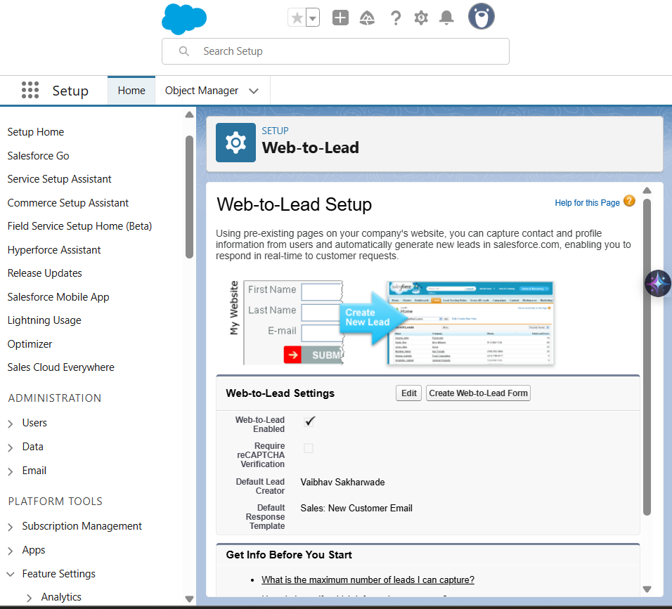

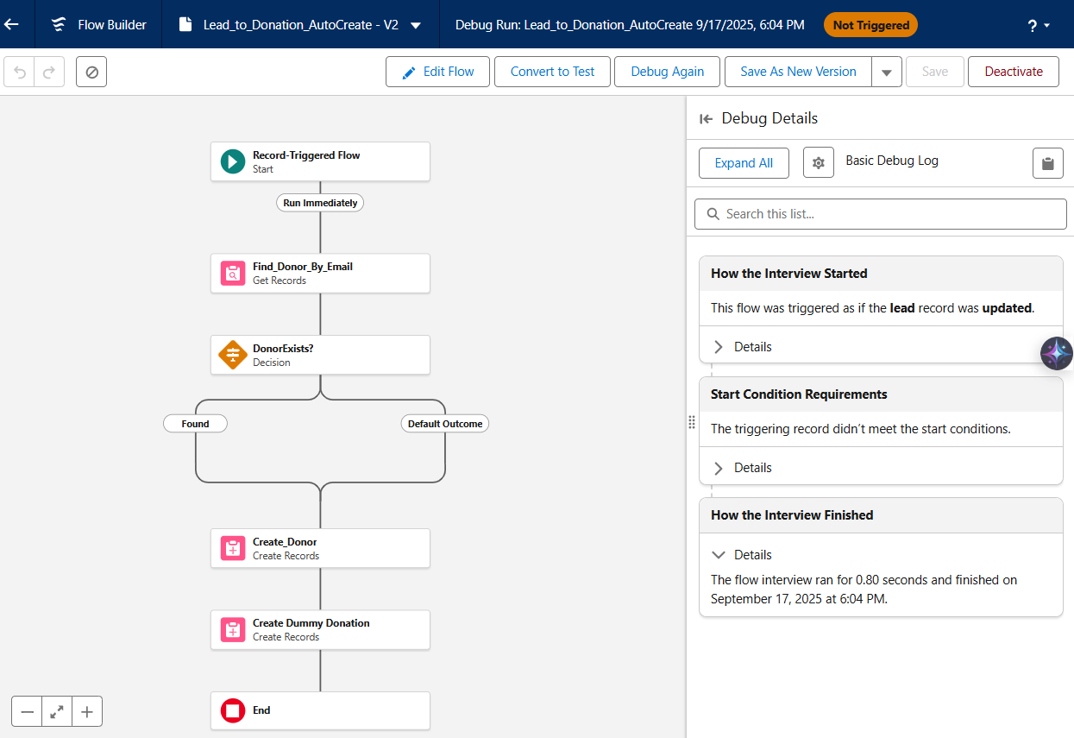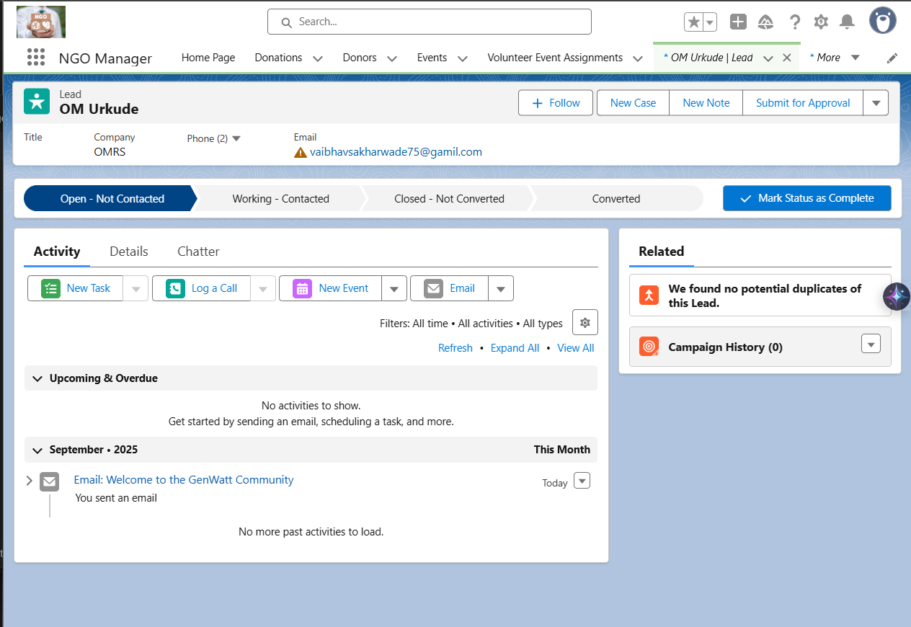

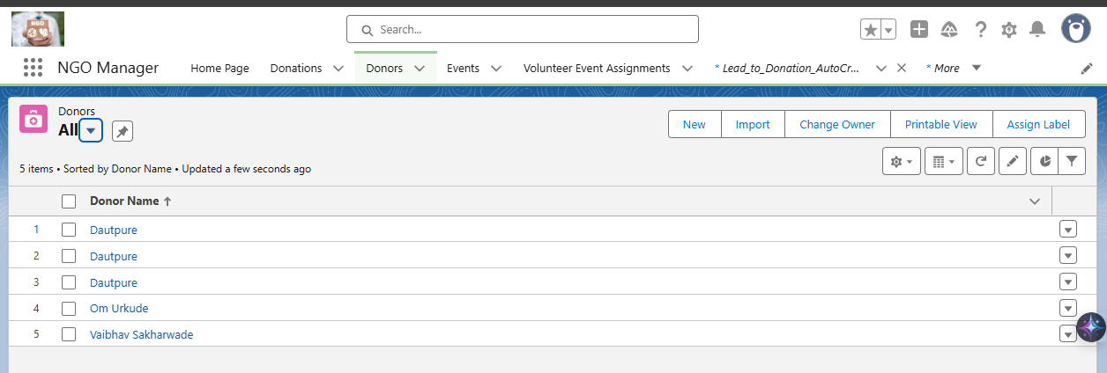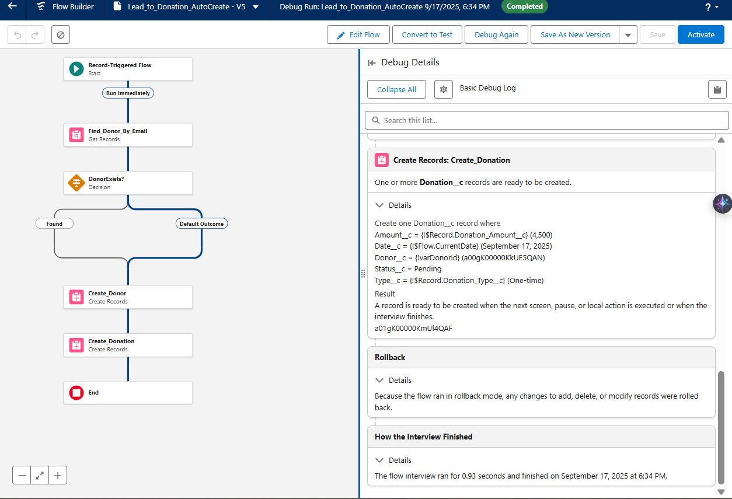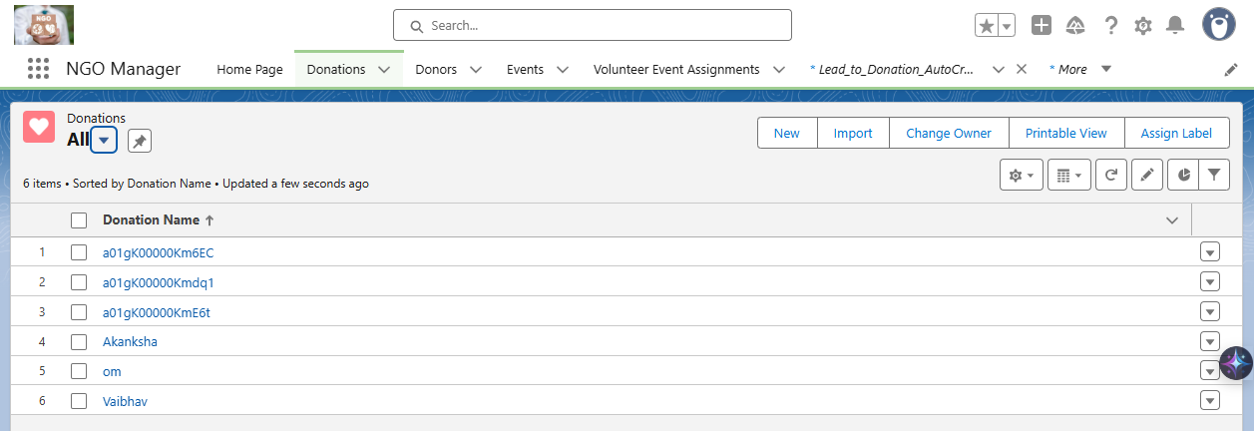

# Day 7 — Daily Progress Report

## Goal of the Day

To populate the Salesforce NGO App with **sample data** (Donors, Volunteers, Events, Donations, and Volunteer–Event Assignments) so the system can demonstrate full end-to-end workflows in later phases.

**Tasks Completed**

### 1. Donors

* Created **25 Donor records** (mix of *Individual* and *Corporate* types).
* Fields filled: *Name, Email, Phone, Donor Type*.
* Verified: Donor records visible under **All Donors** list view.

### 2. Volunteers

* Created **25 Volunteer records**.
* Fields filled: *Name, Email, Skills, Availability*.
* Skills/Availability values aligned with picklist definitions.
* Verified: Volunteer records visible under **All Volunteers** list view.

### 3. Events

* Created multiple **Event records** with details:  
  + *Name, Date, Location, Capacity, Available Slots, Status*.
* Verified: Events visible under **All Events** list view.

### 4. Donations

* Created sample **Donations linked to Donors**.
* Fields filled: *Amount, Date, Type (One-time/Recurring), Status (Pending/Approved)*.
* Verified: Donations appear in **Donations tab** and under **Donor related list**.

### 5. Volunteer Event Assignments (Junction Object)

* Configured **Volunteer ⇄ Event assignments**.
* Edited **Event record page** to show “Volunteer Event Assignments” related list.
* Added roles (Helper, Coordinator, Photographer).
* Verified: Events show linked Volunteers, Volunteers show linked Events.

## Screenshots

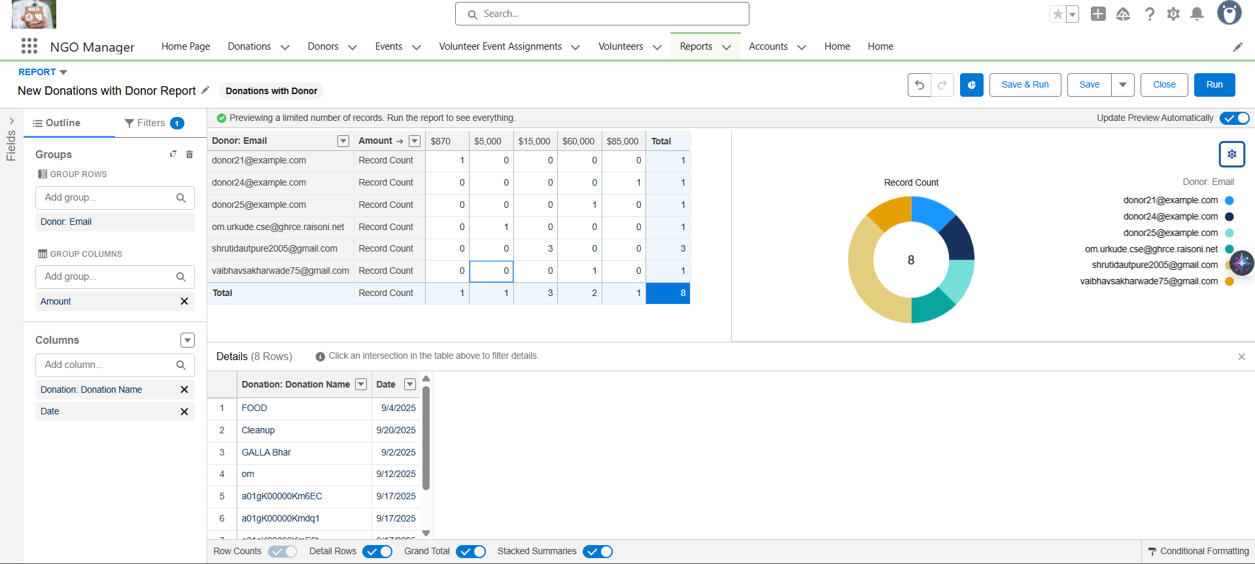

## Challenges Faced

* Errors with picklist values (Skills__c, Availability__c) — resolved by ensuring exact picklist values in Salesforce.
* Field name mismatches (e.g., Event_Name__c vs Name) — resolved by using correct API names.
* Initial Import Wizard issues → switched to **manual entry** for clean dataset creation.

## Outcome

By the end of Day 7, the NGO Salesforce system has a **connected dataset of 25 Donors, 25 Volunteers, multiple Events, Donations, and Volunteer Assignments**. This data is now ready for **Day 8: Reports & Dashboards**

# Day 8 - Daily Progress Report

# 

# Goal of the Day

Build **Reports & Dashboards** to provide NGO managers with real-time insights into **donors, donations, volunteers, and events**.

## Tasks Completed

### 1. Created Report & Dashboard Folders

* Report folder: **NGO Reports**
* Dashboard folder: **NGO Dashboards** Keeps all analytics resources organized.

### 2. Reports Built

* **Donations by Donor** → Groups donations by Donor, shows total amount.
* **High-Value Donations** → Filters approved donations ≥ 5000, grouped by Donor Type.
* **Volunteers by Event** → Shows volunteers assigned per event with their roles.
* **Event Capacity Utilization** → Displays event capacity vs available slots with formula field for “Filled Slots”.

3. Dashboard Created

**NGO Overview Dashboard** with 4 components:

* Bar Chart → Top Donors (from Donations by Donor report).
* Donut Chart → High-Value Donations split by Donor Type.
* Stacked Bar → Volunteers by Event and Role.
* Gauge Chart → Event Capacity Utilization (slots filled).

## Screenshots

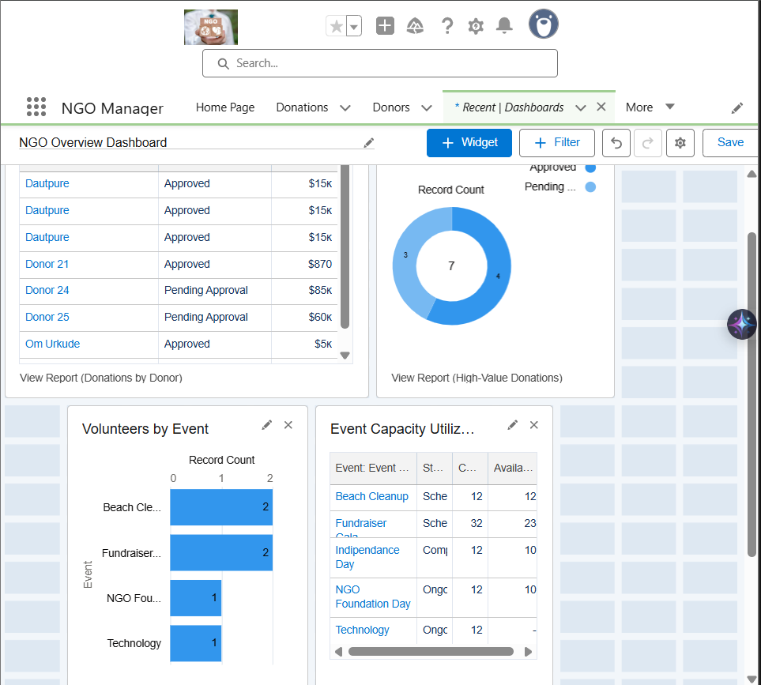

## Challenges Faced

* Needed to adjust **picklist values and formulas** while building reports.
* Ensured correct report types (e.g., “Donations with Donors”, “Volunteer Event Assignments with Volunteers”).  
  .