**Week 01**

* **Sarang**:
  + Learn about different types of datasets used in object detection (e.g., COCO, Pascal VOC).
* **Aakarsh**:
  + Study cloud storage platforms like Google Drive and AWS S3, focusing on how to manage large datasets.
* **Ansh**:
  + Familiarize about object detection preprocessing techniques like image resizing, normalization, and augmentation.
* **Rohit**:
  + Study the architecture of various object detection models, including YOLO, Faster R-CNN, and SSD.
* **Akanksha**:
  + Study the technical aspects of writing reports for machine learning projects.
* **Vaibhav**:
  + Study how different modules (preprocessing, training, evaluation) are integrated into a cohesive system.

**Week 2**

* **Sarang**:
  + Understand how to split datasets into training, validation, and test sets, ensuring no data leakage.
* **Aakarsh**:
  + Learned about implementing data access controls, ensuring each team member can access and work with the dataset.
* **Ansh**:
  + Explore data augmentation techniques (e.g., flipping, rotation, brightness adjustments) for improving model generalization.
* **Rohit**:
  + Discover how to tune hyperparameters for object detection models.
* **Akanksha**:
  + Studied the drafting of the report, detailing preprocessing techniques and dataset preparation strategies.
* **Vaibhav**:
  + Practice development of simple machine learning models and understand how the development will work with object detection models.

**Week 3**

* **Sarang**:
  + Ensure that the dataset is uploaded to the cloud and is accessible to all team members.
* **Aakarsh**:
  + Finalize and test preprocessing on the actual dataset to ensure the format is correct for the object detection models.
* **Ansh**:
  + Test training on a small portion of the dataset to ensure the model is working correctly.
* **Rohit**:
  + Test training on a small portion of the dataset to ensure the model is working correctly.
* **Akanksha**:
  + Finalize the literature table and document any challenges encountered during the data collection and preprocessing stages.
* **Vaibhav**:.
  + Finalize dataset splits to be used for model training and evaluation.

**Week 4**

* **Sarang**:
  + Fully implement data cleaning and augmentation, ensuring the dataset is prepared for training.
* **Aakarsh**:
  + Hand off the dataset to the team for preprocessing and model training with the help of Sarang.
* **Ansh**:
  + Try running the preprocessing on the updated dataset, ensuring the images and labels are in the correct format.
* **Rohit**:
  + Tried training of the object detection models (YOLO, Faster R-CNN, SSD) using the preprocessed dataset.
* **Akanksha**:
  + Examine and highlight any issues or challenges encountered during the early stages of model training.
* **Vaibhav**:
  + Begin integrating the model training modules with the overall system, ensuring the output from preprocessing flows into the training pipeline.

**Result:**

An error occurred while execution.

**Error**: Annotation file missing.

**Week 5**

* **Sarang**:
  + Investigate potential issues within the dataset, such as mislabeled bounding boxes or missing labels, that could be affecting the training process.
* **Aakarsh**:
  + Assigned to check for data corruption during the upload or access process and ensure all files are intact.
* **Ansh**:
  + Assigned to encounter issues during model development (e.g.,dataset issues , incorrect module communication).
* **Rohit**:
  + Identify root causes of these problems and communicate with the team for resolution.
* **Akanksha**:
  + Update the project report with details about the errors and challenges encountered during training. Document any corrective actions taken by the team.
* **Vaibhav**:
  + Debug preprocessing pipeline issues, such as incorrect label formats or scaling inconsistencies, that might be affecting model performance (Work with the team to resolve these issues).

**Result:**

**Week 06 | 07**

* **Sarang**:
  + Resolve any remaining dataset issues identified in Week 5, ensuring that all labels and bounding boxes are correct.
  + Revalidate the dataset splits (train/validation/test) to ensure no overlap and that the data is balanced.
* **Aakarsh**: NULL
* **Ansh**: NULL
* **Rohit**: NULL
* **Akanksha**:
  + Monitor access logs and manage data version control to ensure that the team is using the correct and updated dataset.
  + Document the final training results, including accuracy scores and evaluation metrics.
* **Vaibhav**:
  + Retrain the object detection models after resolving preprocessing and dataset issues. Also, Calculate the model accuracy.
  + Ensure that the system is ready for further stages of the project (e.g., testing, validation).

Link to git: https://github.com/Vaibhav-S75/Team_404_Object_Detection.git

**Result**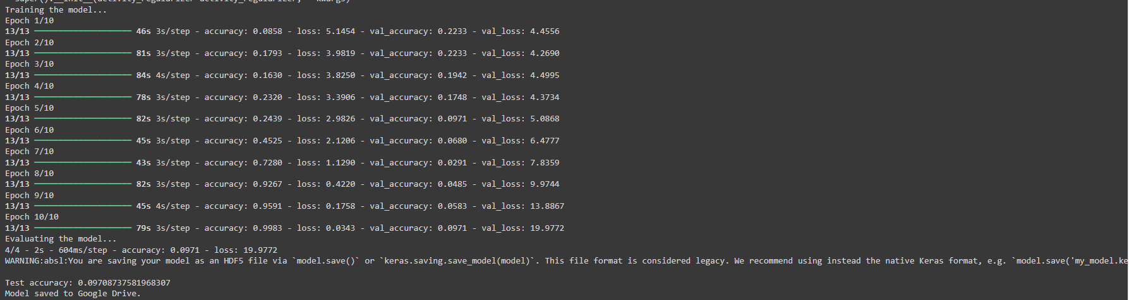

**Week 08**

* **Sarang**:
  + Shorten the 25k dataset to 1k images for testing.
  + Ensure datasets are well-structured and adjustable for training.
* **Aakarsh**: NULL
* **Ansh**: NULL
* **Rohit**: NULL
* **Akanksha**:
  + Study and document **object localization** and **sliding window** approaches.
  + Draft a report section on these concepts and their application.
* **Vaibhav**:
  + Guide the application of **localization** and **sliding window** approaches.
  + Work with Sarang to integrate shortened datasets into the model pipeline.
  + Prepare the system for further testing.

**Week 09**

* **Sarang**:
  + Set up Google Drive and load the dataset, filtering out missing images.
  + Split the dataset into training and validation sets.
* **Aakarsh**: NULL
* **Ansh**: NULL
* **Rohit**:
  + Install required libraries and load COCO annotations.
  + Extract bounding boxes and labels for each image.
* **Akanksha**:
  + Convert labels to one-hot encoding and assist in training.
  + Evaluate model performance and track accuracy.
* **Vaibhav**:
  + Preprocess images and design the CNN model.
  + Retrain the model and optimize its performance.

### 

Link to the colab: [week09_10000_images_withresults](https://colab.research.google.com/drive/1ZWZFhLflySKutQUE7P7xOnDKblMtndSd?usp=drive_open)

**Week 10**

* **Sarang**:
  + Continue loading and filtering the 25k images, ensuring quality and consistency.
  + Finalize the training and validation splits with balanced representation.
* **Aakarsh**: NULL
* **Ansh**: NULL
* **Rohit**:
  + Confirm all annotations align with filtered images and verify label accuracy.
* **Akanksha**:
  + Track model accuracy and key metrics using the full dataset.
  + Document findings and results for the report.
* **Vaibhav**:
  + Checked images for optimal resolution and format.
  + Integrate the full 25k dataset into the model training pipeline.

### 

Link to the colab: [improved_accuracy25k](https://colab.research.google.com/drive/1OHHERCsecP5fhVz8-R0RHMxhUun4vZ1k?usp=sharing)

**Week 11**

* **Sarang**:
  + Continue loading and filtering the 40k images, ensuring quality and consistency.
  + Finalize the training and validation splits with balanced representation.
* **Aakarsh**: NULL
* **Ansh**: NULL
* **Rohit**:
  + Confirm all annotations align with filtered images and verify label accuracy.
* **Akanksha**:
  + Track model accuracy and key metrics using the full dataset.
  + Document findings and results for the report.
* **Vaibhav**:
  + Checked images for optimal resolution and format.
  + Integrate the full 40k dataset into the model training pipeline.

### **Result:** We tried for 40k but as we have resources limitations so we could not proceed further on that.

Link to the colab: [improved_accuracy40k.ipynb](https://colab.research.google.com/drive/1i0wEk3ZrdjB1Fkt9jUUs7z_5sktcpTjx?usp=sharing)