No Objection Certificate for Copyright Application - "SmartDent AI:AI Driven Diagnosis and Treatment Solutions"

To Whom It May Concern,

We, the undersigned, along with the following co-authors, hereby declare that we have jointly authored the software work titled “SmartDent AI:AI Driven Diagnosis and Treatment Solutions”. Collectively, we provide no objection to the copyright of this work being held, as detailed below.

- Vaibhav Suresh Yavalkar; Address: Survey No, 12, Ghodbunder Rd, opp. Hypercity Mall, Bhawani Nagar, Kasarvadavali, Thane West, Thane, Maharashtra 400615; Indian
- Aishwarya Sanjay Londhe; Address: Survey No, 12, Ghodbunder Rd, opp. Hypercity Mall, Bhawani Nagar, Kasarvadavali, Thane West, Thane, Maharashtra 400615; Indian
- Pravin Adivarekar; Address: Survey No, 12, Ghodbunder Rd, opp. Hypercity Mall, Bhawani Nagar, Kasarvadavali, Thane West, Thane, Maharashtra 400615; Indian
- Ekta Suresh Panchal; Address: B-1003, Kavya Residency, Kasarvadavli, Ghodbunder Road, Thane(W)- 400615; Indian
- Aryan Anil Palaspagar; Address: Puranik's Hometown, Near Vedant multi-Speciality Hospital, Ovale 400615; Indian
- Swapnil Mohan Rathod; Address: Room No 2,Gurukrupa Chawl, Chawl no 2,Janki Nagar, Near Sant Nirankari Bhawan, Kalwa, Thane 400605; Indian
- Janvi Dinesh Sharma; Address: Room no.05, Nageshwar niwas, Bhawani chowk, vitawa, kalwa,Thane 400605; Indian

We have no objection to the copyright application filed under Diary Number ……………………… for the software work “SmartDent AI-AI Driven Diagnosis and Treatment Solutions.” being applied by Swapnil Rathod. We further declare that we have provided our full consent willingly and are aware of the implications of the copyright application.

Each author has signed below:

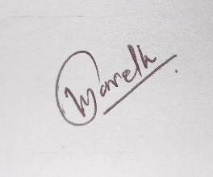

- (Vaibhav Suresh Yavalkar)

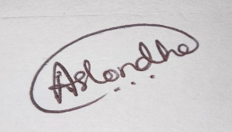
- (Aishwarya Londhe)
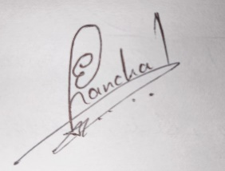
- (Ekta Suresh Panchal)
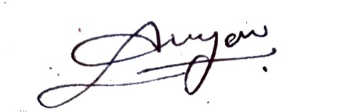
- (Aryan Anil Palaspagar)
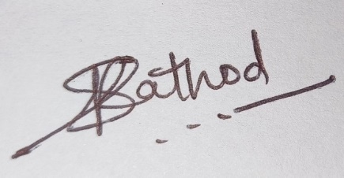
- (Swapnil Mohan Rathod)
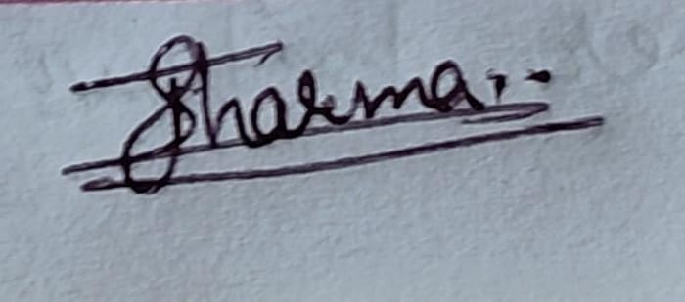
- (Janvi Dinesh Sharma)

Place: A. P. Shah Institute of Technology, Thane
Date: 04/04/2025

