No Objection Certificate for Copyright Application - "SmartAgro: AI-Driven Agricultural System with Climate, Crop, and Market Predictions for Sustainable Farming"

To Whom It May Concern,

We, the undersigned, along with the following co-authors, hereby declare that we have jointly authored the software work titled “SmartAgro: AI-Driven Agricultural System with Climate, Crop, and Market Predictions for Sustainable Farming” Collectively, we provide no objection to the copyright of this work being held, as detailed below.

- Om Dhanaji Jondhale ; Address: B2/301 Ekta Chs ,Old Agra Road, Near Castle, Mill Naka ,Thane West ,400601; Indian

- Meris Nilesh Gada; Address: 104, C-Wing, Green Acres Co-operative Housing Society, Behind Oswal Wadi, Kamatghar Road, Anjurphata, Bhiwandi- 421302 ; Indian

- Vanshika Salve; Address: B11/121, Vijay Nagari, Ghodbundar Road, Waghbil, Thane(W) - 400607; Indian

- Ms. Poonam M Pangarkar; Address: 1502 Evergreen B wing CHS, Hiranandani Rodas, Off Ghodbunder Road, Hiranandani Estate, Thane 400607; Indian

We have no objection to the copyright application filed under Diary Number ……………………… for the software work “SmartAgro: AI-Driven Agricultural System with Climate, Crop, and Market Predictions for Sustainable Farming” being applied by Kunal Saini. We further declare that we have provided our full consent willingly and are aware of the implications of the copyright application.

Each author has signed below:

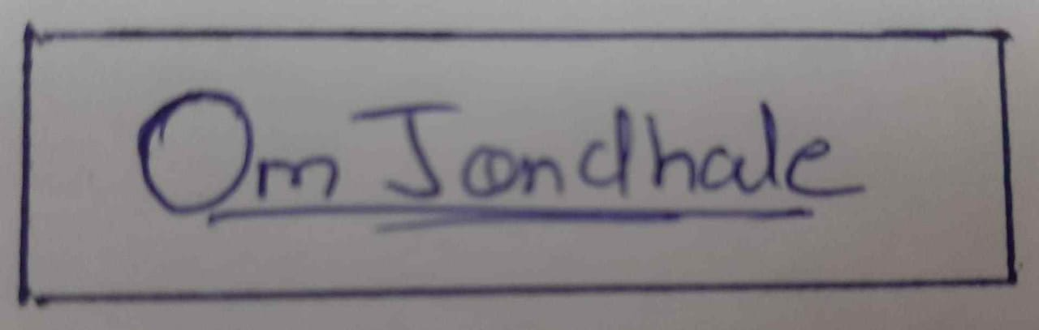

- (Om Dhanaji Jondhale)

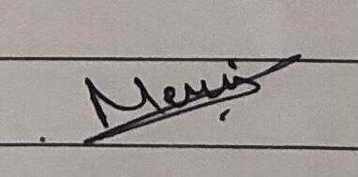
- (Meris Nilesh Gada)
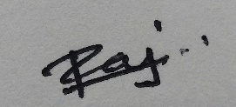

- (Vanshika Salve)


- (Ms. Poonam M Pangarkar)

Place: A. P. Shah Institute of Technology, Thane

Date: 17/04/2025

