**Dr. J. J. Magdum Trust’s**

**Dr. J. J. Magdum College of Engineering,**

**Jaysingpur. 416101**

**Department of Information Technology**

**“ENVIRONMENTAL PROJECT REPORT”**

**“A Study of**

**Conservation of natural Resources”**

**Submitted by,**

**1. HULWAN SHANTANU JAYDEEP**

**2. INGOLE RAVIRAJ NAMDEO**

**3. KALEL AVISHKAR BHARAT**

**4. DUDHAL VIJAY SUNIL**

**Date: - / /2023 Project Guide**

**Place- JAYSINGPUR Prof. Chougule P. A.**

**Year of Submission**

**2022-23Dr. J. J. Magdum Trust’s**

**Dr. J. J. Magdum College of Engineering,**

**Jaysingpur. 416101**

**Department of Information Technology**

**CERTIFICATE**

This is to certify that the project report titled “**A study of Conservation of Natural Resources”**

Submitted by,

**1. HULWAN SHANTANU JAYDEEP**

**2. KALEL AVISHKAR BHARAT**

**3. INGOLE RAVIRAJ NAMDEO**

**4. DUDHAL VIJAY SUNIL**

In Practical fulfillment of the subject “**Environmental studies**” UGC (university grand commission) compulsory course has been completed under the guidance of Prof. Chougule P.A. The conclusion drawn are based on the data collected by them during their stipulated period of field work to the best of our knowledge and belief the matter included in it is their original work

Project In charge Head of Department Principal

Date:

Place: College seal

**Dr. J. J. Magdum Trust’s**

**Dr. J. J. Magdum College of Engineering,**

**Jaysingpur. 416101**

**DECLARATION**

We the undersigned Students of **S.E. (IT)** declare that the field work report entitled “**A study of Conservation of Natural Resource**” written and submitted under the guidance of **Prof. Chougule P.A.** is our original work. The empirical finding is this report is based on the data collected by us. The matter assimilated in this report is not reproduction from any readymade report.

Date :- / /2023

Place-Jaysingpur.

|  |  |  |  |
| --- | --- | --- | --- |
| **Sr No.** | **Name of students** | **Roll No** | **Sign.** |
| 1 | **DUDHAL VIJAY SUNIL** | 13 |  |
| 2 | **SHANTANU JAYDEEP HULWAN** | 21 |  |
| 3 | **INGOLE RAVIRAJ NAMDEO** | 23 |  |
| 4 | **KALEL AVISHKAR BHARAT** | 28 |  |

**Department of Information Technology**

**INDEX**

|  |  |  |
| --- | --- | --- |
| **Sr.No.** | **Contents** | **Page No.** |
| **01** | **Introduction of Environment, Importance Public Awareness &**  **Various types of Environmental Pollution** |  |
| **02** | **Introduction of Project Report** |  |
| **03** | **Aim and Objectives of Project Report** |  |
| **04** | **Actual Methodology** |  |
| **05** | **Observations** |  |
| **06** | **Summary & Conclusion** |  |
| **07** | **Bibliography** |  |

**Introduction of Environment, Importance, Public Awareness.**

**AND**

**Various types of Environmental Pollution.**

Introduction of Environment: -

The Environment is our basic life support system and is composed of living beings, physical surroundings, and climatic conditions. It is derived from a French word, “Environner”, which means “to surround”. The term environment includes all biotic and abiotic entities around us. Biotic refers to the world of living organisms, whereas Abiotic refers to the world of non-living elements.

Environmental studies focus on the impact of human activities on the environment and the need for sustainable practices to ensure the long-term health and well-being of the planet. This includes the study of environmental problems such as pollution, climate change, habitat destruction, and resource depletion.

The field of environmental studies is important for developing solutions to these problems and promoting sustainable development practices. It involves collaboration between scientists, policymakers, and stakeholders to identify problems, develop solutions, and implement strategies for a more sustainable future.

Importance of Environment: -

The Environment provides us with the essential elements – air, water, food, and land which are essential for life to flourish on the Earth. Environment not only works to maintain balance in the climate and also provides all the things necessary for life.

The environment is of vital importance to all living beings on Earth. Here are some reasons why the environment is important:

1. Life Support System:

The environment provides essential resources such as air, water, food, and shelter that are necessary for the survival of all living beings.

1. Biodiversity:

The environment is home to a vast array of plant and animal species, which contribute to the natural balance of ecosystems and support human life through services such as pollination, pest control, and nutrient cycling.

1. Climate Regulation:

The environment plays a critical role in regulating the Earth's climate by absorbing and releasing heat, and regulating the carbon cycle.

1. Cultural Significance:

The environment holds cultural, spiritual, and historical significance for many societies and indigenous communities, and is often the basis of their identity and way of life.

1. Economic Value:

The environment provides numerous economic benefits such as natural resources, tourism, and recreation, which contribute to the livelihoods of millions of people around the world.

Public Awareness: -

Public awareness is the public's level of understanding about the importance and implications of a certain program or an activity. Raising public awareness is not the same as telling the public what to do. It is explaining issues and disseminating knowledge to people so that they can make their own decisions.

It is important to raise public awareness on the environment because it helps people to understand the impact of human activities on the natural world, and to appreciate the value of conserving natural resources and protecting the planet. When people are aware of environmental issues, they are more likely to take action to protect the environment, such as reducing their carbon footprint, conserving water, and supporting environmentally-friendly policies and practices

Various types of Environmental Pollution:

Environmental pollution refers to the introduction of harmful substances or contaminants into the natural environment, which can cause adverse effects on living organisms and the natural world. Modifying the environment caused by human influence, which often renders the environment harmful and unpleasant to live in, is called Pollution. Atmospheric Pollution is caused by gases such as Sulphur dioxide, carbon monoxide, and nitrogen oxides being released into the atmosphere by various industries and by burning fossil fuels. Water Pollution is caused by many substances, such as those found in fertilizers and industrial effluents. There are several types of environmental pollution, including:

**Air Pollution**:

This refers to the release of harmful chemicals and particulate matter into the air, which can lead to respiratory problems, cardiovascular disease, and other health issues. It is the result of a wide range of natural sources and human activities such as the greenhouse gas emissions caused by burning fossil fuels like coal and petroleum, construction and demolition, and the use of chemical and synthetic products. Wildfires are also a major source of air pollution.

**Cause: -**

Air pollution is caused by solid and liquid particles and certain gases that are suspended in the air. These particles and gases can come from car and truck exhaust, factories, dust, pollen, 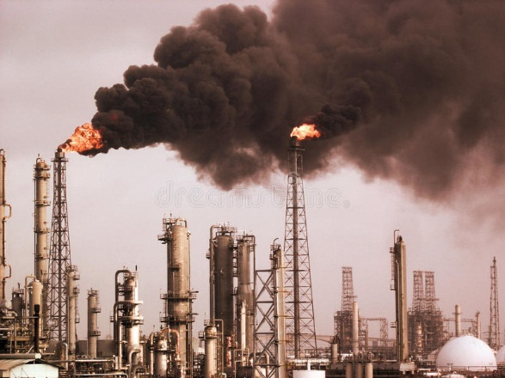mold spores, volcanoes and wildfires. The solid and liquid particles suspended in our air are called aerosols. Air pollution happens when solid and liquid particles—called aerosols—and certain gases end up in our air. These particles and gases can be bad for the planet and for our health, so keeping track of them is important. Air pollution can also happen indoors – for instance; radon gas is colorless and odourless. It also has the tendency to accumulate inside closed spaces, such as the basements of buildings. This gas is also considered to be a carcinogen; hence it may cause cancer.

**Effect: -**

People experience a wide range of health effects from being exposed to air pollution. Effects can be broken down into short-term effects and long-term effects. Like people, animals, and plants, entire ecosystems can suffer effects from air pollution. Haze, like smog, is a visible type of air pollution that obscures shapes and colors. Hazy air pollution can even muffle sounds. Air pollution particles eventually fall back to Earth. Air pollution can directly contaminate the surface of bodies of water and soil. This can kill crops or reduce their yield. It can kill young trees and other plants.

**Solution: -**

Actions You Can Take to Reduce Air Pollution: -Follow these Tips Every Day to Reduce Pollution: Conserve energy - at home, at work, everywhere. Look for the ENERGY STAR label when buying home or office equipment. Carpool, use public transportation, bike, or walk whenever possible. Follow gasoline refueling instructions for efficient vapor recovery, being careful not to spill fuel and always tightening your gas cap securely. Consider purchasing portable gasoline containers labeled “spill-proof,” where available. Keep car, boat, and other engines properly tuned. Be sure your tires are properly inflated. Use environmentally safe paints and cleaning products whenever possible. Mulch or compost leaves and yard waste. Consider using gas logs instead of wood.

**Water Pollution**:

This refers to the contamination of water bodies such as rivers, lakes, and oceans, due to the release of chemicals, sewage, and other pollutants. Water pollution can harm aquatic life, and also affect human health when contaminate water is consumed or used for daily activities.

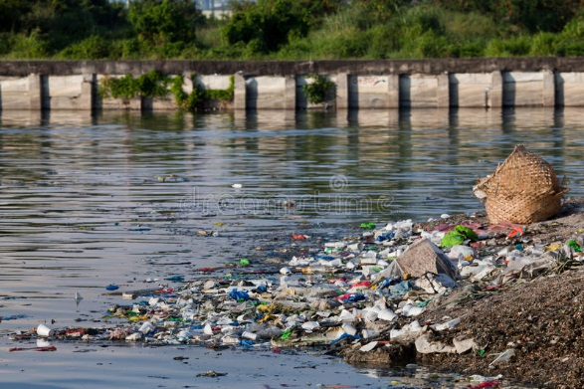

**Causes:** -

Causes of water pollution can be anything from overdevelopment to inappropriate sewage disposal. Once the cause of water pollution is identified, solutions can be made to combat the issue. Some of the water pollution causes - Urban development, Sewage & wastewater, Mining, Marine dumping, Oil leakages, Burning fossil fuels, Agriculture: Chemical fertilizers & pesticides, Sewer leakages, Global warming, Radioactive waste, Animal waste, Eutrophication, Acid rain

**Effects: -**

Deteriorating water quality is damaging the environment, health conditions and the global economy. The president of the World Bank, David Maples, warns of the economic impact: "Deteriorating water quality is stalling economic growth and exacerbating poverty in many countries". The explanation is that, when biological oxygen demand — the indicator that measures the organic pollution found in water — exceeds a certain threshold, the growth in the Gross Domestic Product (GDP) of the regions within the associated water basins falls by a third. In addition, here are some of the other consequences: Destruction of biodiversity, Contamination of the food chain, Lack of potable water, Disease, etc.

**Solution: -**

There is no single or simple answer to stop the water pollution crisis, however, there are many solutions to prevent water pollution both in our daily lives and within industries. We can separate the issue with water pollution into 10 notable solutions: Wastewater Treatment, Reducing Plastic Waste, Water Conservation, Water-efficient Toilets, Septic Tanks, Do Not Use the Toilet as a Trash Bin, Storm water Management, Green Agriculture & Wetlands, DE nitrification, and Ozone Wastewater Treatment.

**Soil Pollution**:

This refers to the contamination of soil with toxic chemicals, pesticides, heavy metals, and other pollutants. Soil pollution can harm plants and animals, and also affect human health when contaminate food is consumed.

**Causes**:

Anthropogenic (man-made) soil pollution originates in several types of processes, some deliberate ([industrial](https://www.environmentalpollutioncenters.org/industrial-sites/)) and some accidental. Human-caused soil pollution can work in conjunction with natural processes to increase the toxic contamination levels in the soil.

Accidental spills and leaks during storage, transport or use of chemicals (e.g. leaks and spills of gasoline and diesel at [gas stations](https://www.environmentalpollutioncenters.org/gas-stations/));, Agricultural activities involving the diffusion of herbicides, pesticides and/or insecticides and fertilizers;, Transportation activities, releasing toxic vehicle emissions, Chemical waste dumping, whether accidental or deliberate – such as illegal dumping;

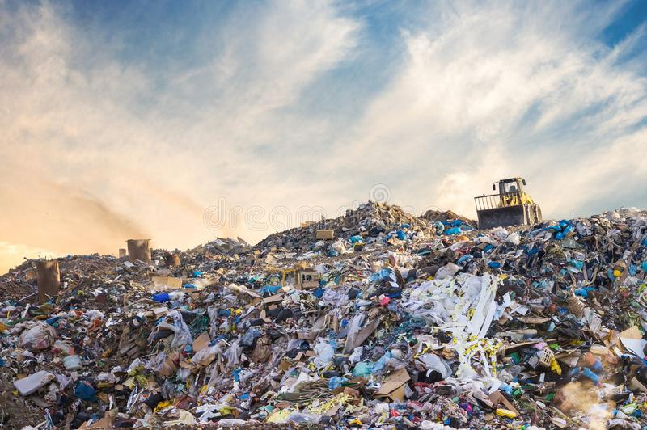

**Effects:**

Soil influences almost all aspects of our daily lives. Sometimes we fail to understand it. As a result of this, we sometimes fail to understand the effect that soil pollution has on our daily lives. Polluted soil means stunted crops or even a toxic underground water table. Some major effects of soil pollution are listed below.

-Effect on Health of Humans, Effect on Growth of Plants, Decreased Soil Fertility, Toxic Dust, Changes in Soil Structure, Poisoning of the Underground Water Table, etc.

**Solutions:**

Soil pollution is a complex problem that ought to be solved. It is essential that we all realize how important soil is to us. The earlier we realize this, the better we will be able to solve the problem of soil pollution. It is a complex problem, and thus, it requires everyone, from an individual to the government, to work in complete unison. Listed below are a few things that could help in reducing soil pollution.

-Reduced Use of Chemical Fertilizers, Reforestation and Afforestation Should be Promoted, Recycle and Reuse Products, Get the Locals Involved, Promote Use of Natural Manure, etc.

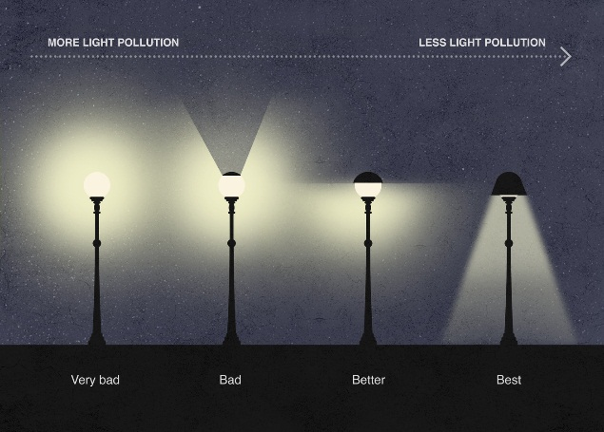**Light Pollution**:

This refers to the excessive or misdirected artificial light that can disrupt ecosystems, interfere with wildlife behavior, and contribute to energy waste. Light pollution, or artificial light at night, is the excessive or poor use of artificial outdoor light, and it disrupts the natural patterns of wildlife, contributes to the increase in carbon dioxide (CO2) in the atmosphere, disrupts human sleep, and obscures the stars in the night sky

**Causes: -**

Light pollution is unique as it is caused by man only. There is no comparable natural form of pollution like there is with carbon dioxide. The main causes of light pollution are: Poor Planning, Irresponsible Use, Overpopulation, Excessive Use of Light, Smog and Clouds, Lights from Cars and Other Motor Vehicles, Streetlamps, Light from Houses and Garage Lamps, Nighttime-lighting, Downtown Areas.

**Effects: -**

While many people choose to dismiss light pollution as being the price of modern life, it has serious effects on everything around it. The Earth’s ecosystem is dependent on cycles of natural light. Since these ecosystems are usually quite sensitive to changes in their environment, they may not be able to adapt to new artificial conditions developed from human-made light pollution. There are also other effects of light pollution such as: Effects on People, Effects on Animals, Sleeping Problems, and Effects on Traffic, Air Pollution, and Waste of Resources.

**Solutions: -**

There are two basic approaches to solving light pollution – planning and education. Planning means more consideration of how areas are zoned and where lights are placed. It also means changing the types of lights used within the home, signs and streetlamps to more efficient bulbs and with a light out Use Certified Lighting put that is not so disruptive. The effective measures are: Light Shields, Warm Lighting, Motion Sensors, Cut off Light, Educate Others.

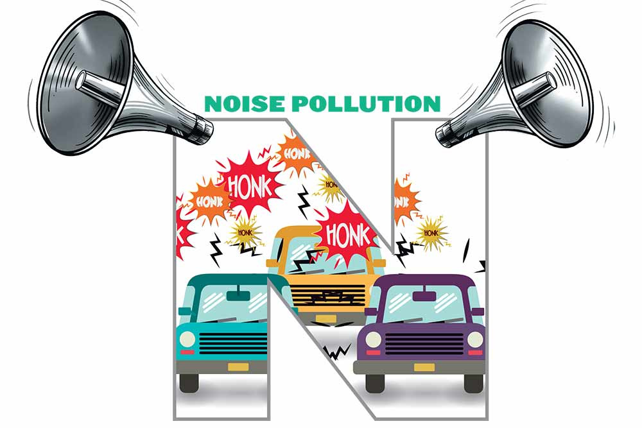**Noise Pollution**:

Noise pollution, unwanted or excessive sound that can have deleterious effects on human health, wildlife, and environmental quality. Noise pollution is commonly generated inside many industrial facilities and some other workplaces, but it also comes from highway, railway, and airplane traffic and from outdoor construction activities.

**Causes**: The natural sources of noise pollution are stormy eruptions, the wild ocean swells, a rush of gutters, thunder, roaring of creatures, etc., They do sometimes, but occasionally they’re veritably damaging. The industrialization has led to an increase in noise pollution.

The use of heavy ministry similar as creators, manufactories, exhaust suckers, etc., produces unwanted noise. The increased number of motorcars on the roads are the alternate reason for noise pollution. marriages and public gatherings involve loudspeakers which results in the product of unwanted noise. Mining, construction of structures and broadsheet., cause noise pollution in the terrain. The use of firecrackers during carnivals is also a source of noise pollution.

**Effect**: -

Noise pollution can beget respiratory problems, high blood pressure, and headaches. Extreme loudness can also lead to a heart attack in some cases. If the sound position is above 80dB. It can beget temporary or endless deafness in people. Sleep Disturbance One cannot have proper sleep during the occasions similar as Diwalietc., and if the regular noise is advanced than 45dB, the children, aged grown-ups, get disturbed with their sleep. Noise may affect people’s capability to concentrate, leading to low performance over time. adding noise pollution day by day reduces the capability and quality of work. If pregnant women are regularly subordinated to noise pollution, they can have a threat of confinement. Loud noise can have hidden goods on humans and creatures, causing aggressive geste and perversity.

**Solution**: -

Honking in public places like tutoring institutes, hospitals, etc., should be banned. The use of firecrackers during carnivals, marriages, and parties should be reduced. Acceptable soundproof systems should be installed in hospitals and artificial structures. thick trees and increased colonies can be useful in noise pollution forestallment. Snares shouldn't be misused in timbers, mountainous, and mining areas. There should be a separation between domestic zones and sources of noise like airfields, manufactories, and diligence. One of the simplest ways you can cover yourself from gratuitous noise pollution is by wearing earplugs.

**Introduction of Project Report**

**Conservation of Natural Resources**

**An Introduction to the Natural Resources:** -

Natural resources are the resources that exist without any actions or intervention of human beings in nature. This includes all of the valued characteristics like gravitational, magnetic, electrical properties and forces, etc. While talking about Earth, it consists of water, sunlight, atmosphere, land including all minerals along with all the vegetation, crops, and animal life that naturally subsists on or within these known and identified substances and characteristics. In this article, we will be learning about natural resources, conservation of natural resources, and the classification of natural resources. Let us first have a look at what natural resources are in detail and how they are conserved.

**What are Natural Resources?**

Natural resources are the ones that come from nature. People cannot make natural resources; however, they can collect them. Some of the examples of natural resources include water, coal, wood, and iron. Some of the resources, for example, hydroelectric energy is not considered to be natural since they are made by people.

**Classifications of Natural Resources: -**

Let us now look at how natural resources are classified.

Natural resources are mainly classified into 2 different categories

1. Renewable natural resources and
2. Non-renewable natural resources
   1. Renewable natural resources are the resources that can be generated again once they are used. Some of the examples of renewable natural resources include sunlight, water, and wood.
   2. Non-renewable Resources: -The resources which cannot be immediately replaced once they are depleted are called non-renewable resources. Examples of non-renewable resources include fossil fuels, such as coal, petroleum, natural gas and rare minerals typically found in meteorites.

**­**

**Introduction to Conservation of Natural Resources:**

Conservation of natural resources is the protection and sustainable use of natural resources such as water, air, soil, minerals, forests, wildlife, marine resources, biodiversity, and renewable energy resources. The conservation of natural resources is essential for sustainable development, the well-being of current and future generations, and the protection of the environment. In this document, we will explore the importance of conservation of natural resources, the challenges faced in conserving natural resources, and the strategies and approaches used to conserve natural resources.

**Importance of Conservation of Natural Resources:**

Natural resources provide essential services such as food, water, air, shelter, and energy. They also support economic development, provide livelihoods, and contribute to cultural and spiritual values. However, the increasing demand for natural resources, population growth, climate change, and environmental degradation have led to the depletion of natural resources and the loss of their services.

**Objective of Subject**

**Aim: Study of Conservation of Natural Resources**

**Objectives:**

1. To study of Natural Resources with practical method.
2. To protect and preserve the flora and fauna to main the balance in the ecosystem
3. To Ensuring Resource Availability for Future Generation
4. To raise public awareness and promote community participation
5. To promote recycling and composting.

**Actual Methodology**

**Introduction to Natural Resources:**

Natural resources are the materials and substances found in the environment that are valuable to humans and other living organisms. They occur naturally and are essential for the survival and well-being of both individuals and societies as a whole. These resources are derived from the Earth and can be classified into two broad categories: renewable and non-renewable resources.

Renewable resources are those that can be replenished or replaced naturally within a relatively short period of time. Examples of renewable resources include sunlight, wind, water, forests, fish, and agricultural crops. These resources are generally sustainable and can be utilized without depleting them permanently. However, proper management and conservation practices are necessary to ensure their long-term availability and prevent overexploitation. On the other hand, non-renewable resources are finite in nature and cannot be replenished within a human lifetime. They exist in limited quantities and are formed over millions of years through geological processes. Non-renewable resources include fossil fuels such as coal, oil, and natural gas, as well as minerals like gold, silver, copper, and uranium. Once these resources are extracted and consumed, they cannot be replaced.

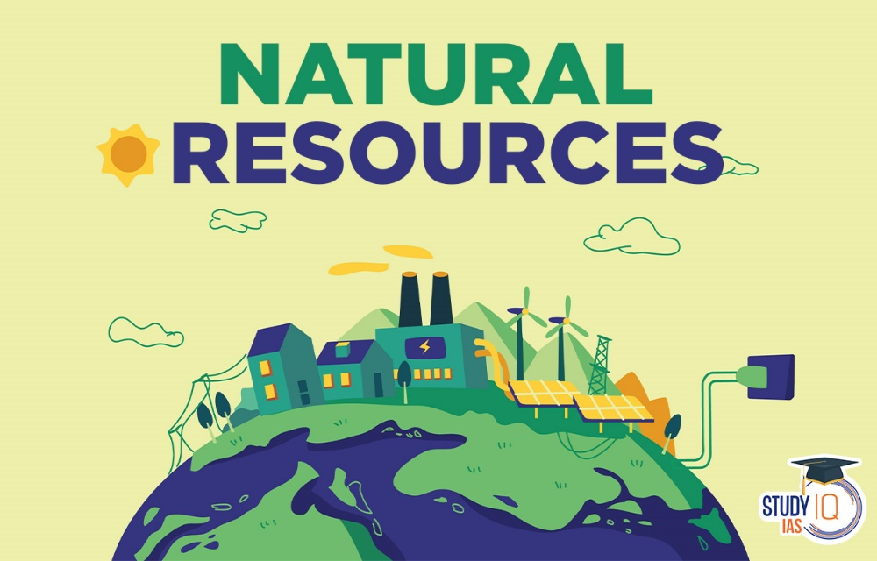

Natural resources play a crucial role in various aspects of human life and the economy. They are used as raw materials for manufacturing, energy production, agriculture, construction, and other industrial processes. Additionally, natural resources provide ecosystem services such as clean air, clean water, and habitat for biodiversity, which are vital for maintaining a healthy environment.

The sustainable management and conservation of natural resources are essential for ensuring their availability for future generations. Overexploitation, pollution, deforestation, and climate change are some of the major challenges that threaten the availability and sustainability of natural resources. To address these issues, it is crucial to adopt practices that promote responsible resource use, reduce waste and emissions, encourage renewable energy sources, protect biodiversity, and promote sustainable development.

**Types of Natural Resource:**

It's important to note that the availability and accessibility of natural resources vary geographically, and their extraction and use can have significant environmental, social, and economic implications. Responsible management and sustainable practices are necessary to ensure their long-term availability and minimize negative impacts on ecosystems and communities.

**1. Renewable Resources:**

a. Solar Energy: Solar energy refers to the radiant light and heat energy emitted by the Sun. It can be harnessed through technologies like photovoltaic (PV) cells, solar panels, and solar thermal systems to generate electricity or provide heating and cooling.

b. Wind Energy: Wind energy is the kinetic energy generated by the movement of air. Wind turbines capture the wind's energy and convert it into electricity through rotational motion.

c. Water Resources: Water resources include freshwater bodies such as rivers, lakes, and underground aquifers. They are essential for human consumption, agriculture, and industrial purposes. Water can also be used to generate hydropower, where the energy of flowing or falling water is converted into electricity.

d. Forests: Forests provide various resources such as timber, wood products, and non-timber forest products (NTFPs) like medicinal plants, fruits, and nuts. They also play a vital role in carbon sequestration, soil conservation, and supporting biodiversity.

e. Agricultural Resources: Agricultural resources encompass crops, fruits, vegetables, and livestock raised for food production. They are renewable through sustainable farming practices and are crucial for ensuring food security.

f. Marine Resources: The oceans provide a wide range of renewable resources. Fisheries yield fish, shellfish, and other seafood, while the ocean floor contains mineral resources like salt, sand, gravel, and even potentially valuable metals. Additionally, marine ecosystems contribute to climate regulation and provide recreational opportunities.

**2. Non-renewable Resources:**

a. Fossil Fuels: Fossil fuels are derived from ancient organic matter, primarily plants and microorganisms. Coal is a solid fuel, while oil (petroleum) and natural gas are hydrocarbon-based fuels. They are major sources of energy for electricity generation, transportation, and industrial processes.

b. .Minerals: Minerals are naturally occurring inorganic substances with specific chemical compositions and physical properties. They include metals like gold, silver, copper, iron, aluminum, and non-metallic minerals such as phosphate, limestone, gypsum, and diamonds. Minerals are used in construction, manufacturing, and various industries.



c. Nuclear Fuels: Nuclear fuels, such as uranium and plutonium, are used in nuclear power plants to generate electricity through a process called nuclear fission. They provide a significant amount of low-carbon electricity, but their use involves concerns related to waste disposal and safety.

d. Natural Gas Liquids (NGLs): NGLs consist of hydrocarbon gases such as ethane, propane, butane, and pentane. They are extracted along with natural gas and are used as fuels, petrochemical feedstocks, and in the production of plastics.

e. Coal Seam Gas (Coalbed Methane): Coal seam gas is methane gas trapped in coal seams. It is extracted and used as a source of energy, particularly for electricity generation and heating.

f. Tar Sands and Oil Shales: Tar sands (bituminous sands) and oil shales are unconventional sources of oil. Tar sands contain a mixture of sand, water, clay, and bitumen, while oil shales contain kerogen. These resources can be processed into oil and petroleum products.

g. Minerals and Metals: This category includes minerals and metals required for various purposes. Rare earth elements are used in electronics, renewable energy technologies, and defence applications. Copper is used in electrical wiring and plumbing, while lithium is vital for batteries in electric vehicles and renewable energy storage systems.

**Importance of Natural Resource:**

Given their importance, it is crucial to manage natural resources sustainably, balancing human needs with long-term environmental and social considerations. Responsible resource management, conservation practices, and the transition to renewable energy sources are essential for ensuring the availability and well-being of current and future generations. Natural resources are of paramount importance to human societies and the environment for several reasons:

1. Economic Significance: Natural resources form the foundation of economic activities and contribute to the overall development of nations. They serve as raw materials for various industries, including manufacturing, construction, energy, and agriculture. The extraction, processing, and utilization of natural resources create jobs, generate revenue, and drive economic growth. For example, the mining industry relies on mineral resources, while the agricultural sector depends on fertile soil, water, and sunlight.

2. Energy Production: Natural resources play a critical role in meeting global energy demands. Fossil fuels, such as coal, oil, and natural gas, have been the primary sources of energy for many years. They power electricity generation, transportation, and industrial processes. Renewable resources like solar, wind, hydro, and geothermal energy are also important contributors to the energy mix. Access to reliable and affordable energy resources is vital for economic productivity, infrastructure development, and improving living standards.

3. Food Security: Natural resources, particularly fertile land, freshwater, and favorable climatic conditions, are essential for agriculture and food production. They support the growth of crops, fruits, and vegetables, as well as livestock rearing. Adequate access to these resources ensures food security, promotes nutrition, and sustains rural livelihoods. Sustainable agricultural practices, including soil conservation and water management, are crucial to protect and enhance these resources.

4. Environmental Stewardship: Natural resources are integral to maintaining the health and balance of ecosystems. Forests, wetlands, and coral reefs provide habitats for numerous species, support biodiversity, and help regulate climate patterns. Natural resources also contribute to climate change mitigation and adaptation. Forests absorb carbon dioxide, acting as carbon sinks, while renewable energy sources reduce greenhouse gas emissions. Protecting and conserving natural resources are vital for preserving ecosystem services, mitigating environmental degradation, and maintaining ecological integrity.

5. Water and Air Quality: Natural resources have a direct impact on the quality of water and air. Rivers, lakes, and aquifers serve as sources of freshwater for drinking, irrigation, and industrial processes. Wetlands act as natural water filters, purifying water and preventing floods. Forests and vegetation play a crucial role in maintaining air quality by absorbing pollutants and releasing oxygen through photosynthesis. Conserving and managing natural resources are necessary to ensure clean and sustainable water and air resources.

6. Cultural and Recreational Value: Natural resources hold cultural, aesthetic, and recreational value. They provide opportunities for outdoor recreation, tourism, and cultural experiences. Natural landscapes, national parks, and protected areas attract visitors, contribute to local economies, and support cultural heritage preservation. Nature-based activities also promote physical and mental well-being, fostering a connection between humans and the natural world.

7. Climate Change Resilience: Natural resources contribute to building resilience against climate change impacts. Forests, wetlands, and mangroves act as natural buffers against storms, floods, and erosion. Ecosystems with high biodiversity tend to be more resilient and adaptable to changing environmental conditions. Conserving and restoring natural resources help mitigate climate change and enhance the resilience of communities and ecosystems.

**Introduction to Conservation of Natural Resource:**

Conservation of natural resources is the protection, preservation, and sustainable use of natural resources to ensure their availability for future generations. It involves managing and using resources in a responsible manner to prevent depletion and damage to the environment. Natural resources include land, water, air, forests, minerals, and wildlife. In this 10-page information, we will explore the importance of natural resource conservation, the threats facing natural resources, and strategies for conservation.

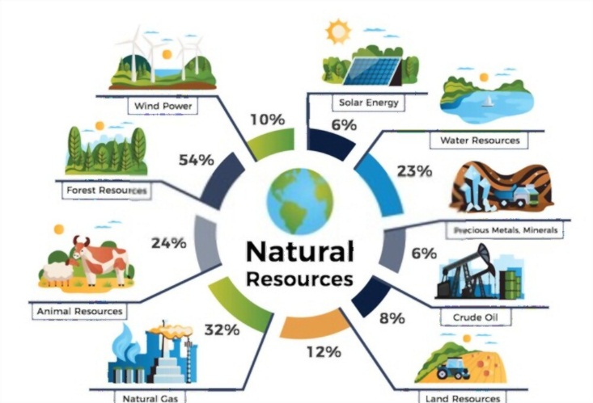**Importance of conservation of natural resources:**

Conservation of natural resources is crucial for several reasons, including:

1. Environmental protection: Natural resources play a vital role in maintaining the balance of the ecosystem. They support the growth of plants and animals, regulate climate, purify water and air, and provide habitats for wildlife. Conservation of natural resources helps protect the environment and prevent the loss of biodiversity.
2. Economic benefits: Natural resources are the basis of many economic activities, such as agriculture, forestry, mining, and tourism. Conservation of these resources helps to sustain these activities and supports the livelihoods of millions of people worldwide.
3. Climate change mitigation: Natural resources such as forests and oceans absorb carbon dioxide, a greenhouse gas that contributes to global warming. Conserving these resources helps to mitigate climate change and reduce the impacts of extreme weather events.

**Types of Conservation :-**

**Forest Conservation**

**Water Conservation**

**Soil Conservation**

**Energy Conservation**

**Forest Conservation: -**

We know that plants and trees are the essential sources of air, food as well as other day-to-day products we use. Forests are the dwelling place of different living creatures and a single disturbance in the ecosystem can cause disruption in the water cycle as well as the food chain. Thus, afforestation is amongst the core Environmental conservation and aims to plant more trees as well as save the existing ones from cutting down as trees play a crucial role in maintaining the ecological balance**.**

Forest conservation is the practice of planting and maintaining forested areas for the benefit and sustainability of future generations. The conservation of forest also stands & aims at a quick shift in the composition of trees species and age distribution. Forest conservation involves the upkeep of the natural resources within a forest that are beneficial to both humans and the environment. Forests are vital for human life because they provide a diverse range of resources: they store carbon &act as carbon sink, produce oxygen which is vital for existence of life on the earth, so they are rightly called as earth lung, help in regulating hydrological cycle, planetary climate, purify water, provide wild life habitat(50% of the earth's biodiversity occurs in forests), reduce global warming, absorb toxic gases & noise, reduce pollution, conserve soil, mitigate natural hazards such as floods& landslides & so on. But now-a-days, forest cover is depleting rapidly due to many reasons such as an expansion of agriculture, timber plantation, other land uses like pulp and paper plantations, urbanization, construction of roads, industries, constitutes the biggest and severe threat to the forest causing serious environmental damage.



Benefits of Forest Conservation: -

1. Forests create oxygen
2. Forests filter the air and reduce pollution
3. Forests provide food security
4. Forests help reduce climate change
5. Forests are an important part of the water cycle
6. Forests prevent soil erosion
7. Forests provide medicine
8. Forests resources provide food, fuel, medicine, shelter, and more.

**Conservation and Management of Water Resources (by Ghanshyam Das): -**

Life on the earth cannot be sustained without water, whether of human beings, animals, flora, or fauna. The demand for fresh water is increasing every day, and the available source of good quality water is in the form of precipitation only, which is more or less constant. It is estimated that this available fresh water on earth is around 36,000 Km3 , which returns to the oceans as runoff. It is, vital to manage this water judiciously for the survival of life on this planet.

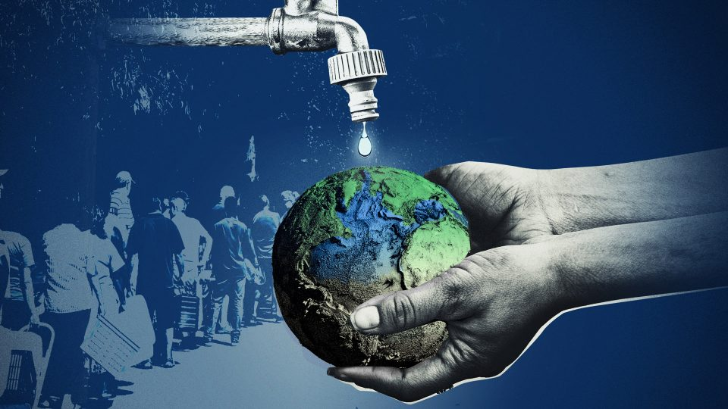 On the earth, about ninety-seven per cent of the total available water is saline and constitutes the oceans. The remaining three per cent is the fresh water, of which seventy-five per cent lies buried as the groundwater, and the remaining one per cent constitutes the fresh water available on the land surface in the form of rivers, lakes, reservoirs, soil moisture and some part of it in the atmosphere.

To effective use freshwater, projects on irrigation, water supply, flood control, water power, water harvesting and navigation are taken up, which require design of different type of energy dissipating, conveyance, and storage structures. Such design work requires hydrological investigations related to storage capacity of reservoirs, flood magnitude and its frequency of occurrence, runoff peak, and seasonal variations in stream discharge.

Benefits of Water Conservation: -

1. If you save water, it can save your money bills.
2. Reduction in interior water use cuts waste water flows, especially overflowing of gutters which contaminates the environment.
3. Environment benefits include eco system and habitat protection.
4. Water conservation helps in improving the quality of your drinking water
5. Saves money
6. Protects drinking water resources
7. Minimizes water pollution and health risks
8. Reduces the need for costly water supply and new wastewater treatment facilities
9. Maintains the health of aquatic environments
10. Saves energy used to pump, heat, and treat water

**Conservation of Soil (by Ghanshyam Das ): -**

Soil Erosion and Sedimentation: -

Soil erosion is the physical removal of topsoil by different agents of nature, viz. falling raindrops, running water, wind velocity and gravitational pull. The Soil Conservation Society of America has defined it as the wearing away of the land surface by running water, wind, ice or other geological agents, including such processes as gravitational creep.

Conservation of Soil: -

The erosive power of natural agents and erodibility properties of the soil combine to cause erosion of soil. This process gets accelerated with and increase in the slope of the land surface and is retarded by a decrease in the slop. The erosive power of rain and wind of the land surface can be decreased by intercepting these agents with a vegetative cover, by increasing the roughness of the land surface by different tillage operations and by decreasing the slope of the land by adoption of suitable practice, viz. bunds, terraces and other such structures. These practices are broadly classified into vegetative, soil management, and mechanical practice, and are employed as per the availability of resource, locally available construction material and expertise, and the severity of soil erosion. The design of these measures for cultivated lands is different from that for forest lands.

Benefits of Soil Conservation: -

1. Improves soil quality and productivity. Increased fertility improves crop yields, reduces the need for chemical fertilizers, and saves money.
2. Optimizes water infiltration. Better filtration increases water storage, preventing soil from drying out.
3. Provides food and shelter. Soil-producing vegetation provides nourishment to all types of animals and offers protection from the elements.
4. Wastewater treatment plants often have a soil treatment.
5. Plants that grow in the soil can be used for medicines, clothing, building materials, etc.
6. Soil provides anchorage for roots and holds water and nutrients.
7. Nutrients are recycled in the soil.
8. Soil is a natural medium for filtering and purifying water.

**Soil Conservation Practices (by Ghanshyam Das): -**

Mechanical and vegetative practice are employed on milder slopes for conservation of soil, by farming across the slope of the land. The basic principle underlying this approach is to cause reduction in the effect of slope on the runoff velocity and, thereby, reduce soil erosion. One steeper slopes, mechanical measures and structure are constructed to reduce the effect of slope on runoff velocity. The most common mechanical measure is the grading (levelling) of land surface, but on very steep slopes deeper cuts and fills are encountered which tend to expose the subsoil, and subsequently cause reductions in the fertility level of soil. In such cases, the land is divided into strips and laid across the slope int he forms of terraces and bunds. Basically, except for bench terraces, in all these strips, the soil forms the top of the strip erodes and settles down at the bottom of the strip, and eventually levels up itself with a grade that is not very erosive.

The following types of vegetative and mechanical practice are being used to present:

* 1. Contouring
  2. Strip cropping
  3. Tillage operation

Author of these book explains how soil erosion take place in first place, how we can prevent soil erosion, and how to face soil erosion problems with solution with deep understanding.

**Energy Conservation :-**

Energy conservation is the decision and practice of using less energy. Turning off the light when you leave the room, unplugging appliances when they’re not in use and walking instead of driving are all examples of energy conservation. The two main reasons people conserve energy are to gain more control over their energy bill and reduce the demand on the earth’s natural resources. While energy efficiency might cost you money up front before potentially saving you money down the road, energy conservation is something you can put into practice immediately, either at very little or no cost to you. Here are 10 energy conservation ideas you can get started with today.

Energy can be conserved by reducing waste and losses, improving efficiency through technological upgrades, improving operations and maintenance, changing user’s behaviours through user profiling or user activities, monitoring appliances, shifting load to off-peak hours, and providing energy-saving recommendations. Observing appliance usage, establishing an energy usage profile, and revealing energy consumption patterns in circumstances where energy is used poorly, can pinpoint user habits and behaviours in energy consumption. Appliance energy profiling helps identify inefficient appliances with high energy consumption and energy load. Seasonal variations also greatly influence energy load, as more air-conditioning is used in warmer seasons and heating in colder seasons. Achieving a balance between energy load and user comfort is complex yet essential for energy preservation. On a large scale, a few factors affect energy consumption trends, including political issues, technological developments, economic growth, and environmental concerns.

Benefits Of Energy Conservation: -

1. Protect the environment
2. Significantly reduce your utility bills
3. Enhance your quality of life
4. Energy savings tips help you easily cut costs
5. Insulate yourself from rising electricity prices
6. Reduce Carbon footprint
7. Helps to reduce other costs & expenses.

**Threats facing natural resources:**

Despite their importance, natural resources face several threats, including:

1. Overexploitation: Many natural resources are being overexploited, leading to depletion and degradation. For instance, overfishing has led to the collapse of several fish stocks, while deforestation has led to soil erosion, loss of habitat, and climate change.
2. Pollution: Pollution of air, water, and soil is a significant threat to natural resources. It affects the health of plants, animals, and humans and can cause irreversible damage to ecosystems.
3. Climate change: Climate change is altering the distribution and abundance of natural resources, leading to changes in ecosystems and the loss of biodiversity. It is also increasing the frequency and severity of extreme weather events, such as floods, droughts, and wildfires.

**Benefits of Conservation of Natural Resources: -**

Conservation of natural resources has numerous benefits, not only for the environment but also for human well-being. Conservation of natural resources is essential for sustaining life on Earth. By protecting these resources, we can ensure the long-term health and well-being of both the environment and human society.

Here are some of the key benefits of conserving natural resources:

1. Biodiversity conservation: Natural resources such as forests, wetlands, and coral reefs are home to a vast array of plant and animal species. By conserving these ecosystems, we can protect the biodiversity of the planet.
2. Climate change mitigation: Natural resources such as forests and oceans play a critical role in regulating the earth's climate. By conserving these ecosystems, we can reduce the impact of climate change.
3. Economic benefits: Natural resources are a critical source of livelihood for millions of people around the world. By conserving these resources, we can ensure sustainable use of these resources, which can help to support local economies and provide long-term benefits.
4. Water conservation: Natural resources such as rivers, lakes, and wetlands are crucial for maintaining a steady supply of clean water. By conserving these ecosystems, we can ensure the availability of clean water for human consumption, agriculture, and other uses.
5. Soil conservation: Soil erosion is a significant threat to agricultural productivity and food security. By conserving natural resources such as forests and grasslands, we can prevent soil erosion and maintain soil fertility.
6. Recreational and cultural benefits: Natural resources such as parks, beaches, and cultural landscapes provide recreational opportunities and cultural significance. By conserving these resources, we can ensure that future generations can enjoy these benefits.
7. Improved air quality: Natural resources such as forests play a critical role in filtering the air we breathe. By conserving these ecosystems, we can improve air quality and promote human health.

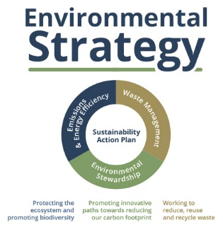**Strategies for conservation of natural resources:**

To conserve natural resources, we need to adopt strategies that promote sustainable use and protect the environment. Some of the strategies include:

1. Sustainable use: We need to use natural resources in a sustainable manner, ensuring that they are not depleted or damaged. This involves using resources efficiently, reducing waste, and promoting recycling.
2. Conservation measures: Conservation measures such as protected areas, wildlife corridors, and habitat restoration can help protect natural resources and preserve biodiversity.
3. Pollution control: Pollution control measures such as reducing emissions from industries and vehicles, promoting clean energy, and proper waste management can help prevent pollution and protect natural resources.
4. Climate change mitigation: Climate change mitigation measures such as reducing greenhouse gas emissions, promoting renewable energy, and forest conservation can help reduce the impacts of climate change on natural resources.
5. Education and awareness: Education and awareness programs can help people understand the importance of natural resource conservation and encourage them to adopt sustainable practices.
6. Renewable Energy: Renewable energy sources such as solar, wind, and hydro can reduce our dependence on fossil fuels, which are non-renewable and contribute to climate change. Using renewable energy sources can help to conserve natural resources such as coal and oil, reduce greenhouse gas emissions, and promote sustainable development.
7. Green Buildings: Green buildings are designed to be energy-efficient, environmentally sustainable, and resource-efficient. Green building practices can help conserve natural resources such as water, reduce energy consumption, and reduce greenhouse gas emissions.
8. Biodiversity Hotspots: Biodiversity hotspots are areas that are rich in biodiversity but are also threatened by human activities such as deforestation and habitat destruction. Protecting biodiversity hotspots can help conserve natural resources and preserve unique ecosystems.
9. Water Conservation: Water is a precious resource, and conserving it is essential for sustainable development. Water conservation strategies such as rainwater harvesting, water-efficient irrigation systems, and water reuse can help conserve natural resources and ensure their availability for future generations.
10. Sustainable Agriculture: Sustainable agriculture involves using farming practices that are environmentally sustainable, socially responsible, and economically viable. Sustainable agriculture practices can help conserve natural resources such as soil and water, reduce greenhouse gas emissions, and promote biodiversity.
11. Green Transportation: Green transportation refers to modes of transportation that are environmentally sustainable, such as electric vehicles, public transportation, and cycling. Using green transportation can help conserve natural resources such as oil and reduce greenhouse gas emissions.

**Importance of technology in conservation efforts.**

Technology has played a significant role in conservation efforts in recent years. Advancements in technology have enabled us to monitor natural resources more accurately, detect changes in ecosystems, and develop more effective conservation strategies.

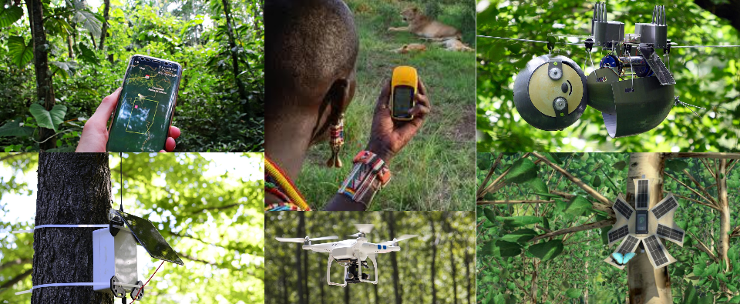Technology plays an important role in conservation efforts. Advancements in satellite technology, GPS tracking, drones, conservation apps, and AI are enabling us to monitor natural resources more accurately, detect changes in ecosystems, and develop more effective conservation strategies. By leveraging technology, we can conserve natural resources and protect them for future generations.

Technology has the potential to revolutionize conservation efforts and enable us to protect natural resources more effectively. By continuing to develop and deploy new technologies, we can ensure that future generations inherit a planet that is healthy, vibrant, and sustainable.

**Examples:**

1. Satellite Technology: Satellites provide high-resolution images that allow us to monitor changes in land use, vegetation cover, and deforestation. This information is essential for identifying areas that require conservation efforts and for tracking changes in biodiversity over time.
2. GPS Tracking: GPS tracking has revolutionized the way we monitor wildlife. Researchers can track the movements of animals and gain insights into their behaviour and habitat use. This information is crucial for developing conservation strategies that protect endangered species and their habitats.
3. Drones: Drones have become increasingly popular for monitoring wildlife and habitat changes. They can provide high-resolution images and videos of inaccessible areas, allowing researchers to identify changes in ecosystems that would have been difficult to detect otherwise.
4. Conservation Apps: There are several conservation apps available that allow people to contribute to conservation efforts. These apps can be used to report sightings of endangered species, monitor water quality, and participate in citizen science projects.
5. Artificial Intelligence: AI technology is being used in conservation efforts to analyse large datasets and identify patterns that would be difficult for humans to detect. For example, AI can be used to analyse satellite images and identify areas that require conservation efforts.
6. Blockchain: Blockchain technology is being used to track the trade of endangered species and prevent illegal wildlife trafficking. By creating a secure and transparent ledger of transactions, blockchain can help ensure that wildlife products are sustainably sourced and legal.
7. In Vitro Meat: In vitro meat is a type of meat that is produced by growing animal cells in a lab. It has the potential to reduce the demand for meat from livestock, which can help to conserve natural resources such as water, land, and energy.
8. Robotics: Robotics technology is being used to study and monitor marine environments, where it can be difficult for humans to operate. For example, underwater robots can be used to study deep-sea habitats and monitor the health of coral reefs.
9. Environmental Sensors: Environmental sensors are being used to monitor air and water quality, soil health, and climate change. They can provide real-time data on environmental conditions, which is essential for developing effective conservation strategies.
10. Wildlife Monitoring Systems: Advanced wildlife monitoring systems use cameras, sensors, and other technologies to detect and track the movements of poachers and illegal wildlife traders. This technology can be used to identify poaching hotspots, track wildlife populations, and monitor the movements of illegal traders.
11. Anti-Poaching Drones: Drones equipped with thermal cameras and other sensors can be used to monitor wildlife reserves and detect poachers. They can also be used to identify and track poachers' vehicles and other equipment, making it easier to catch and prosecute offenders.
12. DNA Testing: DNA testing is being used to identify the origins of illegal wildlife products, such as ivory and rhino horn. By tracing the DNA back to its source, authorities can identify the poaching hotspots and target their efforts to protect these areas.
13. Social Media Monitoring: social media is increasingly being used as a platform for the illegal trade of wildlife products. Conservationists are using social media monitoring tools to identify and track illegal traders, and to raise awareness about the consequences of wildlife trafficking.
14. Wildlife Forensics: Wildlife forensics is the application of scientific techniques to investigate crimes against wildlife. This includes the use of DNA testing, microscopy, and other analytical techniques to identify illegal wildlife products and track their origins.

**Conservation of Natural Resources Location World Wide: -**

There are many places in the world that are known for their efforts to conserve natural resources.

Here are some examples:

1. Serengeti National Park, Tanzania: Serengeti National Park is home to one of the largest mammal migrations in the world and is known for its diverse ecosystem. Efforts are being made to conserve the park's biodiversity through initiatives such as anti-poaching patrols and community-based conservation projects.
2. Yellowstone National Park, USA: Yellowstone National Park is a UNESCO World Heritage Site and is home to several endangered species such as the grey wolf and the grizzly bear. Conservation efforts in the park include the reintroduction of native species and the implementation of sustainable tourism practices.
3. The Great Barrier Reef, Australia: The Great Barrier Reef is the largest coral reef system in the world and is home to several endangered species of marine life. Conservation efforts in the region include initiatives such as coral planting and marine protected areas.
4. Bwindi Impenetrable Forest, Uganda: Bwindi Impenetrable Forest is home to nearly half of the world's remaining mountain gorillas. Conservation efforts in the region include the establishment of national parks and community-based conservation projects.
5. Costa Rica's Ossa Peninsula: The Osa Peninsula is home to several endangered species such as the jaguar and the scarlet macaw. Conservation efforts in the region include the establishment of national parks and community-based conservation projects.

These are just a few examples of the places in the world that are known for their efforts to conserve natural resources. Through initiatives such as national parks, marine protected areas, and community-based conservation projects, these locations are working to protect the natural world for future generations.

**Conservation of Natural Resource in India:** -

India is a country with a rich natural heritage, from the towering Himalayas to the vast forests of the Western Ghats, the country is home to a diverse range of flora and fauna. However, over the years, rapid industrialization and urbanization have taken a toll on the country's natural resources. To counter this, several efforts are underway to conserve India's natural resources.

Here are some of the key conservation initiatives in India:

1. Project Tiger: Project Tiger is a conservation initiative launched by the Indian government in 1973 to protect the Bengal tiger. The project has been successful in increasing the tiger population in India and has now expanded to include other endangered species. The project works towards habitat conservation, anti-poaching activities, and community participation in conservation efforts.
2. National Parks and Wildlife Sanctuaries: India has over 100 national parks and more than 500 wildlife sanctuaries. These protected areas are home to several endangered species and are crucial for the conservation of India's natural resources. The national parks and wildlife sanctuaries are managed by the government and are protected by law.
3. Project Elephant: Project Elephant is a conservation initiative launched by the Indian government in 1992 to protect the Asian elephant. The project works towards elephant conservation, habitat management, and reducing human-elephant conflict.
4. National River Conservation Plan: The National River Conservation Plan was launched in 1985 to improve the quality of India's rivers. The plan works towards controlling pollution, conserving river ecosystems, and creating awareness about river conservation.
5. Coastal Regulation Zone Notification: The Coastal Regulation Zone Notification was introduced in 1991 to regulate development activities in the coastal regions of India. The notification aims to conserve the coastal ecosystems and protect the livelihoods of coastal communities.
6. Green India Mission: The Green India Mission was launched in 2014 to increase India's forest cover and improve the quality of forest ecosystems. The mission aims to increase the forest cover by 5 million hectares and improve the quality of existing forests.
7. Swachh Bharat Abhiyan: The Swachh Bharat Abhiyan was launched in 2014 to promote cleanliness and sanitation in India. The campaign aims to reduce pollution and improve the quality of India's natural resources.
8. Energy Conservation: The government of India has launched several initiatives to promote energy conservation in the country. These initiatives aim to reduce energy consumption and promote the use of renewable energy sources.

**Location in India: -**

1. The Western Ghats: The Western Ghats are a mountain range that runs along the western coast of India. They are home to several endangered species of plants and animals, and efforts are being made to conserve the region's biodiversity through initiatives such as the Western Ghats Hornbill Foundation.
2. Sundarbans National Park: Sundarbans National Park is located in the delta region of the Ganges, Brahmaputra, and Meghna rivers in West Bengal. It is home to the Royal Bengal Tiger and several other endangered species. Conservation efforts in the region include initiatives such as the Sundarbans Biosphere Reserve.
3. Keoladeo National Park: Keoladeo National Park is located in Rajasthan and is a major bird sanctuary. It is home to several migratory bird species, and efforts are being made to conserve the wetland ecosystem of the park.
4. Kanha National Park: Kanha National Park is located in Madhya Pradesh and is one of the largest national parks in India. It is home to the Bengal Tiger and several other endangered species, and conservation efforts in the region include initiatives such as the Kanha Conservation Programme.
5. Silent Valley National Park: Silent Valley National Park is located in Kerala and is home to several endemic species of plants and animals. Conservation efforts in the region include initiatives such as the Silent Valley National Park Conservation Programme.

**Role of Students in Conservation of Natural Resource**: -

Students can make a significant contribution to conservation efforts by educating themselves, raising awareness, reducing their ecological footprint, volunteering, advocating for policy change, and practicing sustainable living. By doing so, they can help ensure a sustainable future for generations to come.

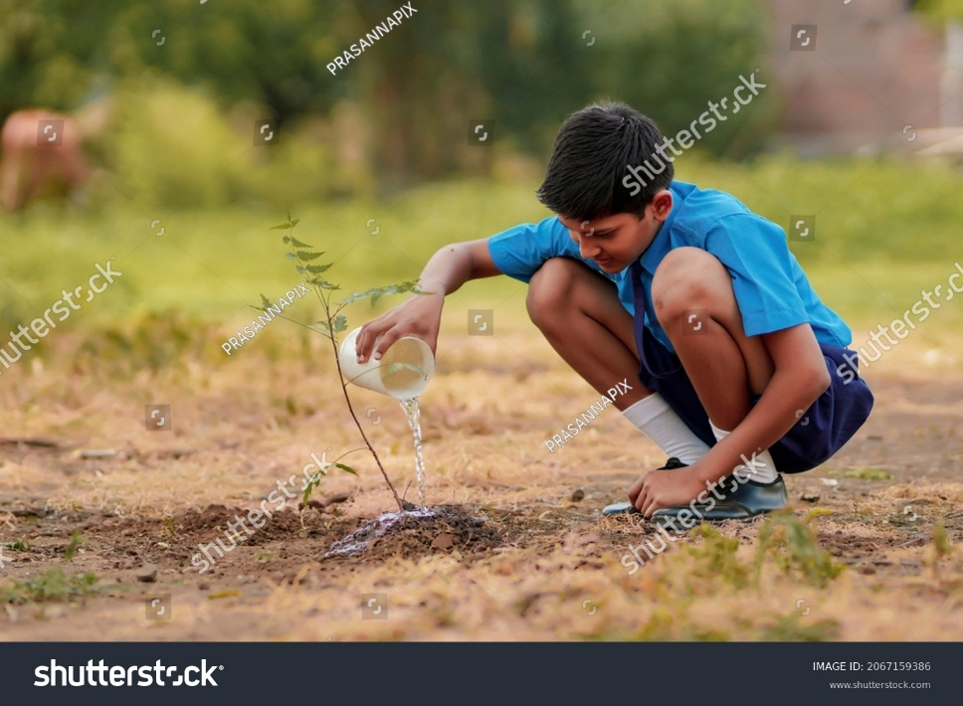Students play a critical role in conservation of natural resources, as they are the future generation who will inherit the planet. Here are some of the ways in which students can contribute to conservation efforts:

1. Educating themselves: Students can start by educating themselves about the importance of natural resources and the threats they face. They can learn about the impacts of human activities such as pollution, deforestation, and climate change on the environment.
2. Spreading awareness: Students can use their voice to raise awareness about the need for conservation. They can organize events, campaigns, and social media drives to spread the word and encourage others to take action.
3. Reducing their ecological footprint: Students can make small changes in their daily lives to reduce their ecological footprint. For example, they can use eco-friendly products, reduce waste, and conserve water and electricity.
4. Volunteering for conservation organizations: Students can volunteer their time and skills for conservation organizations working to protect natural resources. They can assist in habitat restoration, wildlife conservation, and other initiatives.
5. Advocating for policy change: Students can advocate for policy change by writing to their representatives and attending public meetings. They can push for policies that promote conservation and reduce environmental harm.
6. Learning and practicing sustainable living: Students can learn and practice sustainable living by using renewable energy sources, growing their own food, and conserving natural resources.

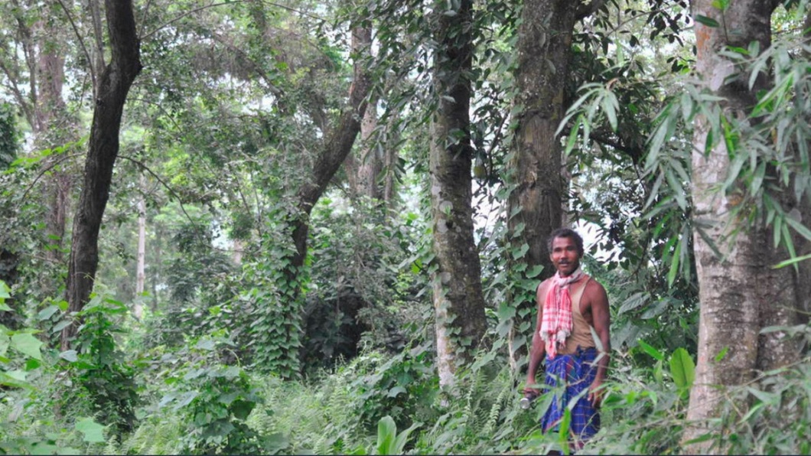**“Forest Man of India”: -**

Jadav Payeng, also known as the "Forest Man of India," is an environmental activist and conservationist from the northeastern state of Assam in India. Payeng is known for his incredible efforts in planting trees and creating a forest on a barren sandbar on the Brahmaputra River in Assam, which is now home to a diverse range of wildlife. Payeng was born in 1963 in the Jorhat district of Assam. He grew up in a small village near the Brahmaputra River and spent most of his childhood in close contact with nature. As a young boy, Payeng was disturbed by the alarming rate of erosion on the river's sandbars, which were turning into barren wastelands devoid of any vegetation.

In 1979, when Payeng was just 16 years old, a severe flood hit the region, washing ashore many snakes who died due to the lack of tree cover. This incident left a deep impression on Payeng, who resolved to do something to help the area's ecosystem. He began planting saplings on the barren sandbar, which had no trees or vegetation at that time, and continued to do so for several years. Payeng's efforts did not go unnoticed, and soon people started taking notice of the growing forest on the sandbar. However, it wasn't until the year 2000 that Payeng's work gained national attention when a journalist stumbled upon the forest while on assignment and reported on his story.

Payeng's forest, which is now known as Molai Forest, covers an area of over 1,360 acres and is home to a diverse range of wildlife, including tigers, rhinos, deer, and elephants. He has received numerous awards and recognition for his work, including the Padma Shri, one of India's highest civilian awards, in 2015. Payeng's story is a shining example of the power of individual action and the importance of conservation efforts to protect our planet's natural resources. He continues to inspire many people around the world to take action and work towards environmental conservation.

**Observations**

Conservation of natural resources has been observed to have several positive impacts, including:

1. Preservation of Ecosystems: Conservation efforts have led to the preservation of important ecosystems such as rainforests, wetlands, and coral reefs. These ecosystems are home to numerous species of plants and animals and play a vital role in maintaining the balance of the Earth's ecosystem.
2. Protection of Endangered Species: Conservation efforts have helped protect endangered species such as tigers, pandas, elephants, and whales. These efforts have led to an increase in their populations and helped to prevent their extinction.
3. Sustainable Use of Resources: Conservation efforts have promoted the sustainable use of natural resources such as water, air, soil, and energy. This has helped to reduce the depletion of these resources and ensured their availability for future generations.
4. Reduction of Pollution: Conservation efforts have helped to reduce pollution and its harmful effects on the environment and human health. By reducing waste and promoting sustainable practices, conservation efforts have led to cleaner air, water, and soil.

However, challenges remain in the conservation of natural resources. These challenges include the increasing human population and demand for resources, climate change, and habitat loss. Therefore, it is crucial to continue conservation efforts and promote sustainable development practices to ensure the long-term sustainability of our planet.

**Summary and Conclusion**

**Summary:**

The conservation of natural resources is a vital concept that emphasizes the need to manage and utilize natural resources sustainably. It involves preserving resources for future generations and preventing depletion due to human activities. Conservation efforts include reducing waste and pollution, reforestation, energy conservation, and sustainable farming practices.

The increasing human population and demand for resources pose a significant challenge to conservation efforts. Sustainable development practices are necessary to balance economic growth with environmental protection. Overall, conservation of natural resources is essential to maintain ecological balance and biodiversity and ensure the long-term sustainability of our planet.

The conservation of natural resources faces various challenges, including the lack of political will, funding, awareness, and education, and conflicts over natural resources. To address these challenges, there is a need for increased political will, funding, and awareness on the importance of natural resource conservation.

Natural resources are the valuable materials and substances found in the environment that support life and contribute to human well-being. They can be renewable or non-renewable and are essential for economic development, societal progress, and environmental sustainability. Proper management and conservation of these resources are crucial to ensure their long-term availability and to mitigate the impact of human activities on the planet.

Natural resources are valuable materials and substances found in the environment that are essential for the survival and well-being of humans and other living organisms. They occur naturally and can be broadly classified into renewable and non-renewable resources. Renewable resources, such as solar energy, wind energy, water resources, forests, and agricultural resources, can be replenished naturally or through human intervention. Non-renewable resources, including fossil fuels and minerals, are finite and cannot be replaced within a human lifetime. Natural resources are economically significant, serving as raw materials for industries and contributing to economic development. They are vital for energy production, food security, environmental stewardship, water and air quality, cultural and recreational value, and climate change resilience. Proper management and conservation of natural resources are crucial to ensure their availability for future generations and to mitigate the impact of human activities on the environment.

Renewable resources are those that can be replenished naturally or through human intervention within a relatively short period. These resources play a crucial role in sustaining life and supporting various human activities. Solar energy, for example, refers to the radiant light and heat energy emitted by the Sun. It can be harnessed using technologies like solar panels and solar thermal systems to generate electricity or provide heating and cooling. Wind energy, on the other hand, is the kinetic energy generated by the movement of air. Wind turbines capture this energy and convert it into electricity through rotational motion. Water resources, including freshwater from rivers, lakes, and underground aquifers, are essential for human consumption, agriculture, and industrial purposes. They also provide opportunities for hydropower generation by harnessing the energy of flowing or falling water. Forests are another valuable renewable resource, providing timber, wood products, and non-timber forest products (NTFPs). They also offer important ecosystem services such as carbon sequestration, air purification, and habitat for wildlife. Agricultural resources encompass crops, fruits, vegetables, and livestock that are cultivated for food production. Lastly, marine resources from the oceans provide a wide range of renewable resources, including fish, shellfish, and other seafood, as well as mineral resources like salt, sand, and gravel. The sustainable management and utilization of renewable resources are crucial for ensuring their long-term availability and minimizing negative impacts on ecosystems and communities.

Conservation of natural resources is a crucial approach to ensure the sustainable and responsible management of our planet's valuable resources. It involves a range of practices aimed at preserving, protecting, and restoring natural resources to maintain their ecological balance and meet the needs of present and future generations. Sustainable resource management is at the core of conservation efforts, emphasizing the use of resources in a manner that allows them to replenish naturally or through human intervention. This includes sustainable forestry, responsible fishing practices, and efficient water management. Biodiversity conservation is another key aspect, focusing on the protection of habitats, preservation of endangered species, and promotion of biodiversity-friendly practices. Pollution prevention and control are essential to minimize the negative impacts of human activities on natural resources. Emphasizing resource efficiency helps optimize resource utilization and reduce waste generation through practices such as energy efficiency, water conservation, and waste reduction. Land and habitat conservation efforts aim to protect and restore natural habitats, including forests, wetlands, and marine ecosystems. Public awareness and education play a crucial role in fostering a sense of responsibility and encouraging individuals and communities to adopt sustainable practices. Additionally, policy and legal frameworks support and enforce conservation measures, ensuring the effective implementation of conservation efforts at various levels. Overall, the conservation of natural resources is essential to preserve biodiversity, maintain ecosystem services, and promote a sustainable future for our planet.

Conservation of natural resources encompasses various types of conservation practices that are implemented to ensure the sustainable use and preservation of valuable resources. These practices can be broadly categorized into three main types:

Habitat Conservation: This type of conservation focuses on preserving and protecting natural habitats, such as forests, wetlands, grasslands, and marine ecosystems. It involves creating and managing protected areas, implementing land-use planning strategies, and restoring degraded habitats to maintain biodiversity and ecosystem services. By safeguarding habitats, we can protect the species that depend on them and maintain the ecological balance.

Species Conservation: Species conservation aims to protect and preserve endangered or threatened species. This involves implementing measures to prevent the loss of biodiversity, such as habitat restoration, captive breeding programs, reintroduction of species into the wild, and strict regulations on hunting and illegal wildlife trade. Preserving species diversity is essential for maintaining ecosystem stability and promoting the resilience of ecosystems.

Resource Management and Sustainable Use: This type of conservation focuses on the responsible and sustainable management of natural resources. It involves practices such as sustainable forestry, responsible fishing, efficient water management, and land-use planning that promote the long-term availability of resources while minimizing negative impacts on the environment. By using resources wisely and adopting sustainable practices, we can ensure their availability for future generations.

**Conclusion:**

The conservation of natural resources is essential for sustainable development and the well-being of future generations. Various approaches can be used to conserve natural resources, including sustainable development, integrated natural resource management, environmental education and awareness, legal and policy frameworks, and community-based natural resource management.

Natural resources are valuable materials and substances found in the environment that are essential for the survival and well-being of humans and other living organisms. They encompass a wide range of resources, including renewable resources like solar energy, wind energy, water resources, forests, agricultural resources, and marine resources, as well as non-renewable resources like fossil fuels and minerals. Natural resources play a crucial role in supporting economic activities, meeting energy demands, ensuring food security, maintaining environmental balance, and providing cultural and recreational value. However, their sustainable management and conservation are of utmost importance to ensure their availability for future generations and to minimize the negative impacts of human activities on the environment. Responsible practices, sustainable development, and the transition to renewable energy sources are key factors in safeguarding natural resources and promoting long-term environmental sustainability. By recognizing the importance of natural resources and adopting conservation measures, we can strive towards a more sustainable and balanced coexistence with the natural world.

Conservation of natural resources is a vital approach to ensure the sustainable management and preservation of our planet's valuable resources. It encompasses various practices and strategies aimed at preserving, protecting, and restoring natural resources to maintain their ecological balance and meet the needs of present and future generations. Conservation efforts involve habitat conservation, species conservation, and resource management for sustainable use. These practices are interconnected and complementary, working together to protect ecosystems, preserve biodiversity, and promote responsible utilization of natural resources. By implementing conservation measures and fostering a sense of responsibility towards the environment, we can create a more sustainable future, safeguarding the integrity of ecosystems, supporting biodiversity, and promoting the well-being of both human and non-human species. Conservation of natural resources is essential for ensuring the long-term availability of resources and maintaining a healthy and balanced planet for generations to come.

*Individual responsibility* plays a crucial role in the conservation of various natural resources. By adopting these conservation practices, individuals can significantly contribute to the sustainable management of water, energy, forests, and soil resources, preserving them for future generations. Here are some examples of how individuals can contribute to the conservation of different resources:

* *Water Conservation:*

- Install low-flow showerheads and faucets to reduce water usage while maintaining adequate water pressure.

- Fix leaky pipes, faucets, and toilets promptly to prevent water waste.

- Collect and use rainwater for tasks like watering plants, cleaning, or flushing toilets.

- Water plants and gardens during cooler parts of the day to minimize evaporation.

- Landscape with native plants that require less water and are well-adapted to the local climate.

- Use mulch around plants to retain moisture in the soil.

- Consider installing a water-efficient irrigation system, such as drip irrigation, to minimize water loss.

* *Energy Conservation:*

- Upgrade to energy-efficient appliances, such as refrigerators, washing machines, and air conditioners, that carry the Energy Star label.

- Replace traditional incandescent light bulbs with energy-efficient alternatives like LED or CFL bulbs.

- Use natural lighting as much as possible and turn off lights when leaving a room.

- Optimize home insulation to reduce heat loss in winter and heat gain in summer.

- Set thermostats at energy-saving temperatures and use programmable thermostats to regulate heating and cooling.

- Unplug electronics and chargers when not in use since they can still draw power in standby mode.

- Utilize natural ventilation by opening windows and using ceiling fans instead of relying solely on air conditioning.

* *Forest Conservation*:

- Choose products made from sustainably harvested or recycled materials, particularly wood and paper products certified by organizations like the Forest Stewardship Council (FSC).

- Reduce paper usage by opting for digital documents, email communications, and online transactions.

- Support organizations and initiatives that promote reforestation and sustainable forestry practices.

- Participate in community tree-planting programs or organize tree-planting events.

- Avoid purchasing or using products made from illegally harvested timber or from endangered or protected species.

- Recycle paper and cardboard products to reduce the demand for virgin materials.

* *Soil Conservation:*

- Practice responsible gardening by using organic fertilizers and compost to enrich the soil naturally.

- Implement erosion control measures, such as terracing, contour plowing, or using retaining walls, in hilly or sloping areas.

- Rotate crops to prevent soil nutrient depletion and reduce the risk of pests and diseases.

- Avoid over-watering plants, as excessive water can lead to soil erosion and nutrient leaching.

- Use cover crops to protect the soil from erosion, improve soil fertility, and suppress weeds.

- Minimize the use of synthetic pesticides and herbicides, opting for organic and environmentally friendly alternatives.

- Implement proper waste management practices, including composting organic waste, to reduce landfill waste and promote recycling.

**Bibliography**

1. "Conservation of Natural Resources." National Geographic Society, www.nationalgeographic.org/encyclopedia/conservation-natural-resources/.
2. "Conservation of Natural Resources." Environmental Science, www.environmentalscience.org/conservation-natural-resources.
3. "What is Conservation of Natural Resources?" Conserve Energy Future, [www.conserve-energy-future.com/conservation-of-natural-resources.php](http://www.conserve-energy-future.com/conservation-of-natural-resources.php).
4. https://www.nationalgeographic.org/society/