**Toll Tax Smart System Using RFID**

**Sachin Takale1, Aditi Bansod2 ,Vaibhav Kathe3 ,Smriti Hunderkari4  and Soham Dhokariya5**

Electronics and Communication Engineering, MIT Art Design & Technology University, Pune, India

([sachin.takale@mituniversity.edu.in](mailto:sachin.takale@mituniversity.edu.in),bansodaditi29@gmail.com,vebzz.2230@gmail,com,hundekarismriti@gmail.com,dhokariyasoham@gmail.com)

**ABSTRACT**

This project presents a simplified toll tax collection system utilizing RFID technology to enhance efficiency and reduce manual intervention. Vehicles are equipped with RFID tags containing unique identification details. When a vehicle passes through the toll plaza, an RFID reader automatically scans the tag, deducts the toll amount from the user's prepaid account, and logs the transaction. The system reduces traffic congestion, minimizes human error, and ensures secure and transparent toll collection. This solution offers a cost-effective and user-friendly approach to automating toll processes, contributing to smarter transportation infrastructure.

1. **INTRODUCTION**

The rapid advancement in technology has led to innovative solutions to streamline various processes, including transportation systems. A toll tax system using RFID (Radio Frequency Identification) is an efficient and automated method to manage toll collection.This system leverages RFID technology to identify and charge vehicles passing through a toll gate without requiring them to stop. An RFID tag, affixed to the vehicle, contains unique identification information. When the vehicle approaches the toll booth, an RFID reader scans the tag and deducts the appropriate toll amount from the linked account. This automated process ensures a seamless, cashless, and time-efficient transaction.Such a system not only reduces traffic congestion at toll plazas but also minimizes human intervention, thereby enhancing accuracy and security. The small-scale implementation of this technology is particularly beneficial for urban and suburban areas with moderate traffic flow, providing a cost-effective solution for toll management

**2. METHODOLOGY**

1. **System Setup and Design**
   * Install RFID readers at the toll gates to detect RFID tags on vehicles.
   * Distribute RFID tags to vehicle owners, pre-linked to a user account with payment details.
   * Configure a central server to store user data, transaction history, and toll rates.
2. **Vehicle Registration**
   * Register vehicle information (license plate, owner details) and link it to an RFID tag in the system.
   * Associate the RFID tag with a prepaid or postpaid account for toll payments.
3. **Approaching the Toll Plaza**
   * When a vehicle approaches, the RFID reader detects the RFID tag attached to the vehicle.
   * The system identifies the tag's unique ID and fetches the corresponding account details from the central server.
4. **Verification and Toll Calculation**
   * Verify the tag's validity and ensure the account has sufficient balance (in case of prepaid accounts).
   * Determine the toll amount based on vehicle type and the specific toll gate.
5. **Automatic Toll Deduction**
   * Deduct the calculated toll amount from the user’s account automatically.
   * Update the account balance and transaction history in real time on the central server.
6. **Gate Control and Notification**
   * If the payment is successful, the toll gate automatically opens for the vehicle.
   * Notify the user via SMS or mobile app with details of the transaction (amount deducted, account balance, etc.).
7. **Exception Handling**
   * If the RFID tag is invalid or the account lacks sufficient funds, alert the toll operator.
   * Provide an alternative manual payment option to avoid disruption.
8. **Data Analysis and Reporting**
   * Record and store all transactions for future reference and analysis.
   * Generate reports for toll plaza management to track revenue, peak hours, and system performance.
9. **Maintenance and Security**
   * Regularly inspect and maintain RFID readers and tags to ensure system reliability.
   * Implement encryption and authentication protocols to secure user data and prevent fraud.

This methodology ensures an efficient, secure, and automated toll collection process, reducing delays and improving user experience.

Fig.1 Block Diagram

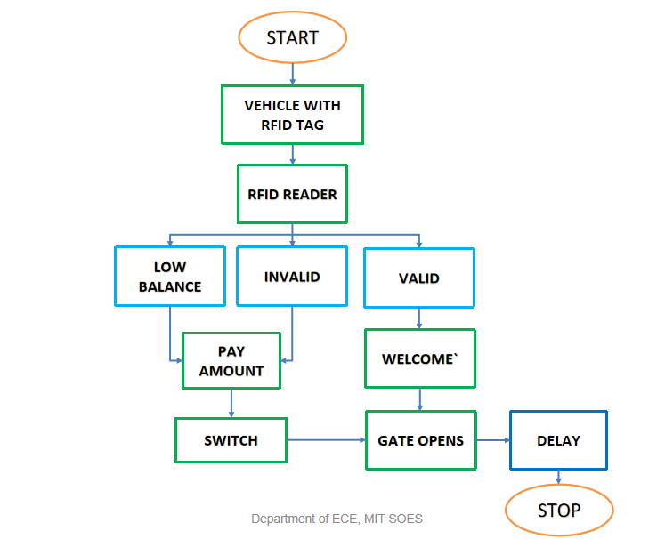

## 3.RESULTS AND DISCUSSIONS

**Results and Discussuions :**

* **Reduced Traffic Congestion:** Vehicles move seamlessly without stopping, reducing delays.
* **Improved Efficiency:** Faster transactions and lower operational costs compared to manual systems.
* **Accurate Transactions:** Automated, error-free toll collection with real-time notifications for users.
* **Environmental Benefits:** Lower vehicle emissions due to reduced idling at toll booths.
* **Challenges:** High initial setup costs, ensuring universal tag adoption, potential system interference, and security risks.
* **User Adoption:** Requires awareness campaigns and incentives like discounts for prepaid accounts.
* **Future Scope:** Integrating GPS for dynamic toll pricing, expanding to parking systems, and leveraging analytics for optimization.
* **Sustainability:** Supports smart city goals by enhancing efficiency and reducing environmental impact.

This system offers a scalable, efficient, and eco-friendly solution for toll collection.

**4.CONCLUSION**

The smart toll tax system using RFID is a highly efficient, automated solution for toll collection, reducing traffic congestion, improving transaction speed, and enhancing accuracy. By minimizing manual intervention, it ensures a seamless and transparent experience for users while lowering operational costs for toll operators. Despite initial implementation challenges, the system is scalable and aligns with smart city initiatives, offering long-term benefits for transportation infrastructure and environmental sustainability.

**ABBREVIATIONS**

1. **RFID** - Radio Frequency Identification
2. **TTS** - Toll Tax System
3. **IoT** - Internet of Things (if integrated with smart systems)
4. **HMI** - Human-Machine Interface (for operator monitoring)
5. **POS** - Point of Sale (for manual payment systems)
6. **UID** - Unique Identification (for RFID tags)
7. **GPS** - Global Positioning System (if used for dynamic tolling)
8. **DBMS** - Database Management System (for storing and managing data)
9. **LAN** - Local Area Network (for communication between components)
10. **SMS** - Short Message Service (for user notifications)

**REFERENCES**

1. [Karunanidhi K Christopher](https://ieeexplore.ieee.org/author/37087230205); [Xavier V M Arul](https://ieeexplore.ieee.org/author/37087234265); [P Karthikeyen](https://ieeexplore.ieee.org/author/37087234346)

11-13 April 2019 IEEE Tamilnadu, India

1. [Prakshaal Jain](https://ieeexplore.ieee.org/author/37086806583); [Prashant Dhillon](https://ieeexplore.ieee.org/author/37086806735); [Anand Vardhan Singh](https://ieeexplore.ieee.org/author/37086805581); [Kaustubh Vats](https://ieeexplore.ieee.org/author/37086806720); [Shrivishal Tripathi](https://ieeexplore.ieee.org/author/37085457966)

**IEEE *Xplore*:**28 March 2019 Greater Noida, India

1. Liu Bin, Lu Xiaobo and GAO Chaohui. Comparing and testing of ETC modes in Chinese freeway. ǁ Journal of Transportation Engineering and Information, 5(2), 2007, pp.31-35.
2. 2018 IEEE 10th International Conference on Humanoid, Nanotechnology, Information Technology, Communication and Control, Environment and Management (HNICEM)
3. A Novel Chipless RFID System Based on Planar Multi resonators for Barcode Replacement Steven Preradovic, Isaac Balbin, Nemai C. Karmakar, and Gerry Swiegers2008