I attach some google drive links for Q.No.4, Q.No.5, Q.No.13

For Q.No.4 Jupiter notebook file

<https://drive.google.com/file/d/1dfzczf29shrBem8PfDy3cHKsRXnAkcSS/view?usp=sharing>

For Q.No.5 and Q.No.13 excel file

<https://docs.google.com/spreadsheets/d/1lVO6XbSdMpDmtYFDdvCgWpAwHkACccXt/edit?usp=sharing&ouid=114176136212881410216&rtpof=true&sd=true>

One screenshot for Q.No.5 and for other tables please visit above mentioned excel files link

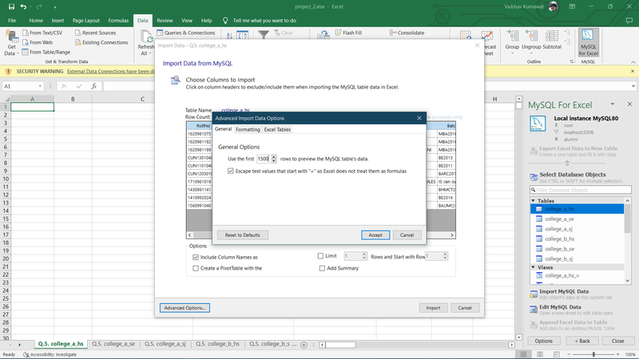

One screenshot for Q.No.13 and for other tables please visit above mentioned excel files link

