NIP Project — Submission
Pega Platform project

Section 1 — Your Details

Full Name | Vaibhav Tiwari
Email ID (registered on NIP) | Vaibhavtiwari0122@gmail.com
Phone Number | 8004596673
College Name | Lloyd Institute of engineering and technology
Course (e.g. IT, CS) | CSE – AI&ML
State | Uttar Pradesh
Project Chosen (Vehicle Service OR Movie Ticket Booking) | Movie Ticket Booking
Pega Application Name | NIP Movie Ticket Booking VAIBHAV TIWARI
Case Type Name (exact) | Movie Ticket Request
Pega Instance URL | https://xmyzg7ek.pegacea.net/prweb/app/movie-ticket-booking-Vaibhav-tiwari/
Operator Name (created in Pega with your full name) | Vaibhav Tiwari (VaibhavT0122)

Section 2B — Movie Ticket Booking Management Application.

US-001 — Submit Movie Ticket Request

What is expected:
Case created, customer submits Movie Name, Show Date, Show Time, Number of Tickets. Validation applied.
Screenshot — paste your screenshot below this line:
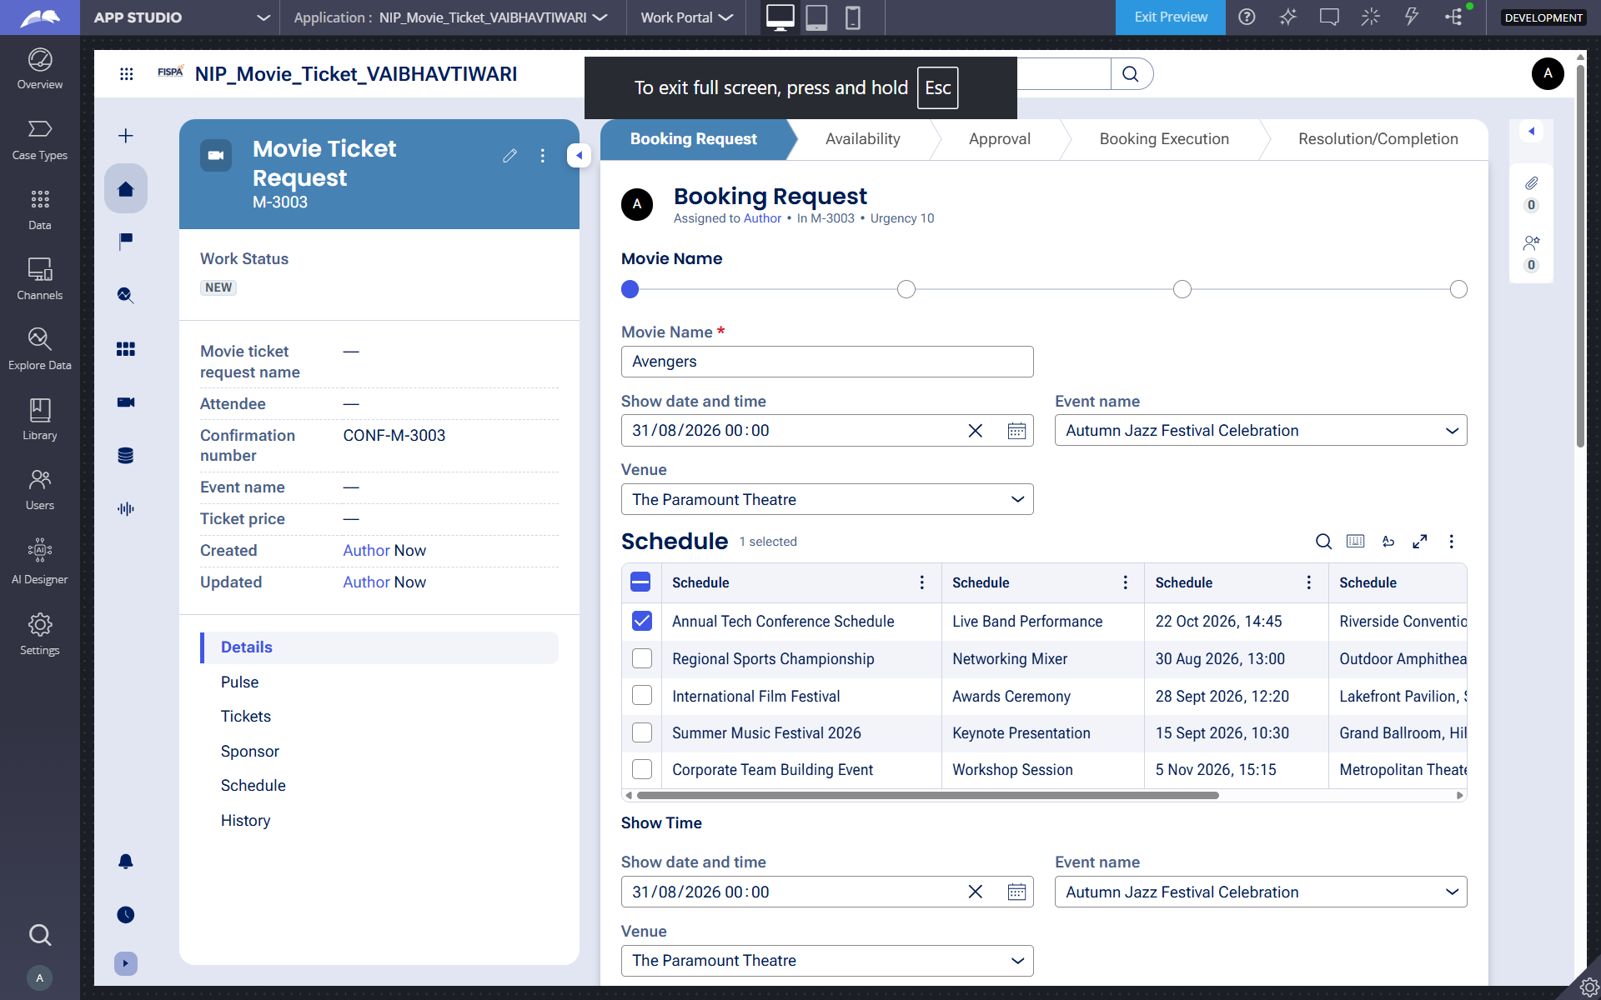

I built the Booking Request stage to capture the Movie Name, Show Date, Show Time and Number of Tickets. I also applied validation to ensure the required booking information is entered before submission.

US-002 — Check Show Availability

What is expected:
Availability stage. Seat Availability Status and Available Seats Count captured. Booking proceeds only if available.
Screenshot — paste your screenshot below this line:
What I built for this (1–2 lines in your own words):
I built an Availability Check stage to verify seat availability. The system captures the Seat Availability Status and Available Seats Count before allowing the booking to proceed.

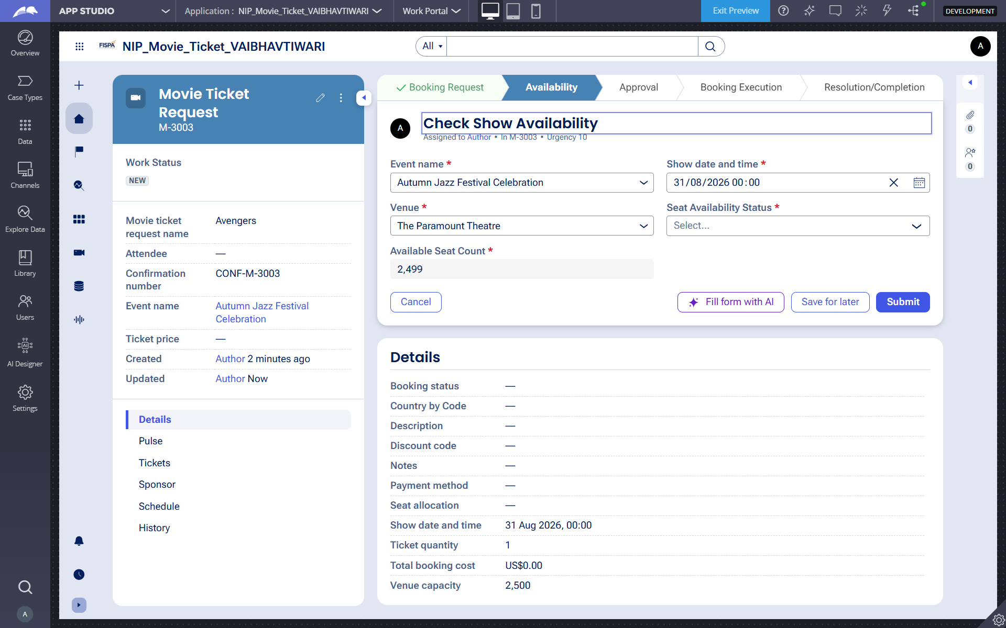
US-003 — Calculate Booking Cost
What is expected:
Total Cost calculated automatically from Ticket Price and Number of Tickets using a business rule.
Screenshot — paste your screenshot below this line:
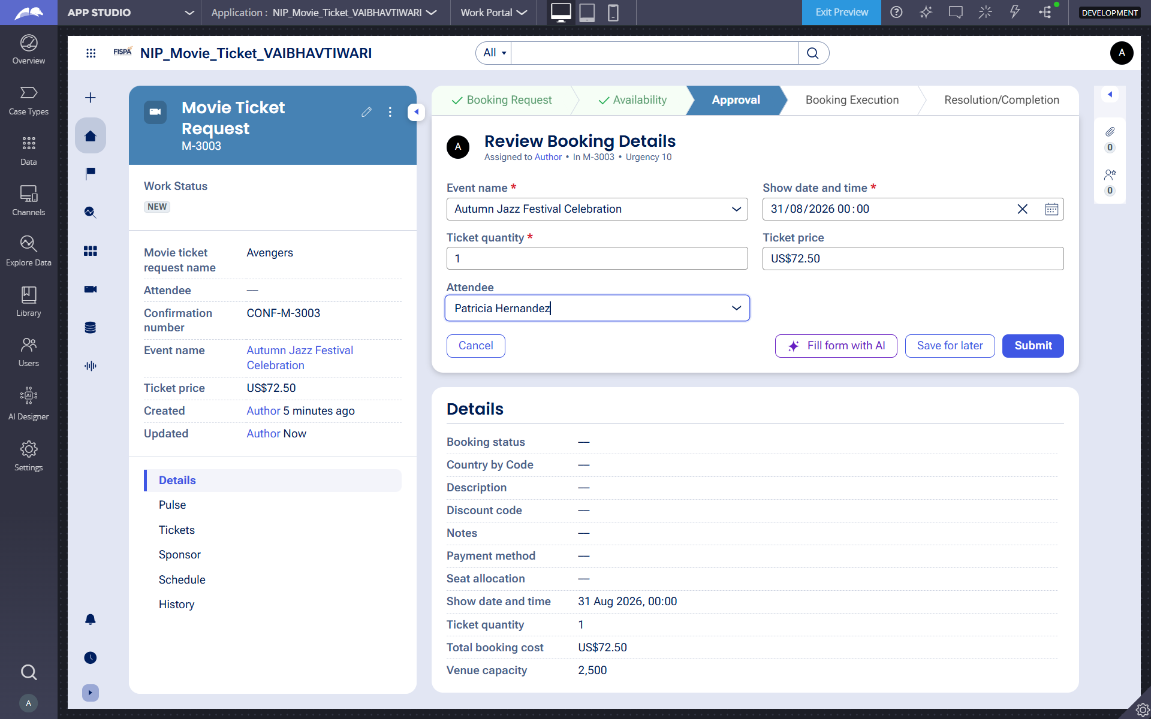

I built an automatic booking cost calculation using a business rule. The Total Cost is calculated from Ticket Price × Number of Tickets ( .TicketPrice*.TicketsQuantity), resulting in $72.500 for 1 ticket at $72.500 each.

US-004 — Confirm Booking Request
What is expected:
Approval stage assigned to Customer. Booking Status captured. Flow branches on confirm/cancel.
Screenshot — paste your screenshot below this line:
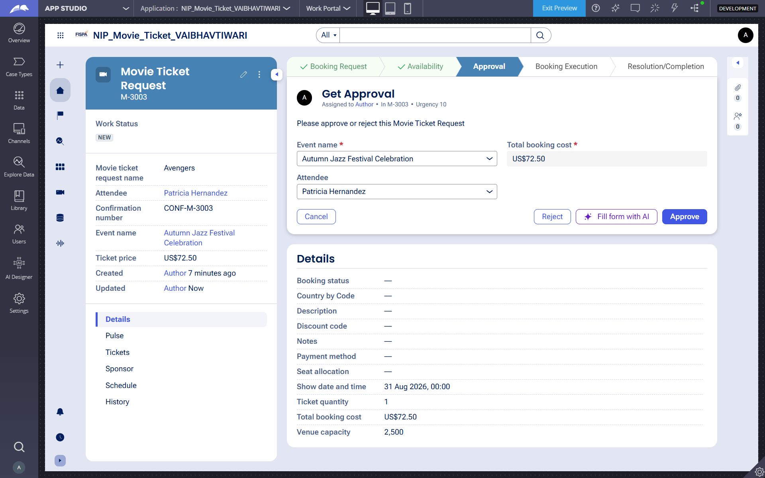

I built the Approval stage assigned to the Customer, with a Customer Confirmation option and approval/rejection actions. The booking flow branches based on the customer’s confirmation decision.

US-005 — Maintain Movie and Show Data
What is expected:
Reusable Movie and Show data objects created with Movie Name, Genre, Show Date, Show Time, Seat Capacity — linked to case.
Screenshot — paste your screenshot below this line:
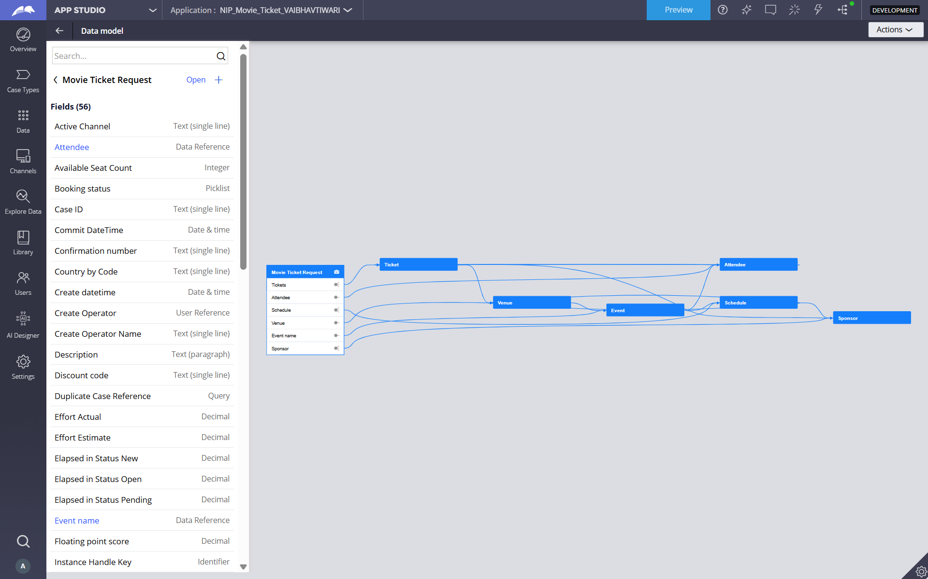

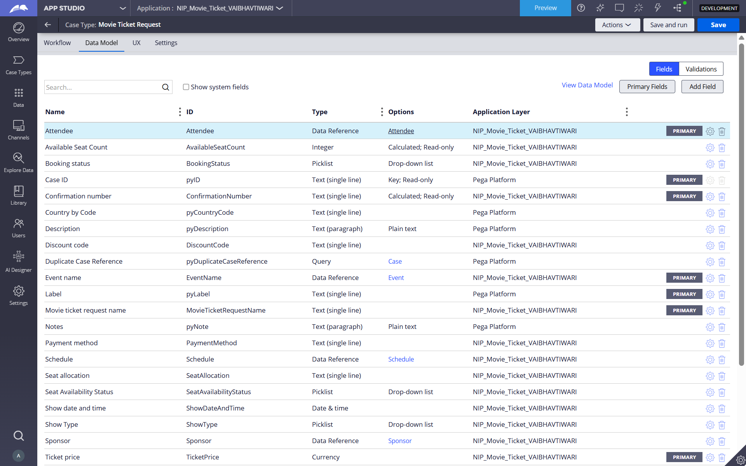

I created reusable Movie and Show data objects in Pega App Studio.
The Movie object stores details such as Movie Name and Genre.
The Show object stores Show Date, Show Time, and Seat Capacity.
I also created data references between Movie, Show, and the Booking case, allowing the show and movie information to be reused within the booking process.

US-006 — Review Booking Details

What is expected:
Confirmation screen shows Movie Name, Show Timing, Number of Tickets and Total Cost clearly.
Screenshot — paste your screenshot below this line:

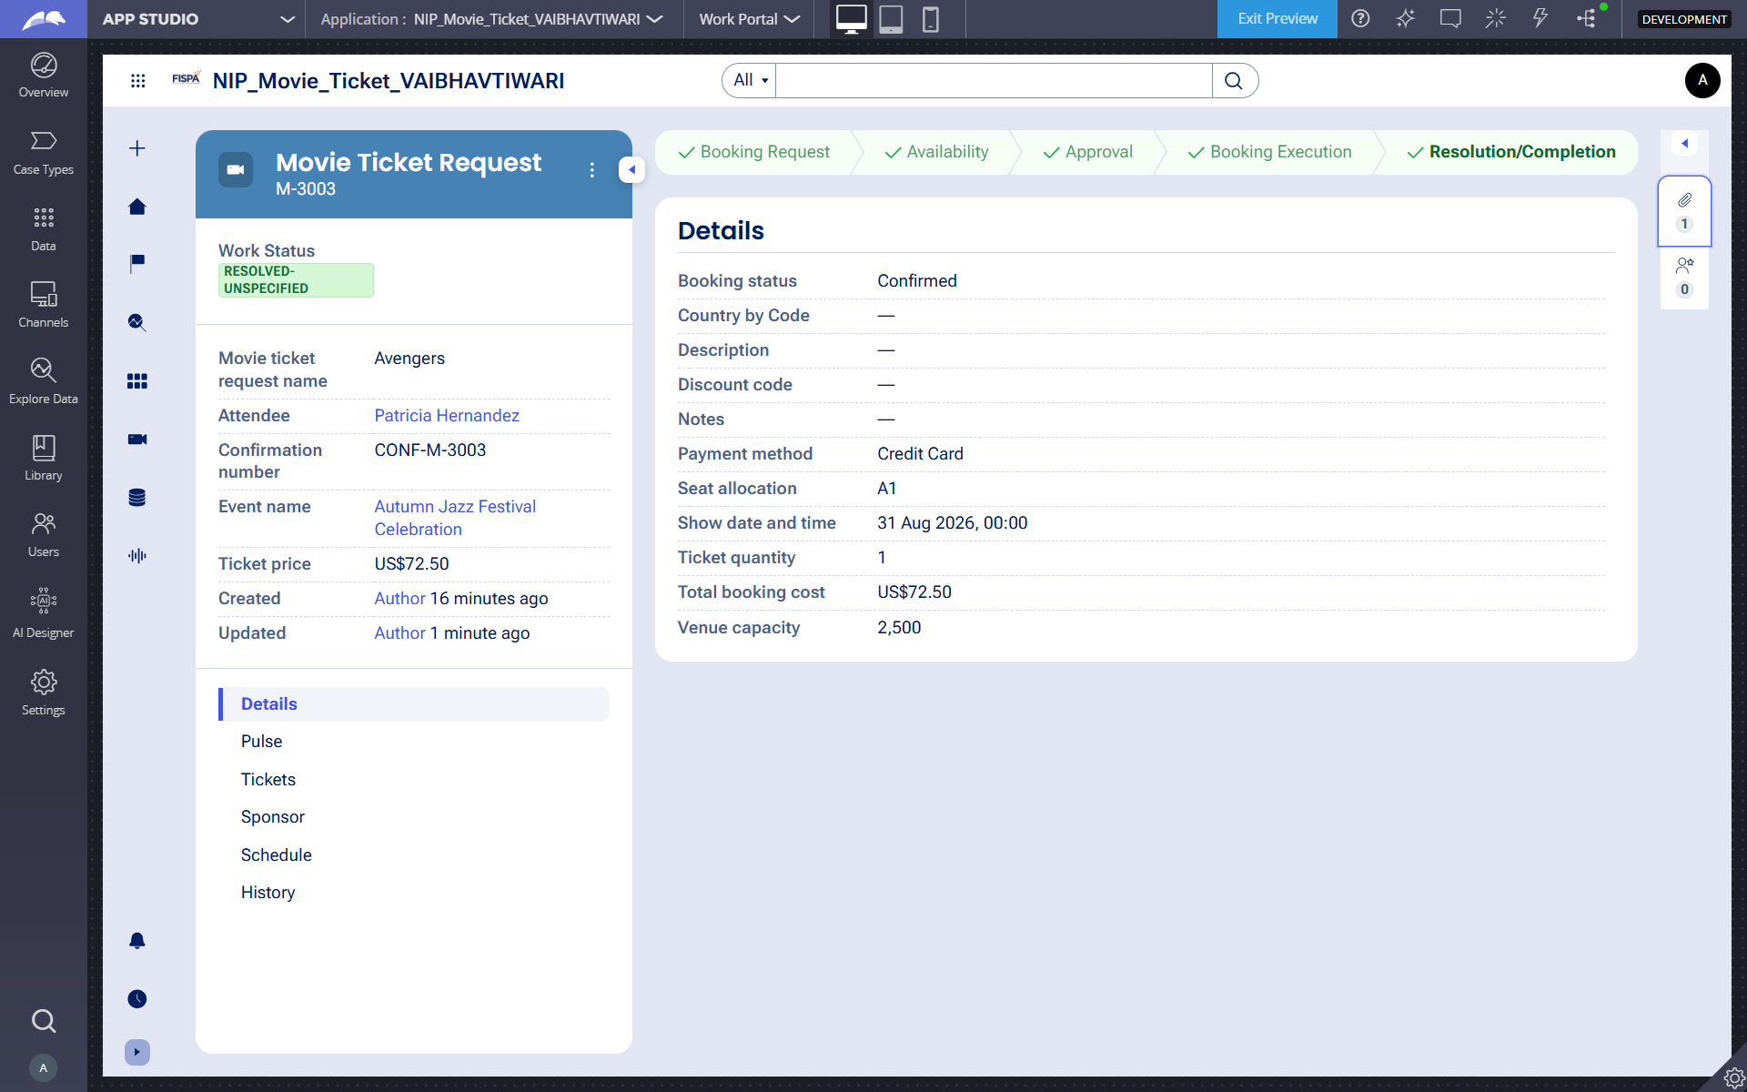

I built the Booking Confirmation stage to clearly display the Movie Name, Show Date and Time, Number of Tickets, and Total Cost, allowing the customer to review the complete booking details before completion.

US-007 — Process Ticket Booking
What is expected:
Booking Execution stage. Seat Numbers, Ticket ID and Booking Confirmation Status maintained.
Screenshot — paste your screenshot below this line:
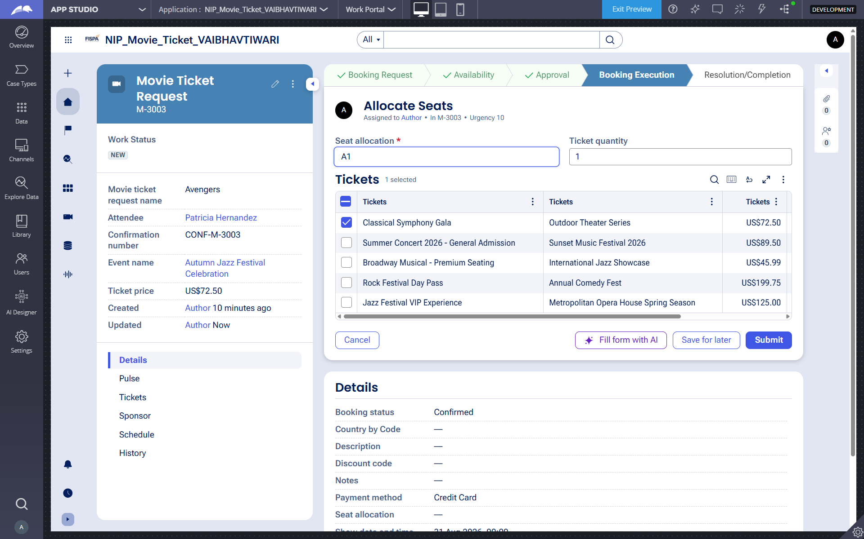

I built the Booking Execution stage to process the approved ticket booking by maintaining the Seat Numbers, Ticket ID, and Booking Confirmation Status.

US-008 — Notify Booking Confirmation
What is expected:
Correspondence rule triggered on case resolution. Email includes movie, show, seat and cost details.
Screenshot — paste your screenshot below this line:
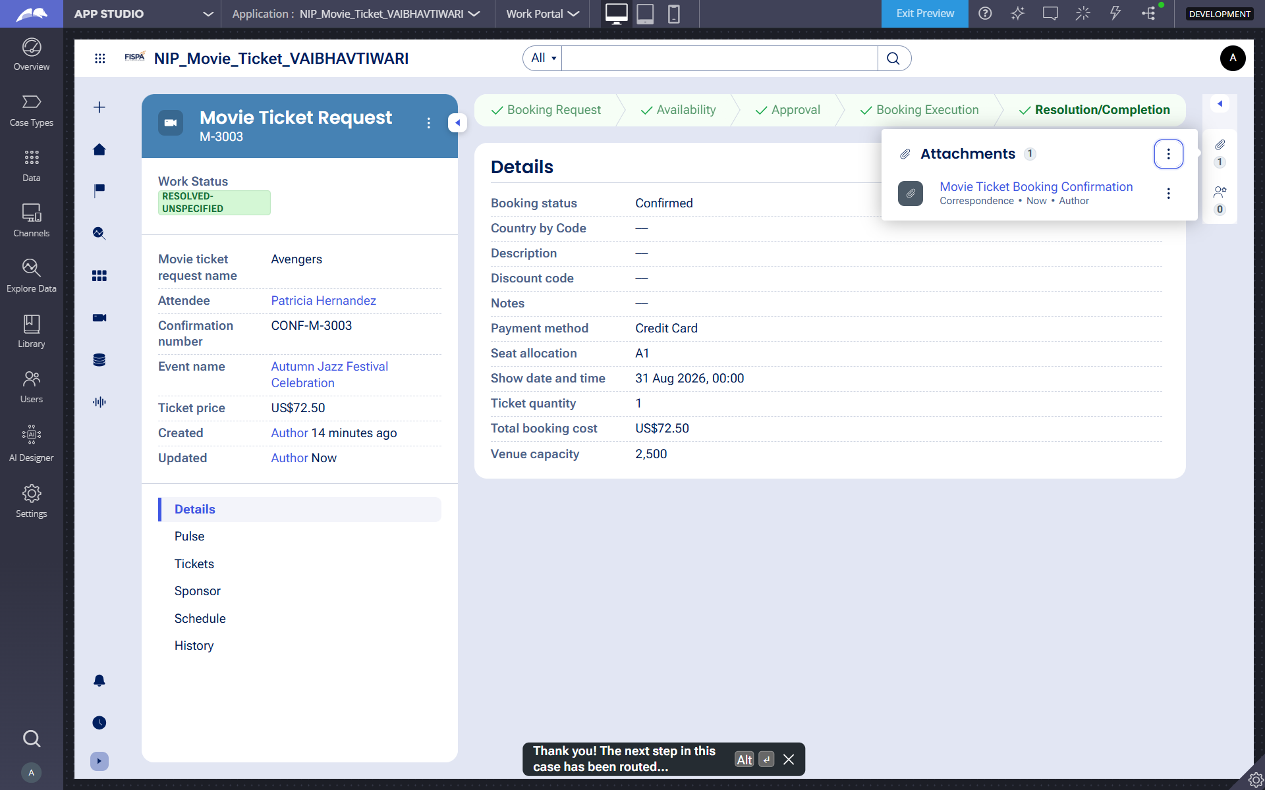

I created a booking confirmation correspondence that is triggered when the case is resolved. The confirmation is attached to the case as a correspondence containing the booking details.

US-009 — Define Booking SLA
What is expected:
SLA configured on the case type. Goal: 1 day. Deadline: 2 days. Priority increases on breach.
Screenshot — paste your screenshot below this line:
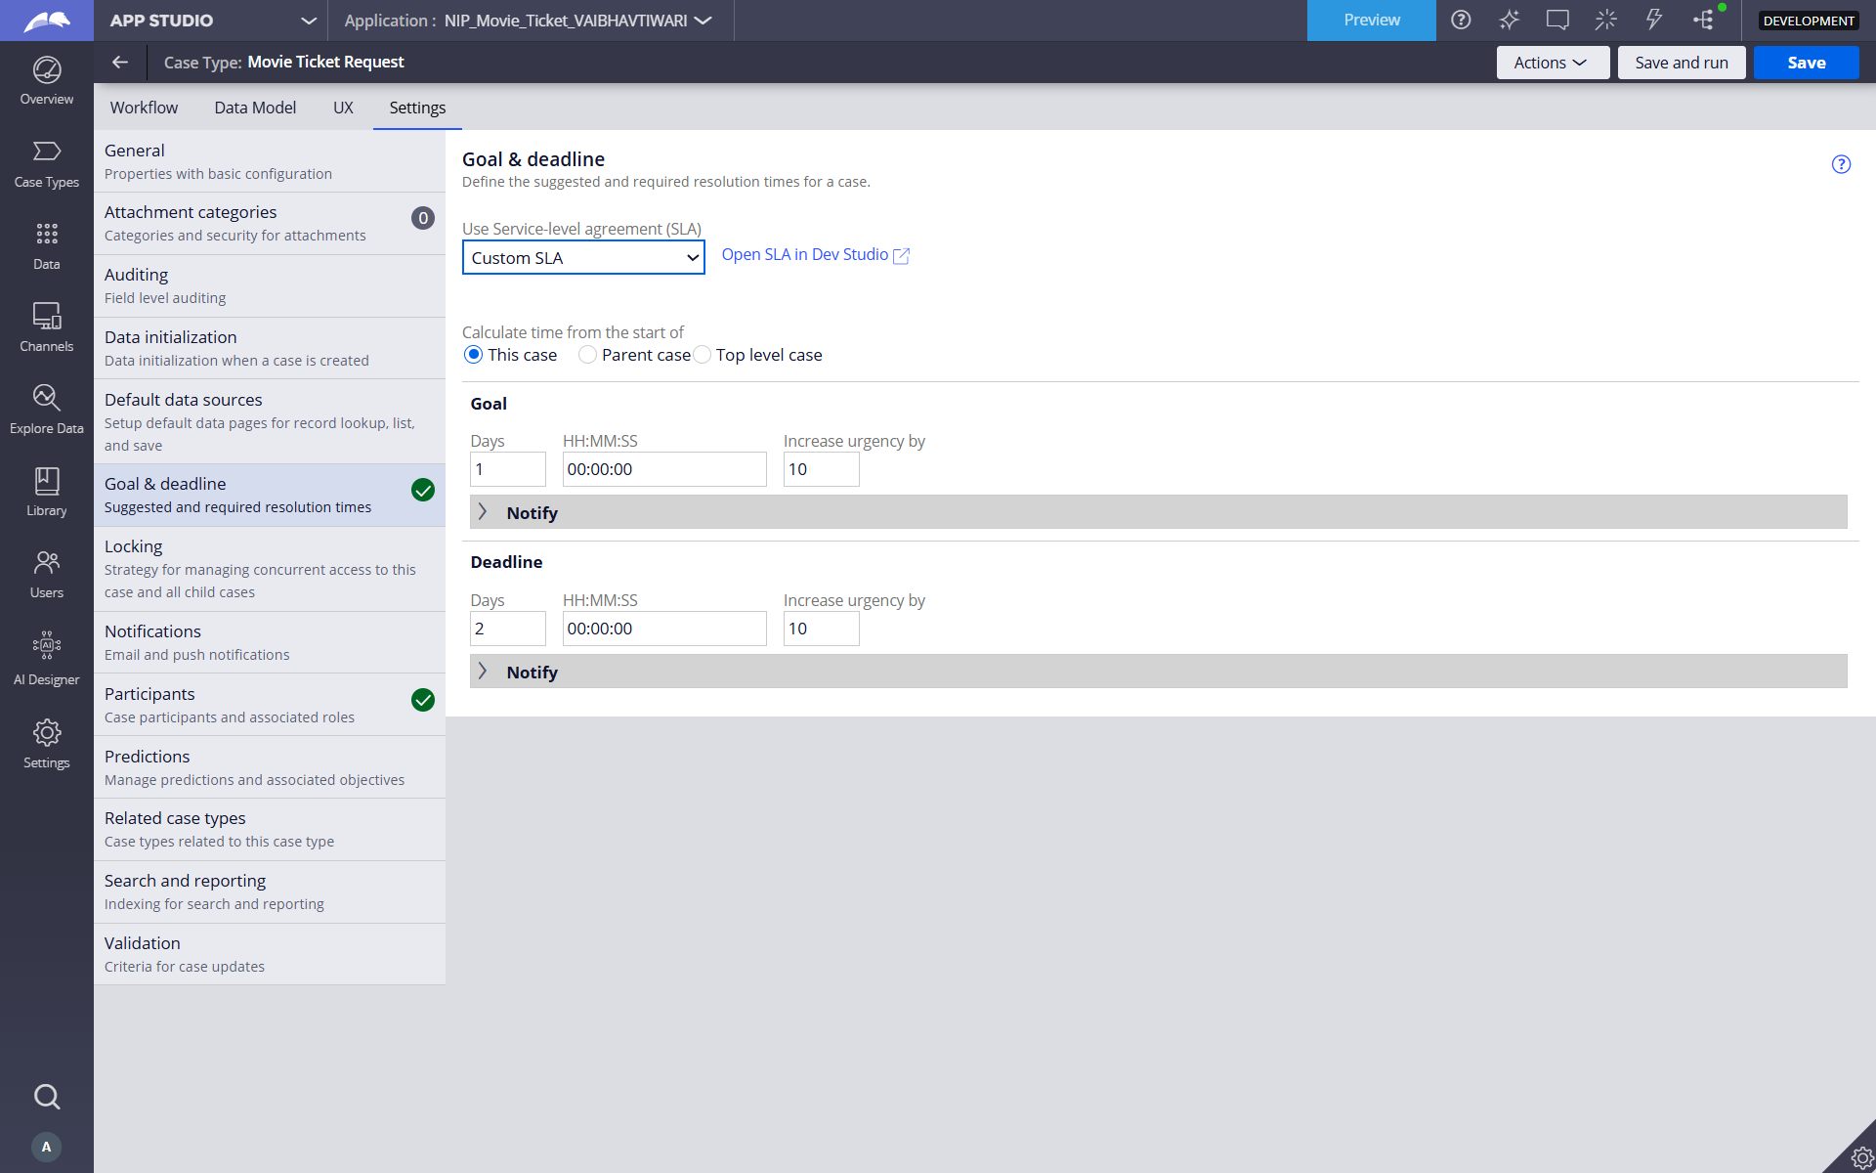

I configured a Custom SLA for the Movie Ticket Request case with a 1-day goal and a 2-day deadline. The case urgency is increased when the deadline is reached or breached.

US-010 — Route by Show Type

What is expected:
Routing rule or Decision Table routes to PremiumShowQueue or StandardShowQueue based on Show Type property.
Screenshot — paste your screenshot below this line:
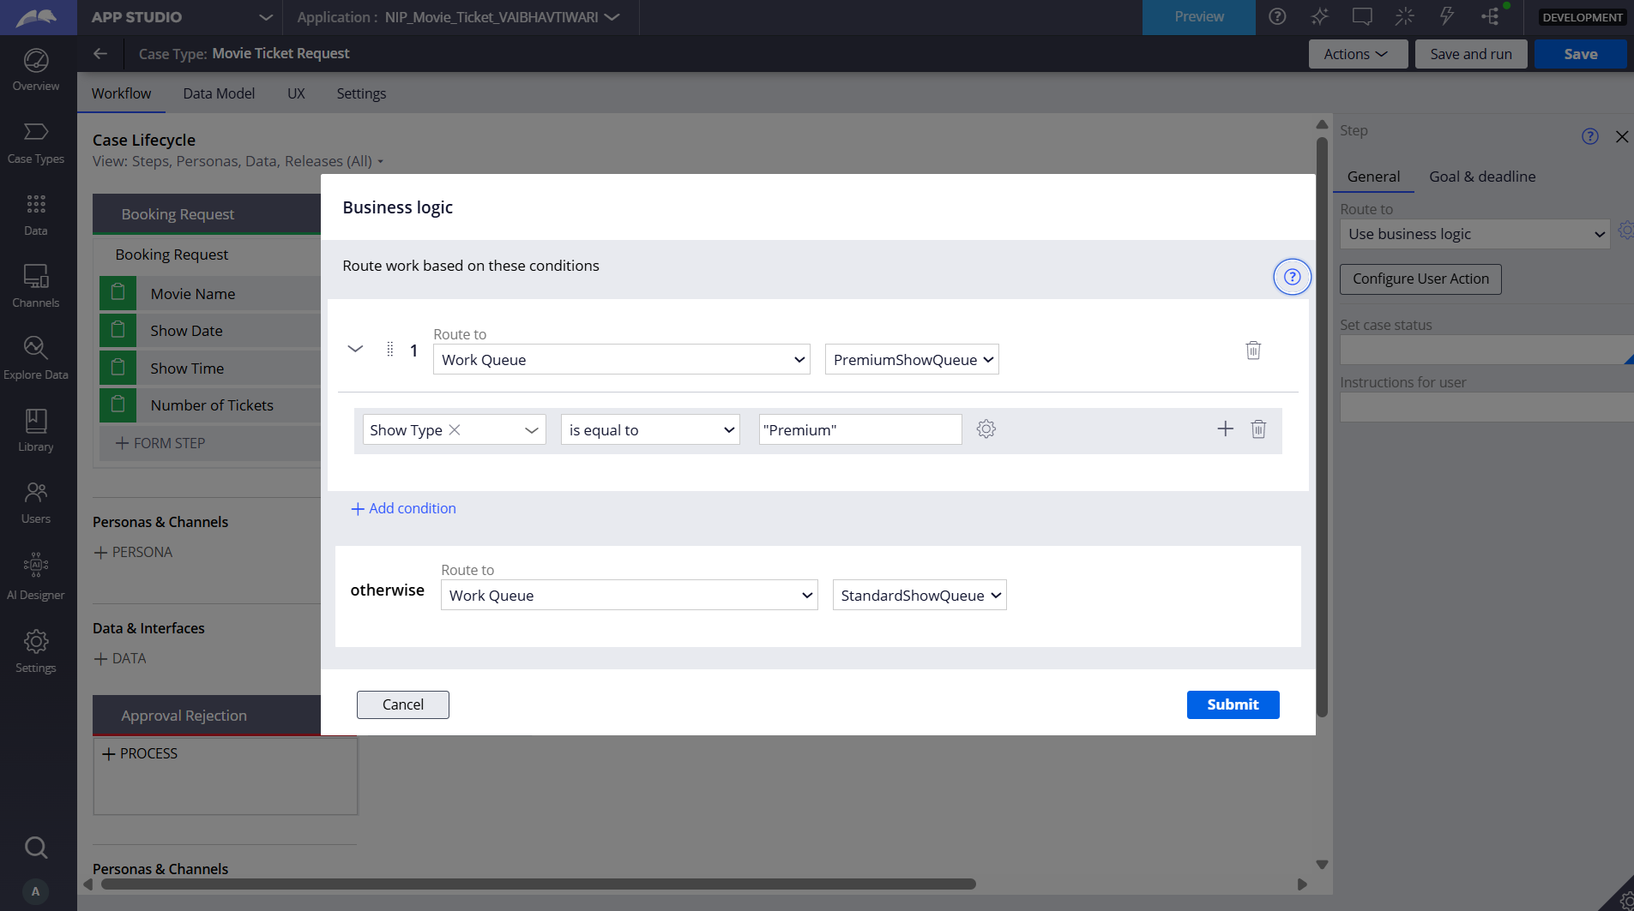

I created a RouteQueue Decision Table to route booking requests based on Show Type. Premium and Special shows are routed to PremiumShowQueue, while Standard shows are routed to StandardShowQueue.

Section 3 — About Your Application

Q1. List your stages in the order they appear in your case lifecycle.

Booking Request, Availability , Approval, Booking Execution, Completion/Resolution

Q2. Name the data object(s) you created and the properties inside them.
Data object name and its properties.
Movie : Movie Name, Duration (minutes), Language, Release Date, Poster Image, Synopsis, Booking List, Show List.
Show : Show Title, Show Date, Show Time, Show Type, Seat Capacity, Available Seats, Seat Numbers, Booking Status, Booking Count, Movie, Booking, Booking Request, Seat, Notification, Show Queue Routing, Is Premium Screening, Show SLA Goal Date, Show SLA Deadline Date, SLA Status, Show Notification URL.
Customer : Customer Full Name, Customer Title, Customer Type, Email Address, Mobile Number, Customer City, Customer State, Customer Date of Birth, Customer Registration Date, Communication Consent, Notification Preference, Preferred Language, Movie, Show, Booking, Notification, Booking Request Count, Last Booking Date, Total Booking Amount.
Seat : Seat Name, Seat Number, Seat Price, Section Name, Row Designation, Seat Maintenance Flag, Seat Allocation Timestamp, Seat Booking History, Show.

Q3. What is the exact name and type of the rule you used to calculate Total Cost?

Rule Name: TotalCostPrice
Rule Type: Calculated Field (Expression)
Properties used: Ticket Price, TicketsQuantity
Formula: .TicketPrice*.TicketsQuantity

Section 4 — Your Understanding

Q4. What did Blueprint generate for you, and what did you add or change yourself afterwards?
Blueprint generated the initial case lifecycle, stages, basic steps, personas, and data model structure. I then configured and modified the application myself by adding the required properties, availability check, cost calculation, approval flow, seat allocation, queue routing, booking confirmation, notifications, and SLA-related configurations.

Q5. Was there anything Blueprint created that you had to correct or configure further? Describe one example.

Yes. I had to configure the Total Cost calculation further because the initial setup did not correctly calculate the booking cost. I configured the Ticket Price and Number of Tickets properties and used a Declare Expression to calculate Total Cost automatically.

Q6. Explain your case flow from creation to resolution, in order.

The customer first submits a booking request with the movie and shows details. The Availability Check stage verifies seat availability, and the booking cost is calculated. The Approval stage allows the customer to review and confirm the booking. After confirmation, the Booking Execution stage processes the ticket booking and assigns seats. Finally, the Booking Confirmation stage sends the confirmation notification/email, and the case is resolved.

Q7. Pick two design choices you made in your application and explain why you made them.

Design Choice 1: Seat Availability Validation
Seat Availability Validation: I applied validation logic in the Availability step to ensure that seat availability status is "Available" and the requested number of tickets is less than or equal to the available seats. I chose this approach to prevent the booking from continuing when there is not enough capacity, helping to avoid overbooking.

Design Choice 2: Automatic Total Cost Calculation
Automatic Total Cost Calculation: I configured Total Cost to be calculated automatically using Ticket Price × Number of Tickets. I chose this approach to avoid manual calculations and reduce errors. This ensures that the correct booking cost is consistently calculated.

Q8. What was the hardest part, and how exactly did you fix it?

The hardest part was configuring the booking cost and notification workflow correctly. I checked the properties and workflow steps, corrected the Ticket Price and Number of Tickets configuration, and configured the Total Cost calculation. I also adjusted the notification step so that the booking confirmation could use the required booking details.

Q9. If the approval step was only needed when Total Cost is above a certain amount, what would you change in your application?

I would add a conditional decision before the Approval stage based on the Total Cost. If Total Cost is above the specified amount, the case would continue to the Approval stage. If it is at or below the amount, the case would skip the Approval stage and continue directly to Booking Execution.

Q10. List three exact rule names from your application that you personally created or modified.

• TotalCost — Calculated Field / Expression: I created this rule and applied the expression .TicketPrice * .TicketQuantity to automate the booking cost calculation.
• NotifyBookingConfirmation — Correspondence / Email: I modified the email template to use the required property references, so the confirmation email contains the booking information entered by the user.
• SeatAvailability — Validate Rule: I created this validation rule on the Availability step to ensure the system proceeds only when the seat availability status is "Available" and the requested ticket count is less than or equal to the available seats.

Q11. List all personas used in your application.

Customer, Booking Agent, System, Users
Q12. List all work queues used in your application and explain when each one is used.

• PremiumShowQueue: Routes premium ticket processing work. Used by the business logic routing when the requested Show Type is selected as "Premium".

• StandardShowQueue: Routes standard ticket processing work. Used as the default "otherwise" route when the requested Show Type is selected as "Standard".

