**Project Overview: Coffee Sales Analysis Using Excel**

This project focused on analyzing a dataset of coffee sales, with 1000 columns of data. The goal was to derive insights on total sales over time, sales by country, top customer segments, and customer preferences for different coffee roast types. Excel was used for the entire analysis process, including data cleaning, exploration, and visualization.

**Key Objectives:**

1. **Sales Over Time**: Analyze total coffee sales trends over time using Excel's time-series analysis tools. This helped identify periods of high demand and seasonal fluctuations.
2. **Sales by Country**: A country-wise breakdown of sales was conducted, identifying key markets and emerging regions for business growth.
3. **Top 5 Customers**: The project focused on profiling the top 5 customers based on total purchases, frequency of orders, and overall engagement, using Excel's ranking functions.
4. **Roast Type Preferences**: The dataset was filtered to examine preferences for different coffee roasts (light, medium, dark) and their correlation with specific customer segments and regions.

**Data Cleaning and Preparation in Excel:**

The dataset contained raw, unstructured data that required extensive cleaning. The steps included:

* **Removing Duplicates**: Excel's built-in duplicate removal tool was used to ensure no repeated records distorted the analysis.
* **Handling Missing Values**: Null values were addressed through imputation techniques such as filling with averages or simply removing incomplete records.
* **Data Standardization**: Various columns were standardized, such as date formats, currency values, and units of measurement, ensuring consistency across the dataset.

Visualizations such as line charts for sales trends, bar graphs for sales by country, and pie charts for customer preferences were created using Excel. The project provided key business insights related to customer loyalty, regional performance, and po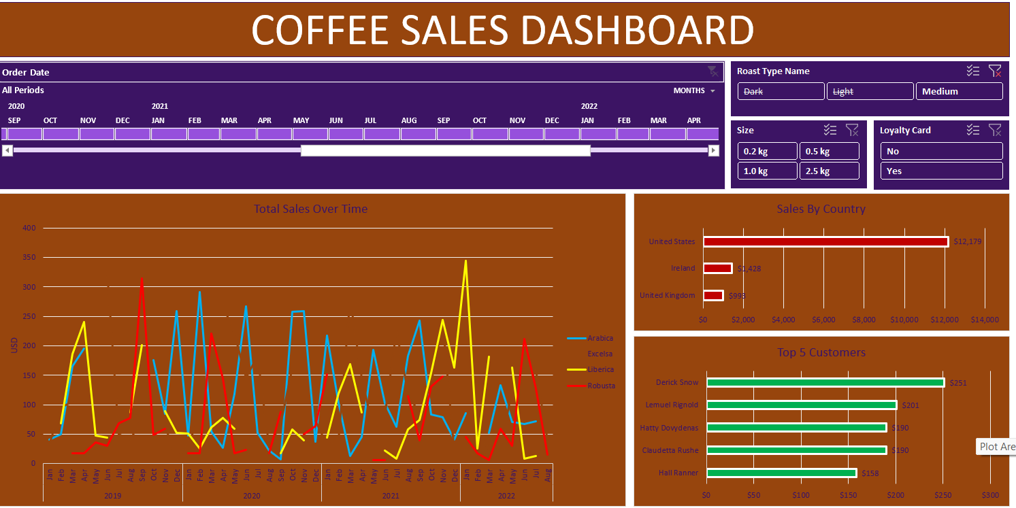pular product categories.