**Sales Dashboard Project Report**

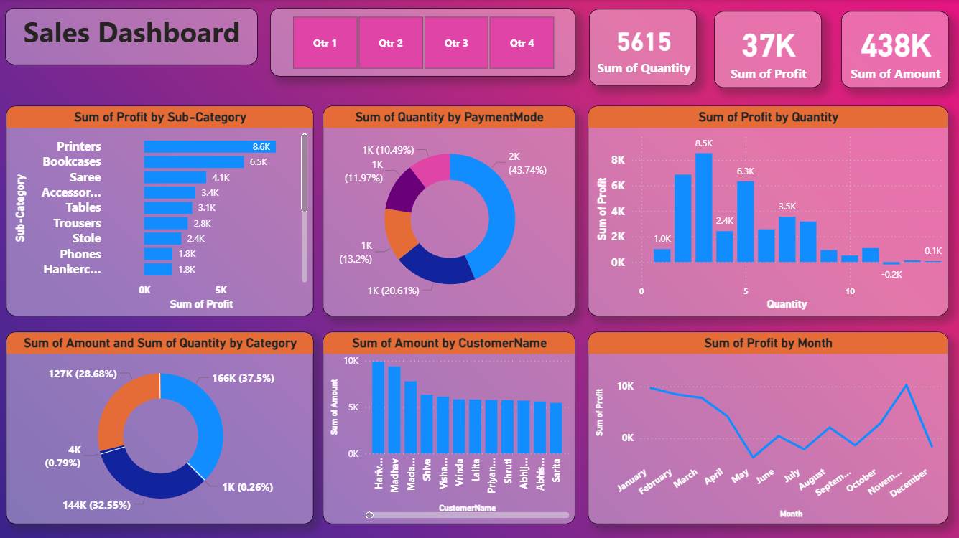

# LAYOUT

**1. Cover Page**

* Title, dashboard image prominently displayed.

**2. Introduction**

* Purpose of the dashboard.
* Business context for sales analysis.

**3. Key Performance Indicators (KPIs)**

* **Sum of Quantity**
* **Sum of Profit**
* **Sum of Amount**

**4. Profit by Sub-Category**

* Detailed breakdown by product type.
* Business insights from high- and low-profit items.

**5. Quantity by Payment Mode**

* Customer preferences.
* Digital vs. cash payments.

**6. Quantity & Amount by Category**

* Product category performance analysis.
* Opportunities for revenue growth.

**7. Amount by Customer Name**

* Top customers.
* Retention and upselling strategies.

**8. Profit by Month**

* Month-wise performance trends.
* Seasonal impact.

**9. Quarter Slicer & Interactive Features**

* How slicer works.
* Benefits for real-time business decision-making.

**10. Conclusion & Recommendations**

* Summary of findings.
* Action points for sales improvement.

# Dashboard Overview

**1. Overview**

The Power BI dashboard in this report combines different types of charts to present sales data in an intuitive format.

**2. KPI Cards**

At the top, KPI cards give an instant snapshot of key metrics:

* Total quantity sold
* Total profit
* Total sales amount

These are crucial for quickly assessing the business's overall performance in a given period.

**3. Product Sub-Category Analysis**

Bar charts show the profit contribution from each product sub-category.  
This helps identify which products are most profitable and which may need price adjustments or better marketing.

**4. Product Quantity Analysis**

Line and Stacked column charts show the quantity contribution from each product quantity.  
This helps identify which products are most quantity and which may need price adjustments or better marketing.

**5. Payment Method Analysis**

Donut charts present proportional data in an easily digestible format, such as:

* The share of total sales made using each payment method.
* The percentage of sales amount contributed by each category.

**6. Customer Analysis**

Column charts highlight high-value customers, helping the business focus retention efforts where they will have the most impact.

**7. Monthly Profit Trends**

The dashboard includes a line chart to track monthly profit trends.  
This is useful for spotting seasonal dips or spikes.

**8. Quarter Slicer Feature**

The quarter slicer allows users to switch the view between:

* Qtr 1
* Qtr 2
* Qtr 3
* Qtr 4

This means the same set of visuals can be reused to analyze different time periods without creating separate reports.

**9. Conclusion**

**Qtr 1 Position**

**Qtr 2 Position**

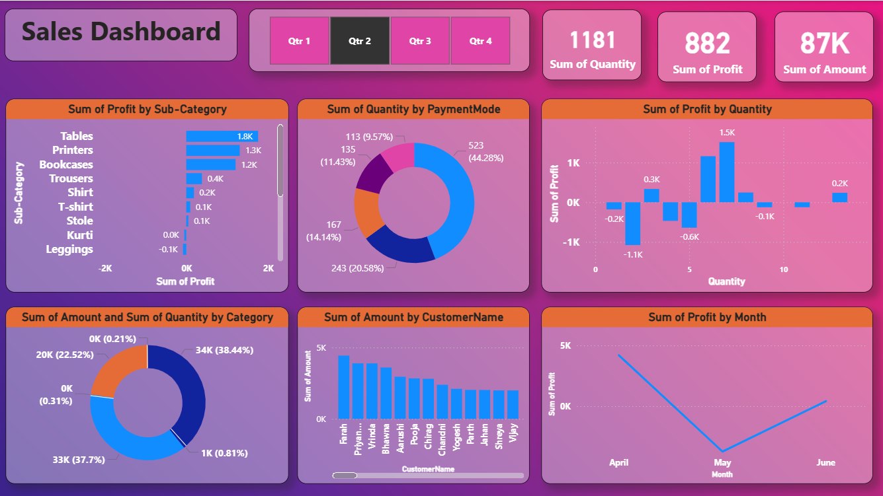

**Qtr 3 Position**

**Qtr 4 Position**

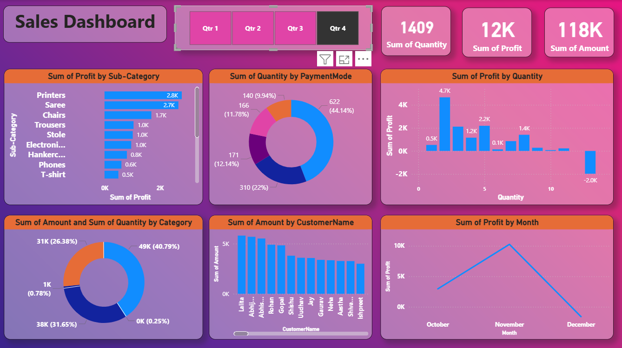

# KPI Explanation

The KPI section of the dashboard shows three important numbers for Q4:

* **Total quantity sold:** 1,409
* **Total profit:** 12K
* **Total sales amount:** 118K

These numbers give a quick idea of how the business is doing.

For example:

* If quantity sold is high but profit is low, it might mean products are too cheap or the most sold items have small profit margins.
* If profit is high but quantity sold is low, it might mean expensive products are making most of the earnings.

By checking these KPIs every quarter, managers can see if their sales and marketing strategies are working. Comparing numbers from different quarters shows if the business is improving or not.

These KPIs are the main indicators of performance. All the other visuals in the dashboard help explain why these numbers look the way they do.

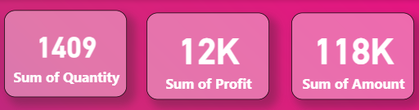

# Profit by Sub-Category

The profit by sub-category chart shows which product types make the most profit.

* **Printers**: 2.8K profit
* **Sarees**: 2.7K profit
* **Chairs**: 1.7K profit
* **Trousers**: 1.0K profit
* **Stoles**: 1.0K profit
* **Electric Games**: 1.0K profit

This information helps decide which products to promote more.

* Products at the top (like Printers and Phones) might get more marketing because they bring in more profit.
* Products at the bottom might need changes in price or special offers to sell better.

It also helps with inventory planning:

* If a product is popular and profitable, keep more stock so you don’t miss sales.
* If a product is less profitable, you might sell less of it or try selling it in a different way.

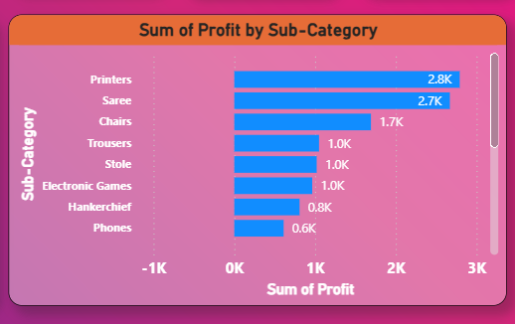

# Profit by Quantity

This chart shows how much profit the business makes depending on the **quantity of items sold** in each order.

**Key Insights:**

* Selling **3 units** in an order gives the **highest profit** — about **8.5K**.
* Selling **2 units** is also very profitable, at nearly **7K**.
* Quantities of **5 units** make **6.3K** in profit.
* Medium quantities (2–5 units) are the **sweet spot** for maximizing profit.
* Orders with **only 1 unit** give much lower profit — about **1K**.
* Very large orders (above 10 units) can **reduce profit**, and in one case even cause a **loss of -0.2K**.

**Why this happens:**

* Large orders might be heavily discounted.
* Bulk deals may have **lower margins**.
* Costs (like shipping or special handling) could be higher for big orders.

This chart helps managers **find the balance** between selling more and keeping profits high. It’s not always about quantity — **smart quantity means smart profit**.

# Quantity by Payment Mode

The quantity by payment mode donut chart shows which payment methods customers use most.

* The most used payment method makes up **43.74%** of all purchases, showing it’s the clear Favorito.
* Other payment methods are used between **10% and 20%** of the time.

Why this is important for the business:

* If most customers use a certain payment method (like digital payments), the business should make sure it is fast, safe, and easy to use.
* Special offers or discounts can be given to encourage customers to use certain payment methods, especially the ones that cost the business less in fees.

This chart helps the business understand **customer habits** and make better decisions about **payment processing and promotions**.

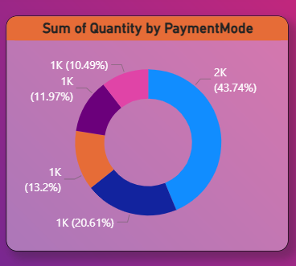

# Quantity and Amount by Category

This chart shows **quantity sold** and **sales amount** together, so we can see both how much is sold and how much money each category makes.

* One category is the leader with **166K in sales** (**37.5% of total sales**).
* The next highest category has **127K in sales** (**28.68% of total sales**).

What this means for the business:

* These numbers help find which product categories earn the most money.
* Products can be grouped into **high-value**, **medium-value**, and **low-value** categories.
* High-value categories can be given better store placement or website visibility.
* Low-value categories can be discounted, bundled, or promoted to sell faster.

This visual helps decide **where to invest in marketing and inventory**.

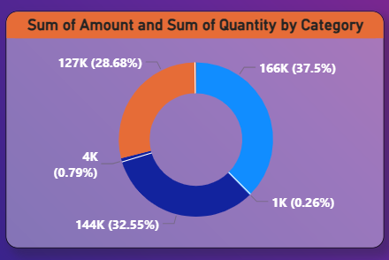

# Amount by Customer Name

This chart shows which customers spend the most money.

* **Hariveer** is the top spender with more than **10K** in purchases.
* **Mahadev** and **mada…** follow as other high-value customers.

Why this is important:

* These top customers are valuable because they are more likely to respond to **loyalty programs**, **exclusive offers**, and **early product releases**.
* Keeping these customers happy is often **cheaper and more profitable** than finding new customers.
* This chart helps businesses **focus on retention strategies** for their most important clients.

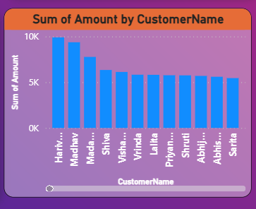

# Profit by Month

This chart shows how profits changed month by month in the first quarter (Q1).

* In **January**, profit was **9.7K**.
* In **February**, it dropped to **8.5K**.
* In **March**, it went down further to **7.8K**.

This steady drop could be because of:

* Seasonal changes in demand.
* Competition offering better deals.
* Customers losing interest in ongoing marketing campaigns.

**What can be done:**

* Run **special promotions** during months when sales are slow.
* Offer **new or different products** to keep customers engaged.
* Plan marketing campaigns that work well throughout the year to avoid big ups and downs.

# Use of Quarter Slicer

The **quarter slicer** is a tool in the dashboard that lets you quickly switch between **Q1, Q2, Q3, and Q4**.

* It makes the dashboard **interactive** so you don’t need different pages for each quarter.
* You can easily compare performance between quarters on the same screen.

**Example:**  
If you switch from **Q1** to **Q2**, you can immediately see whether profits went up or down.  
This helps managers **spot trends early** and take quick action — like launching promotions or adjusting stock levels.

**Why it’s useful:**

* Saves time when reviewing data.
* Makes side-by-side comparisons easy.
* Supports faster and smarter decision-making.

# Conclusion

1. The dashboard clearly **highlights top-performing products** based on sales and profit data.
2. Certain products stand out as **highly profitable**, meaning they not only sell well but also bring in good margins.
3. The visuals also reveal **preferred payment methods** among customers, showing how people like to pay for their purchases.
4. This helps in making decisions about payment options to improve the customer experience.
5. The dashboard also lists **key customers** who are the biggest spenders.
6. Possible reasons could be **seasonal demand changes**, stronger **competition**, or **marketing fatigue** where promotions lose impact.
7. The dashboard makes it easy to compare performance across different months and categories.
8. One solution could be to **adjust marketing strategies**, especially during slow months.
9. Another step is to review **pricing strategies** to make sure the business remains competitive.
10. Introducing **new product variations** or seasonal offers could help keep customer interest high.
11. Promotions and targeted advertising could be aimed at underperforming categories to boost sales.
12. The quarter slicer feature allows easy switching between Q1, Q2, Q3, and Q4 to compare trends.
13. This interactivity makes it faster for management to track improvements or spot new challenges.