[1]

Article on **Inductor Design**

Vaibhav Saini, *Student,* IIT(BHU), Varanasi

***Abstract***

**We have worked on,**

* **What is an inductor?**
* **Brief History**
* **How are inductors used in practical life**
* **Advantages of using inductors**
* **Steps to design an inductor**
* **A program to determine physical properties of a given inductor, by knowing just the Inductance and current values.**

# I. INTRODUCTION

* **An inductor, also called a coil, choke, or reactor, is a passive two-terminal electrical component that stores energy in a magnetic field when electric current flows through it. An inductor typically consists of an insulated wire wound into a coil.**
* ***Faraday* invented the inductor while discovering the phenomenon of electromagnetic-induction nearly two hundred years ago, which subsequently proved crucial for practical large-scale use of electricity for power and telegraph communication.**
* **An electric current flowing through a conductor generates a magnetic field surrounding it. The magnetic flux linkage generated by a given current depends on the geometric shape of the circuit. Their ratio defines the inductance L.**

**The Core of Inductor is generally made up of materials like silicon steel, iron powder and ferrites. It is wound by a wire with several turns. A sketch of inductor is depicted below:-**

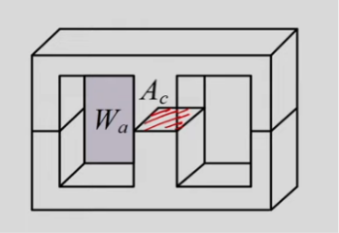

**Uses in practical life**

* **Inductors are used for tuning circuits.**
* **Used as sensors.**
* **Used as energy storage devices, it stores energy in the form of magnetic field.**
* **Used as induction motors.**
* **Combination of inductors is used as transformer.**
* **Inductors are used as filters as well.**
* **They are used in chokes and as ferrite beads as well.**

# II. Math

Our main two objectives are-To design an inductor and to use the program to get appropriate values of the inductor’s physical properties.

## A. Equations

Various equations are used in designing of an inductor. They are listed below accordingly.

* Energy(stored in air gap):- E=[L(Imax)2**]/**2.
* Estimate Area Product(Ap)=AWA.c=2E/(KW*J*Bm)

Generally, KW=0.6

* Permeance(λ)= $\frac{μ_{0}μ_{r}A_{C}}{l_{m}+μ_{r}l_{g}}$
* Otherwise, λ is calculated using AL factor written on core as: L=λ*N^2 , λ=L/(N^2)

The terminologies used are explained below

Window Area(AW or Wa): It is the area of window or the hollow section of the core with

coil wire crossing through it

Cross Sectional Area Of Core(Ac): Cross section area of core as given in the

figure.

Area Product (Ap) : It is defined as the product of window area(Aw) and Cross section area of core(Ac).

Current Density(J)

Maximum Flux Density (Bm)

Cross Section Area of Wire(Aw)

Window Utilization Factor (Kw): Its value generally depends upon the fraction of window area occupied by wire of cross section area (Aw).

## B. Algorithms

Screenshots of the code written, which determines the physical properties of the inductor by feeding current and inductance values.

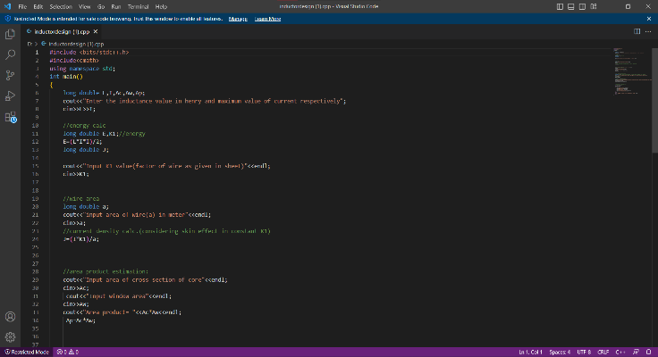

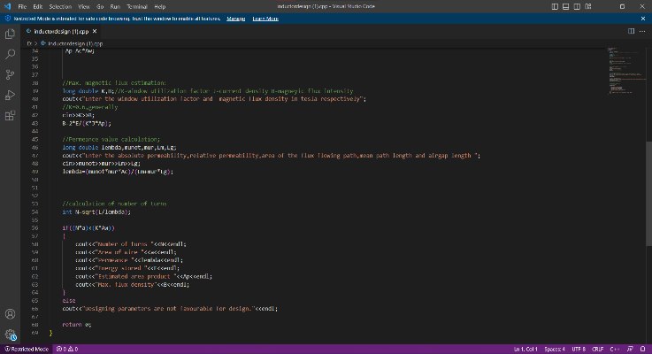

The code is written on the next page.

# III. Conclusion

I have done research in this field and have come to know a lot about inductors and how they are designed in Electrical Engineering. It is of great help to us as Inductors play a big part in our upcoming and ongoing courses.

# IEEE Guidelines and Policies

A full overview of IEEE publishing guidelines and policies can be found at <https://journals.ieeeauthorcenter.ieee.org/become-an-ieee-journal-author/publishing-ethics/guidelines-and-policies/>. They are designed to help authors understand and navigate the publishing process successfully. Learn more about IEEE’s fundamental publishing guidelines and principles, submission and peer review policies, post-publication policies, and guidelines on advertising, accessibility, and data privacy.

# Acknowledgment

I would like to express my sincere gratitude to Dr. Naveen Yalla for his invaluable guidance and support throughout this project. His expertise and insights have been instrumental in shaping my work and I am grateful for his commitment to project. Thanks sir for your unwavering support.

# References

* "Electric Machines” by DP Kothari and IJ Nagrath
* "Electrical Power Equipment Maintenance and Testing" by Paul Gill
* "Principles of Electric Machines and Power Electronics" by P.C. Sen
* "Handbook of Electrical Design Details" by Neil Sclater
* "Electric Power Distribution Handbook" by T.A. Short
* "Electric Motor Drives: Modeling, Analysis, and Control" by R. Krishnan
* "Electrical Machines, Drives, and Power Systems" by Theodore Wildi
* "Electrical Equipment Handbook: Troubleshooting and Maintenance" by Philip Kiameh

#include <bits/stdc++.h>

#include<cmath>

using namespace std;

int main()

{

long double L,I,Ac,Aw,Ap;

cout<<"Enter the inductance value in henry and maximum value of current respectively";

cin>>L>>I;

//energy calc

long double E,K1;//energy

E=(L*I*I)/2;

long double J;

cout<<"Input K1 value(factor of wire as given in sheet)"<<endl;

cin>>K1;

//wire area

long double a;

cout<<"input area of wire(a) in meter"<<endl;

cin>>a;

//current density calc.(considering skin effect in constant K1)

J=(I*K1)/a;

//area product estimation:

cout<<"Input area of cross section of core"<<endl;

cin>>Ac;

cout<<"Input window area"<<endl;

cin>>Aw;

cout<<"Area product= "<<Ac*Aw<<endl;

Ap=Ac*Aw;

//Max. magnetic flux estimation:

long double K,B;//K-window utilization factor J-current density B-magneyic flux intensity

cout<<"Enter the window utilization factor and magnetic flux density in tesla respectively";

//K=0.6,generally

cin>>K>>B;

B=2*E/(K*J*Ap);

//Permeance value calculation;

long double lembda,munot,mur,Lm,Lg;

cout<<"Enter the absolute permeability,relative permeability,area of the flux flowing path,mean path length and airgap length ";

cin>>munot>>mur>>Lm>>Lg;

lembda=(munot*mur*Ac)/(Lm+mur*Lg);

//calculation of number of turns

int N=sqrt(L/lembda);

if((N*a)<(K*Aw))

{

cout<<"Number of turns "<<N<<endl;

cout<<"Area of wire "<<a<<endl;

cout<<"Permeance "<<lembda<<endl;

cout<<"Energy stored "<<E<<endl;

cout<<"Estimated area product "<<Ap<<endl;

cout<<"Max. flux density"<<B<<endl;

}

else

cout<<"Designing parameters are not favourable for design."<<endl;

return 0;

}

1. Vaibhav Saini is with the Indian Institute of Technology,(BHU),Varanasi (e-mail: vaibhav.saini.eee21@iitbhu.ac.in).