
Business Question and Visualization Report

Date | 23 September 2026
Team ID | Individual Project
Project Name | Global AI Adoption in Education: A Comprehensive Global Analysis
Maximum Marks | 5 Marks

Visualization development refers to the process of creating graphical representations of data to facilitate understanding, analysis, and decision-making. The goal is to transform complex datasets into visual formats that are easy to interpret, enabling users to gain insights and make informed decisions. Visualization development involves selecting appropriate visual elements, designing layouts, and using interactive features to enhance the user experience. This process is commonly associated with data visualization tools and platforms, and it plays a crucial role in business intelligence, analytics, and reporting
Business Questions and Visualisation
1. What is the overall level of Student AI Usage?
Visualization: KPI card showing average Student AI Usage of 31.0%.
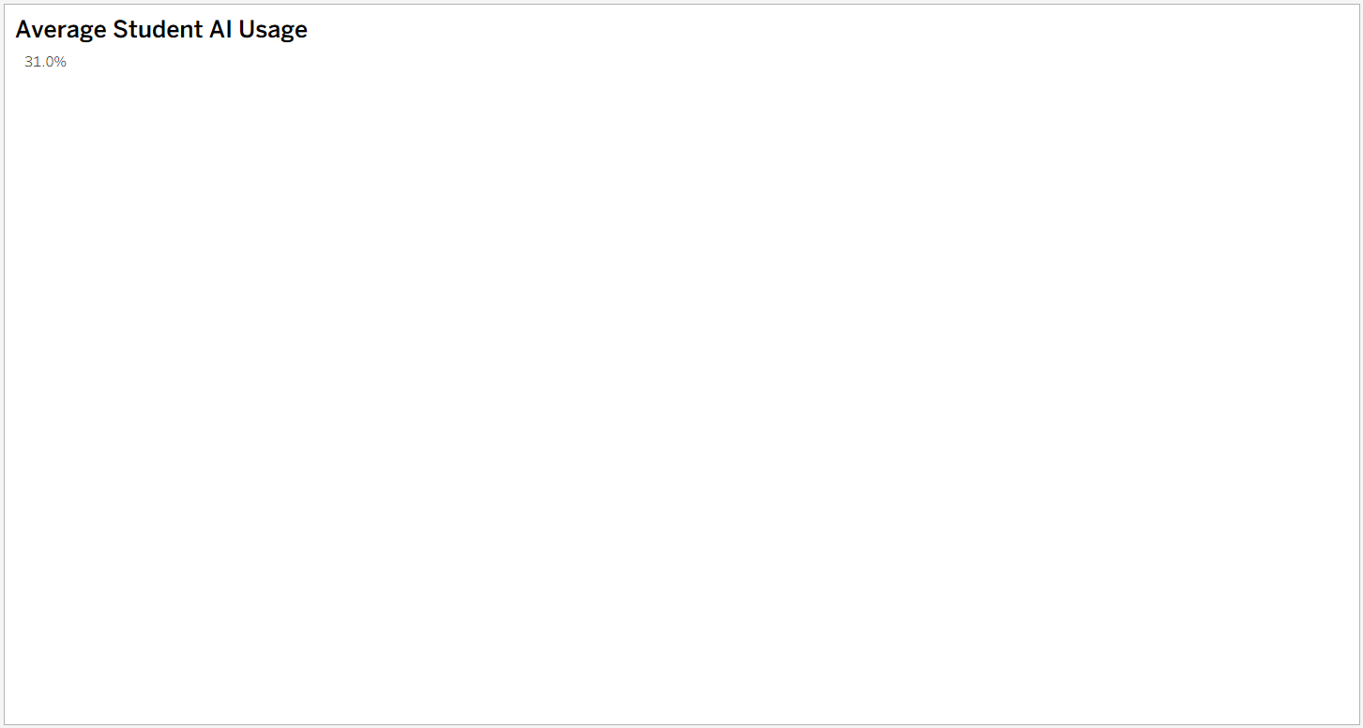
Figure 1: Tableau visualization

2. What is the overall level of Teacher AI Usage?
Visualization: KPI card showing average Teacher AI Usage of 29.9%.

Figure 2: Tableau visualization

3. What is the overall level of Internet Penetration?
Visualization: KPI card showing the Average Internet Penetration measure displayed in the Tableau visual.
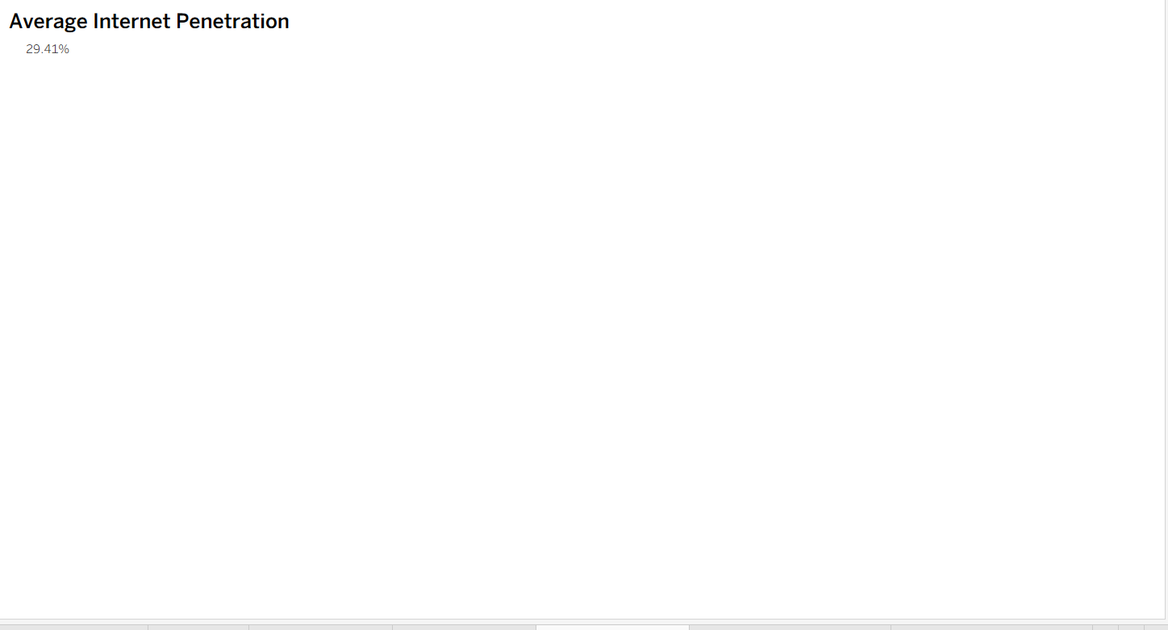
Figure 3: Tableau visualization

4. How has School AI Adoption changed from 2015 to 2026?
Visualization: Line chart showing the AI Adoption Journey in Education from 2015 to 2026.
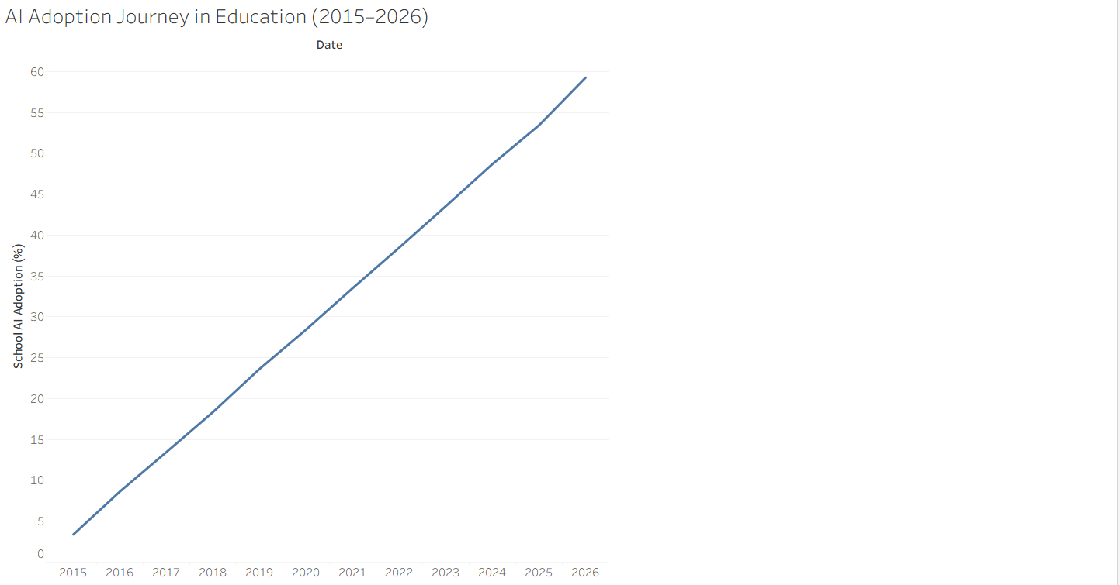
Figure 4: Tableau visualization

5. How does Student AI Usage compare with Teacher AI Usage over time?
Visualization: Two-line chart comparing Student and Teacher AI Usage from 2015 to 2026.
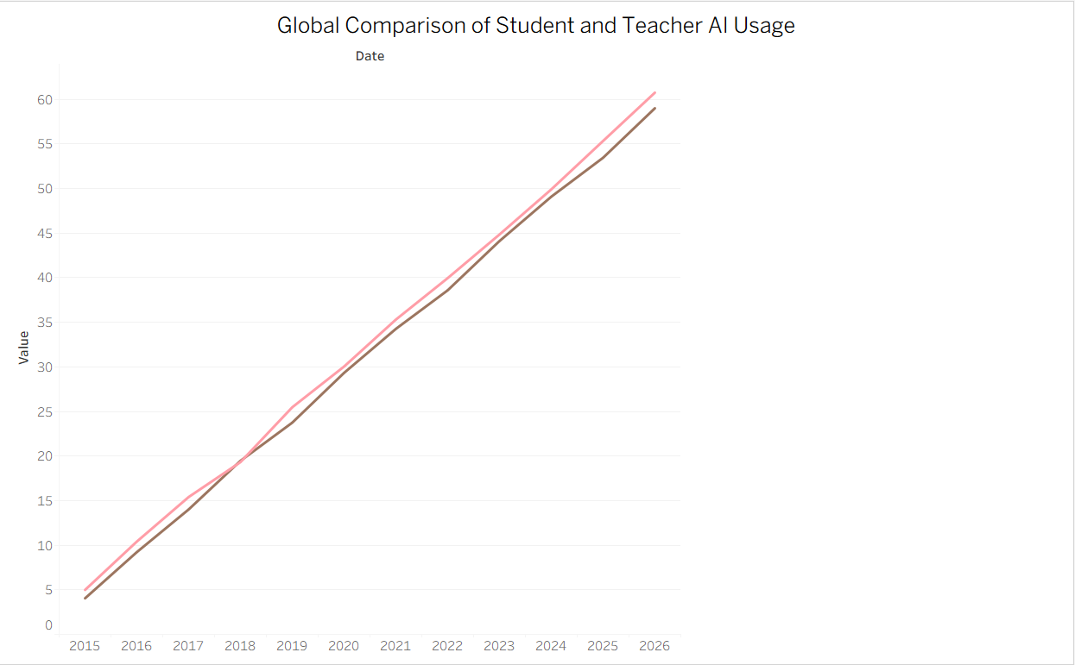
Figure 5: Tableau visualization

6. How does AI usage differ between rural and urban communities over time?
Visualization: Line chart comparing average Rural and Urban AI Usage from 2015 to 2026.
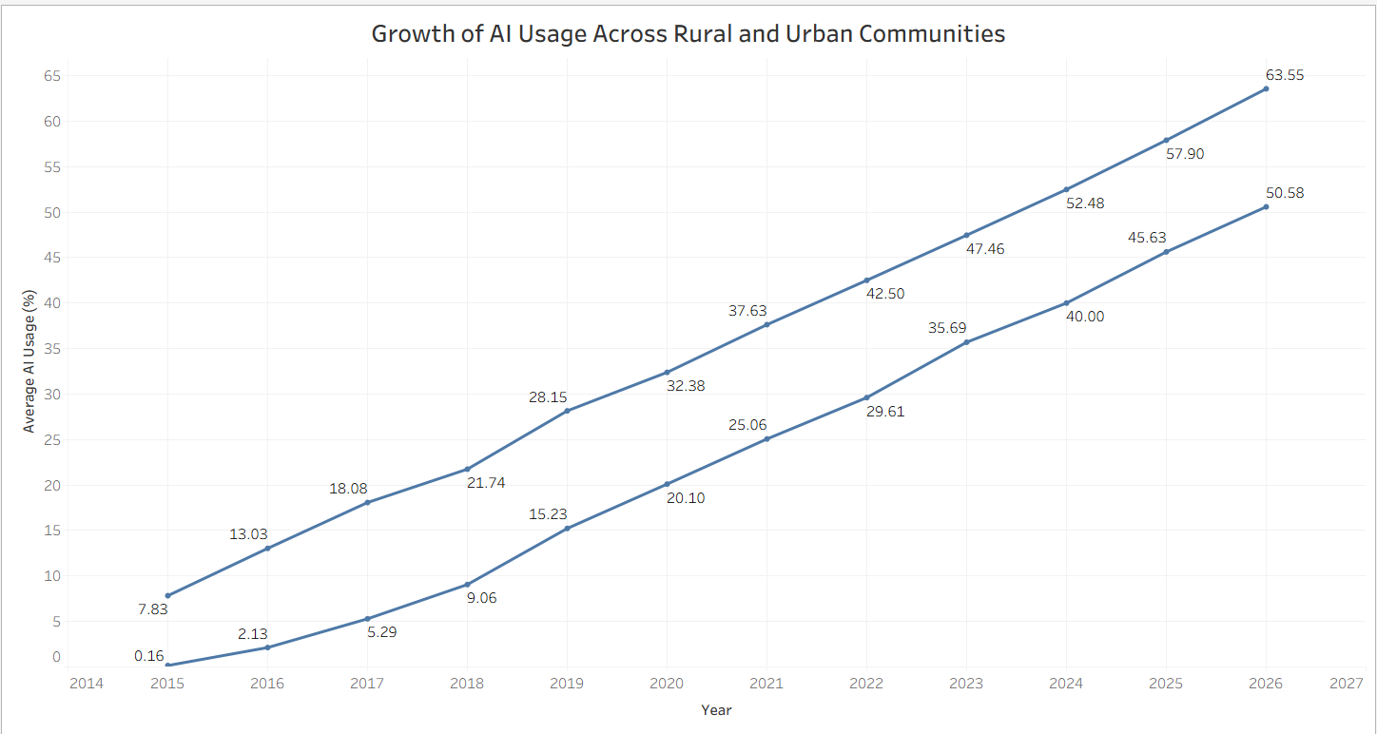
Figure 6: Tableau visualization

7. Which AI tools are most frequently represented in the dataset?
Visualization: Horizontal bar chart comparing ChatGPT, Microsoft Copilot, Google Gemini, and Khanmigo.
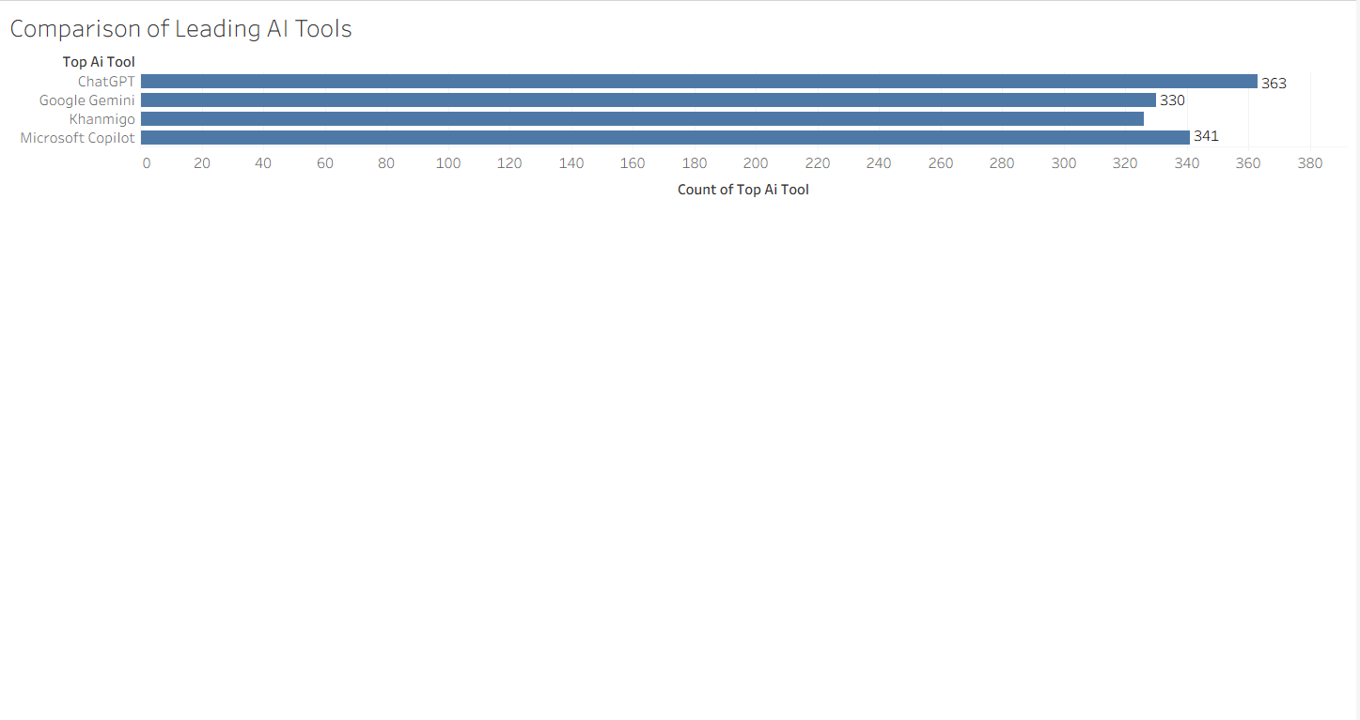
Figure 7: Tableau visualization

8. How does School AI Adoption vary across regions?
Visualization: Horizontal bar chart comparing average School AI Adoption across six regions.
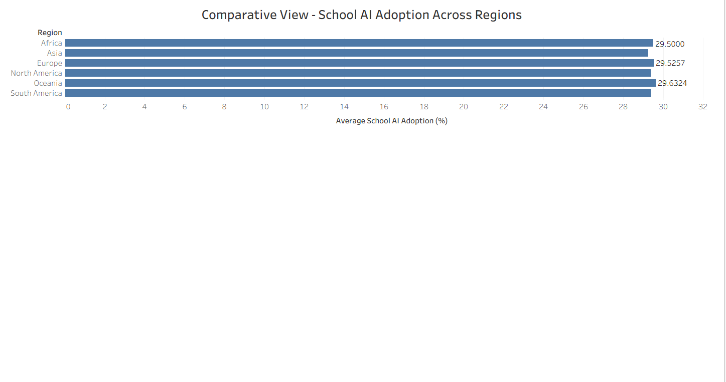
Figure 8: Tableau visualization

9. What is the distribution of records across AI Adoption categories?
Visualization: Bar chart showing the Low, Medium, and High AI Adoption categories.
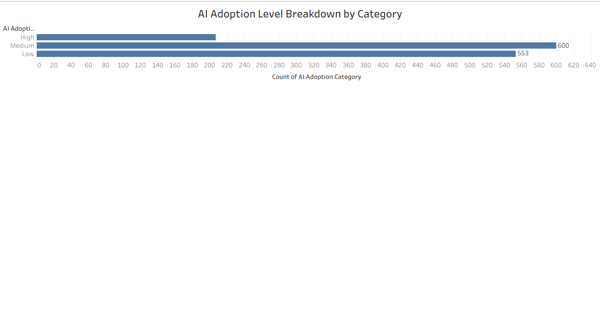
Figure 9: Tableau visualization

10. How does educational development vary geographically?
Visualization: World map showing Education Index by country.
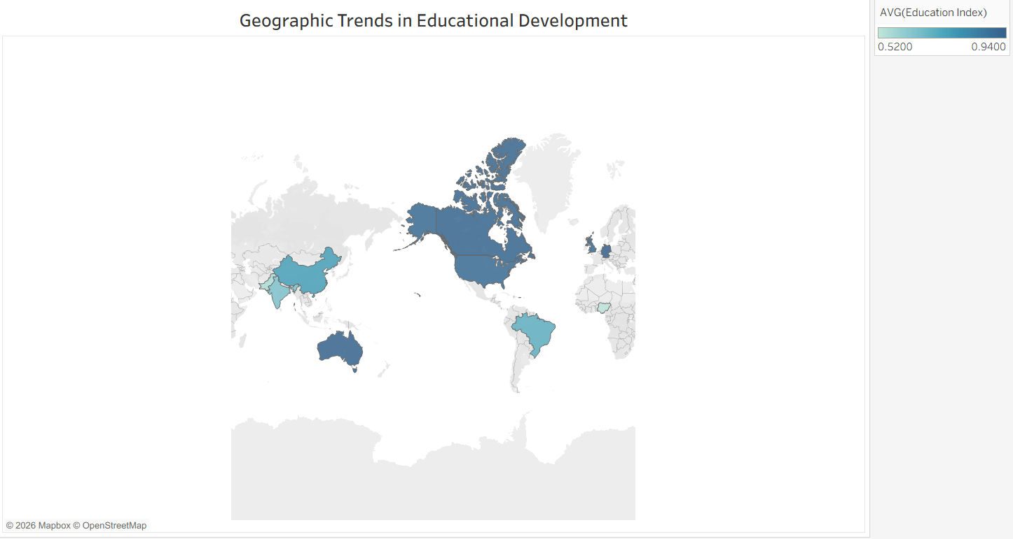
Figure 10: Tableau visualization

11. How does country-level AI adoption relate to daily AI usage?
Visualization: Scatter plot comparing average daily AI usage minutes with average student AI usage.
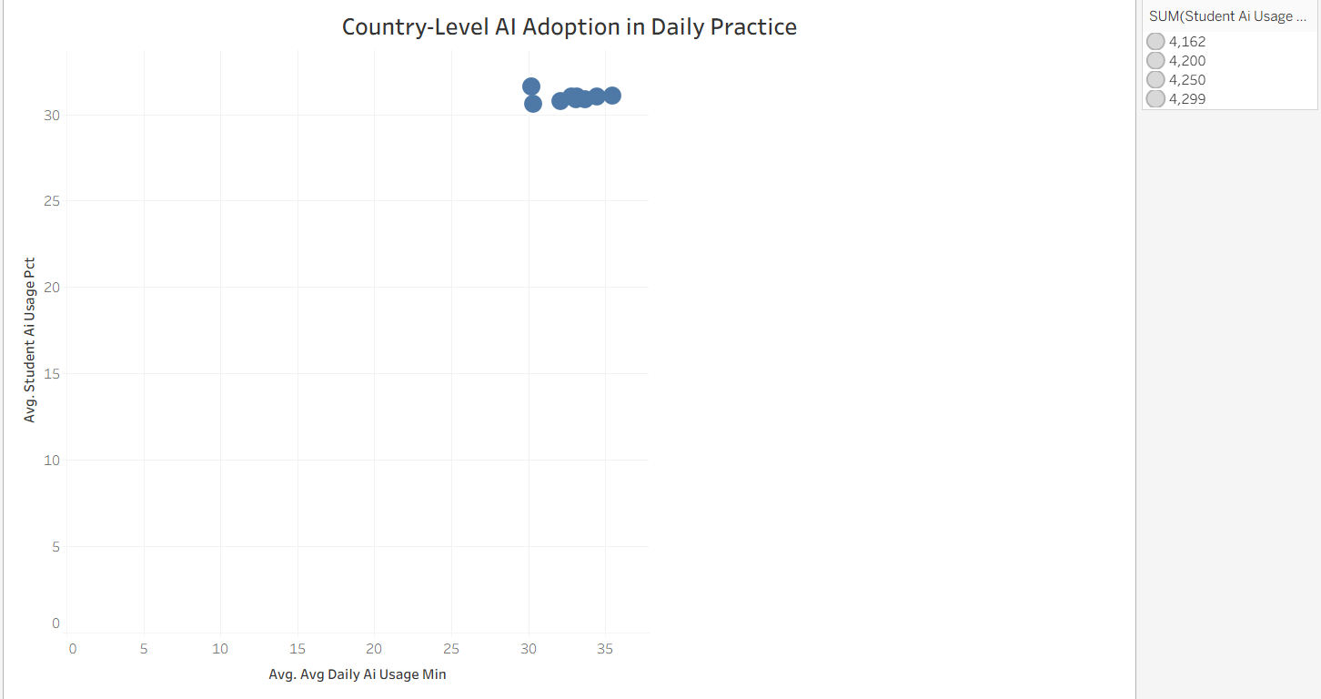
Figure 11: Tableau visualization
Note: 11 business questions and corresponding Tableau visualizations are included, exceeding the required minimum of 8.

