Dashboard Design

Date | 15 September 2026
Team ID | Individual Project
Project Name | Global AI Adoption in Education: A Comprehensive Global Analysis
Maximum Marks | 5 Marks

Creating an effective dashboard involves thoughtful design to ensure that the presented information is clear, relevant, and easily understandable for the intended audience. Here are some key principles and best practices for dashboard design
Activity 1: Interactive and visually appealing dashboards
Creating interactive and visually appealing dashboards involves a combination of thoughtful design, effective use of visual elements, and the incorporation of interactive features. Here are some tips to help you design dashboards that are both visually appealing and engaging for users so take care of below points
- Clear and Intuitive Layout
- Use Appropriate Visualizations
- Colour and Theming
- Interactive Filters and Slicers
- Drill-Down Capabilities
- Responsive Design
- Custom Visuals and Icons
- Use of Infographics
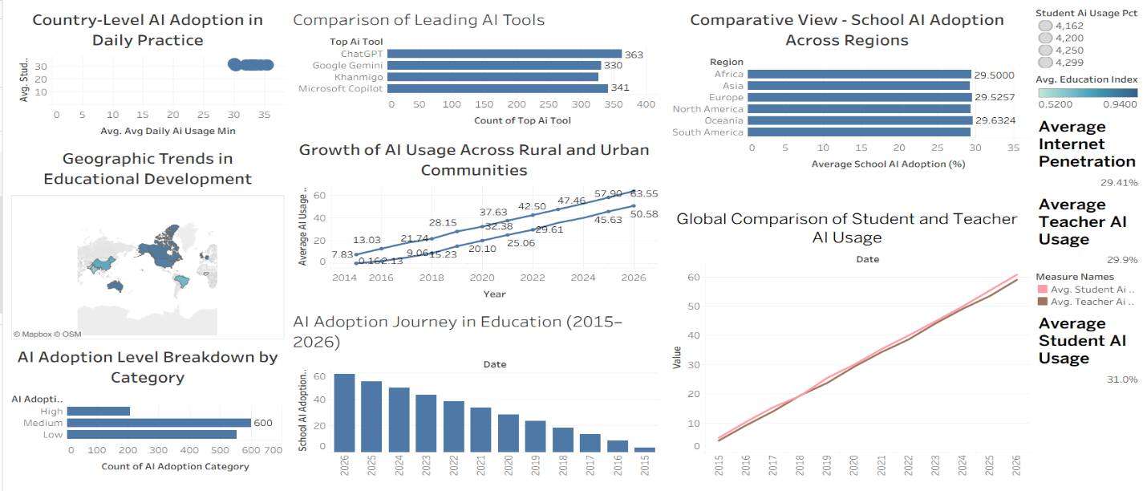

Note: Highlight the major outcomes in form of bullet points

Major Outcomes from the Global AI Adoption in Education Dashboard:
• Student AI Usage: Average student AI usage is approximately 31.0%, showing significant adoption of AI in learning activities.
• Teacher AI Usage: Average teacher AI usage is approximately 29.9%, indicating increasing use of AI tools by educators.
• School AI Adoption: School AI adoption increases strongly from 2015 to 2026, reaching about 59% in 2026.
• Urban–Rural Usage: Urban AI usage remains higher than rural AI usage, while rural usage also shows substantial growth over the period.
• Regional and Tool Insights: Oceania has the highest average regional school AI adoption at about 29.63%, while ChatGPT is the most frequently represented AI tool with 363 records.

Dashboard Link :
DASHBOARD | Tableau Public

