Story

Date | 25 September 2026
Team ID | Individual Project
Project Name | Global AI Adoption in Education: A Comprehensive Global Analysis
Maximum Marks | 5 Marks

By using stories in Tableau, you can effectively communicate complex data in a way that is both interactive and engaging, making it easier for the audience to follow along and understand the insights. It’s a tool for data storytelling, allowing you to present insights in a cohesive, engaging way that takes viewers through a logical progression of findings or analyses.
In Tableau, Story is a feature that allows you to create a sequence of dashboards, visualizations, and text to present data insights in a cohesive and narrative-driven way. It's like a slideshow within Tableau that guides the audience through a series of data points, helping them understand key insights, trends, or outcomes of your analysis.
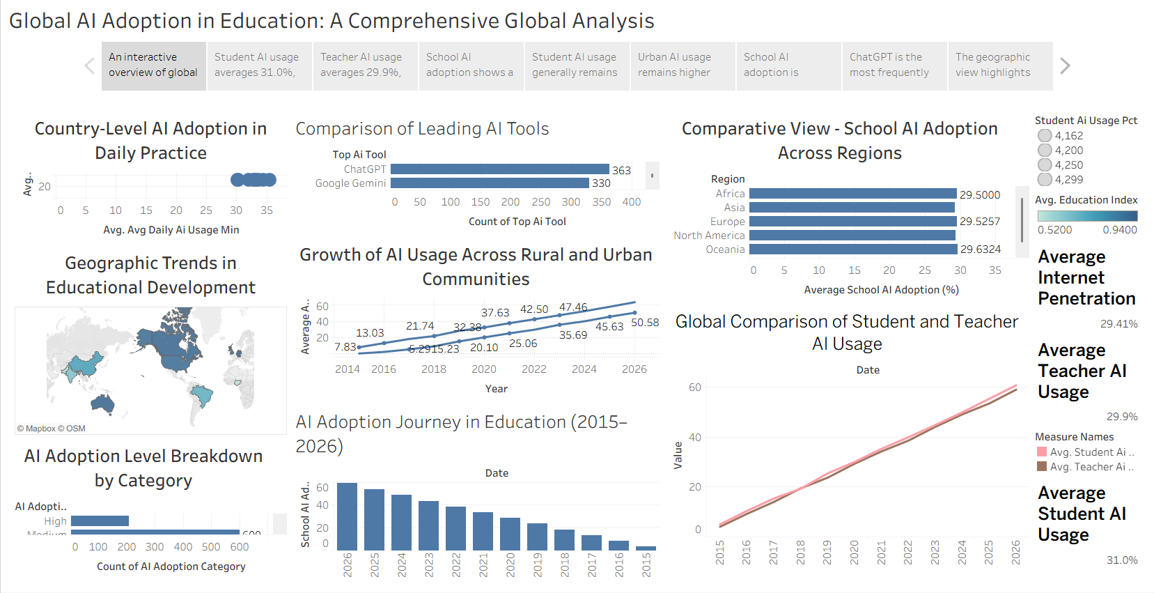

Observations:
• Overall Student AI Usage: Student AI usage averages 31.0%, indicating that AI has become an important part of learning and educational activities.
• Overall Teacher AI Usage: Teacher AI usage averages 29.9%, showing increasing adoption of AI tools by educators.
• AI Adoption Growth: School AI adoption increases from 3.4% in 2015 to approximately 59.3% in 2026, showing rapid growth in educational AI integration.
• Student vs Teacher Usage: Student AI usage generally remains slightly higher than teacher AI usage, with both showing strong growth from 2015 to 2026.
• Urban vs Rural Usage: Urban AI usage remains higher than rural usage throughout the period, although rural communities also show substantial growth.
• Regional Adoption: Regional school AI adoption is broadly similar, with Oceania recording the highest average at approximately 29.63%.
• Leading AI Tools: ChatGPT is the most frequently represented AI tool in the dataset with 363 records, followed by Microsoft Copilot, Google Gemini, and Khanmigo.
• Geographic Educational Development: The geographic view highlights differences in Education Index across countries and provides a global perspective on educational development alongside AI adoption.

Story Link:
STORY | Tableau Public

