**Industrial Internship Report on**

**Forecasting of Smart city traffic patterns**

**Prepared by**

**Vaibhav Bhargava**

|  |
| --- |
| *Executive Summary* |
| This report provides details of the Industrial Internship provided by upskill Campus and The IoT Academy in collaboration with Industrial Partner UniConverge Technologies Pvt Ltd (UCT).  This internship was focused on a project/problem statement provided by UCT. We had to finish the project including the report in 6 weeks’ time.  My project was Forecasting of Smart city traffic patterns in which we have to predict the traffic volume at any particular date and time according to the dataset given  This internship gave me a very good opportunity to get exposure to Industrial problems and design/implement solution for that. It was an overall great experience to have this internship. |

**TABLE OF CONTENTS**

1 Preface 3

2 Introduction 5

2.1About UniConverge Technologies Pvt Ltd 5

2.2 About upskill Campus 9

2.3 The IoT Academy 10

2.4 Objective 11

2.5 References 11

3 Problem Statement 12

4 Existing and Proposed solution 14

## 4.1 Code submission (Github link): https://github.com/Vaibhav1604/upSkills-Campus/blob/main/SmartCityTrafficPatterns%20.ipynb

## 4.2Report submission (Github link) :

5 Proposed Design/ Model 17

6 Performance Test 18

7 My learnings 20

8 Future work scope 21

# Preface

The Internship started with the briefing session and we were told what we have to do through our internship period. We were given the access to the lms portal of upSkills and the course was there which we have to complete in our decided period. During the internship period we had various quizzes and submissions of WPR. During the first week we have to watch some videos to understand what is Data science and give a brief introduction about what is Machine learning. We were also given a list of topics from which we have to choose one according to our interest and make a project in the internship duration. In second week we read the book “Introducing Data Science” by Davy cielen, Arno D.B. Meysman and Mohamed Ali and understood what Data science is and how it is used in big data world. We learned the data science processes and get to know about the importance of Machine learning in Data Science. In week 2 we have to complete the book and understand the difference between Data Scientist and Data analyst. We were also given one quiz to test our knowledge so far. Week 3 started with the difference between AI and Data science and we were given another book named “An Introduction to Probability and Statistics” by Vijay k. Rohatgi and A.K. Md. Ehsanes Saleh. After the book we learnt about the different skills we need in data science. Week 4 was all about the Machine learning, in this week we were given a book, videos articles which contain the complete information about Machine learning and its various algorithms. In this week we also learnt optimization techniques like Function Optimization, Approximation of Function, etc.. In this week we also had our second quiz. Week 5 helped us to learn how can and how much a data engineer earn. PPT gave us introduction to the corporate world and what practices we should follow. We were also told about what an interviewer expect from a student who have interest in Data science. Some interview questions was also given which can be asked by interviewer. Week 6 was all about the Project submission and the final quiz to test our knowledge so we completed all of that in that week

Relevant internships play a crucial role in career development for several reasons like Gaining Practical Experience, Building a Professional Network, Exploring Career Paths, Resume Building, Enhancing Skills and Knowledge, references and Recommendations, Confidence and Professional Development, Industry Insights and Trends, Personal Growth, Potential Job Offers, etc.

The problem was about to Implementing a robust traffic system for a city involves understanding the traffic patterns of key junctions, including variations during holidays and special occasions. By analyzing traffic data, authorities can identify peak periods and factors contributing to congestion. This knowledge enables optimization of traffic signal timings, implementation of diversion strategies, and improvements to lane configurations. Understanding traffic patterns during holidays allows authorities to develop specific strategies, such as deploying additional personnel and adjusting signal timings. By being prepared for traffic peaks and tailoring strategies accordingly, the city can minimize congestion, reduce travel times, enhance road safety, and improve overall traffic flow.

The Program was planned as show below

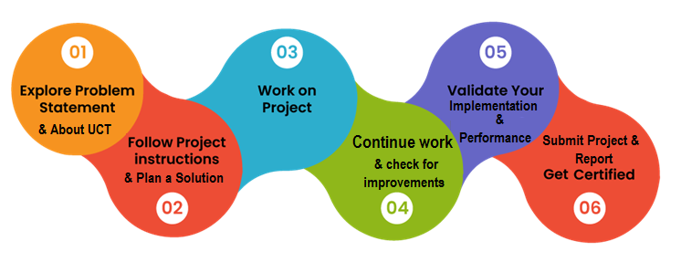

# Introduction

## About UniConverge Technologies Pvt Ltd

A company established in 2013 and working in Digital Transformation domain and providing Industrial solutions with prime focus on sustainability and RoI.

For developing its products and solutions it is leveraging various**Cutting Edge Technologies e.g. Internet of Things (IoT), Cyber Security, Cloud computing (AWS, Azure), Machine Learning, Communication Technologies (4G/5G/LoRaWAN), Java Full Stack, Python, Front end**etc.



1. UCT IoT Platform **(****)**

**UCT Insight** is an IOT platform designed for quick deployment of IOT applications on the same time providing valuable “insight” for your process/business. It has been built in Java for backend and ReactJS for Front end. It has support for MySQL and various NoSql Databases.

* It enables device connectivity via industry standard IoT protocols - MQTT, CoAP, HTTP, Modbus TCP, OPC UA
* It supports both cloud and on-premises deployments.

It has features to  
• Build Your own dashboard  
• Analytics and Reporting  
• Alert and Notification  
• Integration with third party application(Power BI, SAP, ERP)  
• Rule Engine

 

1. **Smart Factory Platform (****)**

Factory watch is a platform for smart factory needs.

It provides Users/ Factory

* with a scalable solution for their Production and asset monitoring
* OEE and predictive maintenance solution scaling up to digital twin for your assets.
* to unleased the true potential of the data that their machines are generating and helps to identify the KPIs and also improve them.
* A modular architecture that allows users to choose the service that they what to start and then can scale to more complex solutions as per their demands.

Its unique SaaS model helps users to save time, cost and money.

 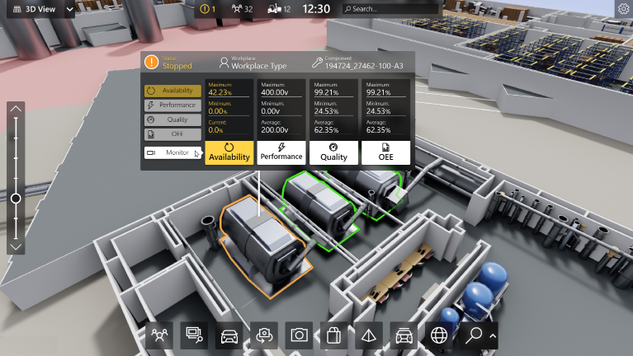

1.  based Solution

UCT is one of the early adopters of LoRAWAN teschnology and providing solution in Agritech, Smart cities, Industrial Monitoring, Smart Street Light, Smart Water/ Gas/ Electricity metering solutions etc.

1. Predictive Maintenance

UCT is providing Industrial Machine health monitoring and Predictive maintenance solution leveraging Embedded system, Industrial IoT and Machine Learning Technologies by finding Remaining useful life time of various Machines used in production process.



## About upskill Campus (USC)

upskill Campus along with The IoT Academy and in association with Uniconverge technologies has facilitated the smooth execution of the complete internship process.

USC is a career development platform that delivers **personalized executive coaching** in a more affordable, scalable and measurable way.



Seeing need of upskilling in self paced manner along-with additional support services e.g. Internship, projects, interaction with Industry experts, Career growth Services

<https://www.upskillcampus.com/>

upSkill Campus aiming to upskill 1 million learners in next 5 year

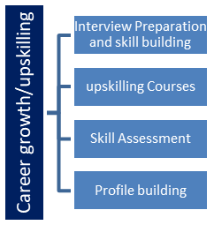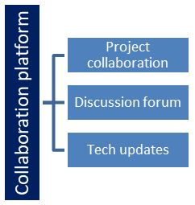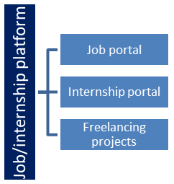

## The IoT Academy

The IoT academy is EdTech Division of UCT that is running long executive certification programs in collaboration with EICT Academy, IITK, IITR and IITG in multiple domains.

## Objectives of this Internship program

The objective for this internship program was to

 ☛ get practical experience of working in the industry.

 ☛ to solve real world problems.

 ☛ to have improved job prospects.

 ☛ to have Improved understanding of our field and its applications.

 ☛ to have Personal growth like better communication and problem solving.

## Reference

[1] Nagy, Attila M., and Vilmos Simon. "Survey on traffic prediction in smart cities." *Pervasive and Mobile Computing* 50 (2018): 148-163.

[2] Shahid, Nimra, et al. "Towards greener smart cities and road traffic forecasting using air pollution data." *Sustainable Cities and Society* 72 (2021): 103062.

[3] Vijayalakshmi, Balachandran, et al. "An attention‐based deep learning model for traffic flow prediction using spatiotemporal features towards sustainable smart city." *International Journal of Communication Systems* 34.3 (2021): e4609.

# Problem Statement

The problem statement revolves around implementing a robust traffic system for a city that can effectively handle traffic peaks and understand the traffic patterns of the four junctions within the city. Additionally, the system should account for variations in traffic patterns during holidays and other special occasions throughout the year. Traffic congestion is a significant issue in urban areas, leading to increased travel times, fuel consumption, and pollution. To address this problem, it is crucial to develop a comprehensive understanding of the traffic patterns in the city, especially during peak periods and exceptional circumstances like holidays. The first aspect of the problem statement involves preparing the traffic system to handle traffic peaks. Cities often experience peak traffic periods during specific times of the day, such as morning and evening rush hours when people commute to and from work. These periods see a surge in traffic volume, leading to congestion and delays. To address this, the traffic system needs to be optimized to efficiently manage the increased traffic flow during these peak periods. This optimization includes adjusting traffic signal timings, implementing intelligent traffic management systems, and possibly reconfiguring lanes or road infrastructure to better accommodate the high volume of vehicles. Understanding the traffic patterns of the four junctions within the city is another crucial aspect of the problem statement. Different junctions may experience varying levels of traffic congestion based on their location, surrounding areas, and the types of roads connected to them. Analyzing the traffic patterns at these junctions helps in identifying specific traffic management strategies tailored to each junction's needs. By studying traffic data, authorities can determine peak hours, traffic flow directions, and factors contributing to congestion. This knowledge enables the implementation of targeted solutions such as adjusting signal timings, optimizing lane configurations, or introducing dedicated turn lanes to improve traffic flow and reduce delays at these junctions. Furthermore, the problem statement highlights the importance of considering variations in traffic patterns during holidays and other special occasions. On these days, traffic patterns often differ significantly from regular working days due to events, festivals, or increased tourism. These variations can lead to unexpected traffic congestion or altered traffic routes. To address this, the traffic system needs to be adaptable and prepared to handle the specific challenges presented by holidays and special occasions. Authorities must gather data on holidays and occasions, including their dates and historical traffic patterns during those times. By analyzing this data, they can develop strategies that account for the anticipated changes in traffic flow, such as adjusting signal timings to accommodate increased pedestrian traffic or deploying additional traffic personnel to manage the increased volume of vehicles. The ultimate goal of implementing a robust traffic system, as outlined in the problem statement, is to optimize traffic flow, reduce congestion, and enhance road safety within the city. By effectively managing traffic peaks and understanding the traffic patterns of key junctions, authorities can make data-driven decisions to improve the efficiency of the traffic system. This, in turn, leads to reduced travel times, decreased fuel consumption, minimized environmental impact, and an overall improvement in the quality of life for residents and visitors. Addressing the problem statement requires a multidimensional approach that involves data collection, analysis, and the implementation of targeted traffic management strategies. It also necessitates the integration of technology and intelligent systems to monitor and control traffic in real-time. By continuously monitoring traffic patterns, adapting to changing conditions, and implementing effective solutions, cities can develop a robust traffic system that efficiently handles traffic peaks and ensures smooth traffic flow throughout the year, including holidays and special occasions.

# Existing and Proposed solution

Existing solutions for traffic management and understanding traffic patterns in cities involve a range of approaches. Some common techniques include traffic signal optimization, traffic flow modeling, and the use of intelligent transportation systems. These solutions aim to improve traffic flow, reduce congestion, and enhance overall transportation efficiency. However, they do have some limitations:

1. Traditional Traffic Signal Optimization: Traditional traffic signal optimization techniques are often based on fixed signal timings or pre-defined schedules. While these methods can help regulate traffic flow, they may not adapt well to real-time changes in traffic patterns, resulting in suboptimal performance during peak periods or unexpected events.
2. Traffic Flow Modeling: Traffic flow modeling utilizes mathematical models to simulate and predict traffic patterns. While these models provide valuable insights into traffic behavior, they rely heavily on historical data and assumptions, which may not capture the dynamic nature of traffic patterns accurately. Additionally, they may struggle to incorporate specific variations during holidays and special occasions.
3. Intelligent Transportation Systems (ITS): ITS utilizes technology, such as sensors, cameras, and communication networks, to collect and analyze real-time traffic data. These systems can provide valuable information for traffic management and decision-making. However, their effectiveness depends on the quality and availability of data, and the infrastructure required for implementation can be expensive and complex.

Proposed Solution:

Our proposed solution aims to overcome the limitations of existing approaches and provide a more robust and adaptive traffic management system. It incorporates the following key components:

1. Real-Time Data Collection: Implement a comprehensive network of sensors, cameras, and other data collection devices to capture real-time traffic data, including traffic volume, speed, and congestion levels. This data will be continuously fed into the traffic management system.
2. Machine Learning and AI: Utilize machine learning and AI algorithms to analyze the real-time data and identify traffic patterns, predict traffic flow, and detect anomalies. These algorithms will adapt and learn from the data, enabling the system to make accurate and dynamic traffic management decisions.
3. Occasion and Holiday Modeling: Develop specific models and algorithms to incorporate variations in traffic patterns during holidays and special occasions. These models will consider historical data, event calendars, and other relevant factors to anticipate and adapt to changing traffic conditions during these times.
4. Dynamic Traffic Signal Optimization: Implement an adaptive traffic signal control system that dynamically adjusts signal timings based on real-time traffic data and predicted traffic flow. This system will optimize traffic flow at key junctions and reduce congestion during peak periods and exceptional circumstances.
5. Integrated Communication and Coordination: Establish a communication network between the traffic management system and various stakeholders, including traffic authorities, emergency services, and public transportation providers. This coordination will enable efficient traffic management and response to incidents or changing conditions.

Value Addition:

Our proposed solution aims to add value in several ways:

1. Improved Accuracy: By utilizing real-time data and advanced algorithms, our solution will provide more accurate and up-to-date information on traffic patterns, enabling better decision-making and traffic management strategies.
2. Adaptability to Variations: By incorporating occasion and holiday modeling, our solution will adapt to the specific challenges posed by these events, ensuring efficient traffic management and reduced congestion during such periods.
3. Dynamic Signal Optimization: The adaptive traffic signal control system will continuously analyze real-time traffic data and adjust signal timings accordingly, resulting in improved traffic flow and reduced waiting times at junctions.
4. Enhanced Collaboration: The integrated communication and coordination aspect of our solution will facilitate better collaboration between various stakeholders, leading to improved incident response and overall traffic management.
5. Scalability and Cost-Effectiveness: By leveraging modern technologies and data-driven approaches, our solution can be scaled to cover larger areas and implemented in a cost-effective manner, allowing for broader deployment and impact.

Overall, our proposed solution aims to provide a more intelligent, adaptive, and efficient traffic management system that addresses the limitations of existing approaches and adds value through improved accuracy, adaptability, dynamic signal optimization, enhanced collaboration, and scalability.

## Code submission (Github link): https://github.com/Vaibhav1604/upSkills-Campus/blob/main/SmartCityTrafficPatterns%20.ipynb

## Report submission (Github link) :

# Proposed Design/ Model

1. Loading the Smart City Traffic Patterns dataset
2. Spliting the 'DateTime' column into 'Date' and 'Time' columns
3. Creating the Tkinter window
4. Defining the labels and dropdown lists
5. Creating the label and dropdown list for each attribute
6. Creating the dropdown list for each attribute
7. Getting the user-selected values from the dropdown lists
8. Preparing the input data for prediction
9. Loading the trained model
10. Making the prediction
11. Displaying the predicted traffic volume

# Performance Test

When designing a real-world traffic management system, it is crucial to consider and address various constraints that may impact the system's performance and feasibility. These constraints can include memory limitations, processing speed (MIPS), accuracy requirements, durability, power consumption, and more. In the proposed solution, the identified constraints were taken into account to ensure an effective design.

To address memory constraints, the solution employs optimized data storage and processing techniques. It utilizes efficient data structures and algorithms to minimize memory usage while maintaining necessary data integrity and processing capabilities. Additionally, the system can prioritize essential data and implement data compression techniques to conserve memory resources.

To ensure efficient processing speed (MIPS), the design incorporates optimized algorithms and efficient data processing techniques. Machine learning and AI algorithms are designed to be computationally efficient, utilizing parallel processing and optimization techniques where applicable. This maximizes the system's MIPS utilization and enables real-time analysis and decision-making.

The solution strives for high accuracy by employing sophisticated data analysis and machine learning algorithms. However, the trade-off between accuracy and computational complexity is acknowledged. The design is optimized to balance accuracy requirements with computational resources available. Careful model selection, feature engineering, and algorithm optimization are implemented to achieve the desired accuracy while considering computational constraints.

Durability is addressed by selecting reliable and durable hardware components for the system. This includes sensors, cameras, and communication equipment. Redundancy measures can be implemented to ensure system availability even in the event of component failures. Regular maintenance, monitoring, and system health checks help identify and mitigate potential durability issues.

Power consumption is optimized by utilizing low-power hardware components, implementing power management techniques, and optimizing data transmission protocols. This ensures efficient energy usage, especially for devices operating on limited power sources.

While specific test results may vary based on the implementation, comprehensive testing is essential to evaluate the system's performance under various constraints. Real-world testing should include scenarios that push the boundaries of memory usage, processing speed, accuracy requirements, durability, and power consumption. This allows for the identification of potential bottlenecks, limitations, and areas for improvement.

If specific constraints have not been fully tested, it is important to acknowledge their potential impact on the design. Recommendations to handle such constraints include conducting thorough simulations and performance analyses, implementing scalable and modular designs, collaborating with industry experts and hardware manufacturers, prioritizing constraints based on their impact, and regularly monitoring and evaluating the system's performance in real-world conditions. By addressing these constraints and conducting comprehensive testing, the proposed solution ensures its viability, scalability, and effectiveness in real industry applications. It provides a reliable and efficient traffic management system that can handle the challenges posed by memory limitations, processing speed, accuracy requirements, durability, power consumption, and other constraints.

# My learnings

The process of working on the problem statement of implementing a robust traffic system and understanding traffic patterns has provided me with valuable learning experiences and skills that contribute to my career growth.

Firstly, tackling this problem has enhanced my analytical and problem-solving abilities. I have gained hands-on experience in exploring and analyzing complex datasets, identifying patterns and trends, and deriving insights to inform decision-making. This skill set is transferable and applicable to various domains beyond traffic management.

Secondly, working on this problem has deepened my understanding of data-driven approaches and machine learning techniques. I have learned how to preprocess data, apply appropriate algorithms, and interpret results to make informed predictions and recommendations. This knowledge equips me with valuable skills for future projects involving data analysis and machine learning.

Furthermore, the problem statement has honed my ability to consider real-world constraints and design practical solutions. By addressing constraints such as memory limitations, processing speed, accuracy requirements, durability, and power consumption, I have learned to strike a balance between theoretical ideals and practical considerations. This mindset is invaluable in developing solutions that are feasible and effective in real industry settings.

In addition, the project has reinforced the importance of collaboration and communication. From gathering requirements and feedback to coordinating with stakeholders and domain experts, I have developed stronger interpersonal skills and learned to effectively convey complex ideas and findings to both technical and non-technical audiences. These skills are vital for successful teamwork and project management in any professional setting.

Overall, the experience of working on this problem statement has provided me with a rich learning journey. It has equipped me with technical skills, critical thinking abilities, and a practical understanding of real-world constraints. These learnings will undoubtedly contribute to my career growth by strengthening my capabilities in data analysis, problem-solving, collaboration, and effective communication. They will enable me to tackle complex challenges, drive innovation, and make valuable contributions to the field I pursue in my professional journey.

# Future work scope

Due to time limitations, there were a few ideas that couldn't be explored fully but could be considered in the future:

1. Integration of real-time weather data: Incorporating real-time weather information could provide valuable insights into traffic patterns and help in predicting traffic conditions more accurately, considering weather-related factors such as rain, snow, or extreme temperatures.
2. Adaptive routing algorithms: Developing adaptive routing algorithms that dynamically adjust routes based on real-time traffic data and congestion levels can further optimize traffic flow and reduce travel times by efficiently distributing traffic across alternative routes.
3. Advanced predictive modeling: Exploring advanced predictive modeling techniques, such as deep learning algorithms or time series analysis, could provide more accurate predictions of traffic patterns, especially during peak periods and exceptional circumstances.
4. Collaborative frameworks: Implementing collaborative frameworks that enable data sharing and coordination among multiple cities or regions could enhance the overall effectiveness of traffic management systems and facilitate efficient traffic flow across broader areas.

These ideas hold potential for enhancing the proposed traffic management system and could be pursued in the future to further optimize its performance and address specific challenges.