**Running the project:**

These are the following steps to run project :

**Note:-** Python must be installed on the system and should be added in the system variables.

First clone the project from the github using the url provided below:-

<https://github.com/Vaibhav3009/JobPortal.git>

**Copy the above link.**

Now using command prompt type the below command to have the code in the local machine in the directory as per your wish.

**git clone** [**https://github.com/Vaibhav3009/JobPortal.git**](https://github.com/Vaibhav3009/JobPortal.git)

press **Enter**

**Project is cloned.**

**STEPS TO RUN THE PROJECT CLONED:-**

**1)Installing Virtual Environment**

Installing virtualenv :

* Run these commands on command prompt On macOS and Linux: python3 -m pip install --user virtualenv

On Windows: **pip install virtualenv**

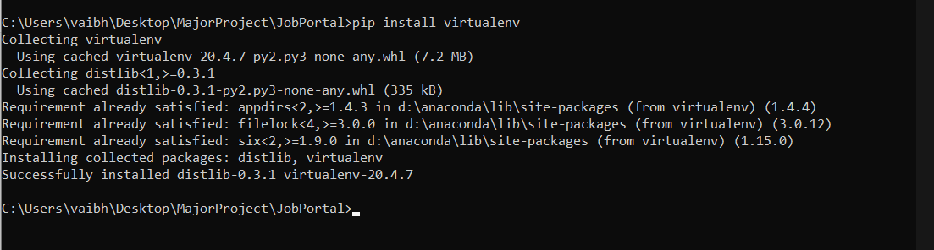

* **Creating a virtual environment**:To create a virtual environment, go to your project’s directory and run venv. If you are using Python 2, replace venv with virtualenv in the below commands.

**On Windows**: “virtualenv env”. Here **env** is the name of the environment. Any name can be used.

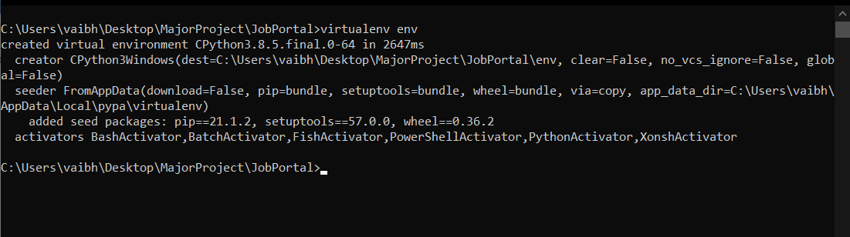

* **Activating a virtual environment**:

**On macOS and Linux**: source env/bin/activate

**On Windows:** .\env\Scripts\activate

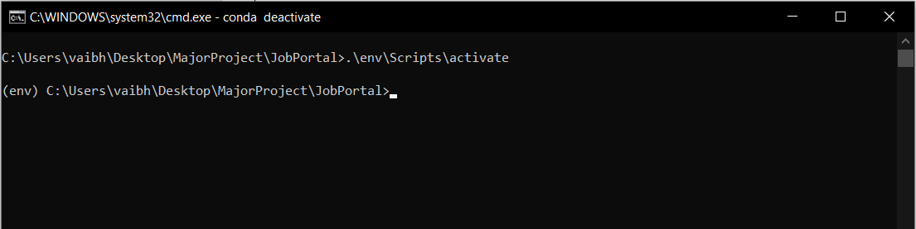

**2)Installing the required packages to run the project**

Installing packages Now that you’re in your virtual environment you can install packages. Go to the project directory i.e., "Job Portal and run the following command

**pip install -r requirements.txt**

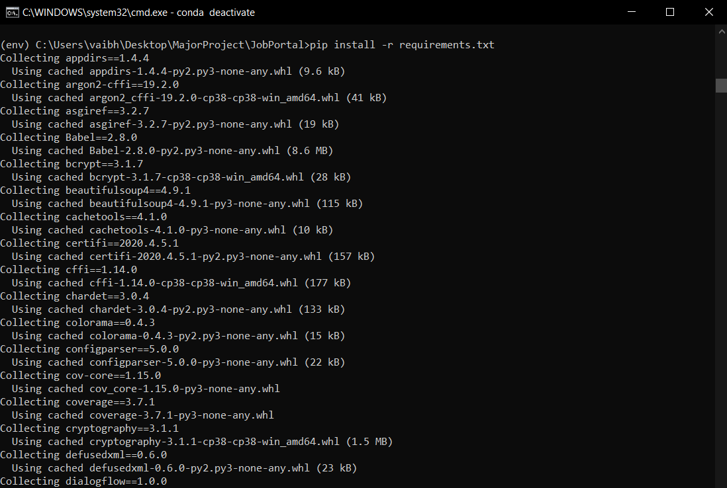

**3)Run** **Server**

After installing all the requirements run the following command in the command prompt

**python manage.py runserver**

**(Using dir do check if you are in the correct directory it should have “manage.py” file in it)**

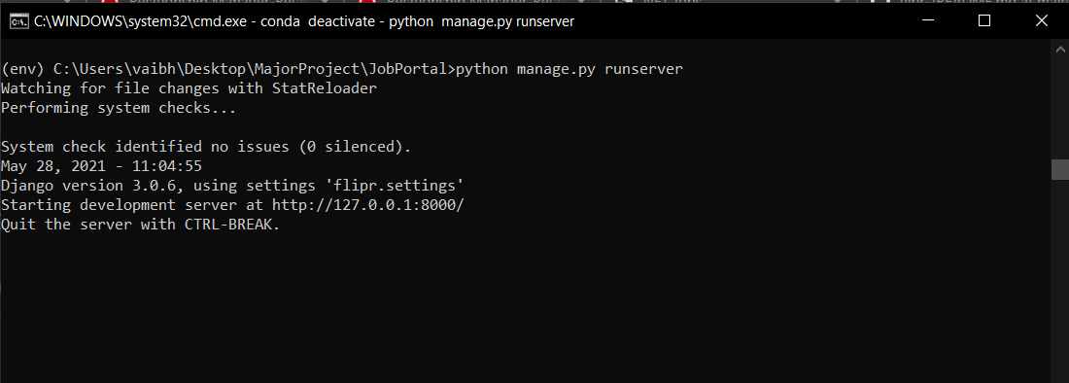

**4) Run any browser and open the following url :**

http://127.0.0.1:8000/