1. Assume you intercepted the following ciphertext. Using a statistical attack, find the plaintext

"XLILSYWIMWRSAJSVWEPIJSVJSYVQMPPMSRHSPPEVWMXMWASVX-LQSVILYVVCFIJSVIXLIWIPPIVVIGIMZIWQSVISJJIVW"   
  
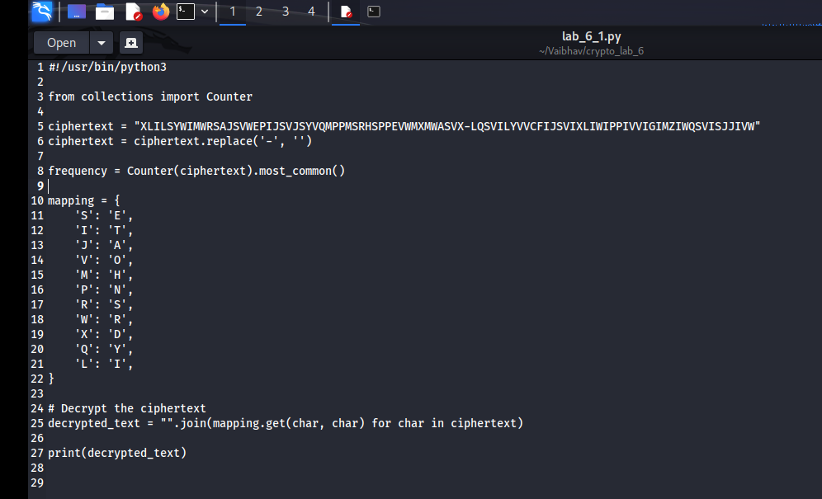  
  


2. Write a Python script to encrypt using Rail Fence (Zig zag ) with three rows and with key (ONE).  
  
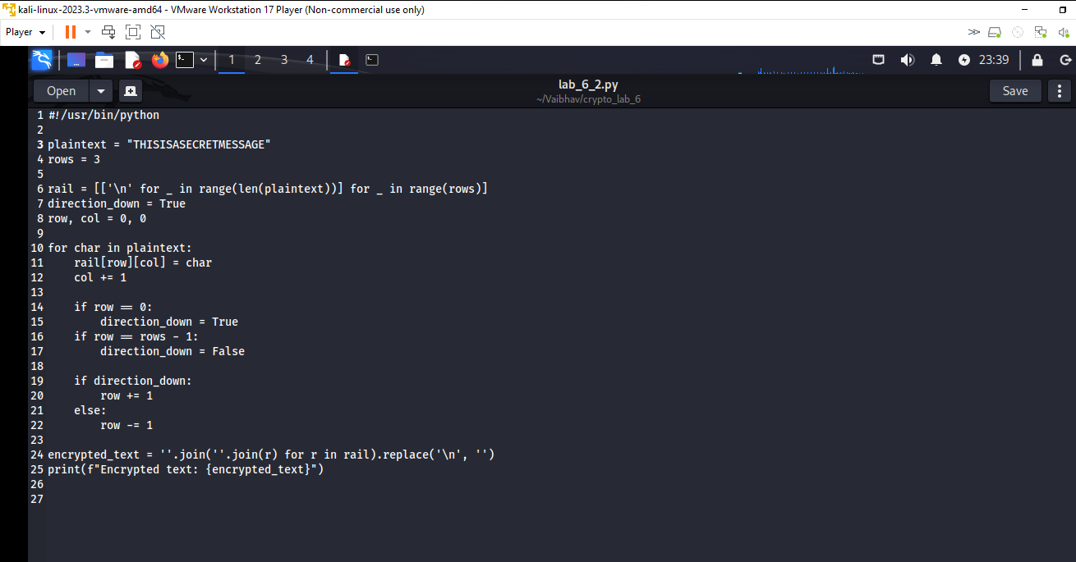  
  
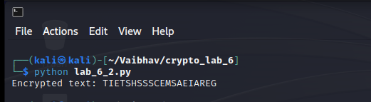

3. Write a python script to encrypt columnar transposition

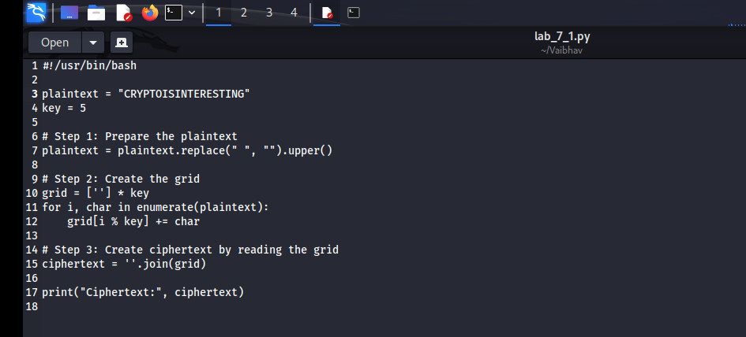  
  
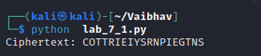

4. Write a Python script to decrypt Rail Fence Cipher   
  
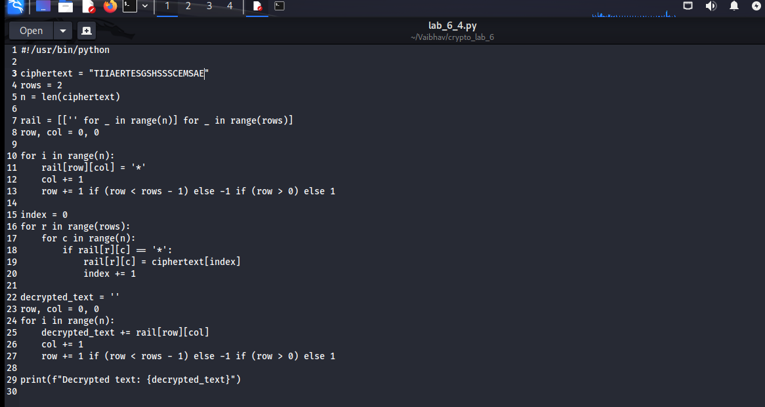  
  
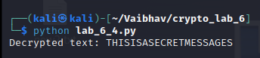

===============================================================================

"It does not matter how slowly you go so long as you do not stop." —Confucius

===============================================================================