1. Write a Python script to encrypt columnar transposition using keyword.   
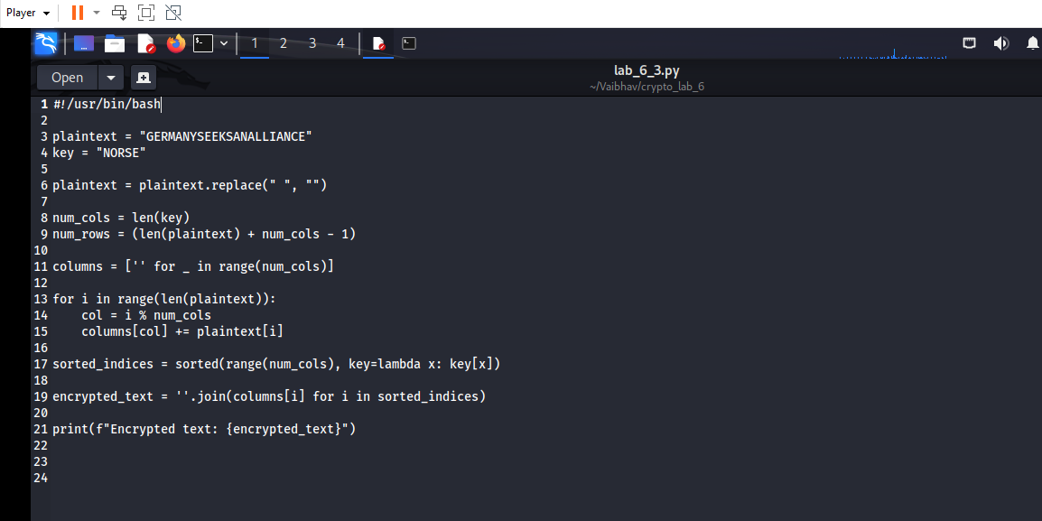  
  
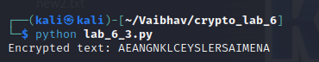

2. Write a Python script to encrypt double columnar transposition.

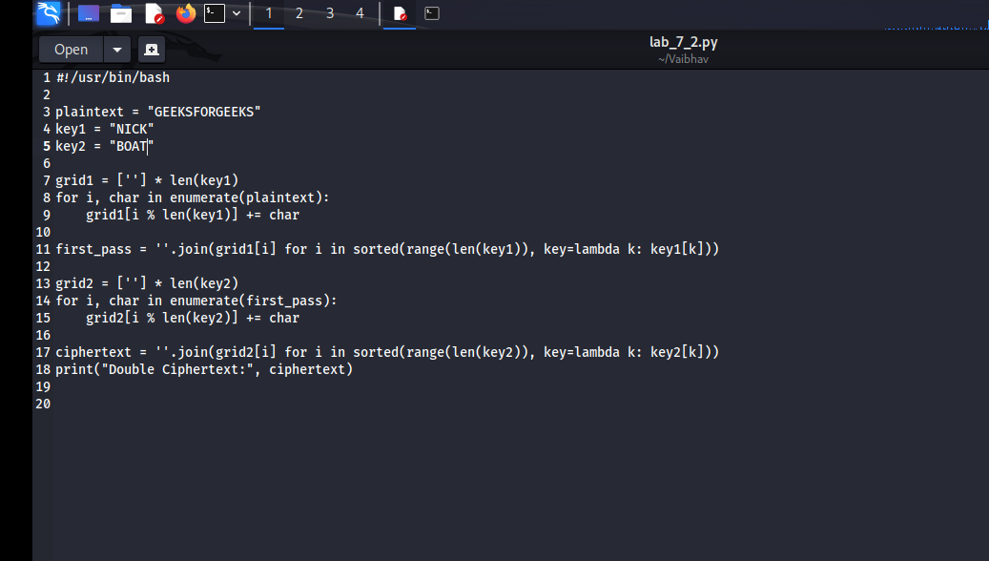  
  
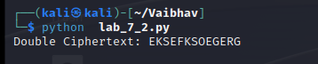

3. Write a Python script to encrypt the message “She is listening” using the 6-character keyword “PASCAL” with Vigenere cipher.  
  
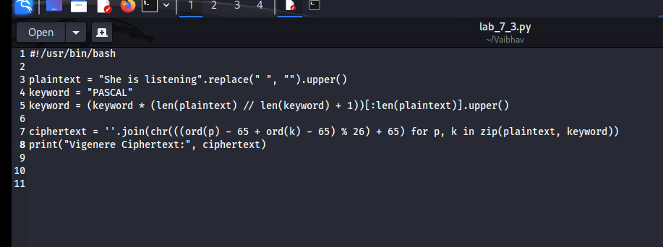  
  
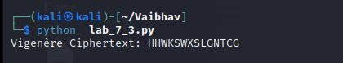

4. Write a Python script to encrypt and decrypt Hill cipher  
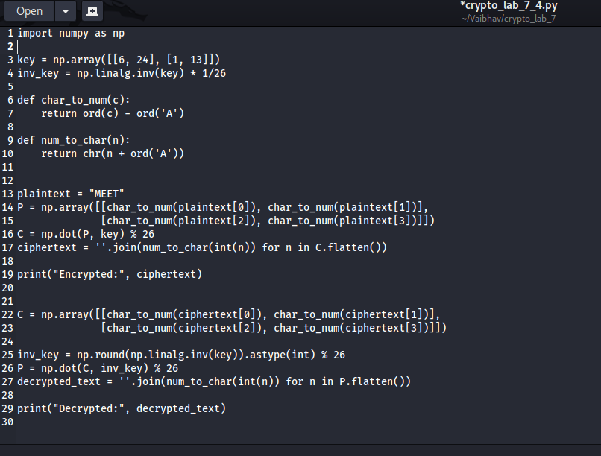

Bonus Point:

5. Write a Python script to perform Kasiski test.

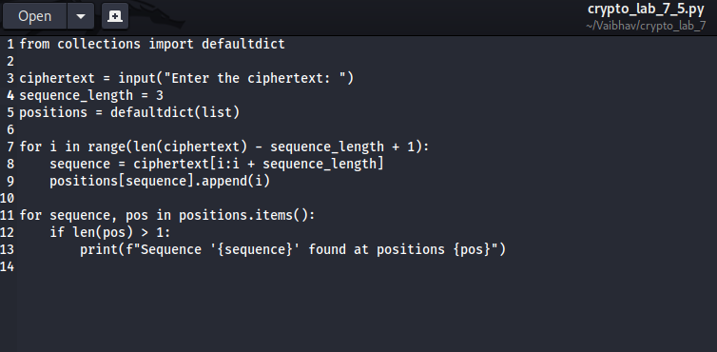

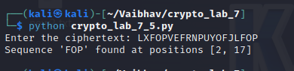

======================================================================================================================================

"Obstacles can't stop you. Problems can't stop you. Most of all, other people can't stop you. Only you can stop you." —Jeffrey Gitomer

======================================================================================================================================