1. Use the ping command to test the connectivity to a remote server (e.g., example.com).

2. Write a script to measure the round-trip time for each packet and analyze the results.

3. Use the traceroute to trace the route packets take to a destination  
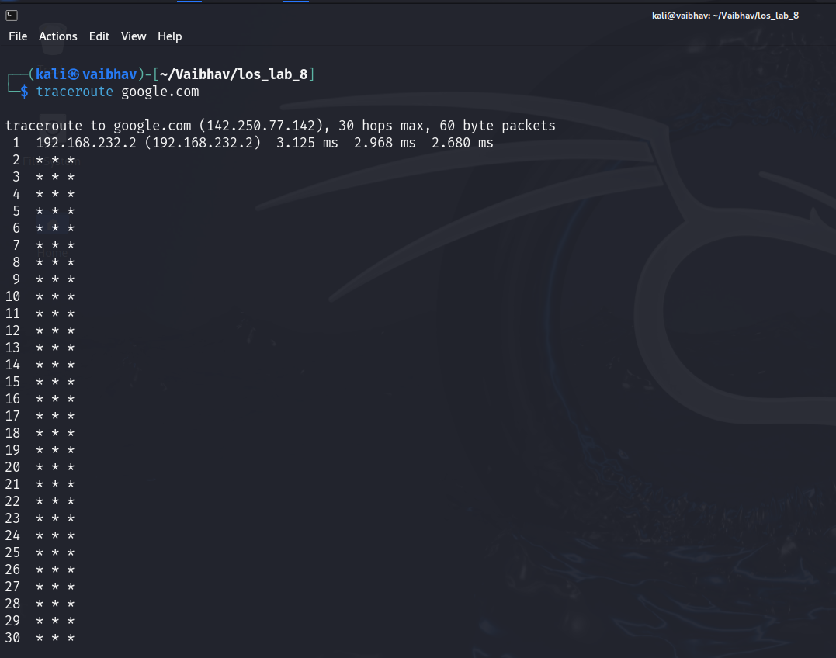

4. Analyze the output to identify any potential bottlenecks or points of failure in the route.  
**Analyze Traceroute Output**

When analyzing the output of the traceroute, look for:

* **High Latency**: Identify any hops with significantly higher response times.
* **Timeouts**: Any * * * entries indicate that a hop did not respond. This may suggest a potential bottleneck or a firewall blocking ICMP packets.
* **Consistent Delays**: If a hop consistently shows delays, it could be a point of failure.

5. Use the nslookup command to find the IP address of a given domain (e.g., example.com).

6. Use the netstat command to view active connections and listening ports on your machine.

7. Use the ifconfig (Linux) or ip a command to display network interface configurations.

8. Write a script to report document the configuration of each interface, noting the IP address, subnet mask, and any other relevant information.  
  
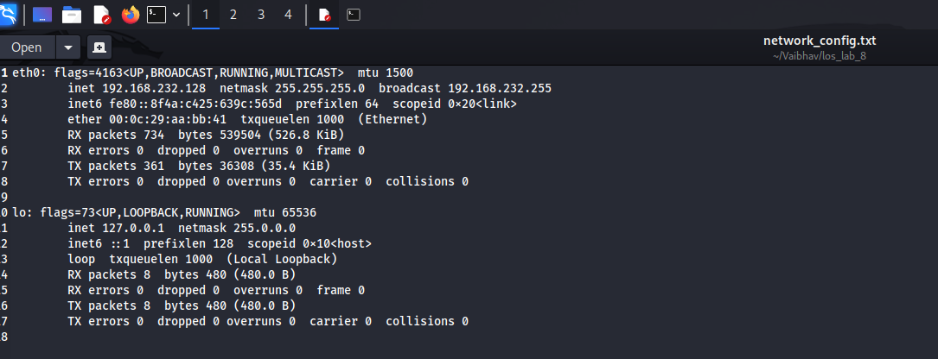

9. Perform a basic network scan using nmap on your local network to identify active devices and open ports.  
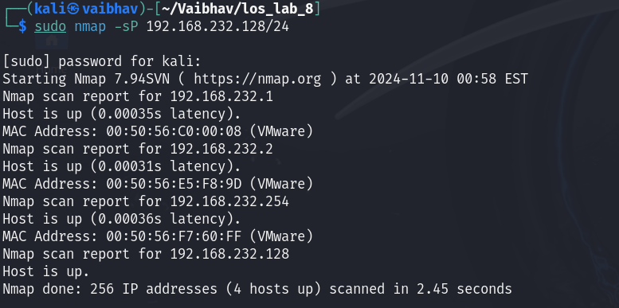

10. Create a report summarizing the devices found, their IP addresses, and the services running on the open ports.  
  
11. Capture network packets using tcpdump on a specific interface.

12. Analyze the captured packets for specific protocols (like HTTP or DNS) and summarize your findings.

13. Use the whois command to gather registration information about a domain.

14. Use the hostname command to display and change the hostname of your machine.

15. Use the finger command to gather information about users on a system.

16. Use the who command to see who is currently logged into the system and the last command to view the login history.

-------------------------------------------------------------------------------------------------------------------------

Xargs

-------------------------------------------------------------------------------------------------------------------------

1. Write a shell script called testurl.sh that accepts a list of urls in a separate file and tests if the website is up or not.   
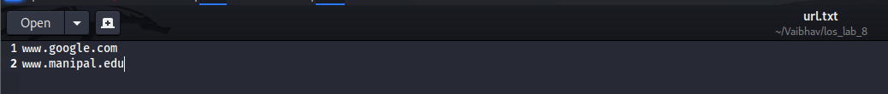  
  
  
  
  
  
  
  
  
  
  
  
2. Create a shell script called diskhog.sh that lists the 5 largest items (files or directories) in the current directory in decreasing order of size.

3. compress all .log files found in the /var/logs/ directory?  
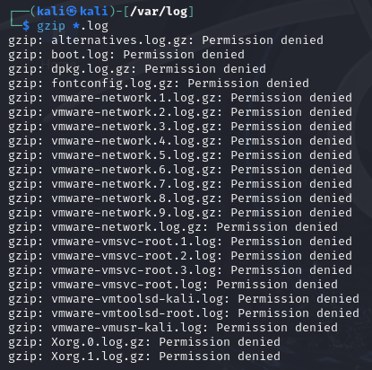

4. delete all temporary files older than 7 days from the /tmp/ directory?

5. write a shell script to make all .sh files in your home directory executable?

6. search for the string "auth" in all .conf files in the /etc/ directory  
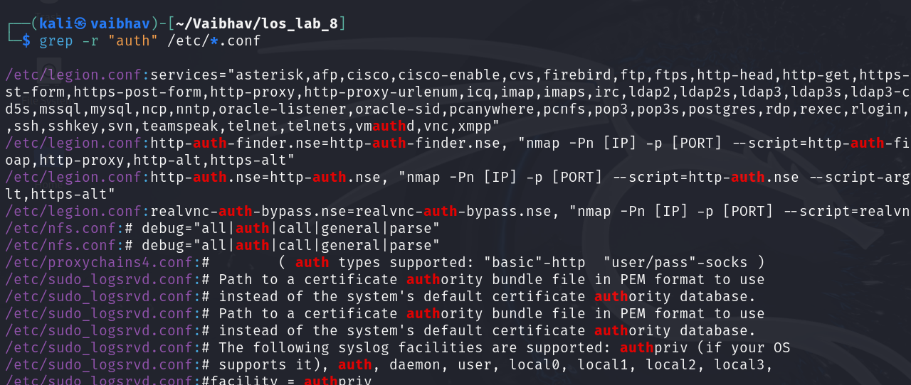

7. count the number of "failed" login attempts in all .log files in /var/log/?

8. rename all .txt files in the current directory by appending .bak

9. Write a shell script to check if a list of users from users.txt exist in the system.  
  
10. search for keywords like "ERROR" or "CRITICAL" in all log files over 1MB in size.

=================================================================================================================================================================

“If everyone is moving forward together, then success takes care of itself.” — Henry Ford