The main idea of this lab exercise to give hands on experiance on

grep

constructs

command line arguments

1. write a shell script to get value the pattern and file name from the user and check the pattern exists or not. If the pattern exists print the relavent

message , if pattern not found print relevent message.

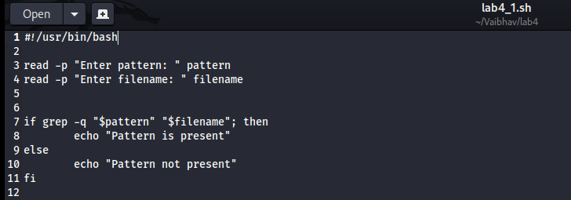  
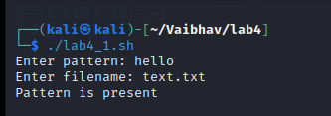

2. Modify the above script to pass the arguments from command line arguments.

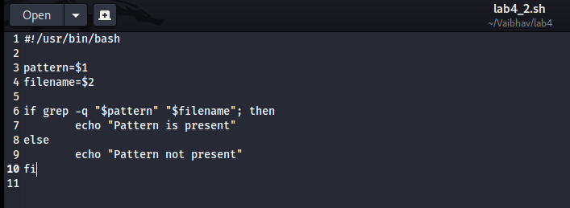  
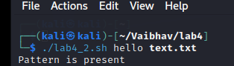

3. Modify the above script to pass the values inside the script.

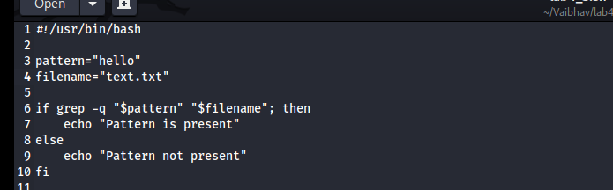  
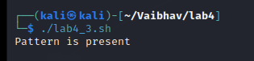

4. validate the script (script 1, script 2)

- the file exists or not

- arguments passed or not   
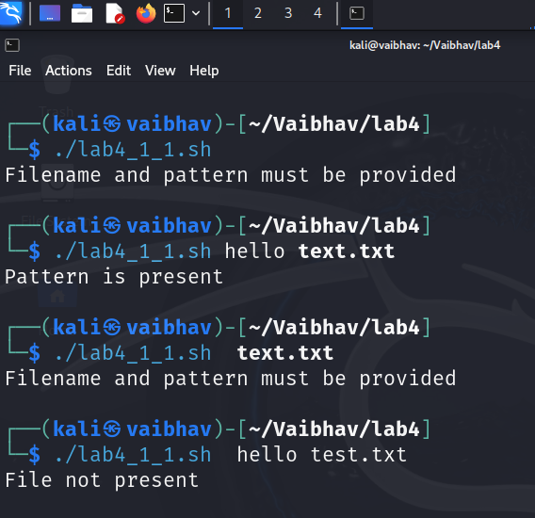

5. Apply grep commands

Note: Make sure to use the options -e -c -n -q -s -f -A -B -C -i -h, -l -o -w

Frame the questions (as per your choice)

to extract user information

to extract network information

to extract login details  
  
1) How would you search for lines containing either Aarav or Deepak?  
  
2) How many lines contain the word workmail?  
  
3) Find all lines containing Mumbai and show their line numbers.  
  
4) Check if any line contains the word Chennai without displaying the result.  
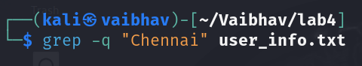  
  
5) Silently check for the word Goa in a non-existent file without throwing errors.  
  
6) How would you search for patterns stored in a separate file patterns.txt inside userdata.txt?  
  
7) Display the line containing Chirag and the 1 line following it  
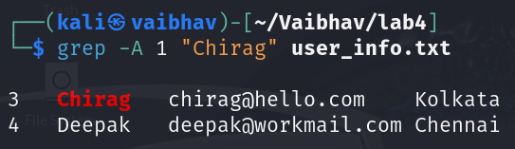

8) Display the line containing Farhan and the 2 lines before it  
  
9) Show 1 line before and after the match for Gauri  
  
10) Search for the word esha in a case-insensitive manner  
  
11) Search for the word Delhi across multiple files and suppress the file name in the output.  
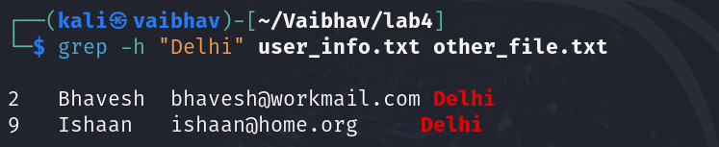  
  
12) Search for Chennai in multiple files and only display the file names containing matches.  
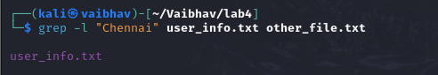  
  
13) Extract just the email addresses from the file

14) Search for the whole word Aarav without matching substrings like Saarav  
  
