**Day-1**

**Different Operating system used for Cybersecurity :**

1) Kali Linux

2) Parrot OS

3) Network Security ToolKit (NST)

4) Digital Evidence and Forensic Toolkit (DEFT)

5) Cyborg Hawk

6) Pentoo

7) GnackTrack

8) Fedora Security Lab

**Installation Process Of Kali Linux**

1. First Install VMware as we will be running our Kali Linux in Virtual Machine .
2. Visit <https://www.broadcom.com/> as virtual box is now acquired by Broadcom.
3. After the Installation Of VmWare now install the kali linux

from <https://www.kali.org/get-kali/#kali-platforms> and then select virtual machines.

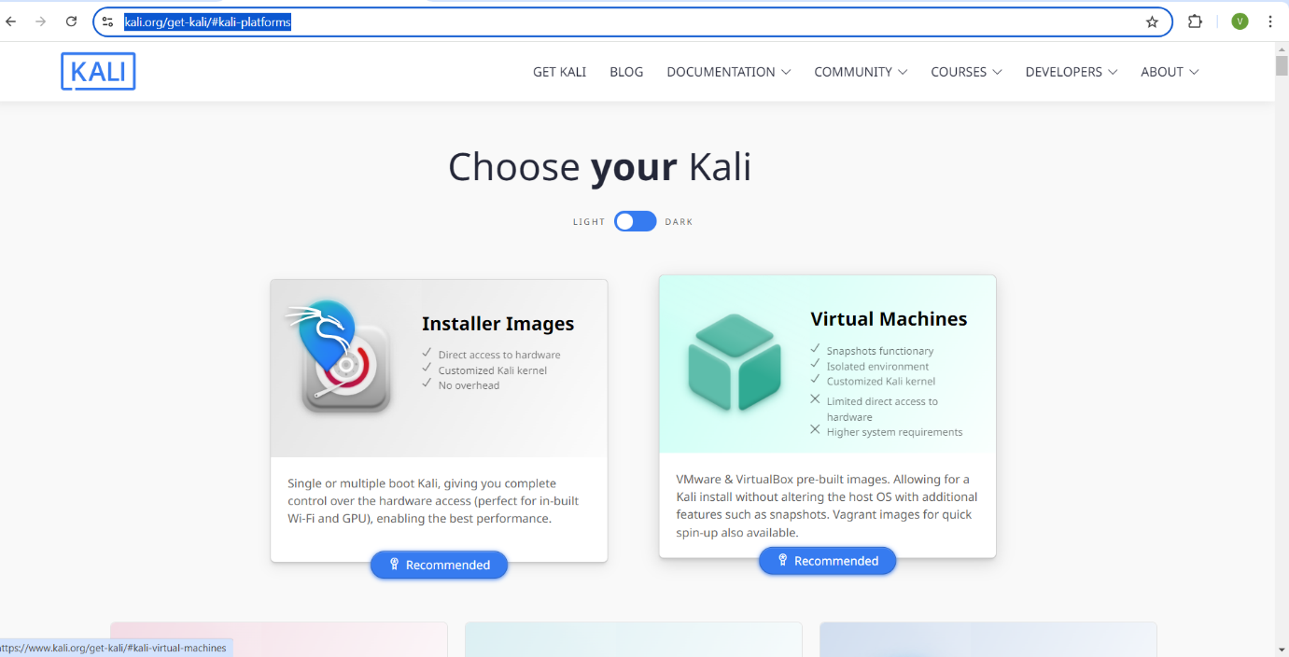

1. After selecting virtual machines then select Vmware and download it.

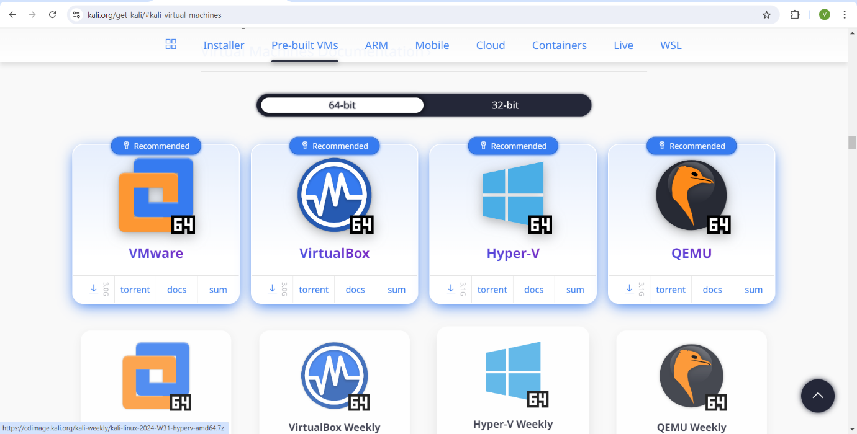

1. Once the kali Linux is installed go to VMware and select Open a virtual machine then browse the folder where the kali linux is downloaded.

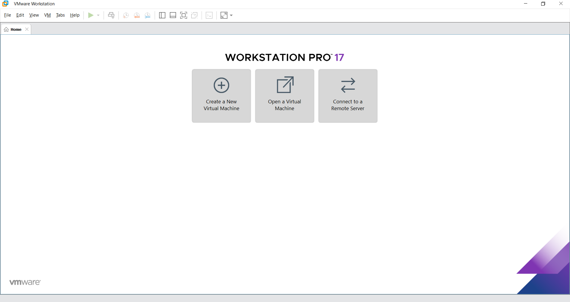

1. Open the kali linux folder and it will be there in the VMware then Select the kali linux and power on the virtual machine.

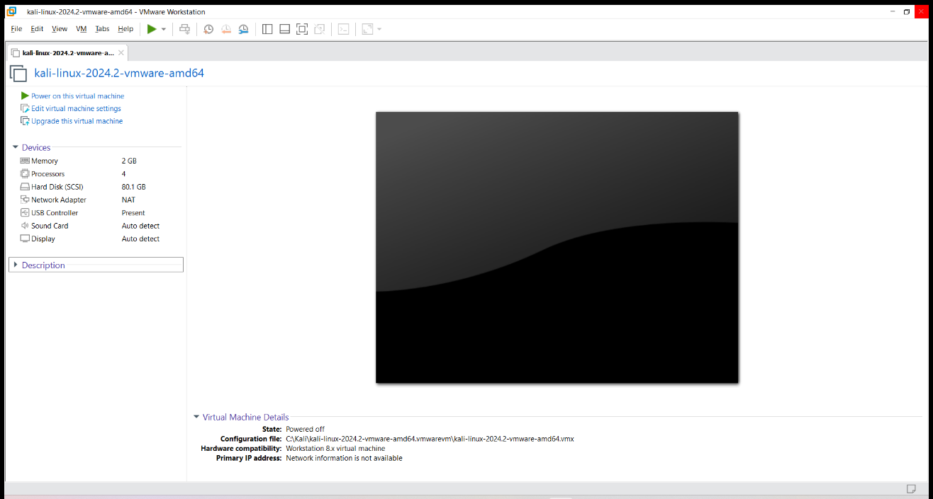

1. Then enter the default username and password of kali linux which is kali.

8)The installation of Kali Linux is done successfully.