BRACT’s
Vishwakarma Institute of Technology, Pune
Practical Implementation Sheet
Department: CSE-AI Semester: 5 Academic Year: 2026-27
Division: E Batch: 01 Practical No: 01
Roll no: 01 PRN No: 12410844 Name of Student: Vaibhav Vaijnath Chate
Subject Name : Deep Learning

Problem Statement : Install and configure TensorFlow/Keras in Google Colab. Perform data preprocessing, normalization, train-test split, and visualization on a sample dataset.

Algorithm :
- Import the required libraries (TensorFlow and Matplotlib).
- Load the MNIST handwritten digit dataset.
- Normalize the image pixel values by dividing them by 255.
- Display a sample image from the dataset.
- Create a Sequential neural network model.
- Add a Flatten layer to convert the 28×28 image into a 1D vector.
- Add a Dense hidden layer with 128 neurons and ReLU activation.
- Add an output Dense layer with 10 neurons and Softmax activation.
- Compile the model using the Adam optimizer and Sparse Categorical Crossentropy loss.
- Train the model using the training dataset for 3 epochs.
- Evaluate the trained model on the test dataset.
- Display the test accuracy.
- Save the trained model for future use.

Code :

# Import Libraries
import tensorflow as tf
import matplotlib.pyplot as plt

# Load MNIST Dataset
(train_images, train_labels), (test_images, test_labels) = tf.keras.datasets.mnist.load_data()

# Normalize Images (0-255 --> 0-1)
train_images = train_images / 255.0
test_images = test_images / 255.0

# Display Dataset Information
print("Train Images Shape:", train_images.shape)
print("Test Images Shape:", test_images.shape)
print("Train Labels:", train_labels)

# Display First Image
plt.imshow(train_images[1], cmap='gray')
plt.title(f"Label: {train_labels[1]}")
plt.show()

# Create Neural Network Model
model = tf.keras.models.Sequential([
tf.keras.layers.Flatten(input_shape=(28, 28)),
tf.keras.layers.Dense(128, activation='relu'),
tf.keras.layers.Dense(10, activation='softmax')
])

# Compile Model
model.compile(
optimizer='adam',
loss='sparse_categorical_crossentropy',
metrics=['accuracy']
)

# Train Model
model.fit(train_images, train_labels, epochs=3)

# Evaluate Model
test_loss, test_accuracy = model.evaluate(test_images, test_labels)
print("Test Accuracy:", test_accuracy)

# Save Model
model.save("my_mnist_model.keras")

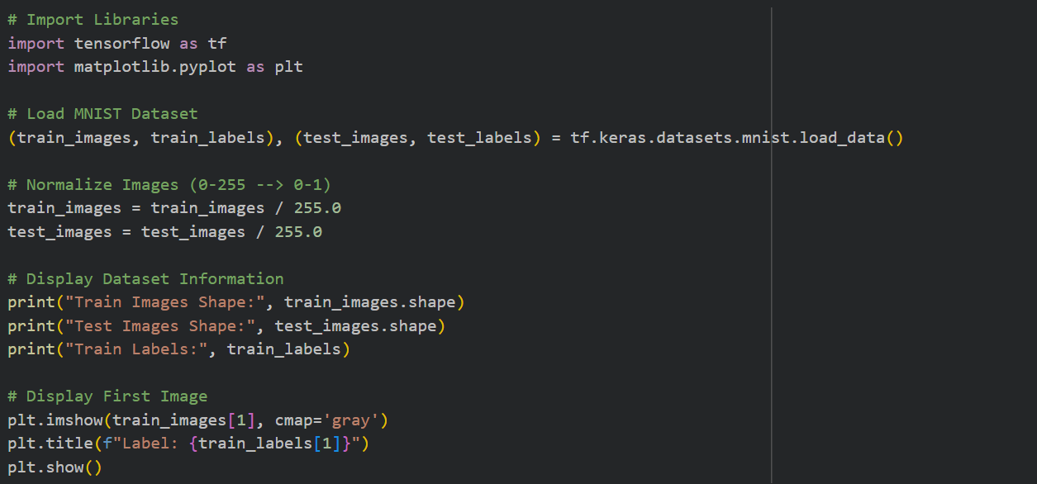
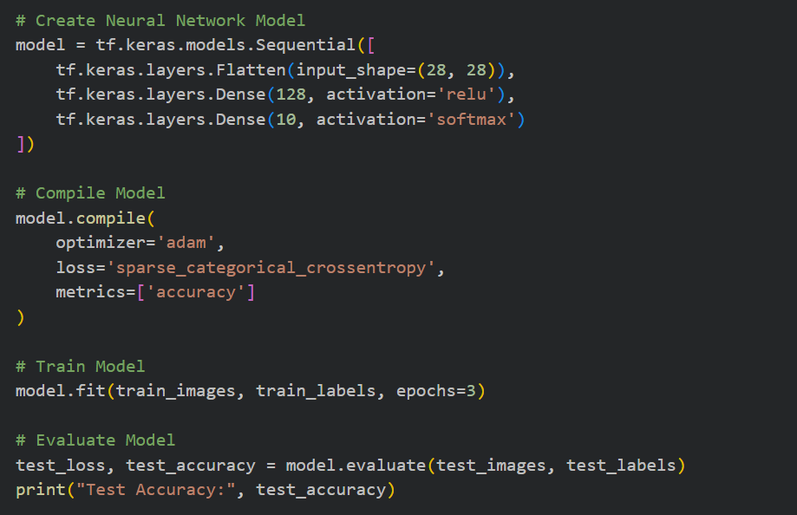
Output :
